LOGISTIC REGRESSION

Logistic regression is a statistical model that in its basic form uses a logistic function which is the sigmoid function to model a [binary](https://en.wikipedia.org/wiki/Binary_variable) [dependent variable](https://en.wikipedia.org/wiki/Dependent_variable), although many more complex [extensions](https://en.wikipedia.org/wiki/Logistic_regression#Extensions) exist. Mathematically, a binary logistic model has a dependent variable with two possible values, such as pass/fail which is represented by an [indicator variable](https://en.wikipedia.org/wiki/Indicator_variable), where the two values are labelled "0" and "1"

**IMPLEMENTATION:**

We will import all the necessary python libraries and load the csv file into dataframe. Then we have initialised the total number of random splits (total_itr=10)

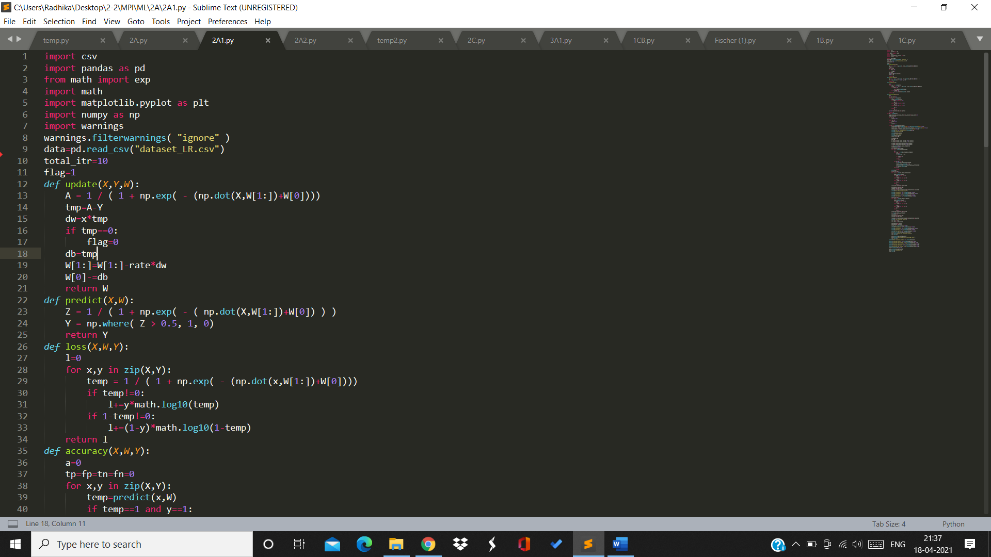

The update function updates the weights by finding the gradient of the loss*learning rate

The predict function predicts the class of the test cases. The loss function calculates the loss which we will get from the sigmoid function. 

Accuracy function will calculate the accuracy of our model by comparing with the target attribute and the prediction we get from our model.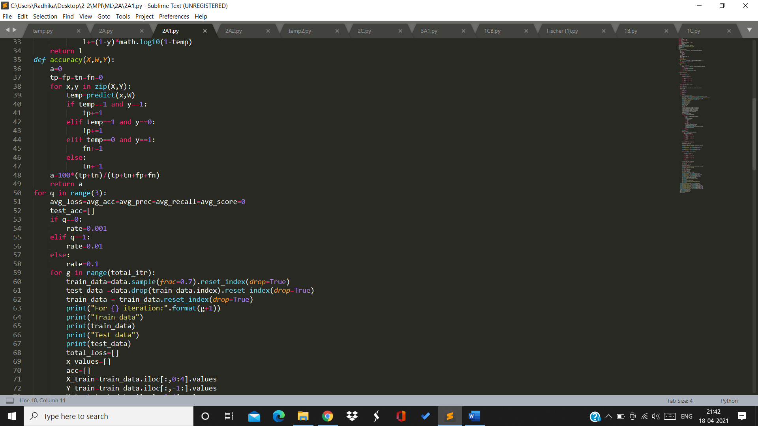

**FOR GRADIENT DESCENT:**

We will go through full training data in each iteration and update the weights accordingly. 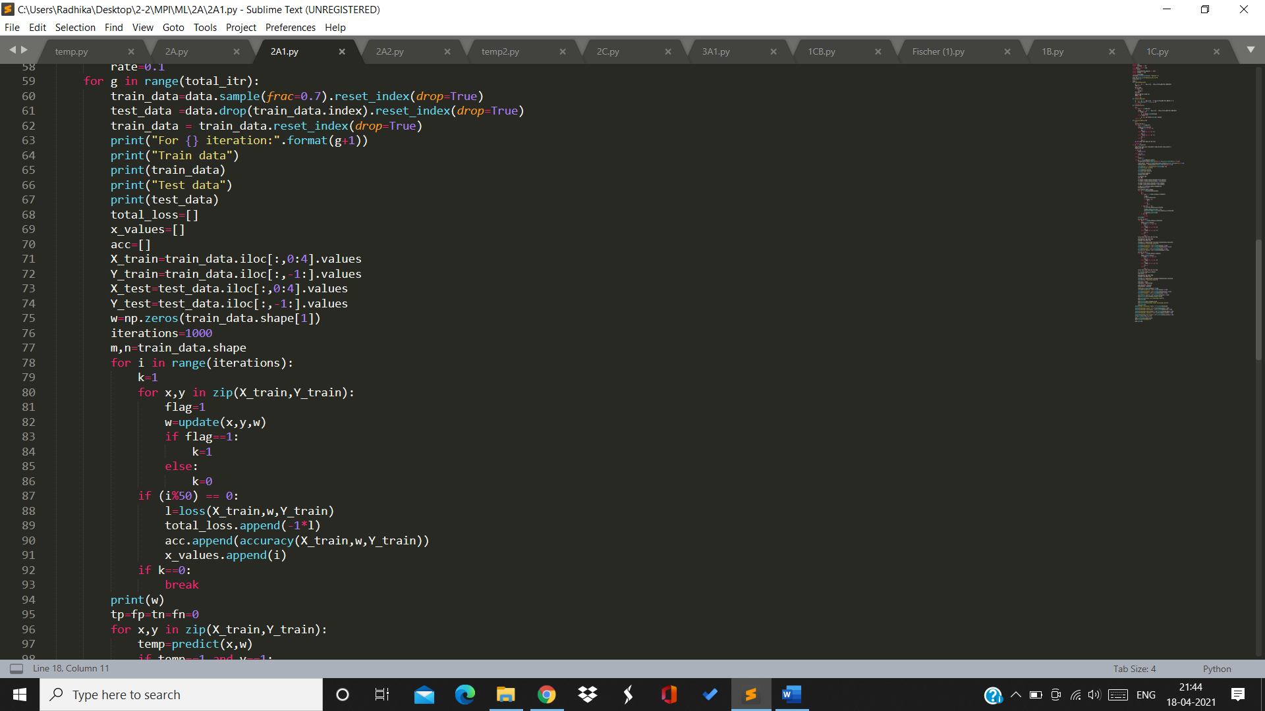

**FOR STOCHASTIC GRADIENT DESCENT:**

We will choose 1 random sample from training data in each iteration and update the weights accordingly.

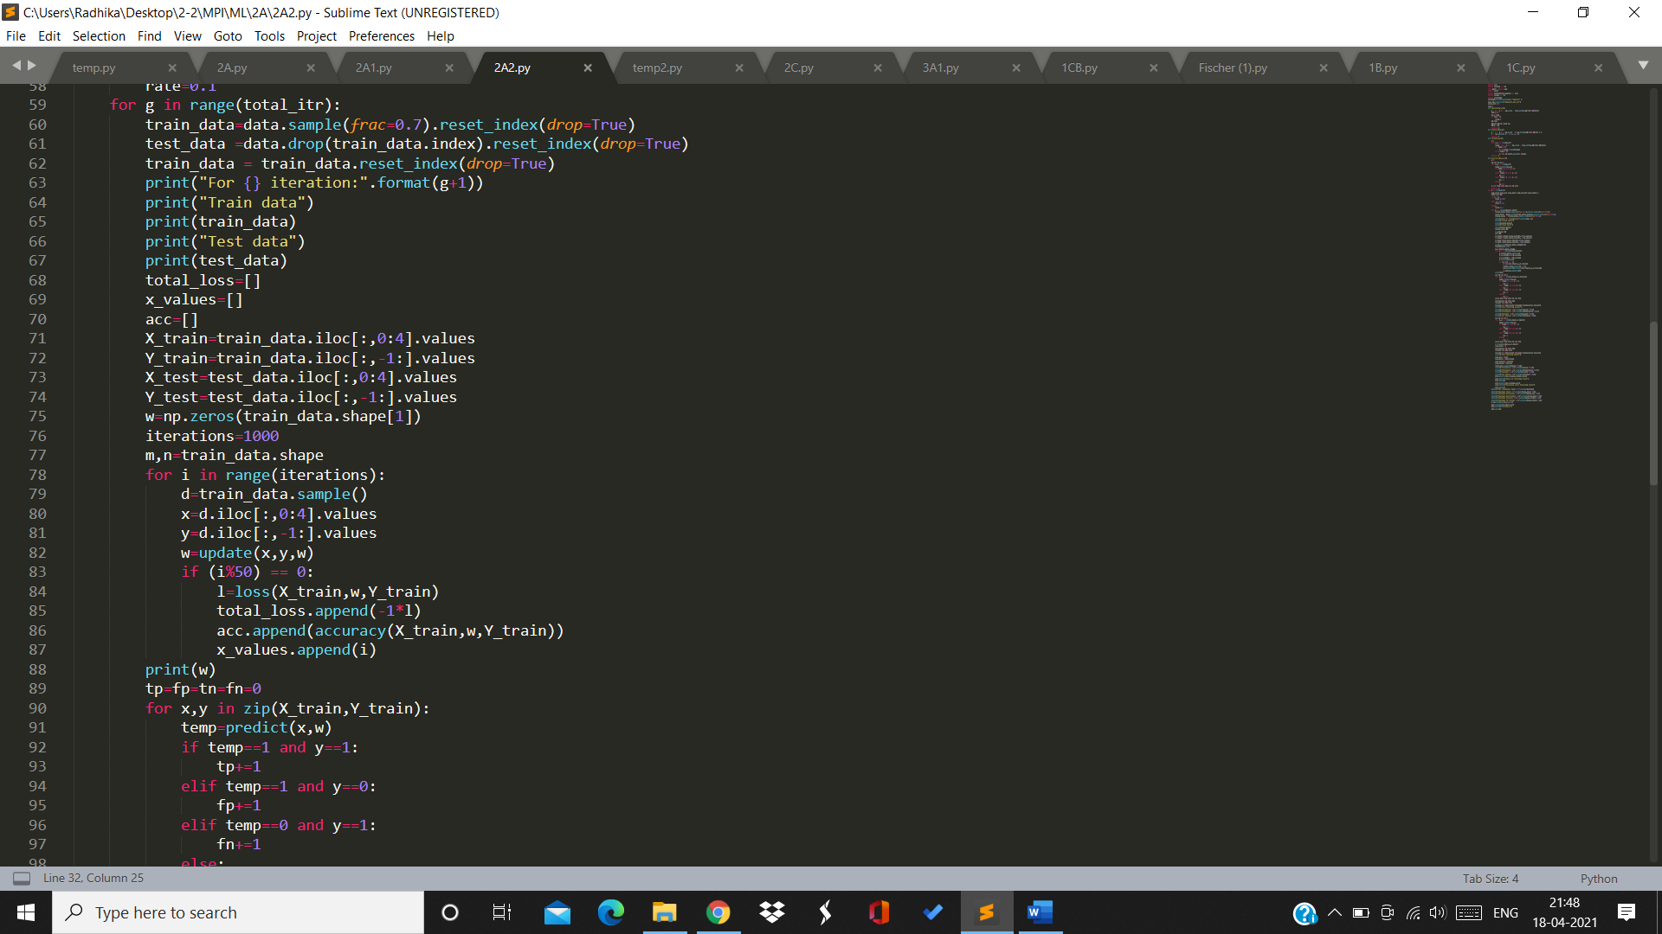

Then we will find all the test metrics: Accuracy,Precision,Recall,F1 Score.

At last we will find the mean loss, mean accuracy after all 10 splits.

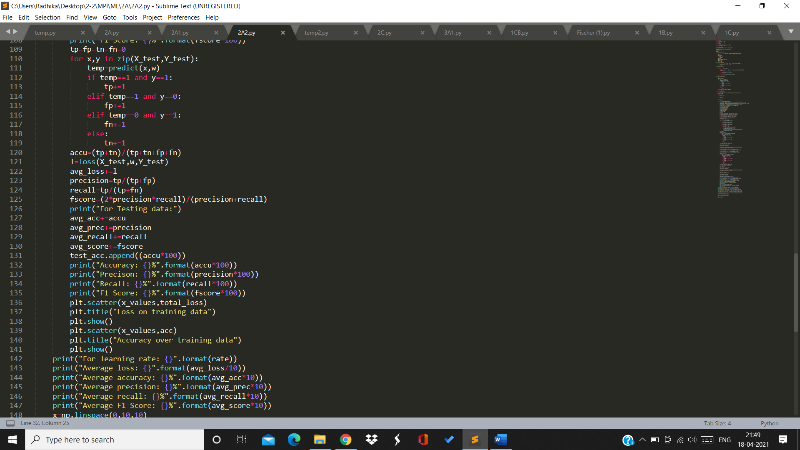

**RESULTS:**

Rate=0.001

1st split:

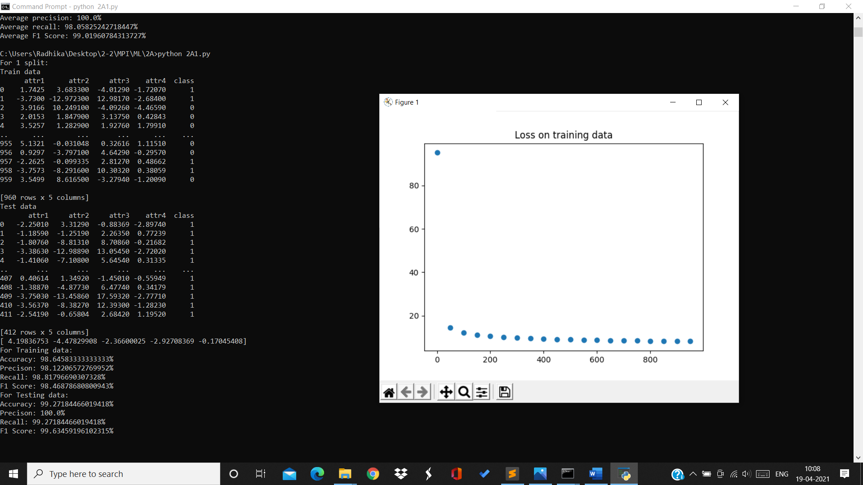

Training data:

Accuracy=98.6% Precision=98.12% Recall=98.81% F1Score=98.468%

Testing data:

Accuracy=99.27% Precision=100% Recall=99.27% F1Score=99.63%

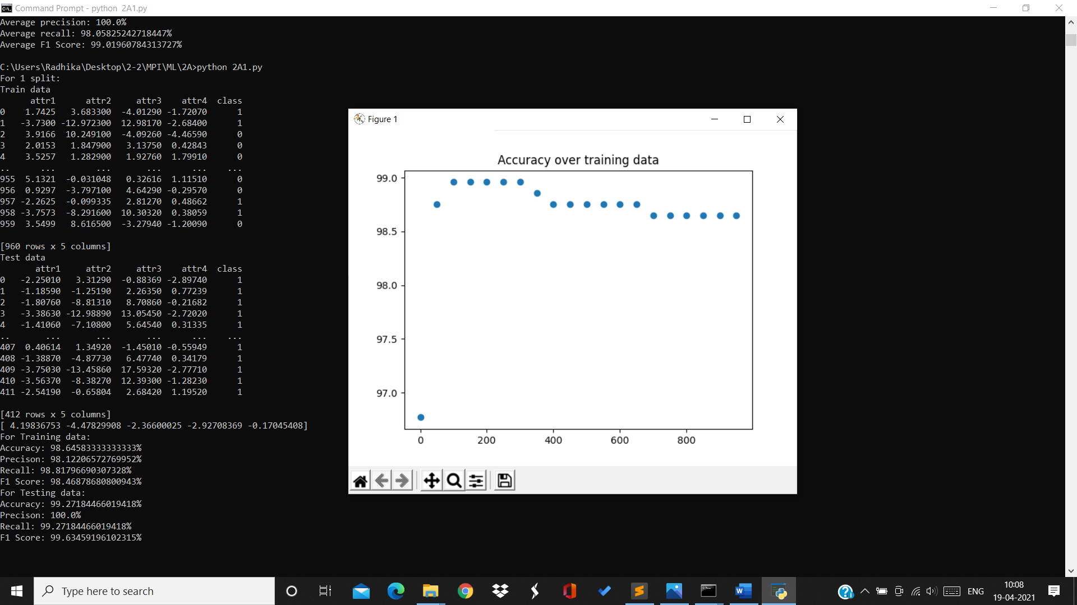

For 2nd split:

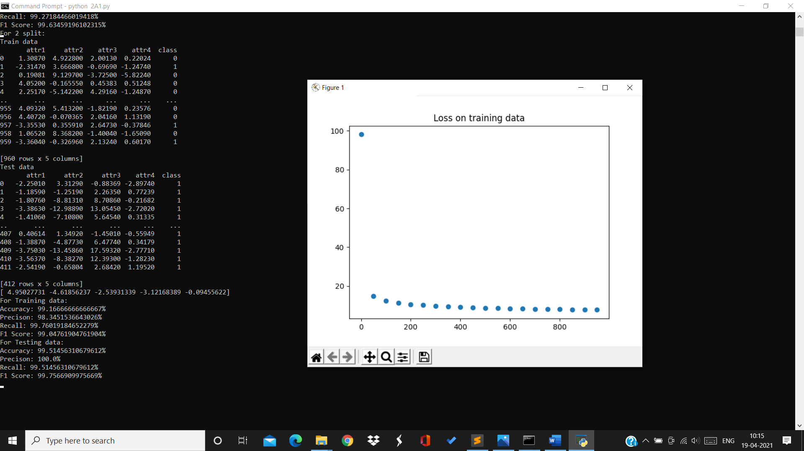

Training data:

Accuracy=99.16% Precision=98.34% Recall=99.76% F1Score=99.04%

Testing data:

Accuracy=99.514% Precision=100% Recall=99.51% F1Score=99.75%

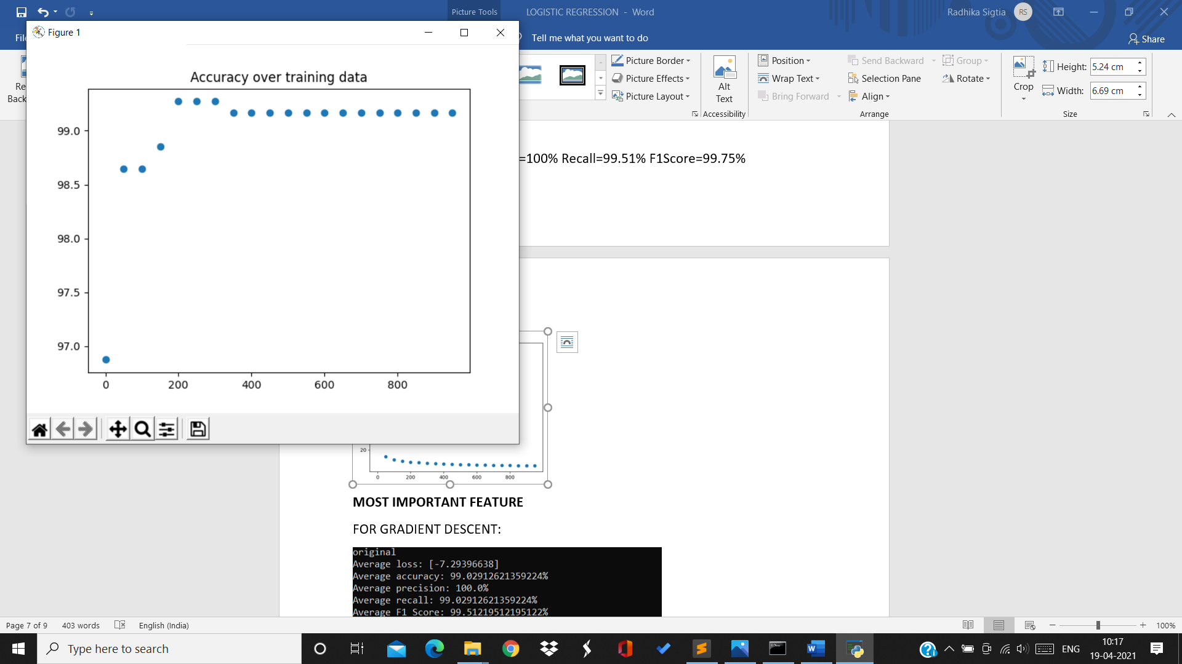

For 3rd split:

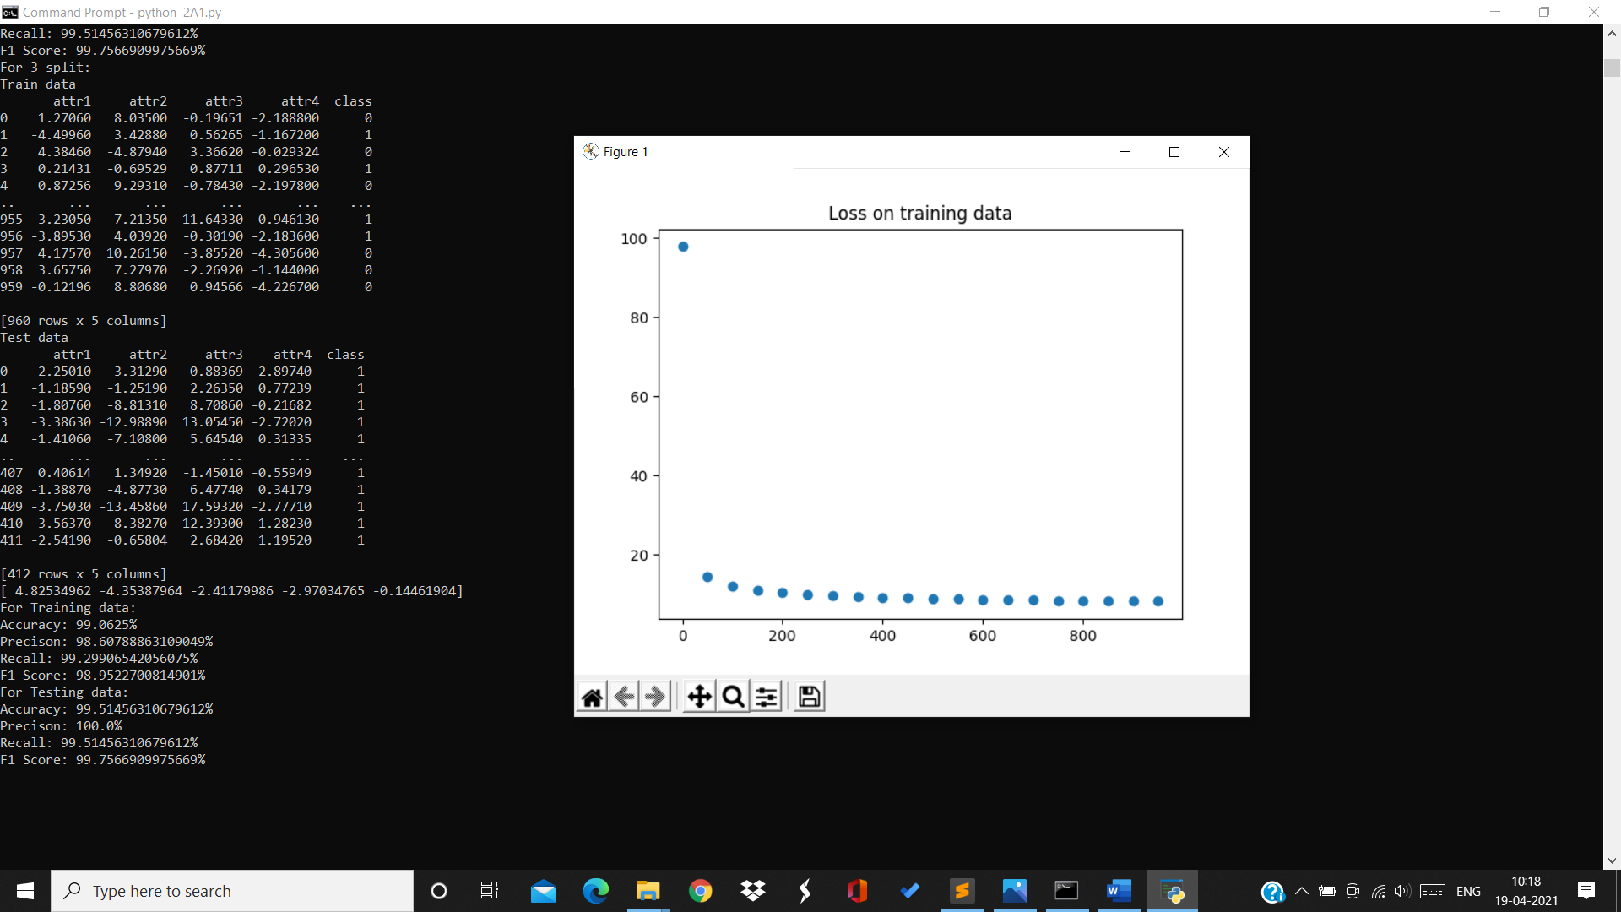

Training data:

Accuracy=99.06% Precision=98.65% Recall=99.29% F1Score=98.95%

Testing data:

Accuracy=99.5% Precision=100% Recall=99.51% F1Score=99.75%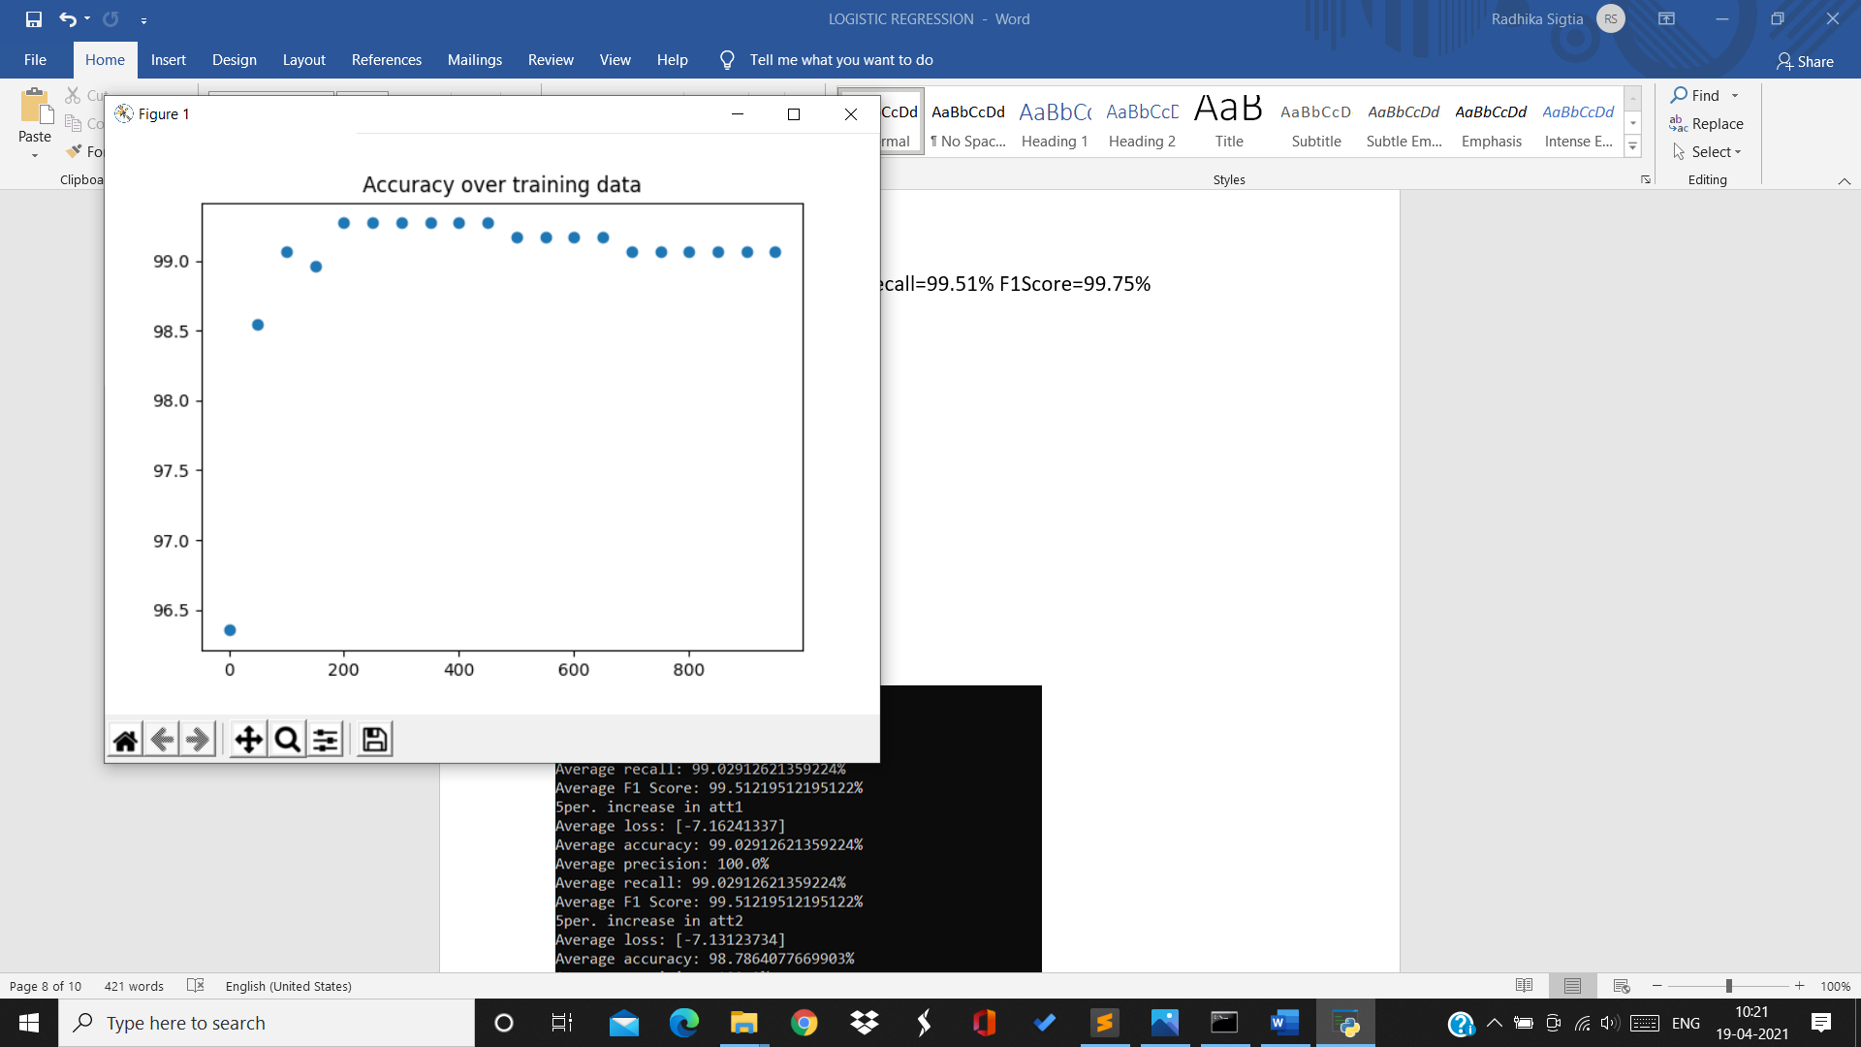

For 4th split:

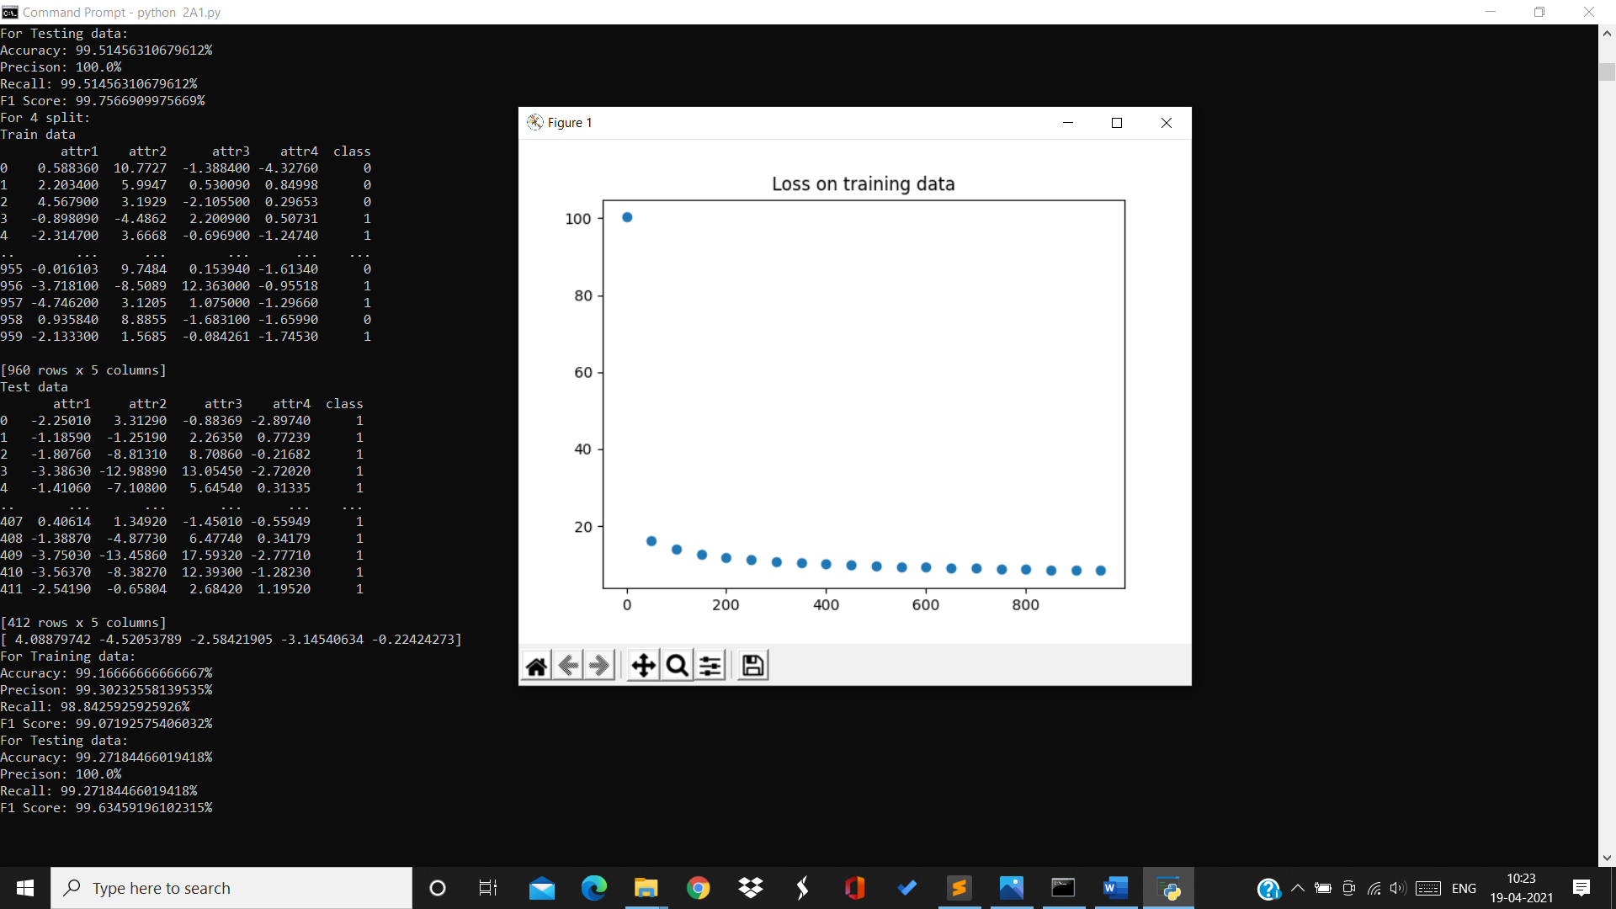

Training data:

Accuracy=99.16% Precision=99.3% Recall=98.84% F1Score=99.07%

Testing data:

Accuracy=99.27% Precision=100% Recall=99.27% F1Score=99.63%

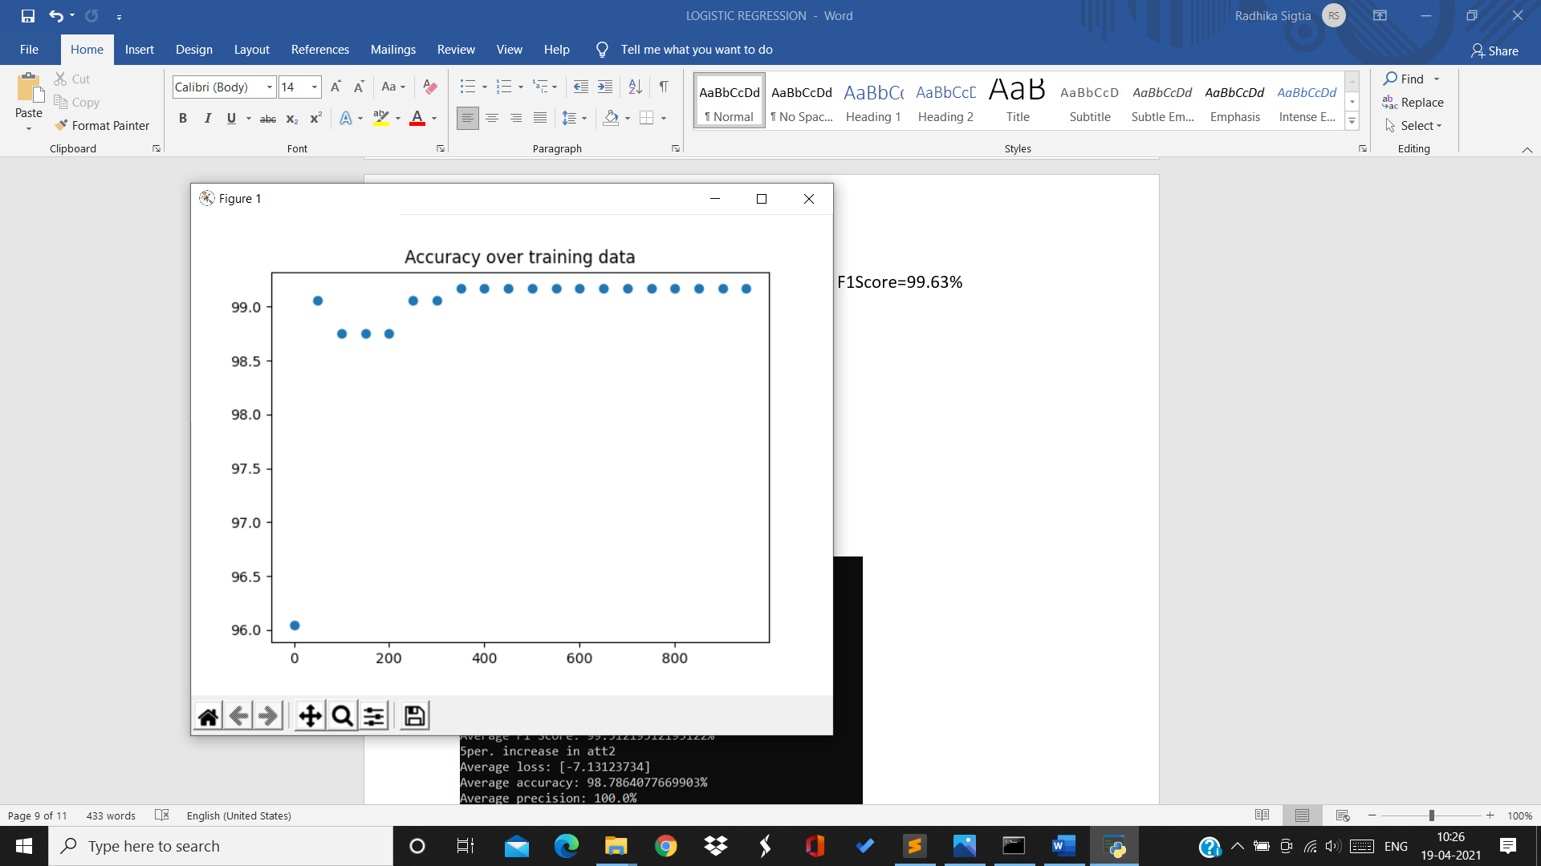

For 5th split:

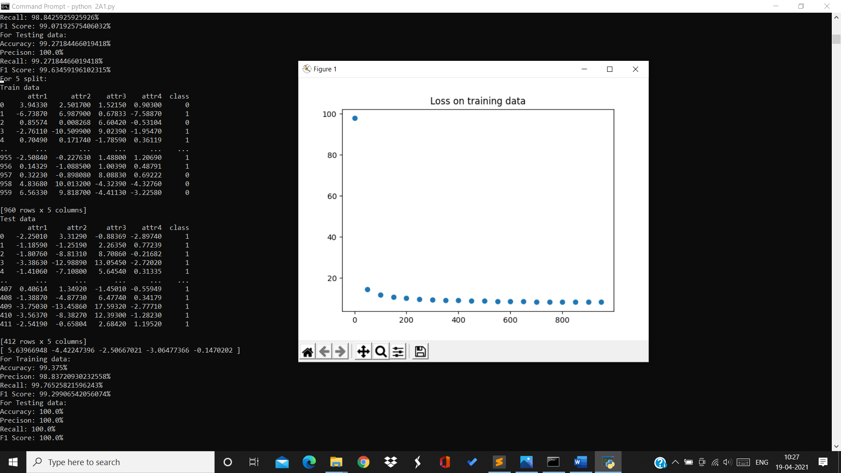

Training data:

Accuracy=99.375% Precision=989.83% Recall=99.76% F1Score=99.29%

Testing data:

Accuracy=100% Precision=100% Recall=100% F1Score=100%

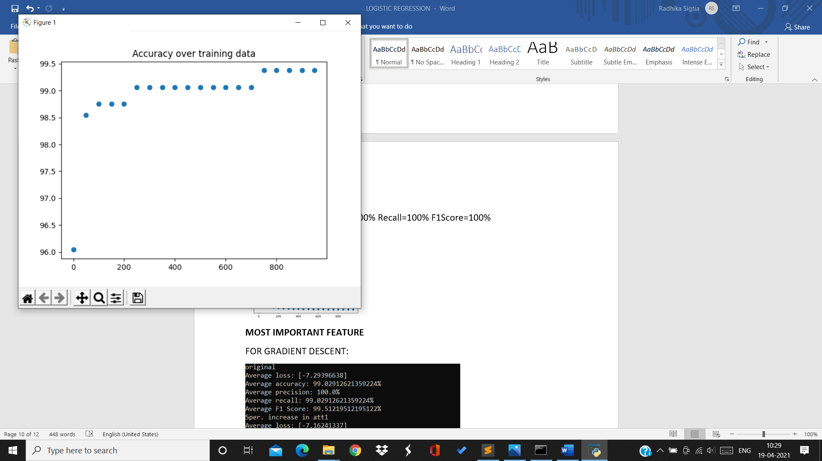

For 6th split:

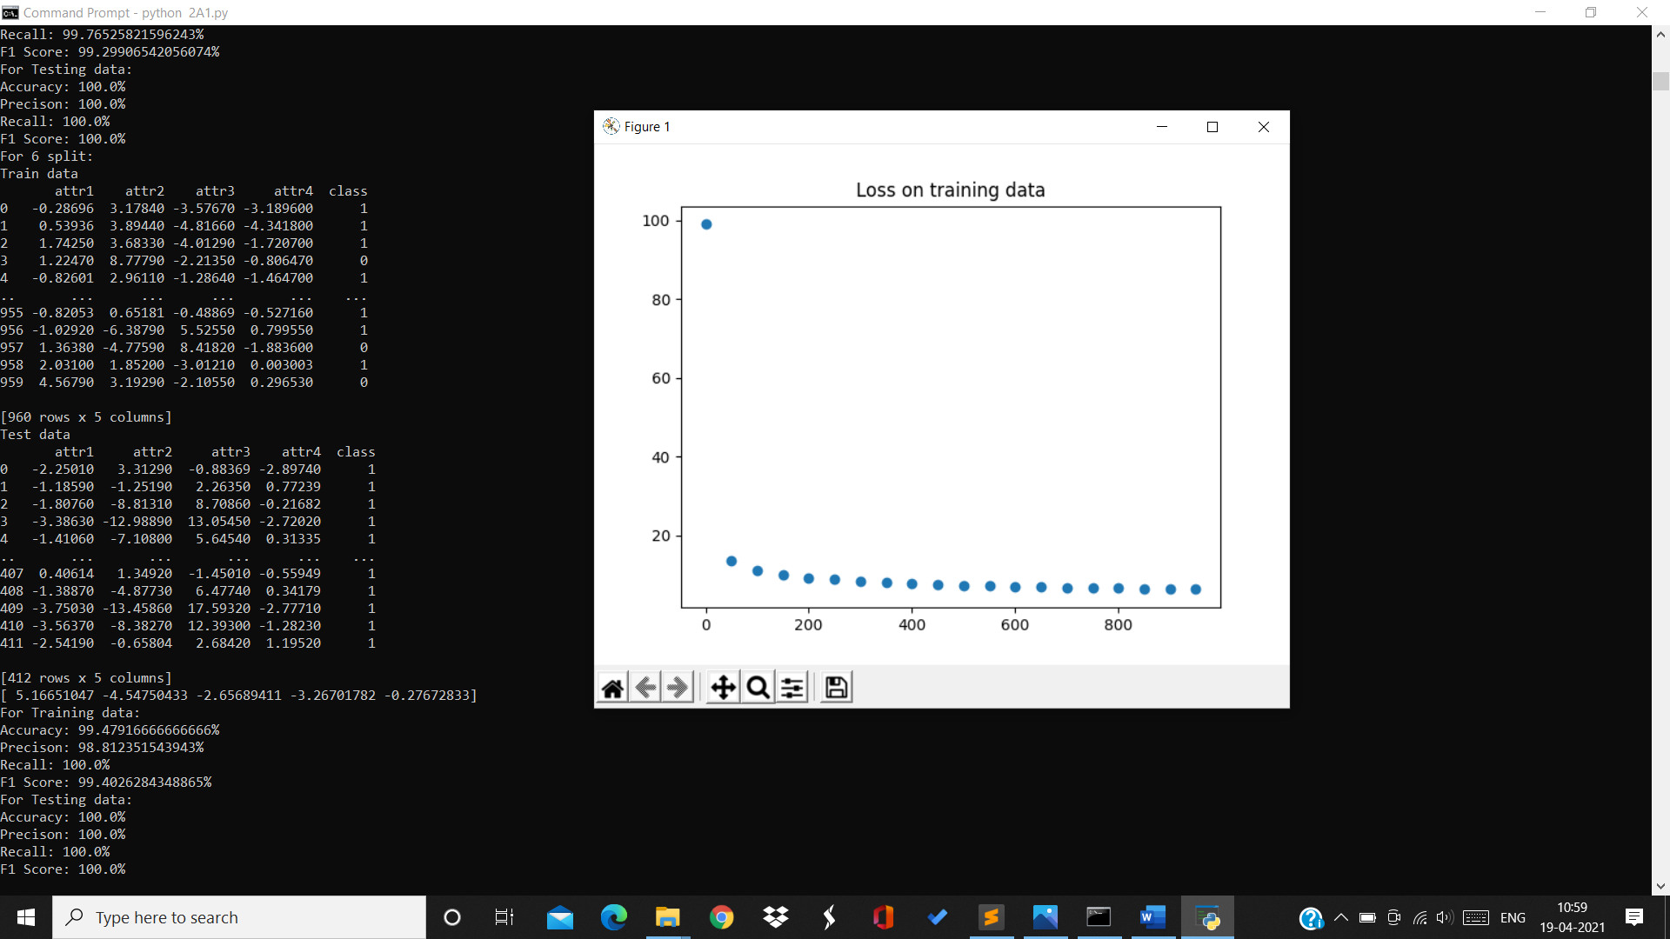

Training data:

Accuracy=99.47% Precision=98.85 Recall=100% F1Score=99.4%

Testing data:

Accuracy=100% Precision=100% Recall=100% F1Score=100%

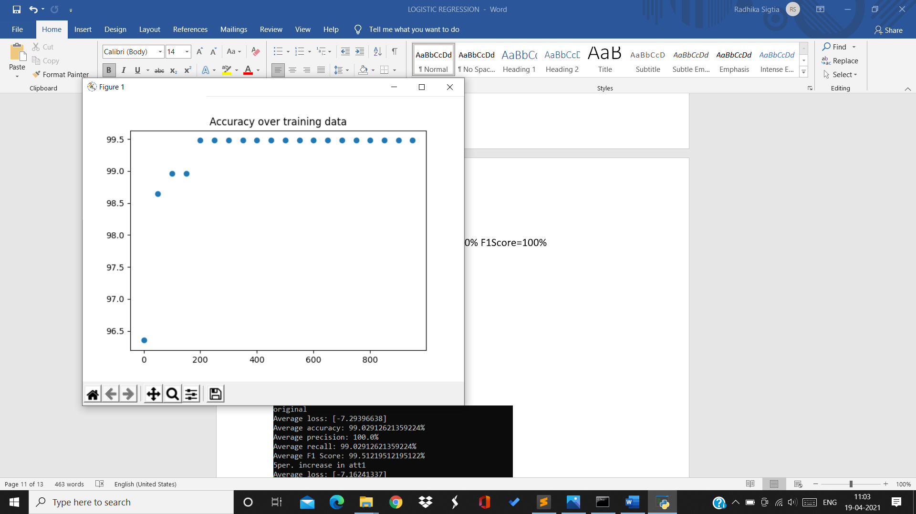

For 7th split:

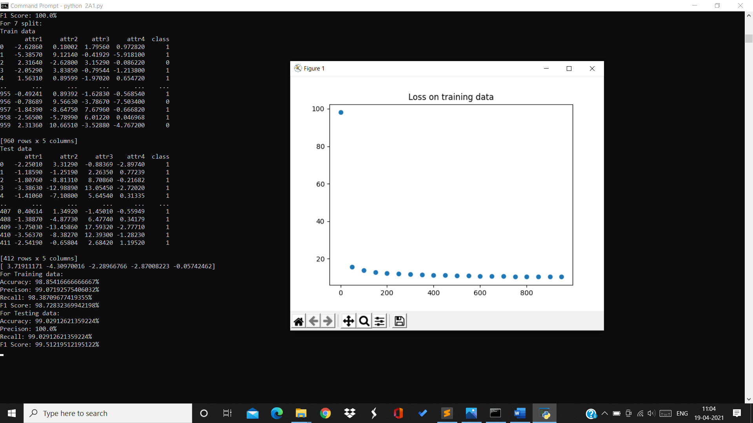

Training data:

Accuracy=98.85% Precision=99.07% Recall=98.38% F1Score=9.72%

Testing data:

Accuracy=99.02% Precision=100% Recall=99.02% F1Score=99.512%

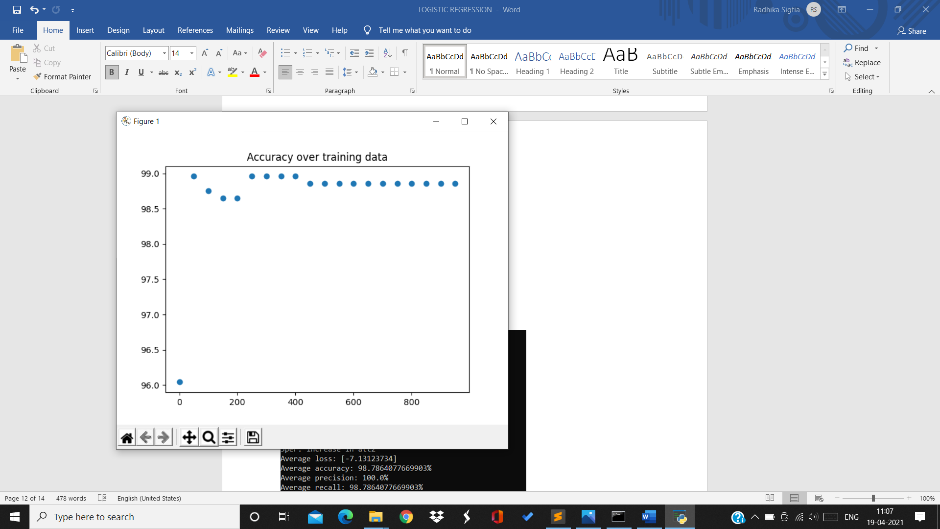

For 8th split:

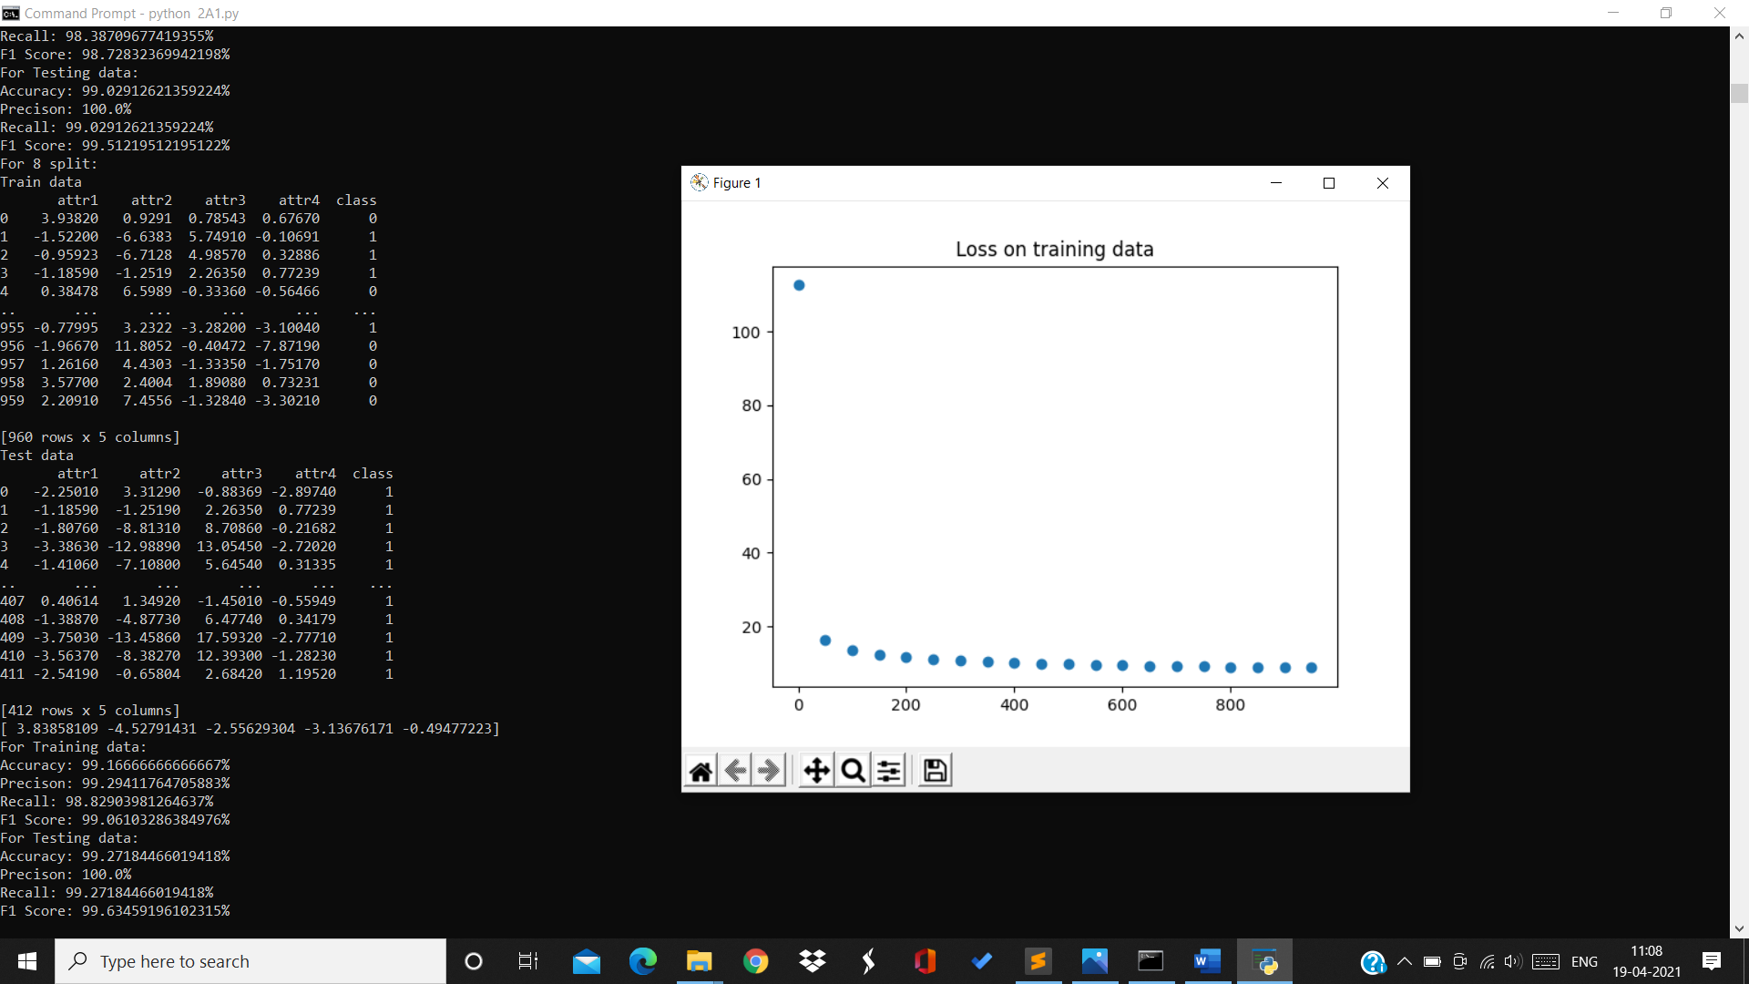

Training data:

Accuracy=99.16% Precision=99.29% Recall=98.82% F1Score=99.06%

Testing data:

Accuracy=99.27% Precision=100% Recall=99.27% F1Score=99.634%

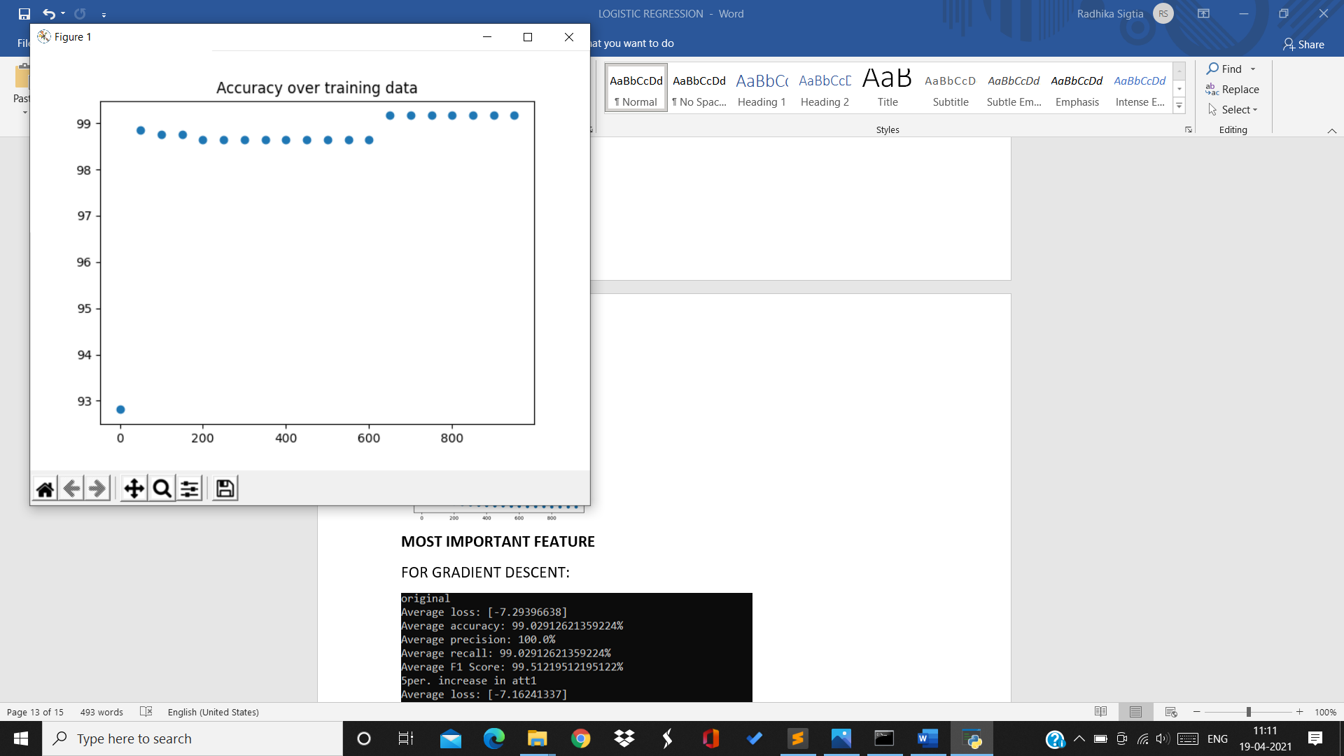

For 9th split:

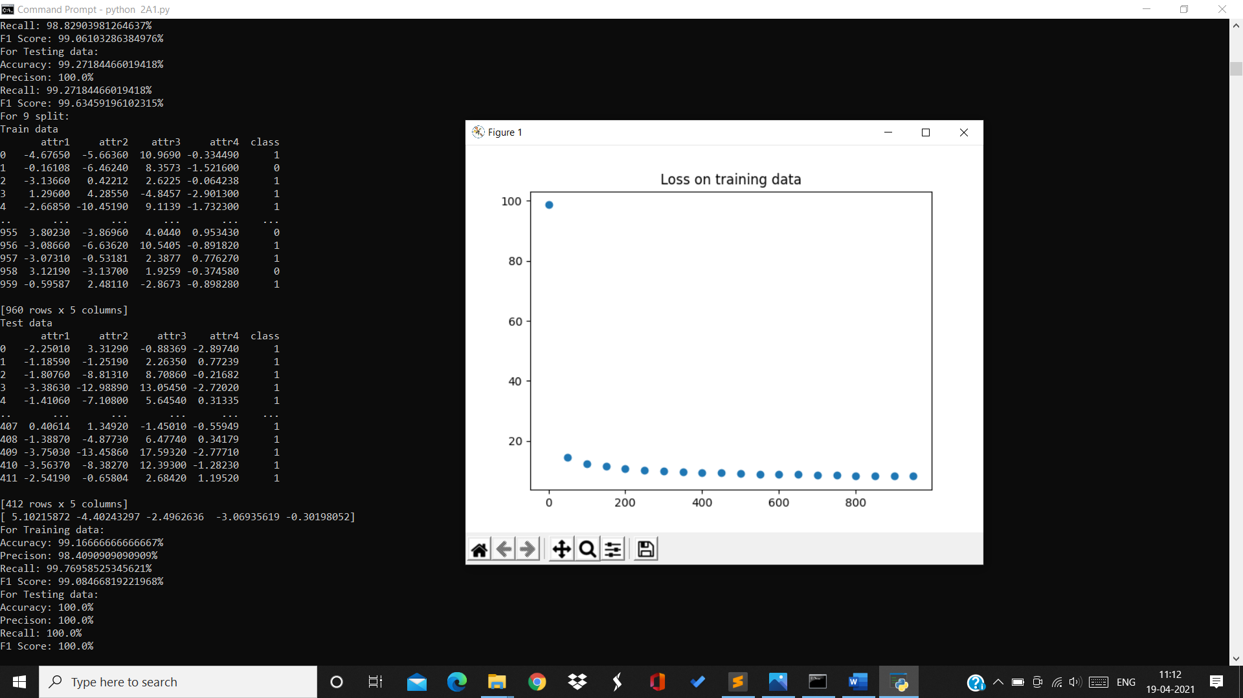

Training data:

Accuracy=99.16% Precision=98.4% Recall=99.76% F1Score=99.08%

Testing data:

Accuracy=100% Precision=100% Recall=100% F1Score=100%

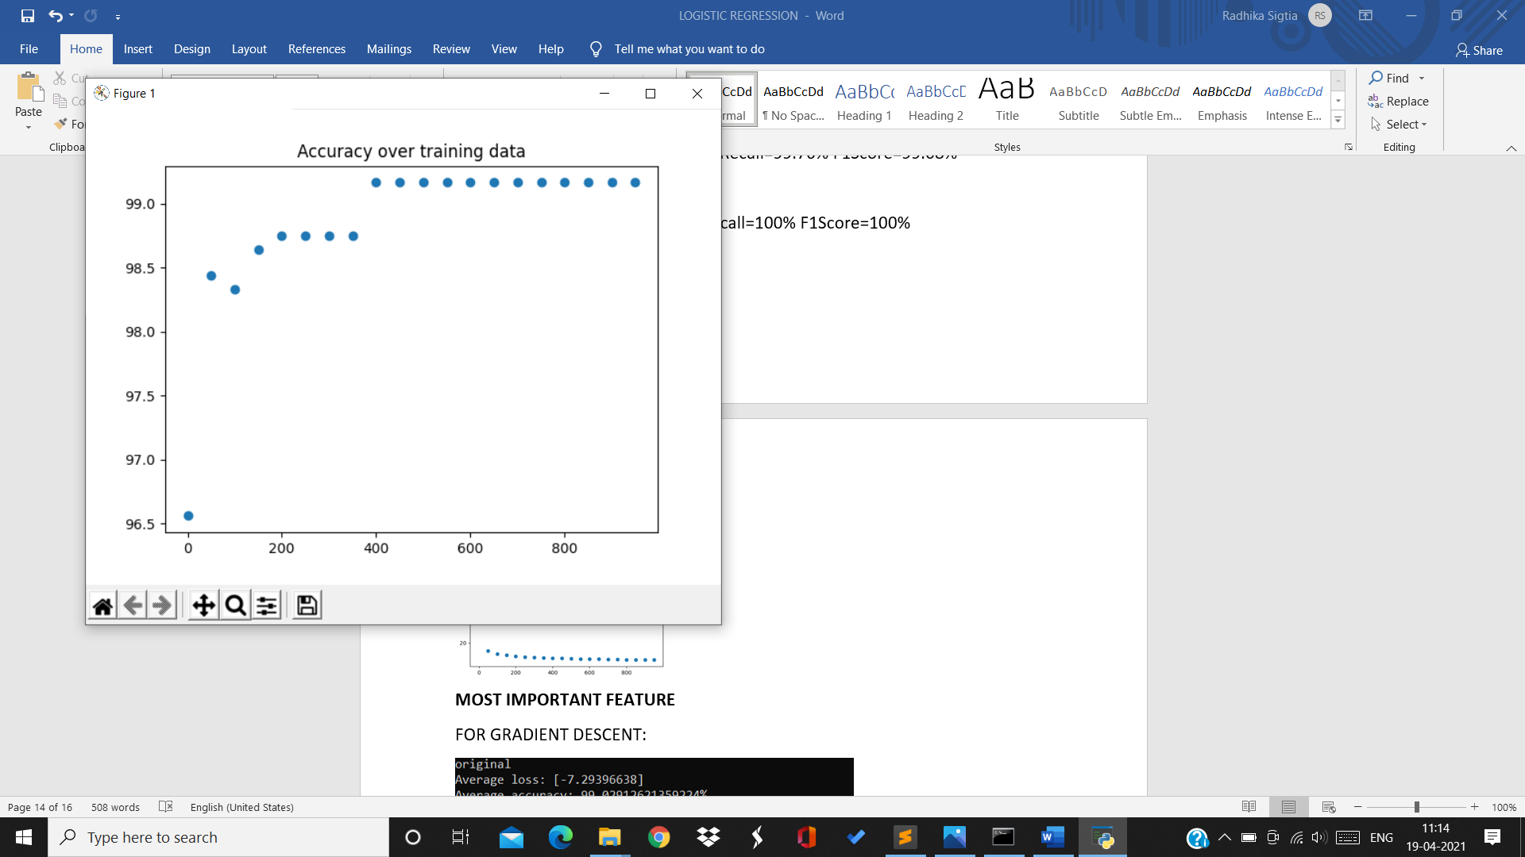

For 10th split:

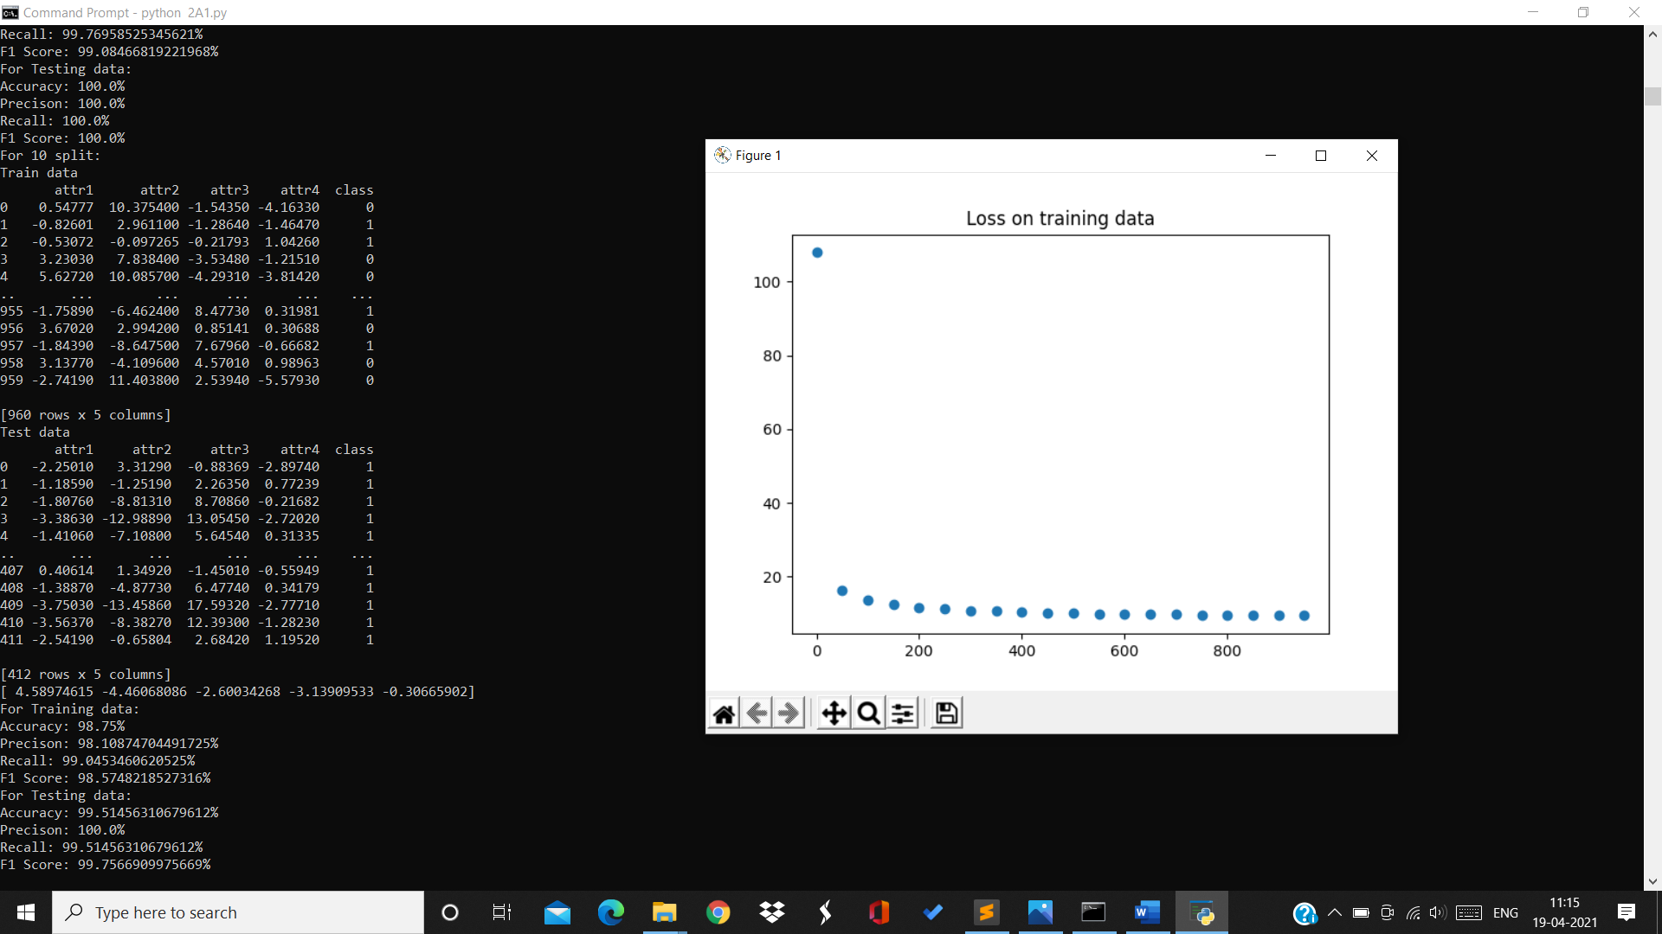

Training data:

Accuracy=98.75% Precision=98.1% Recall=99.04% F1Score=98.57%

Testing data:

Accuracy=99.51% Precision=100% Recall=99.51% F1Score=99.75%

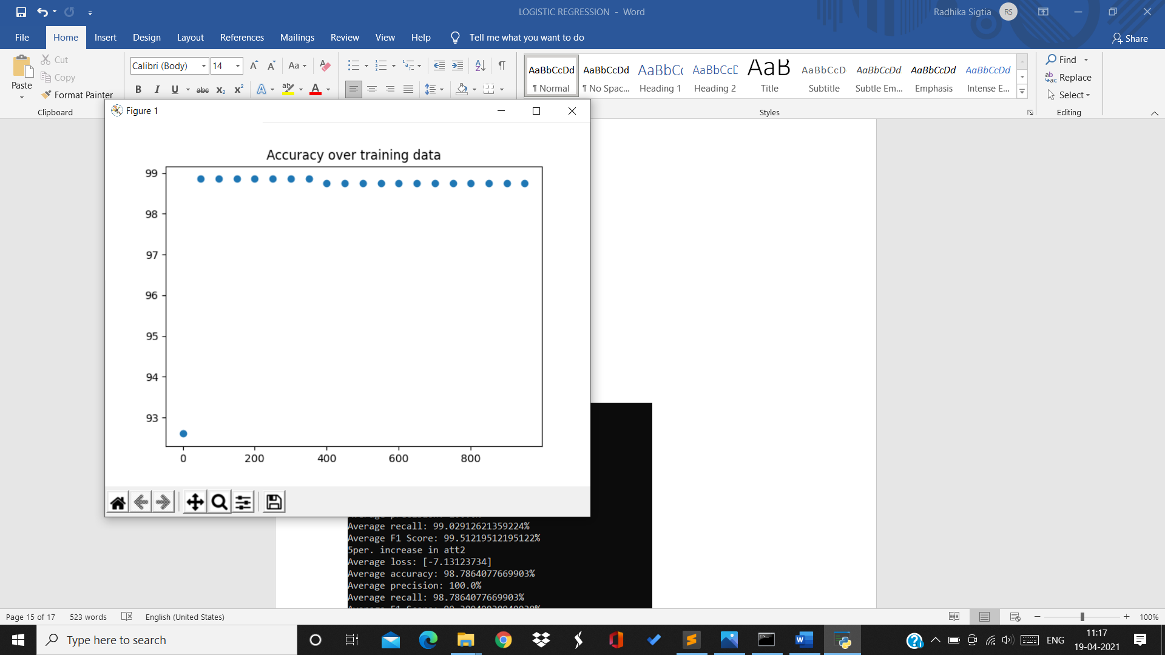

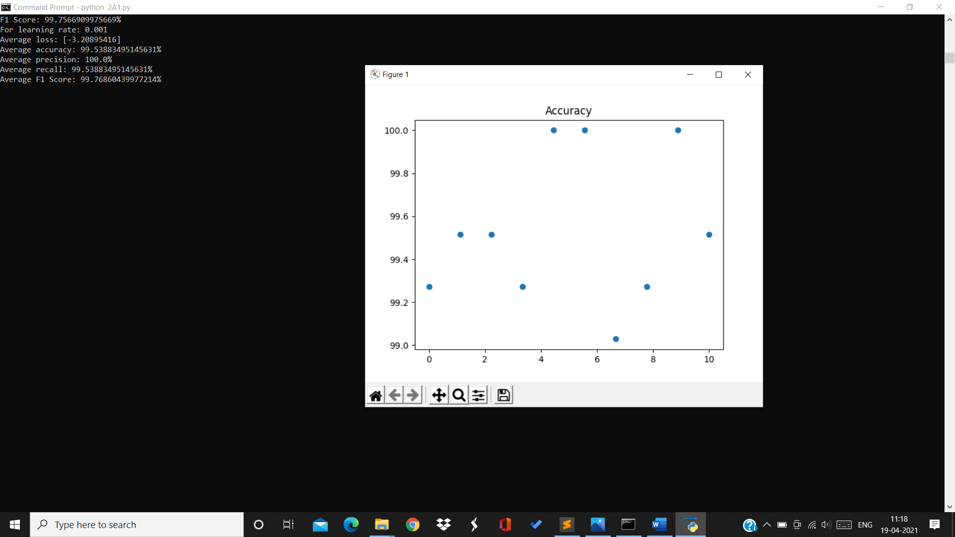

For rate 0.001:

Average loss=-3.2 Average accuracy=99.5% Average precision=100%

Average recall=99.53% Average F1Score=99.76%

Accuracy on testing data over 10 splits with rate 0.001:



For rate=0.01

For 1st split:

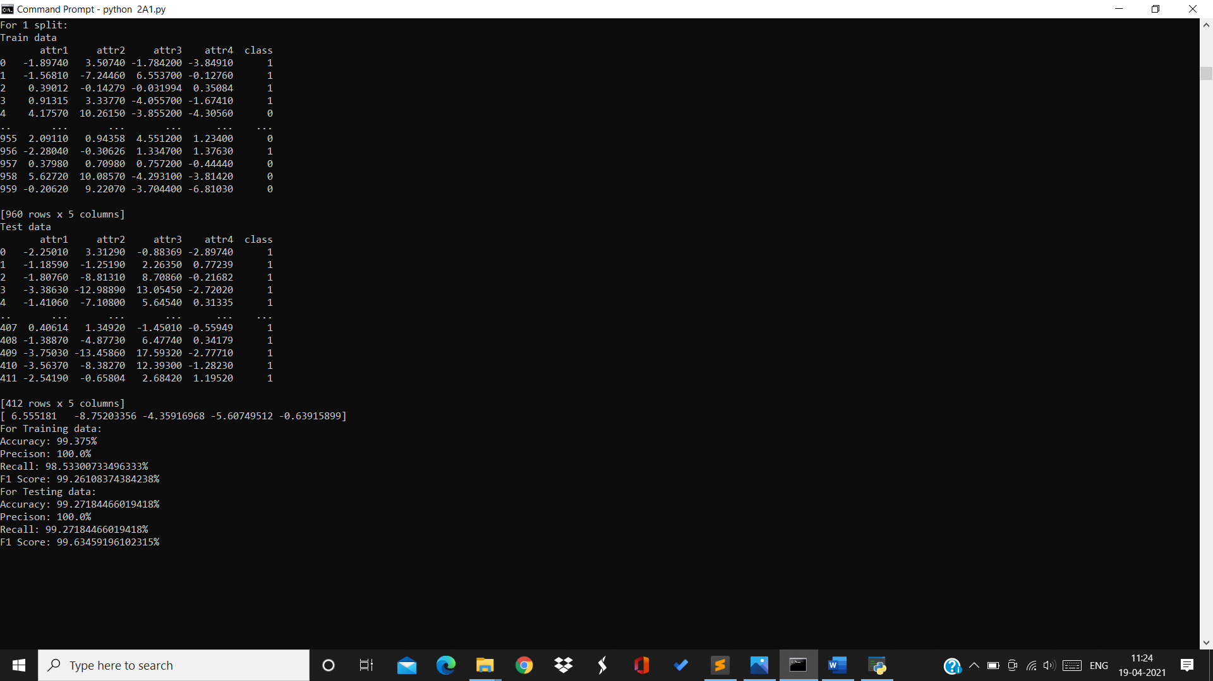

Training data:

Accuracy=99.375% Precision=100% Recall=98.53% F1Score=99.26%

Testing data:

Accuracy=99.27% Precision=100% Recall=99.27% F1Score=99.63%

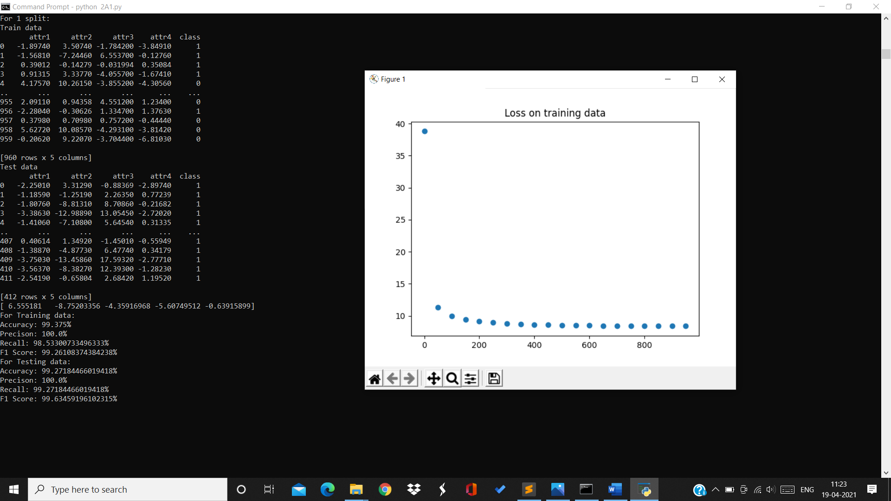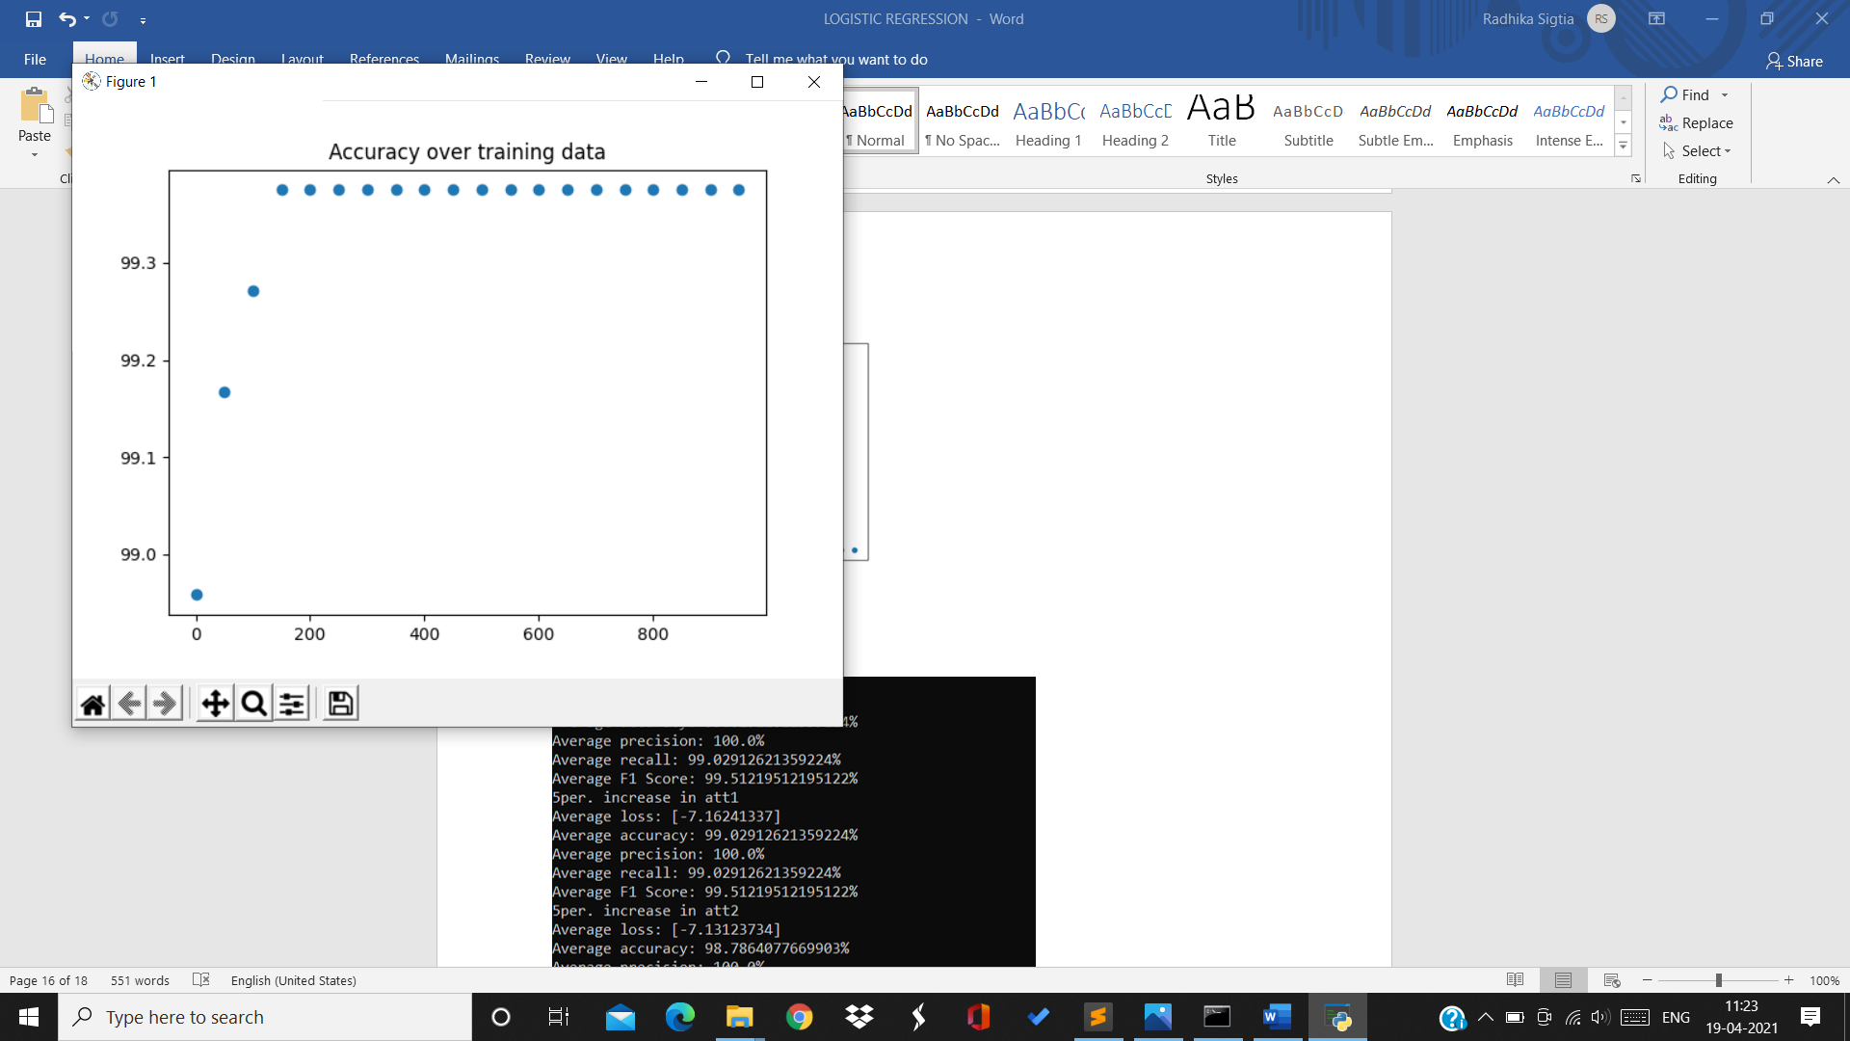

For 2nd split:

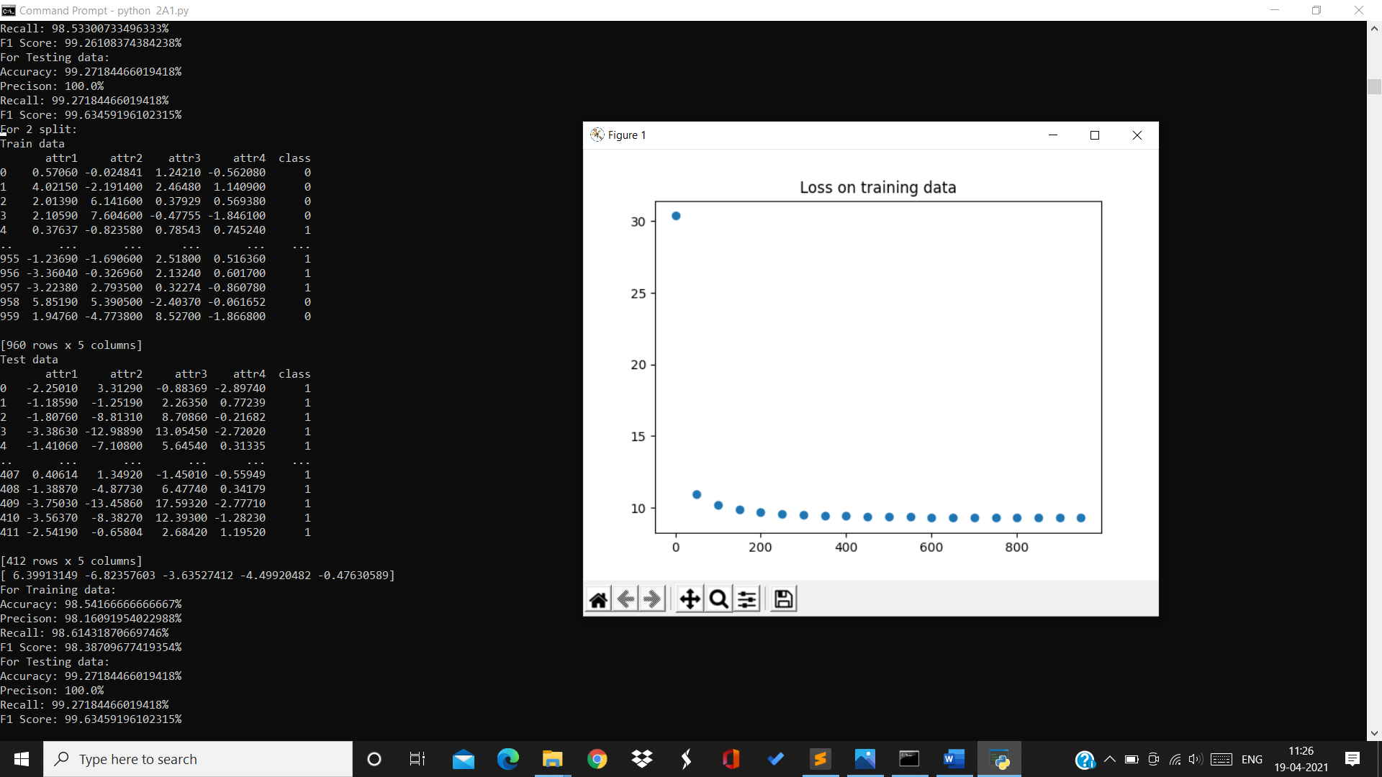

Training data:

Accuracy=98.54% Precision=98.16% Recall=98.6% F1Score=98.38%

For testing data:

Accuracy=99.27% Precision=100% Recall=99.27% F1Score=99.63%

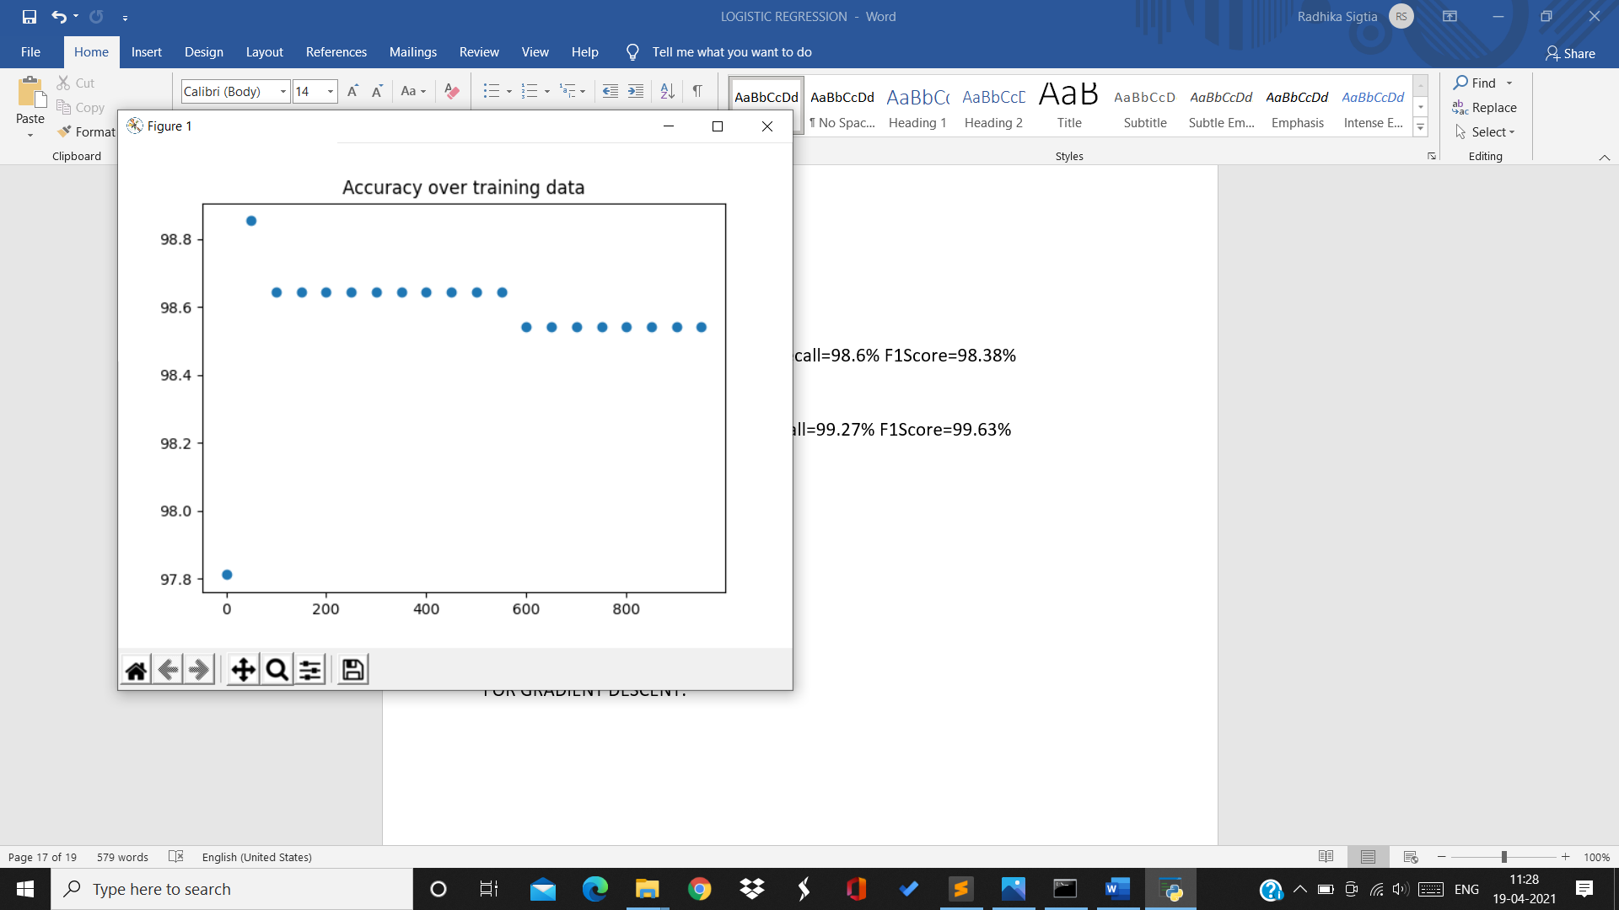

For 3rd split:

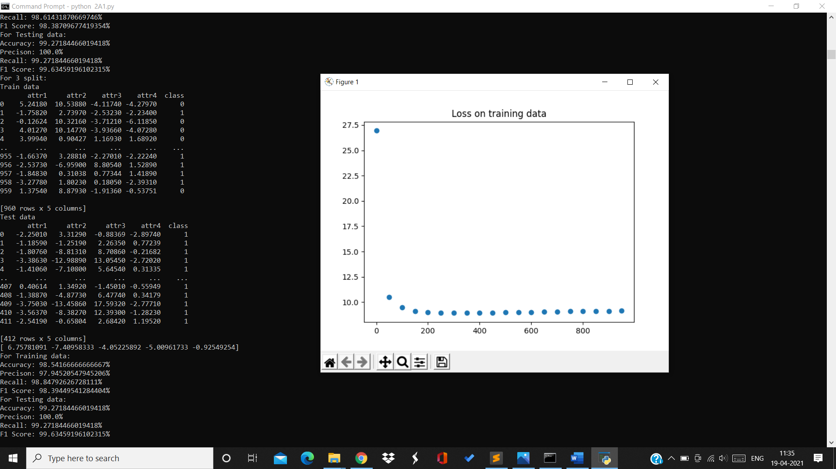

Training data:

Accuracy=98.54% Precision=97.94% Recall=98.84% F1Score=98.39%

Testing data:

Accuracy=99.27% Precision=100% Recall=99.27% F1Score =99.63%

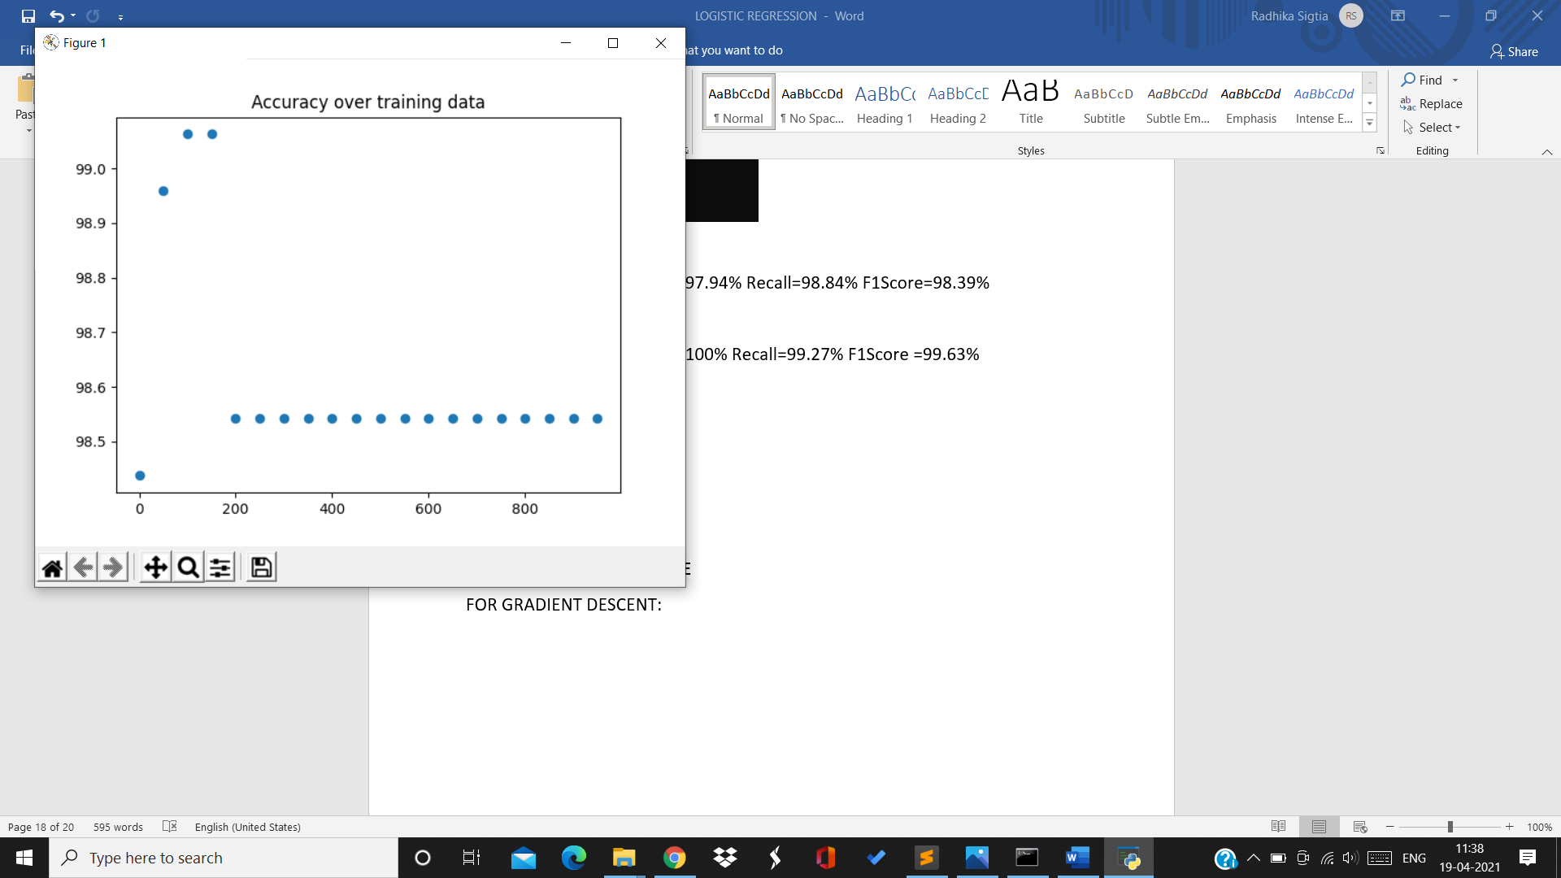

For 4th split:

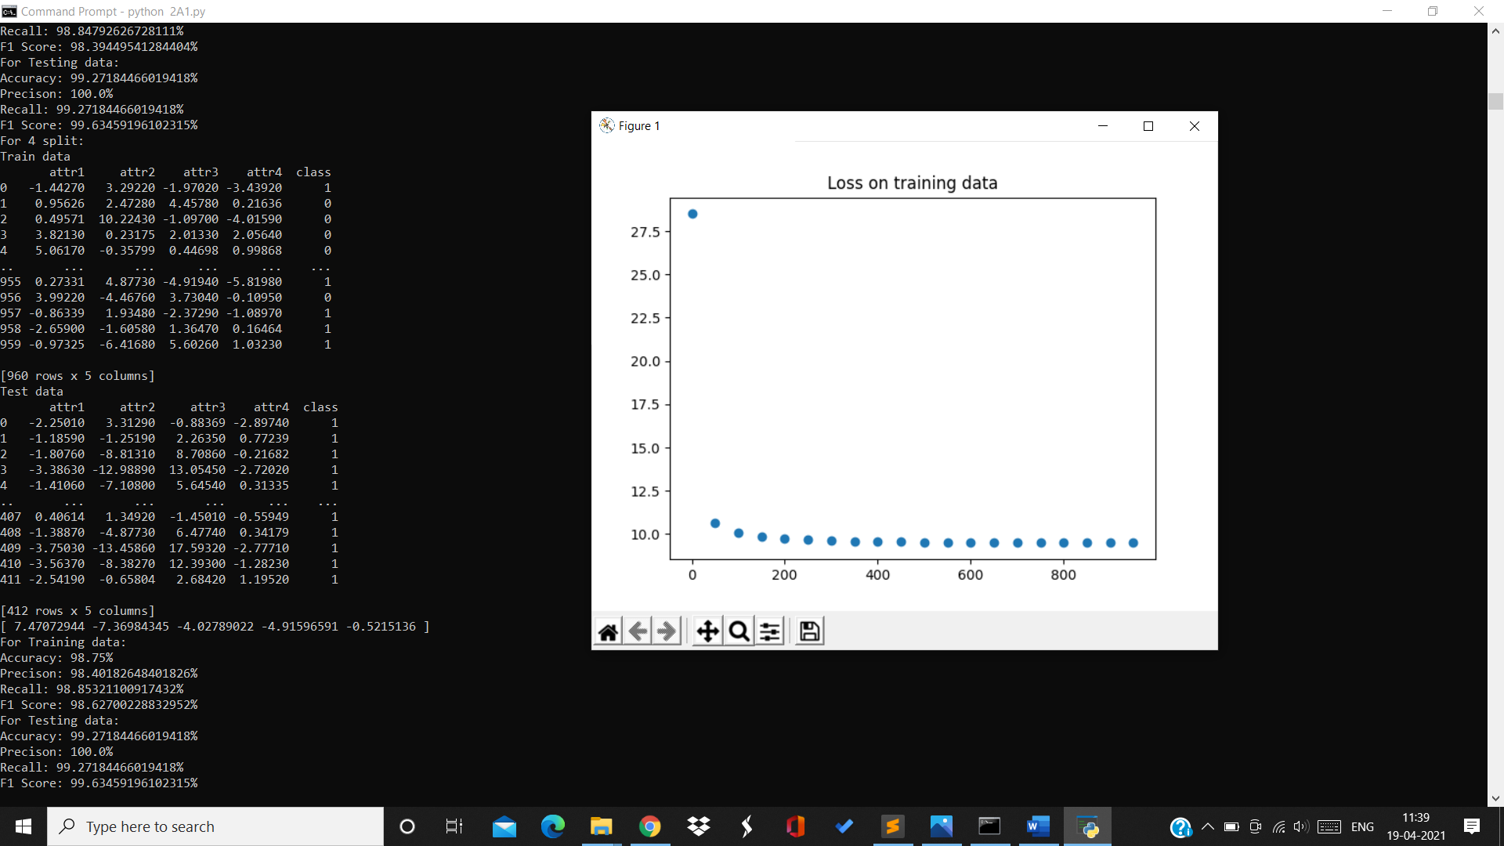

Training data:

Accuracy=98.75% Precision=98.4% Recall=98.85% F1Score=98.6%

Testing data:

Accuracy=99.2% Precision=100% Recall=99.27% F1Score=99.63%

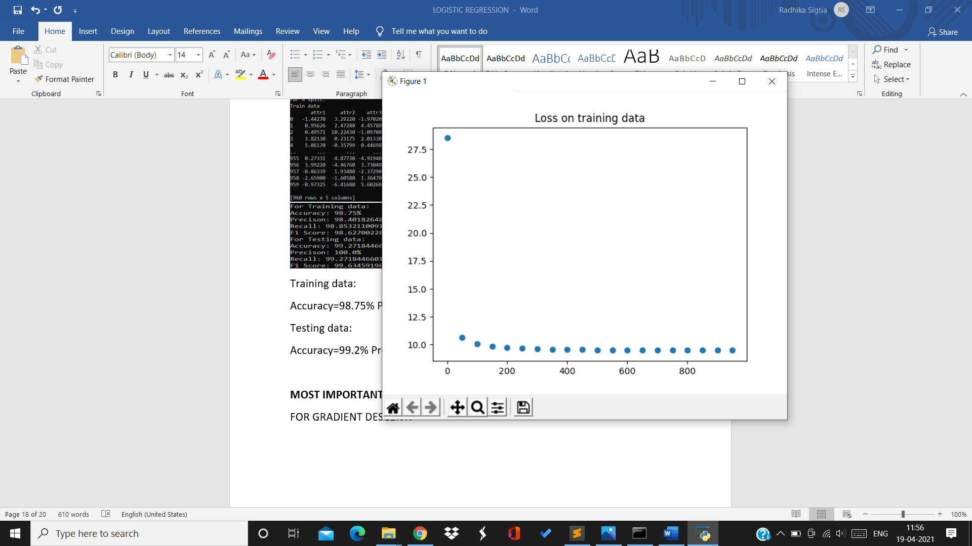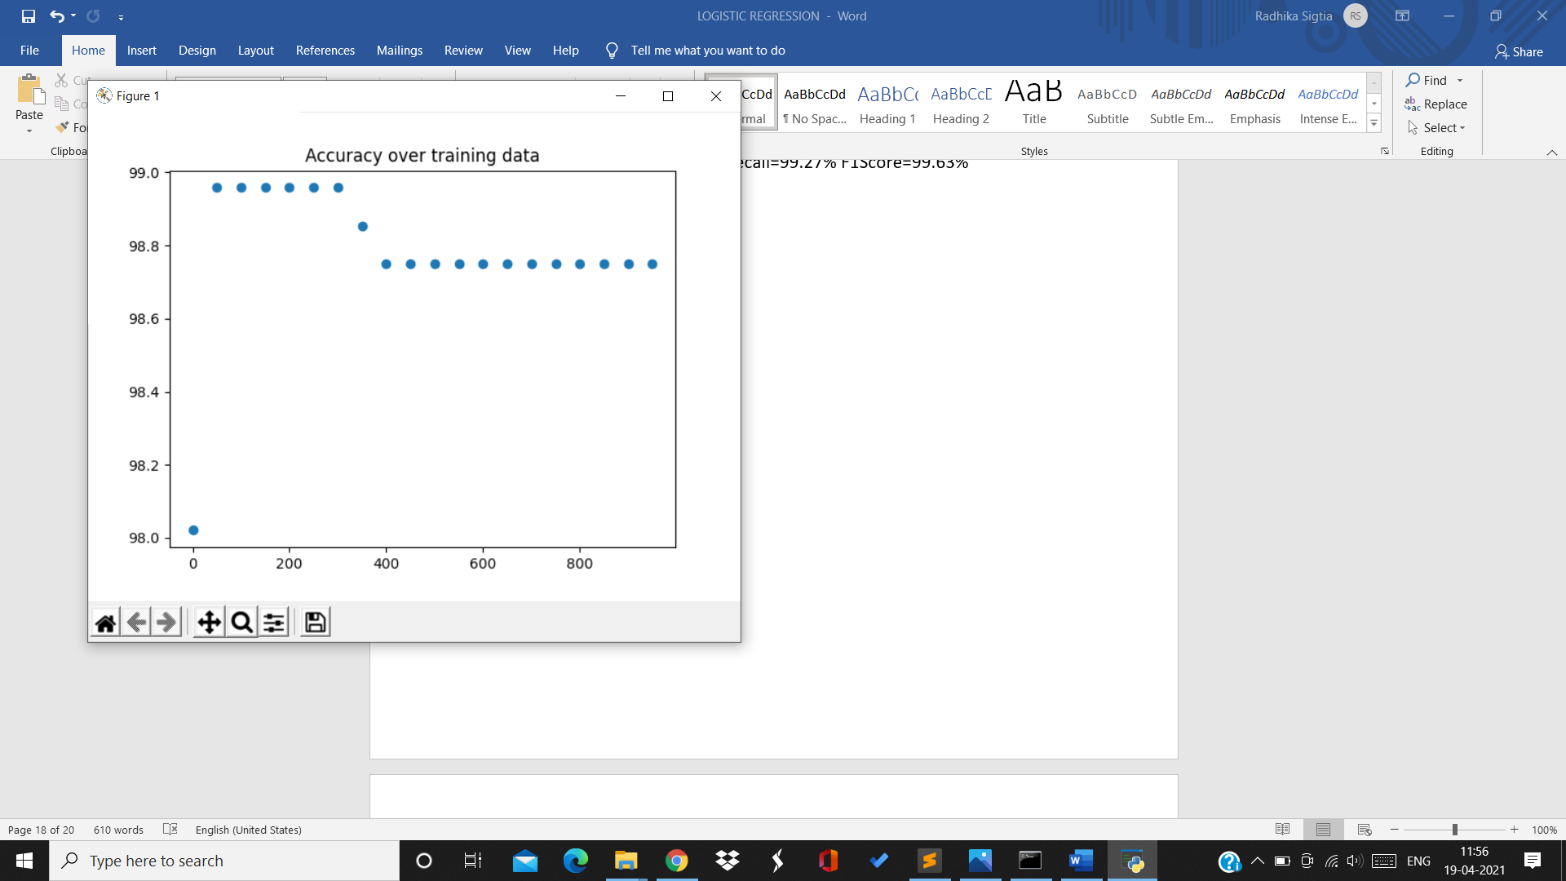

For 5th split:

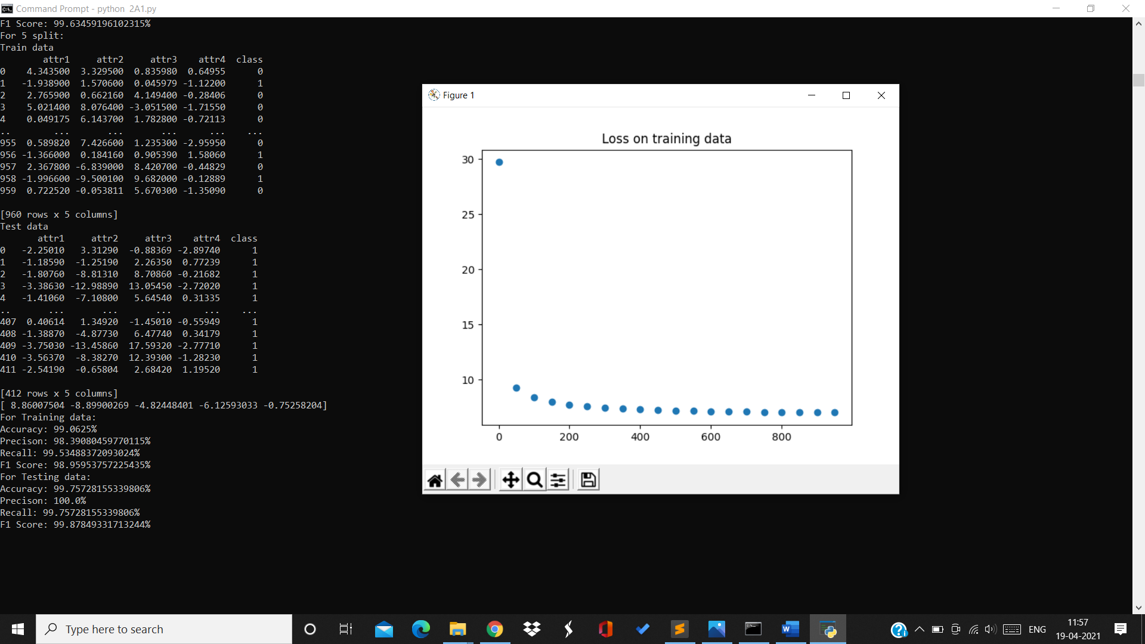

Training data:

Accuracy=99.06% Precision=98.39% Recall=99.5% F1Score=98.95%

Testing data:

Accuracy=99.75% Precision=100% Recall=99.75% F1Score=99.87%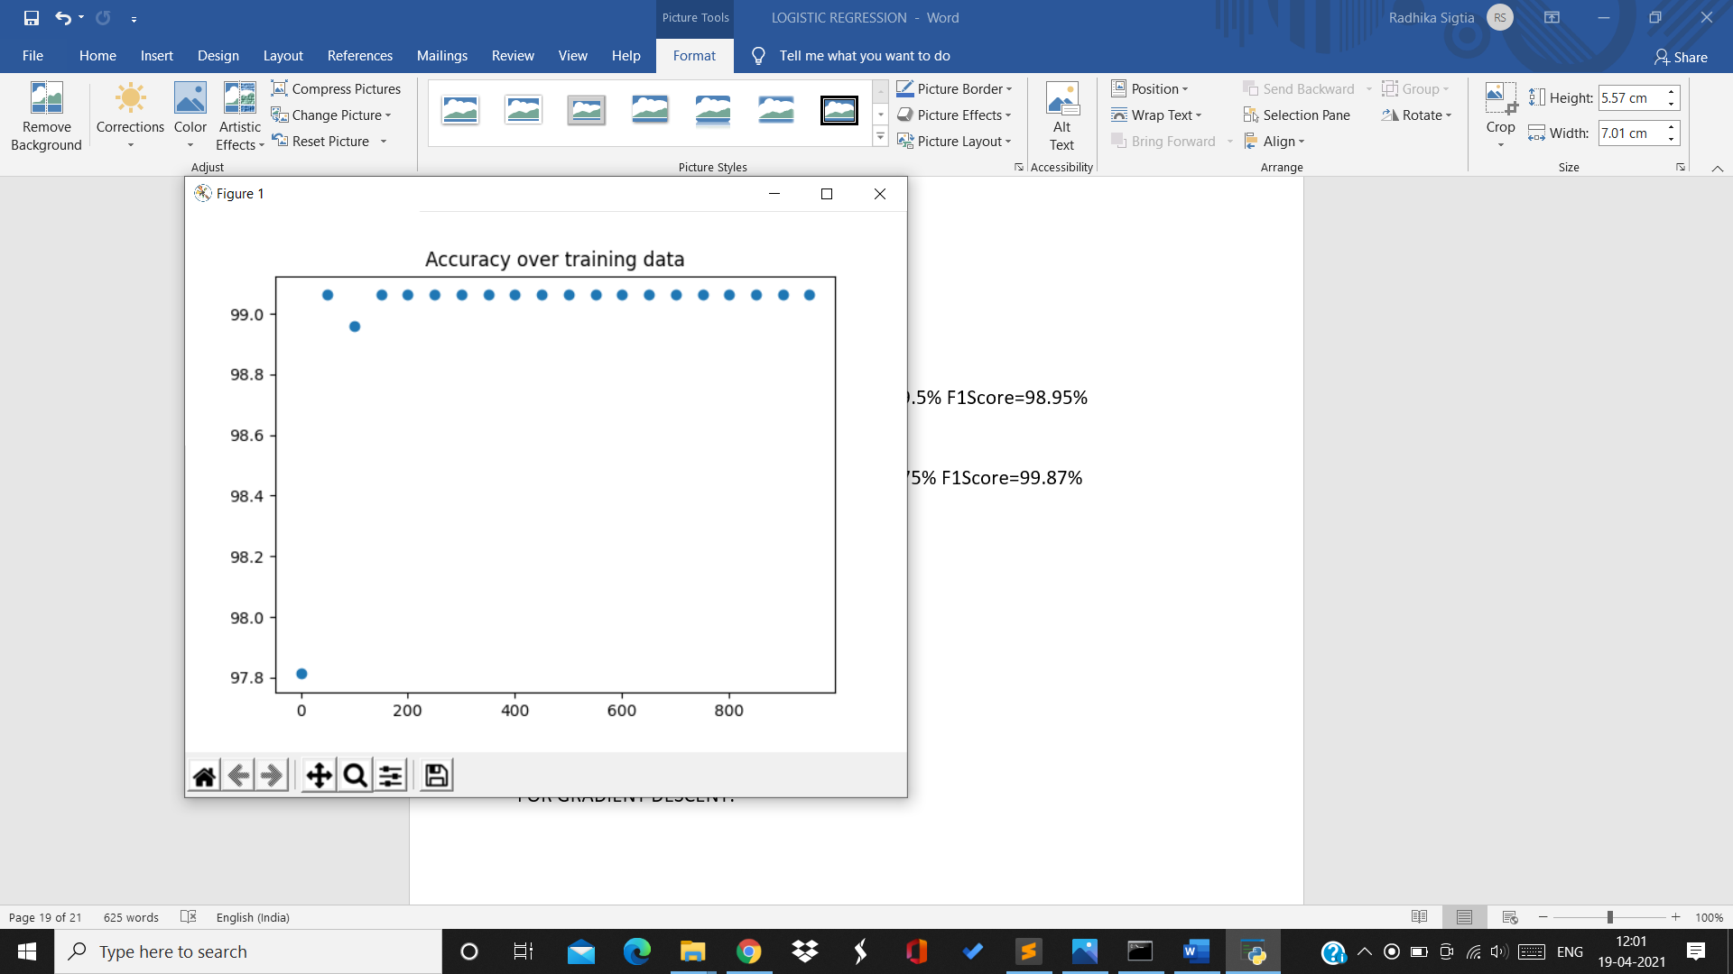

For 6th split:

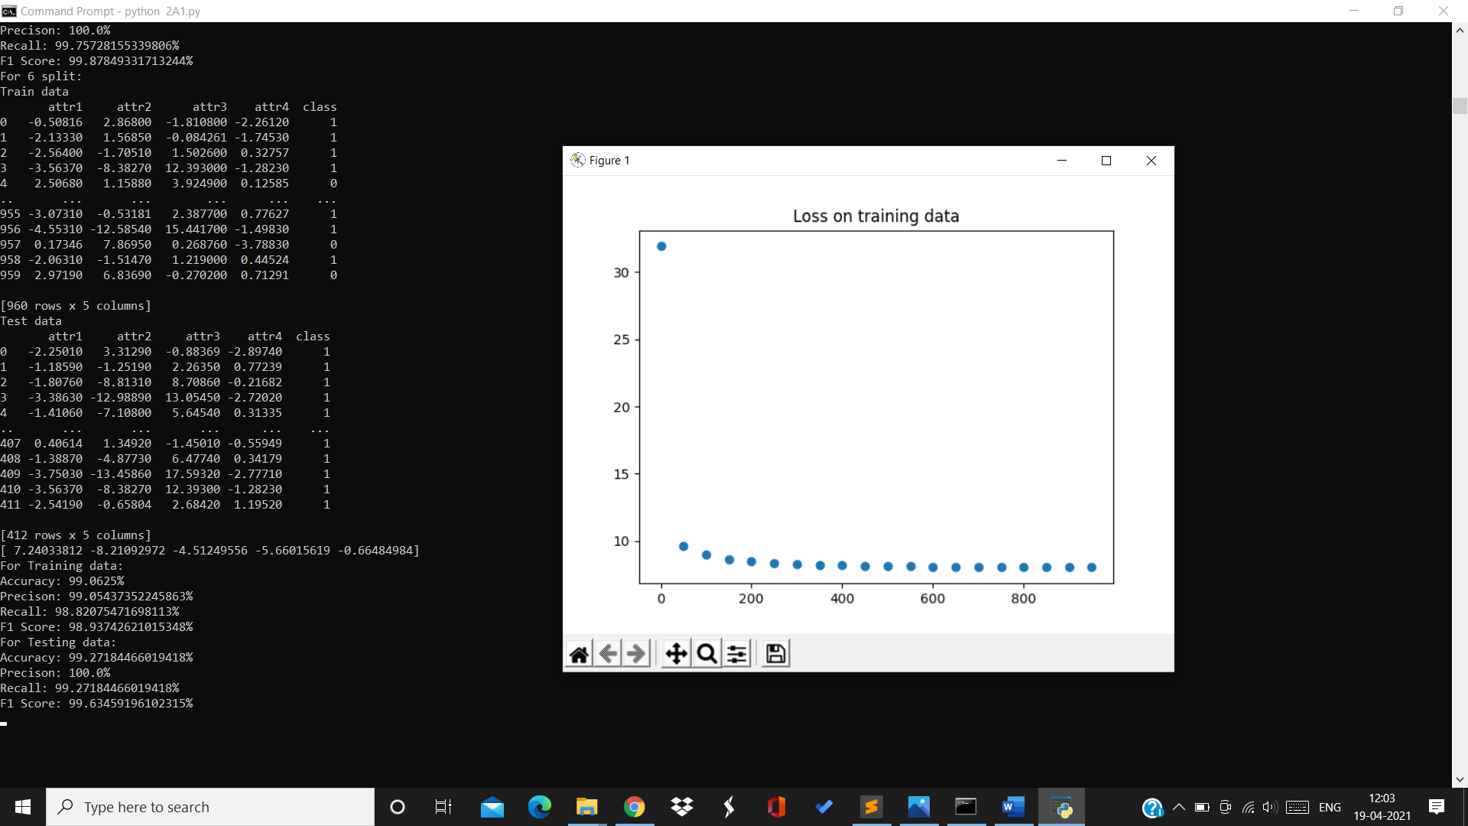

Training data:

Accuracy=99.06% Precision=99% Recall=98.82% F1Score=98.93%

Testing data:

Accuracy=99.27% Precision=100% Recall=99.27% F1Score=99.6%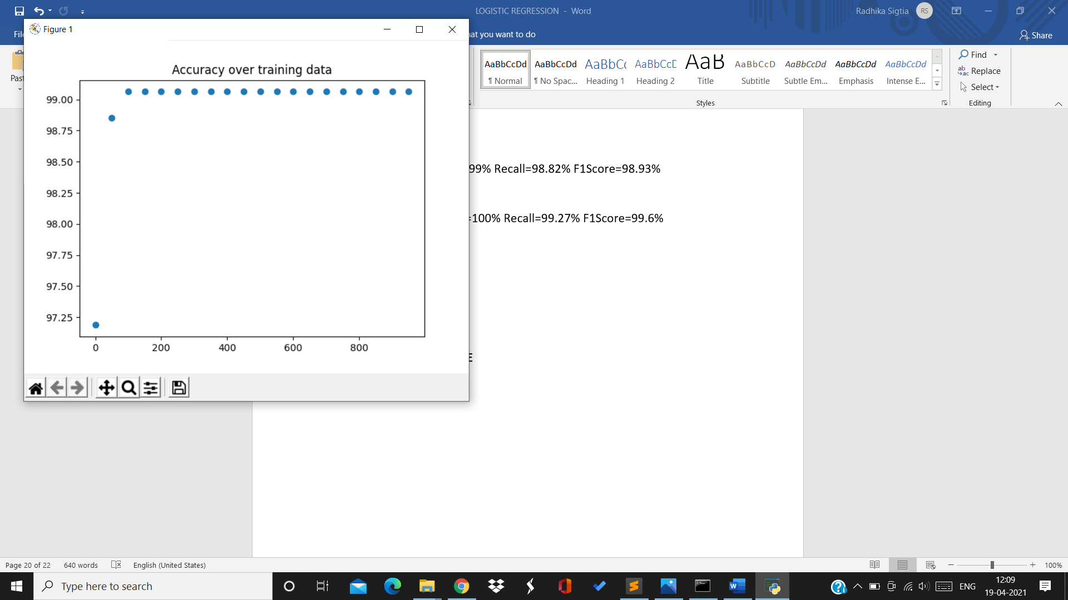

For 7th split:

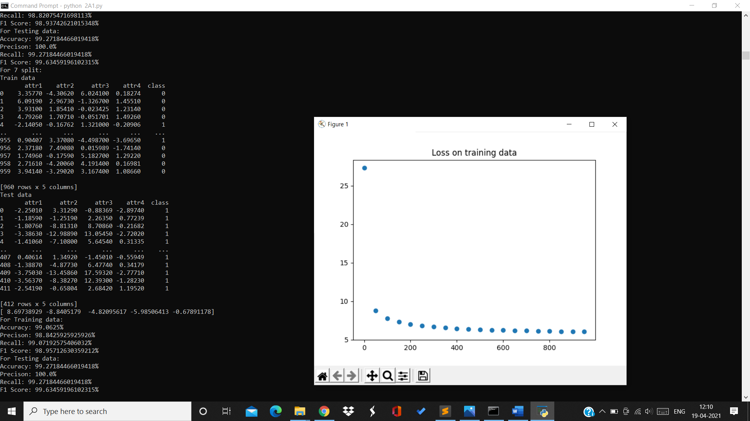

Training data:

Accuracy=99% Precision=98.8% Recall=99% F1Score=98.95%

Test data:

Accuracy=99.27% Precision=100% Recall=99.27% F1Score=99.64%

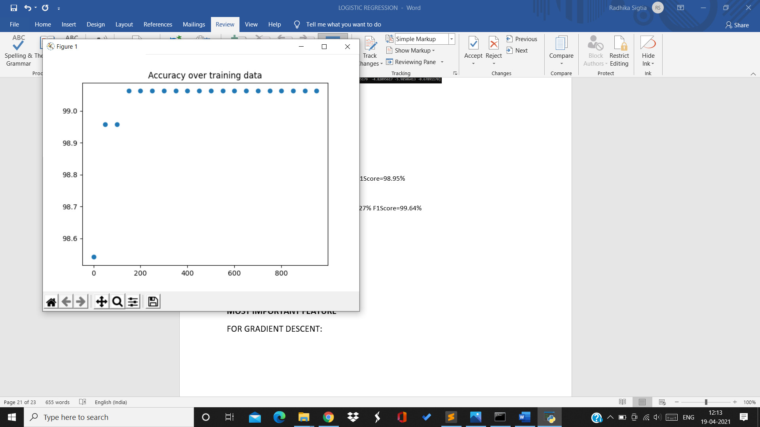

For 8th split:

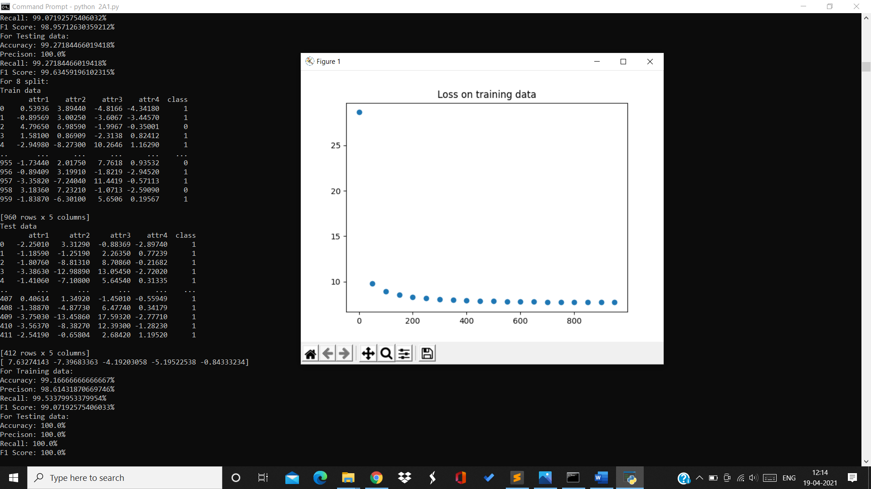

Training data:

Accuracy=99.16% Precision=98.61% Recall=99.53% F1Score=99%

Testing data:

Accuracy=100% Precision=100% Recall=100% F1Score=100%

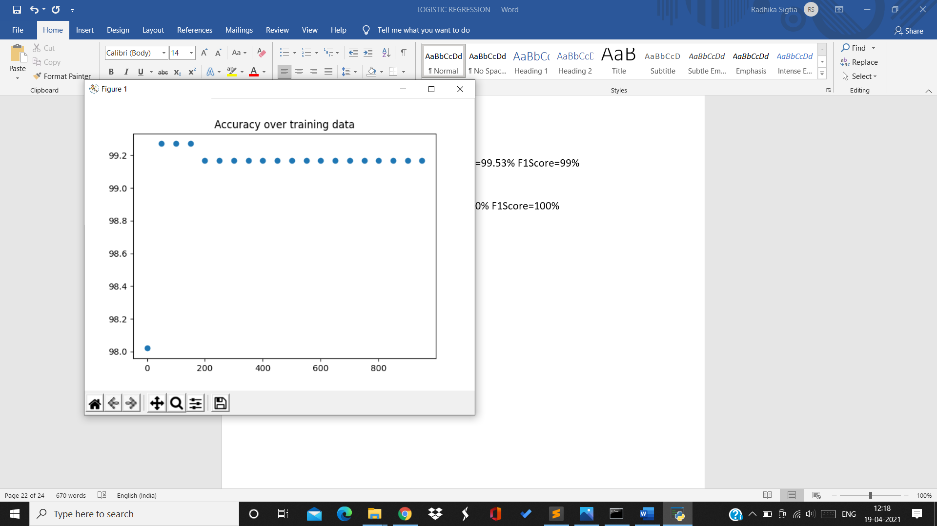

For 9th split:

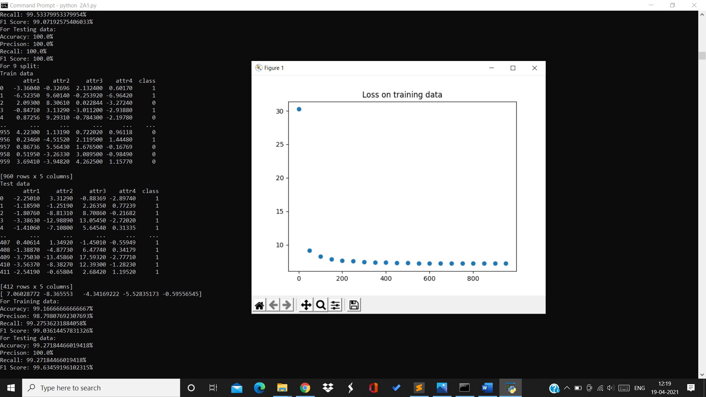

Training data:

Accuracy=99.16% Precision=98.79% Recall=99.2% F1Score=99%

Testing data:

Accuracy=99.27% Precision=100% Recall=99.27% F1Score=99.63%

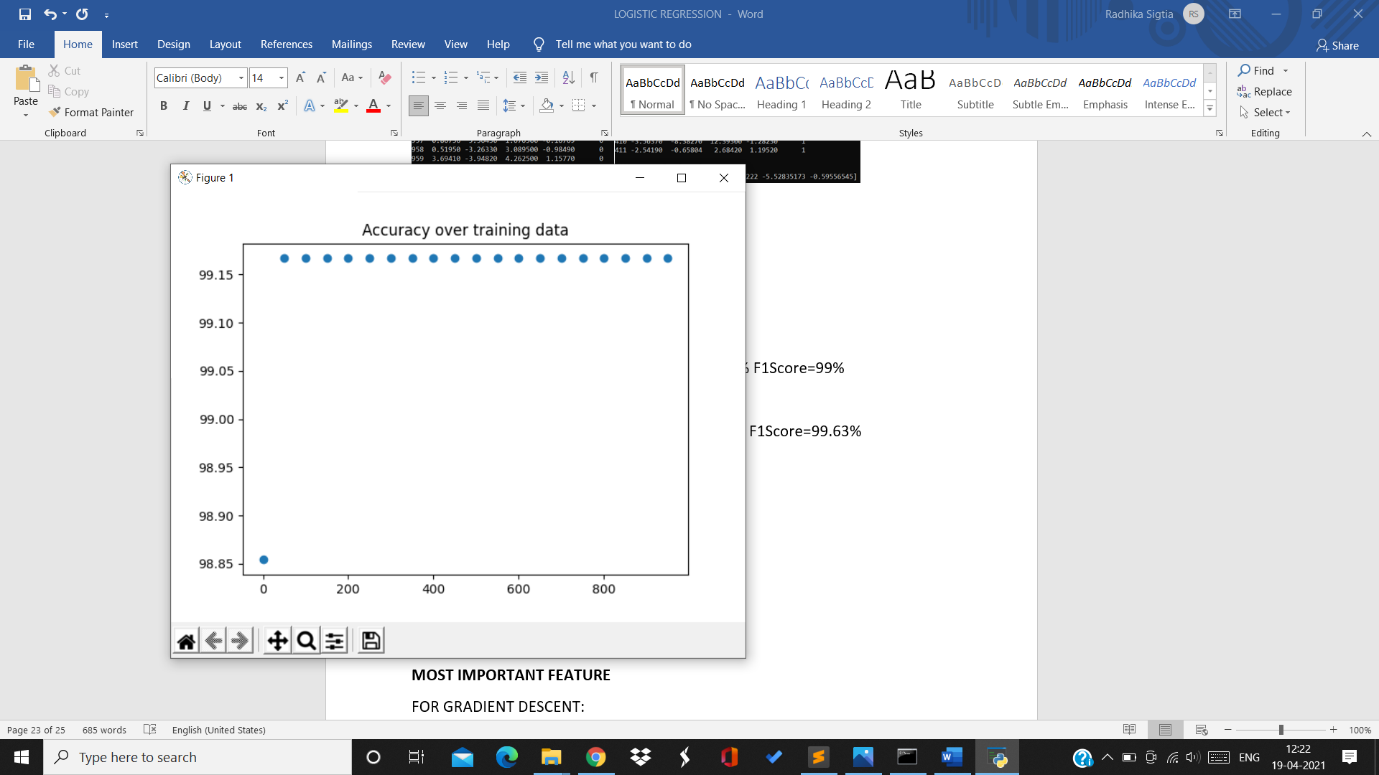

For 10th split:

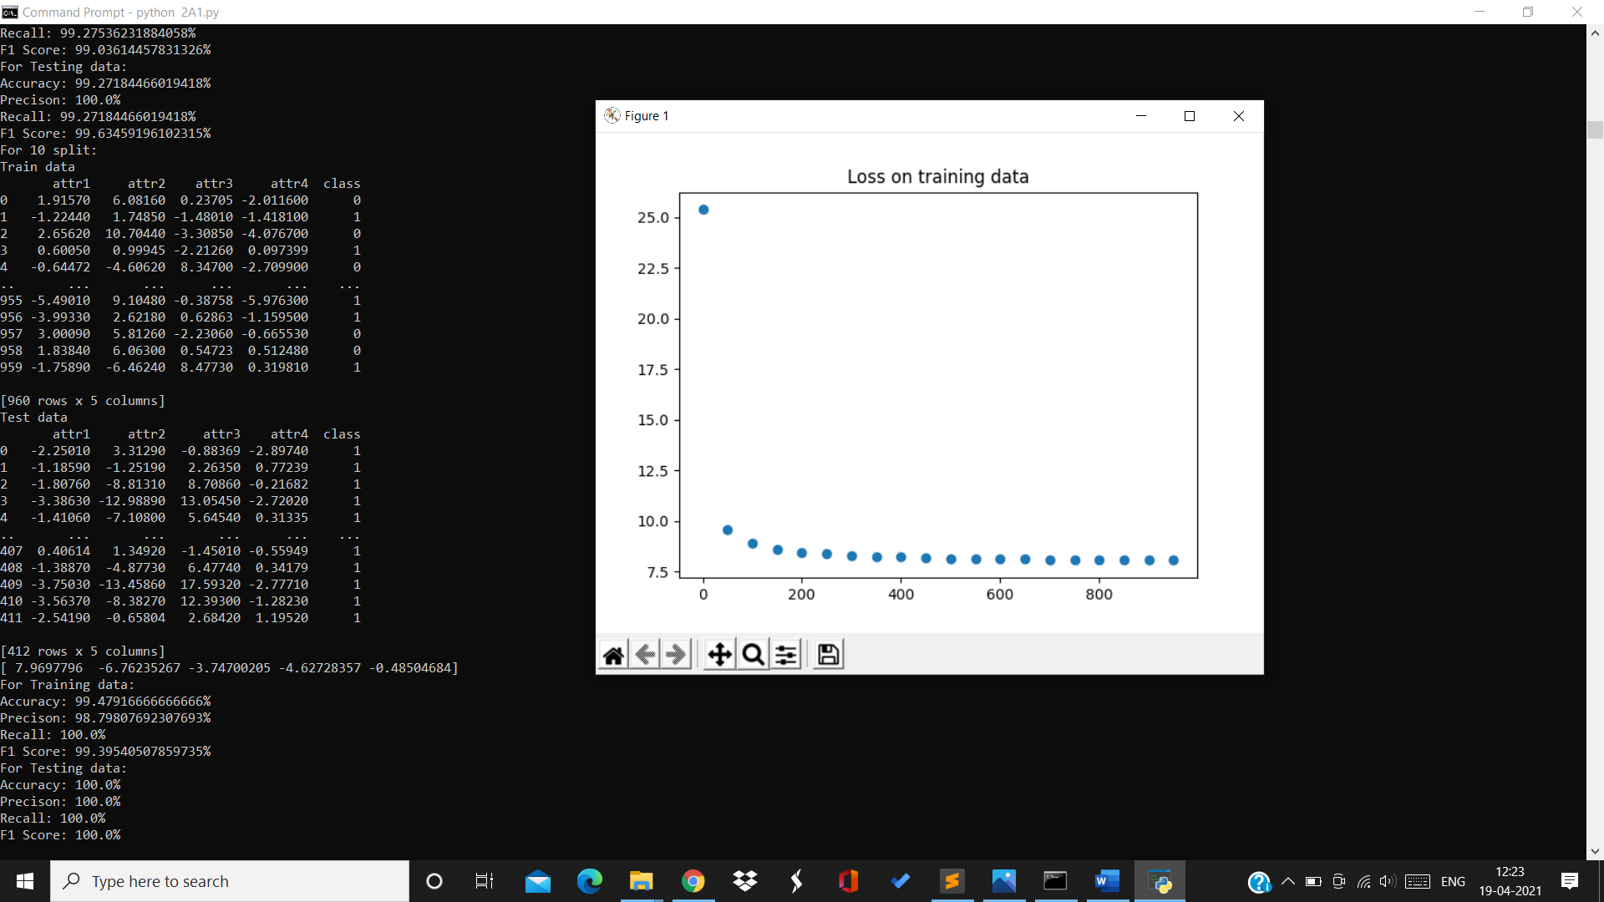

Training data:

Accuracy=99.47% Precision=98.79% Recall=100% F1Score=99.39%

Testing data:

Accuracy=100% Precsion=100% Recall=100% F1Score=100%

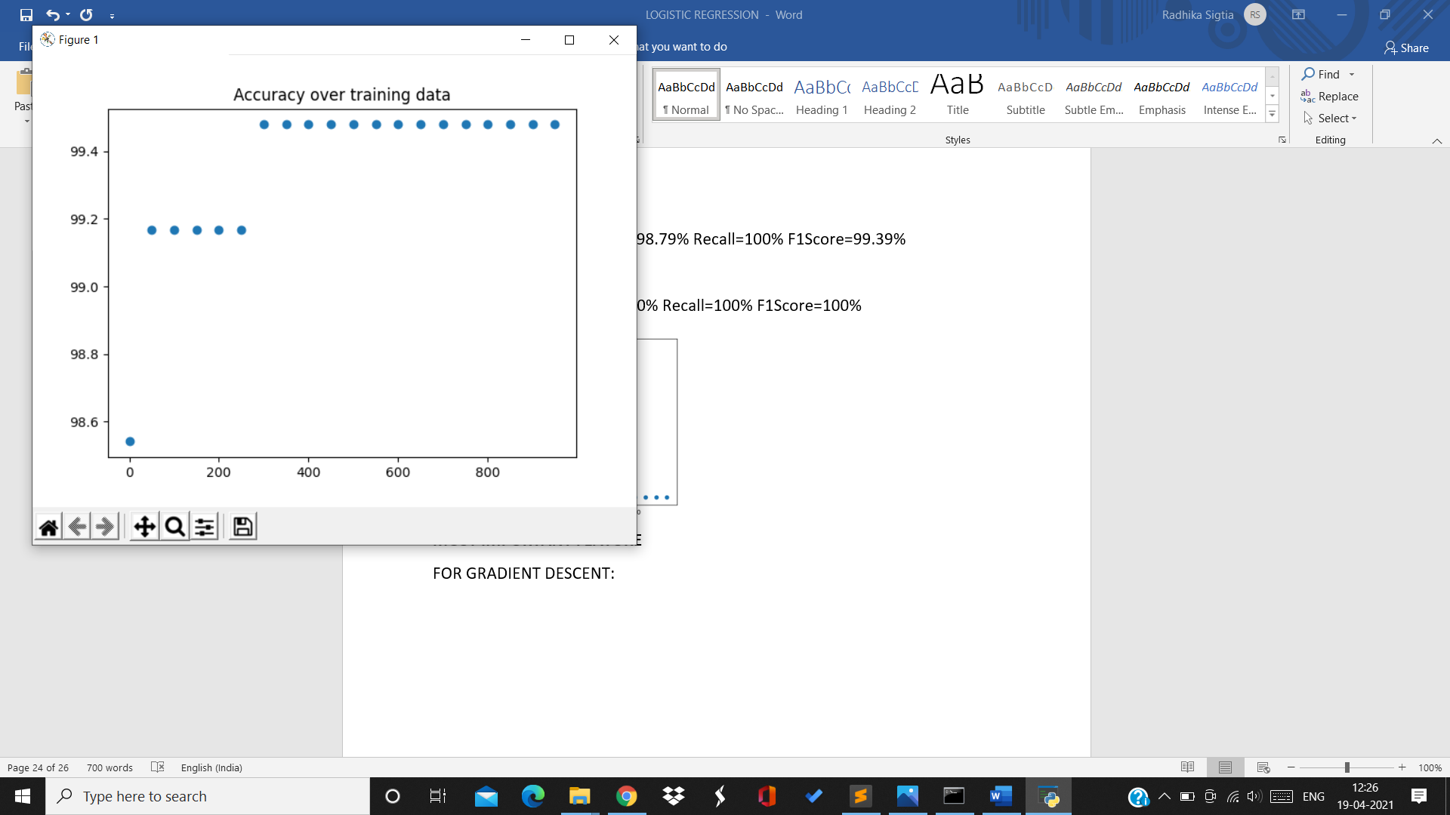

For rate 0.01:

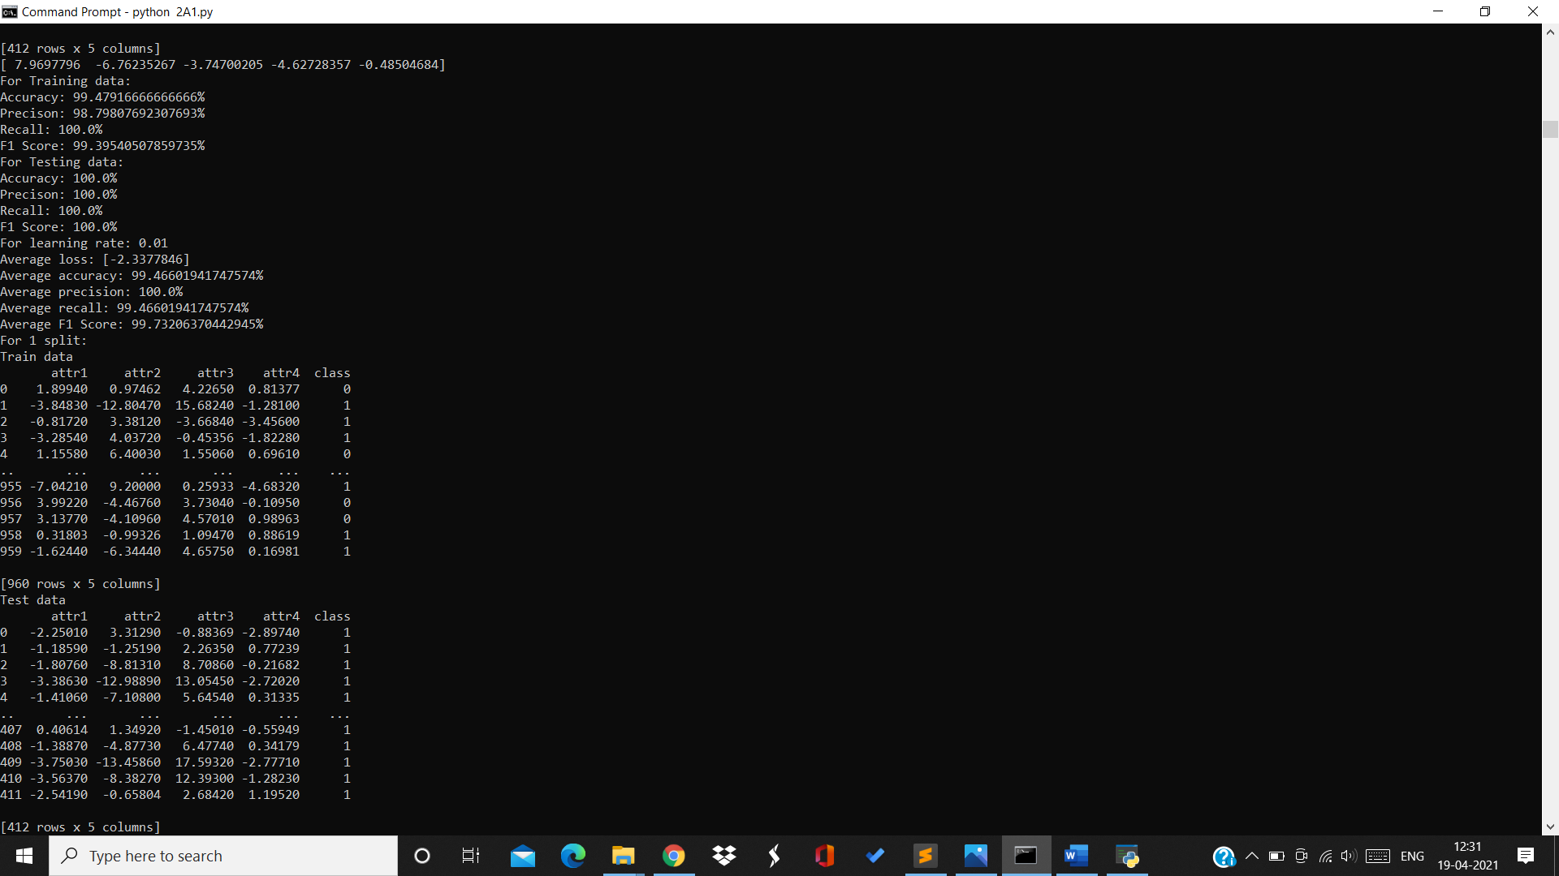

Average loss=-2.33 Average accuracy=99.46% Average precision=100%

Average recall=99.46% Average F1Score=99.73%

Accuracy over testing data for 10 splits with rate 0.01:

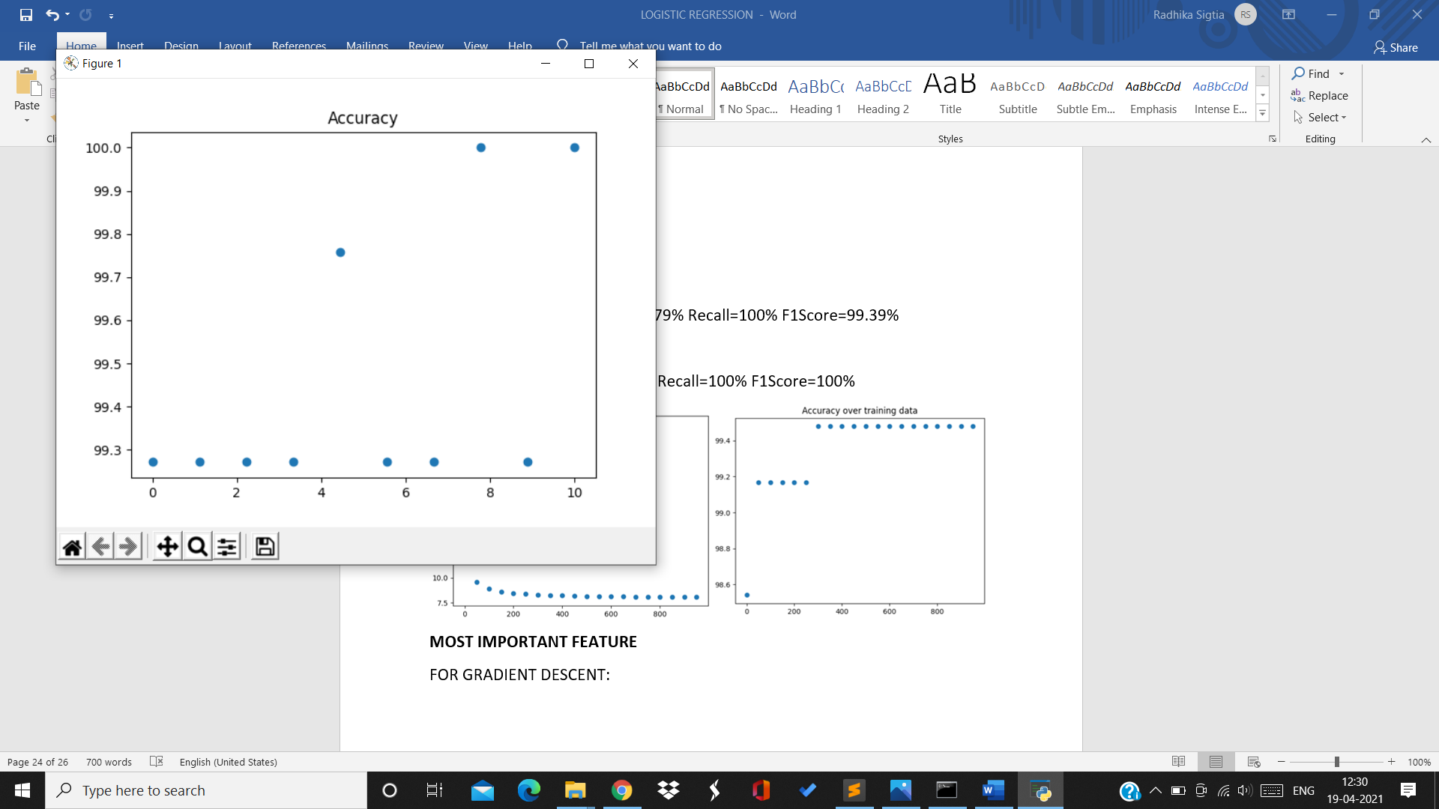

For rate=0.1:

For 1st split:

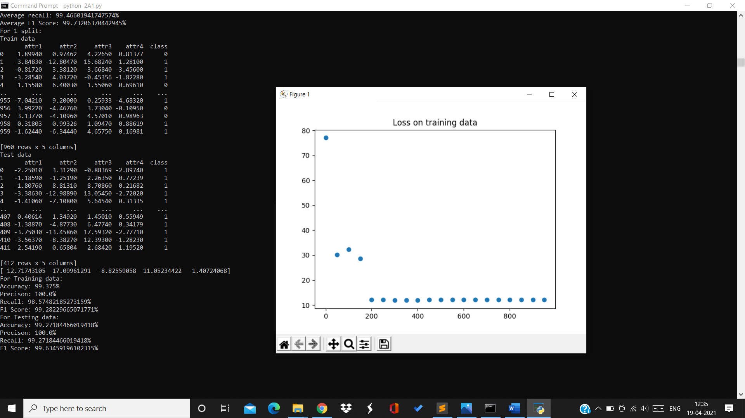

Training data:

Accuracy=99.37% Precision=100% Recall=98.57% F1Score=99.28%

Testing data:

Accuracy=99.27% Precision=100% Recall=99.27% F1Score=99.63%

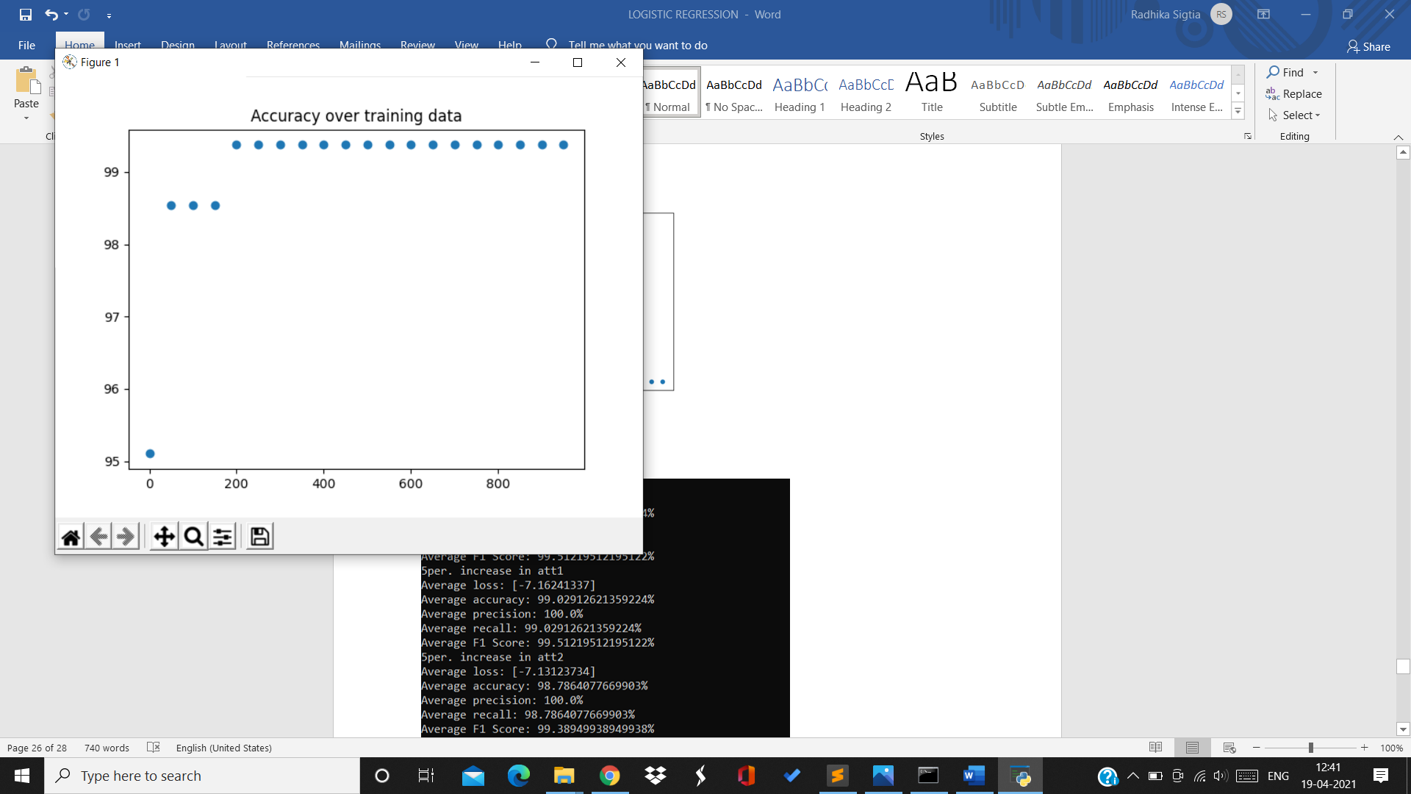

For 2nd split:

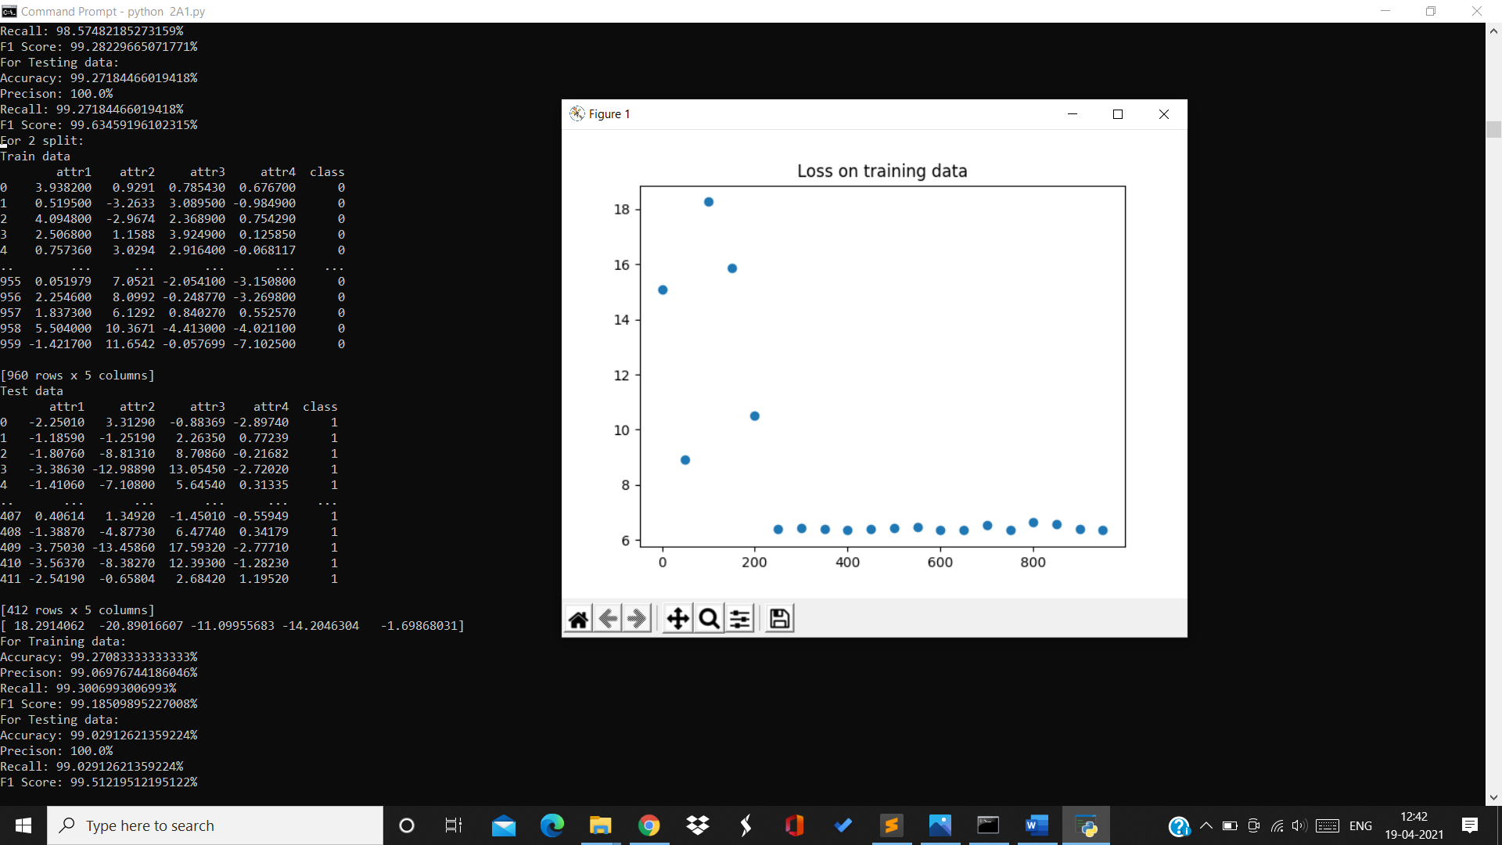

Training data:

Accuracy=99.27% Precision=99.06% Recall=00.3% F1Score=99.18%

Testing data:

Accuracy=99.02% Precision=100% Recall=00.02% F1Score=99.512%

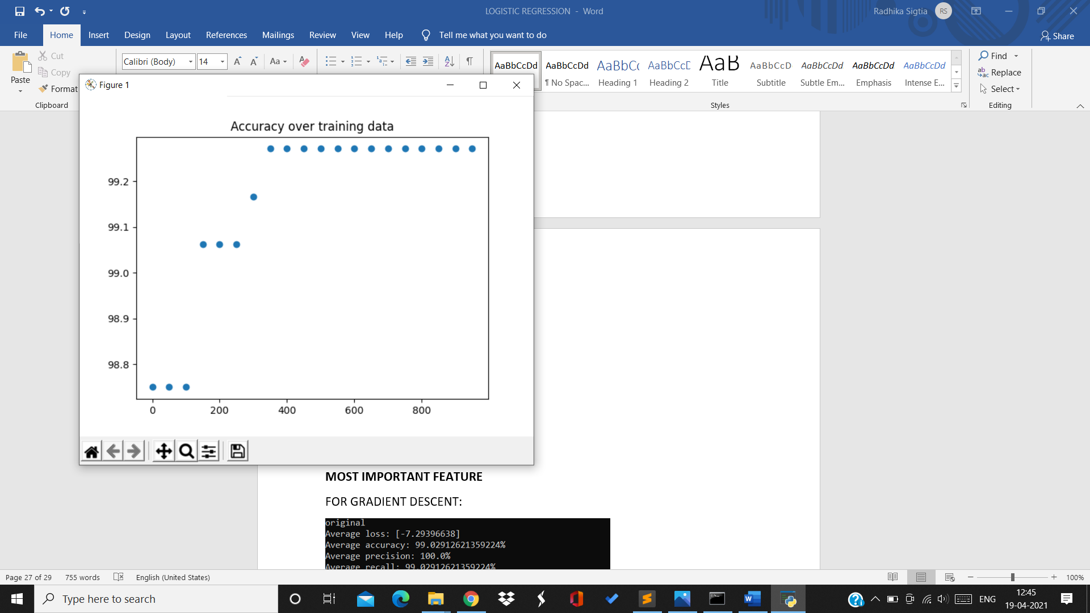

For 3rd split:

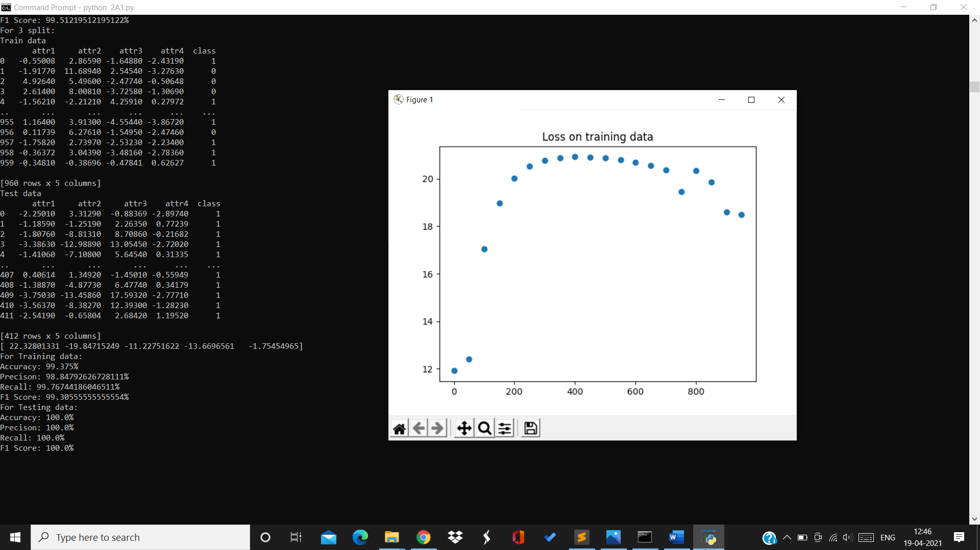

Training data:

Accuracy=99.375% Precision=98.84% Recall=99.76% F1Score=99.3%

Testing data:

Accuracy=100% Precision=100% Recall=100% F1Score=100%

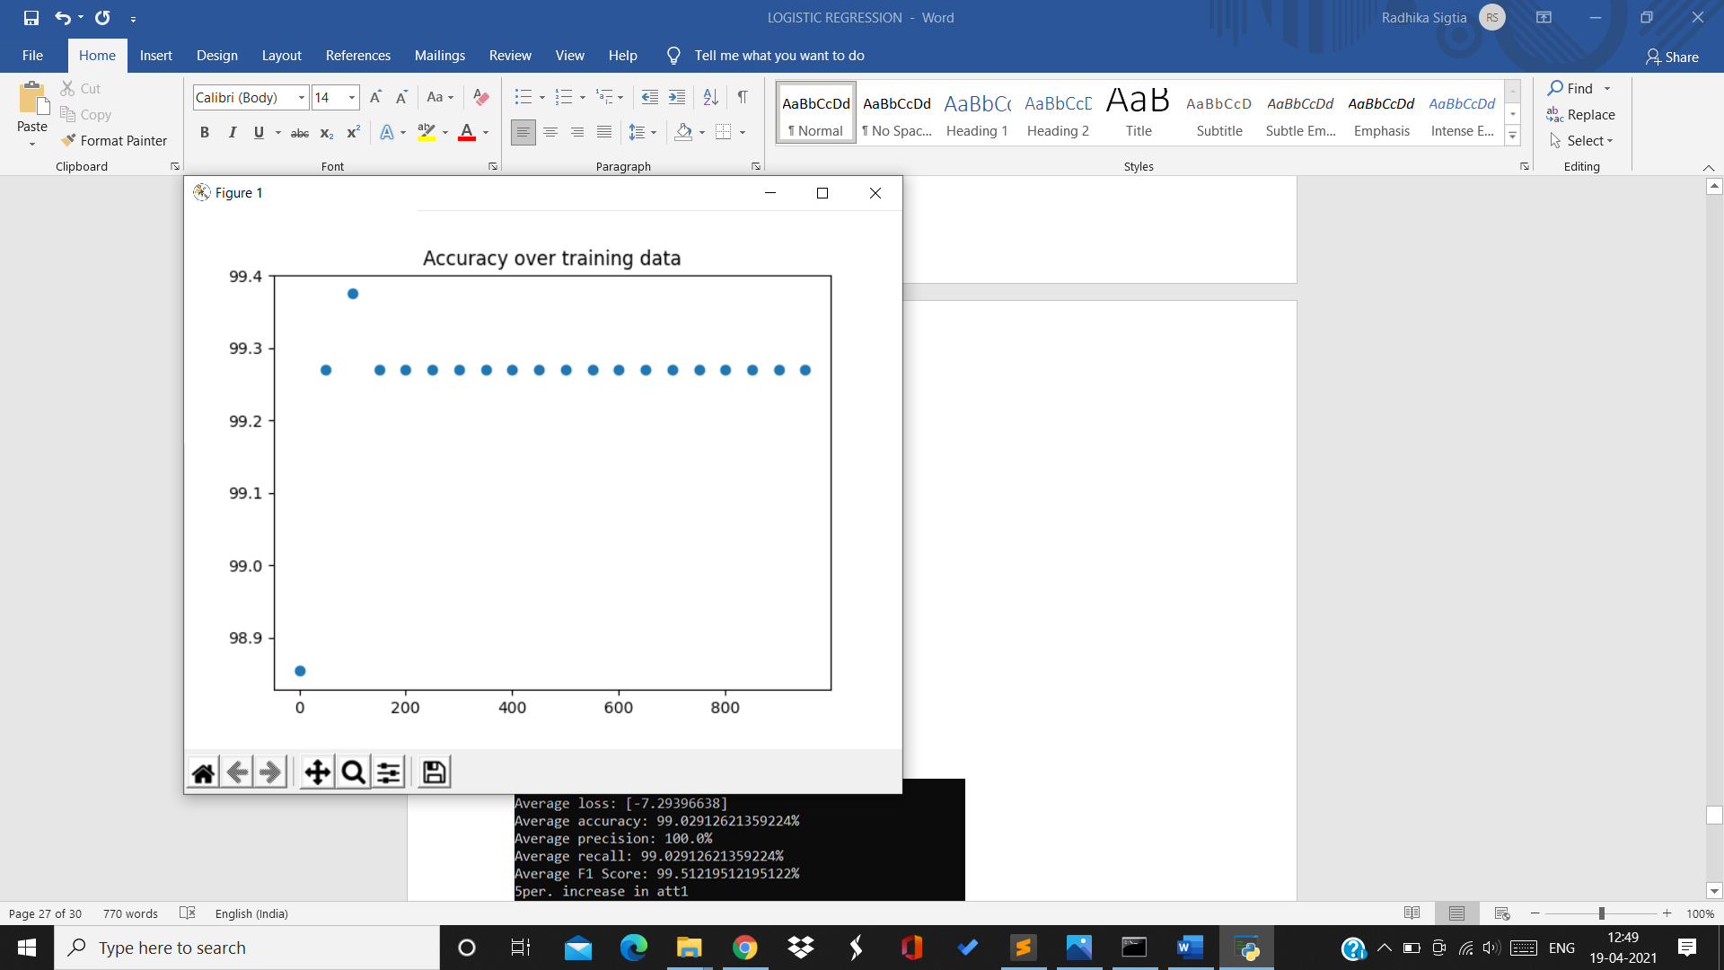

For 4th split:

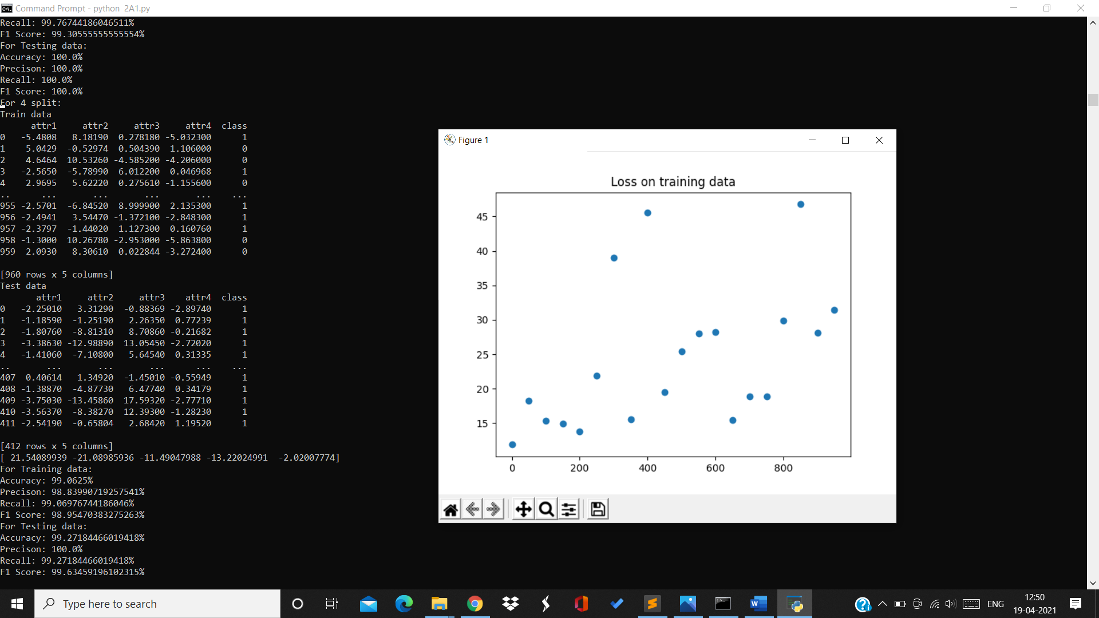

Training data:

Accuracy=99.06% Precision=98.83% Recall=99.06% F1Score=98.95%

Testing data:

Accuracy=99.27% Precision=100% Recall=99.27% F1Score=99.63%

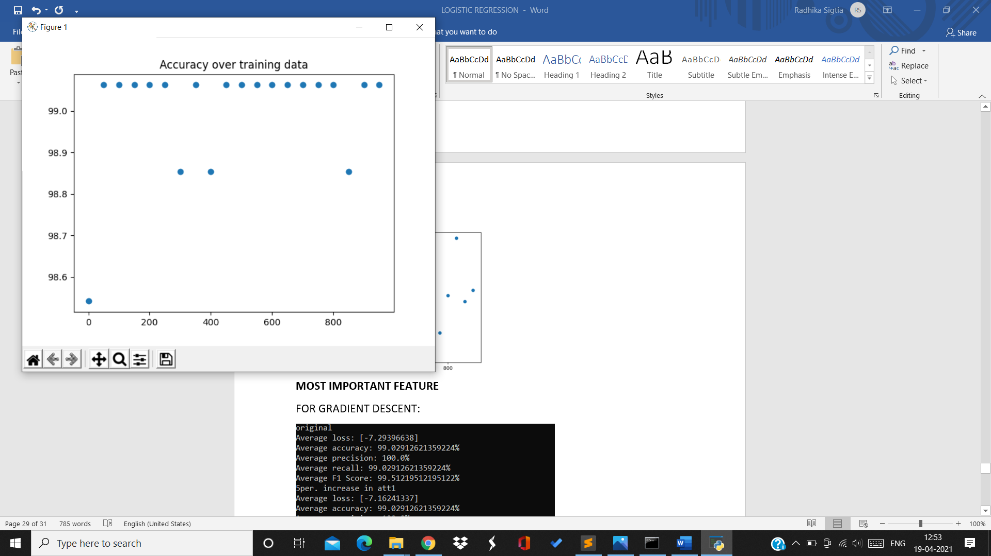

For 5th split:

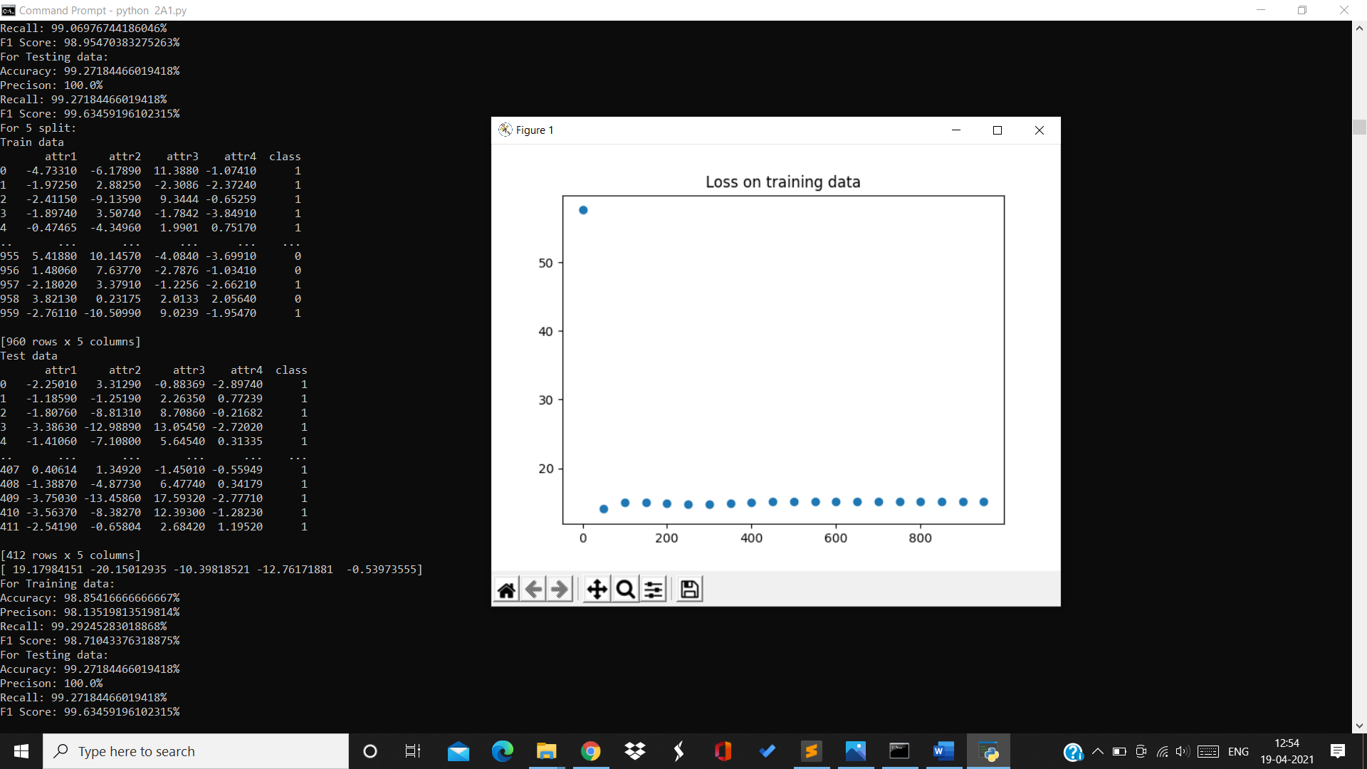

Training data:

Accuracy=98.85% Precision=98.13% Recall=99.29% F1Score=98.71%

Testing data:

Accuracy=99.27% Precision=100% Recall=99.27% F1Score=99.63%

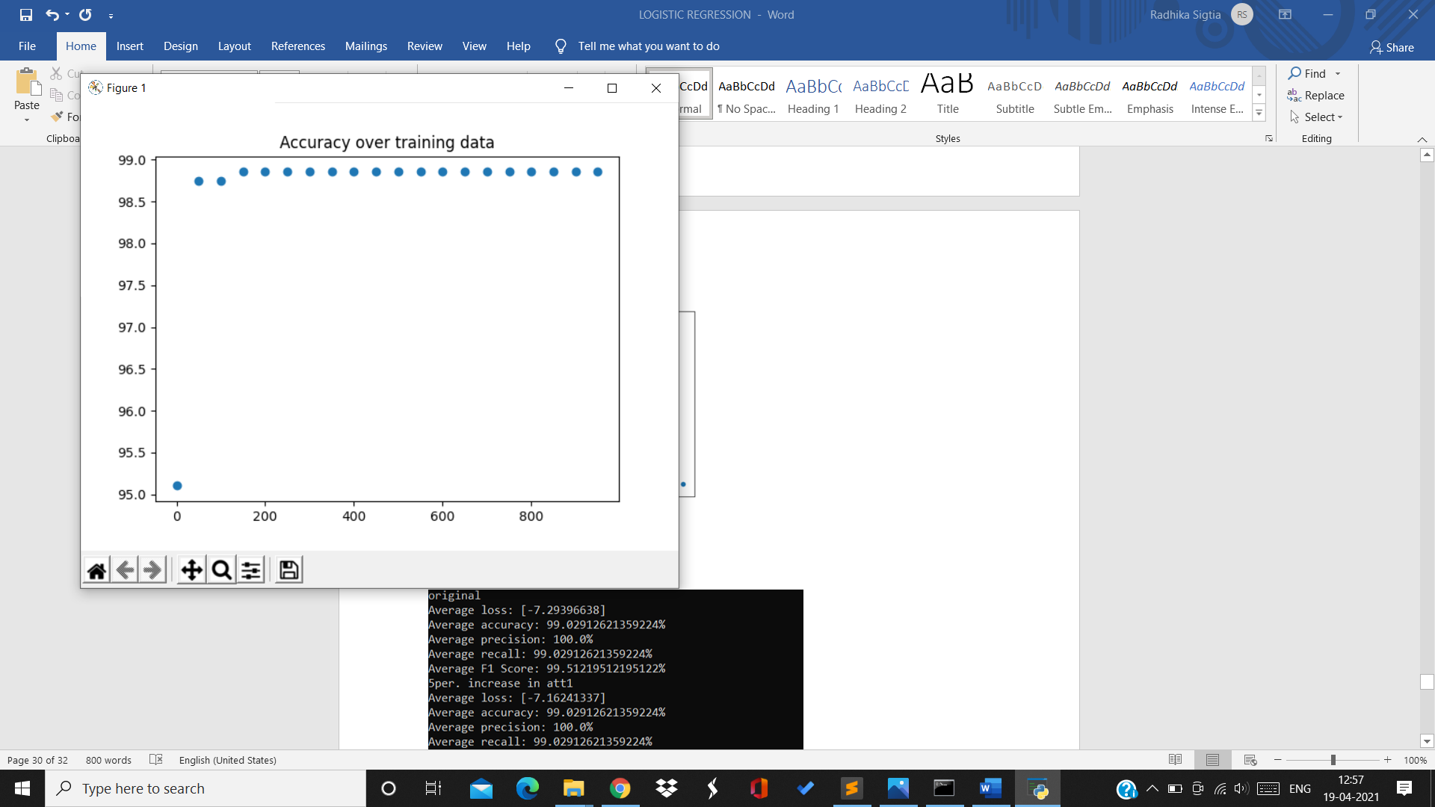

For 6th split:

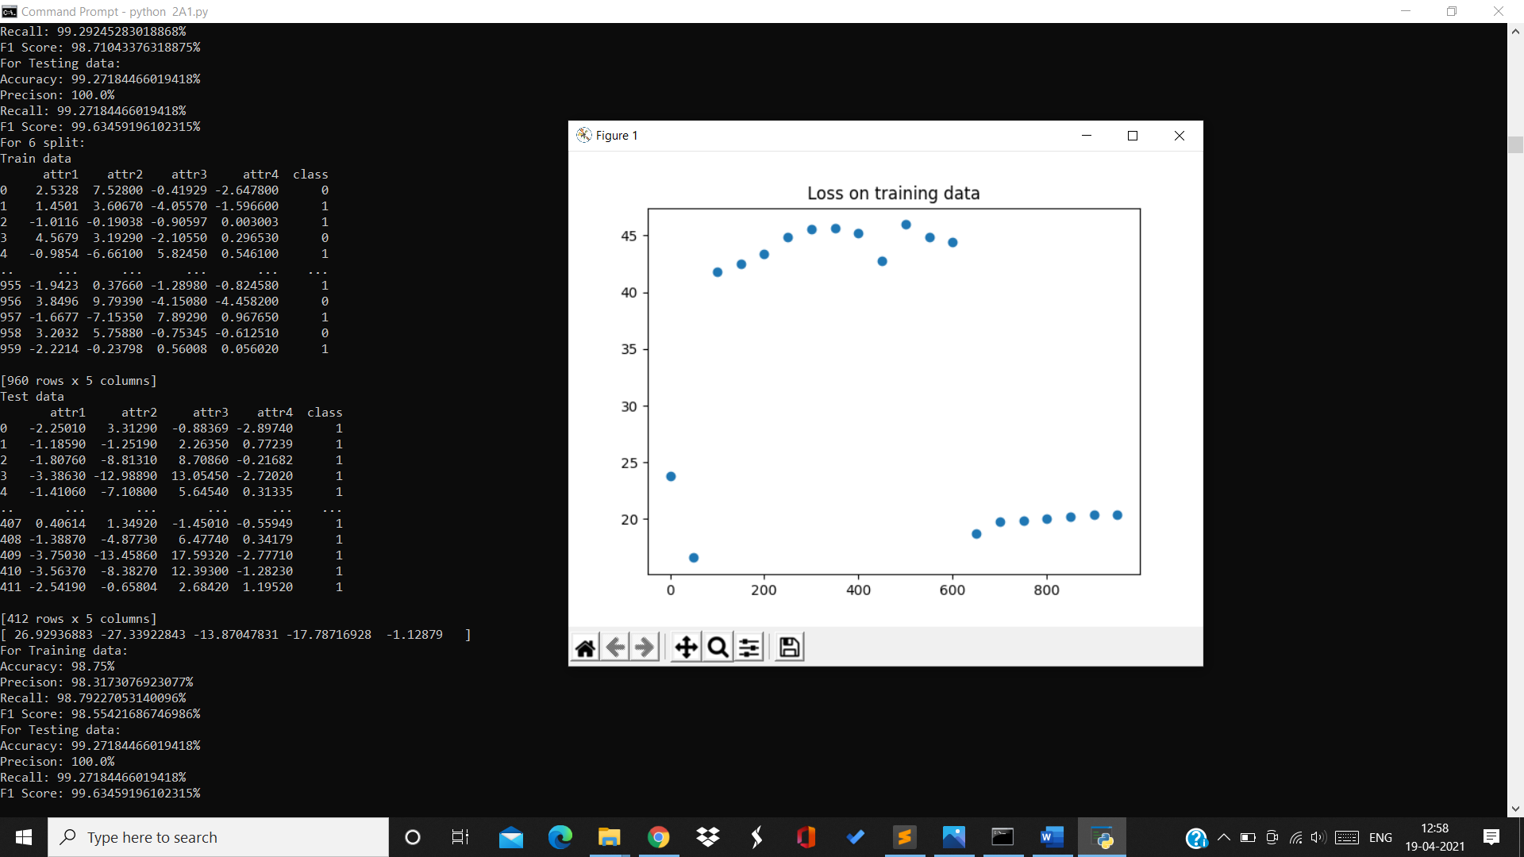

Training data:

Accuracy=98.75% Precision=98.31% Recall=98.79% F1Score=98.55%

Testing data:

Accuracy=99.27% Precision=100% Recall=99.27% F1Score=99.63%

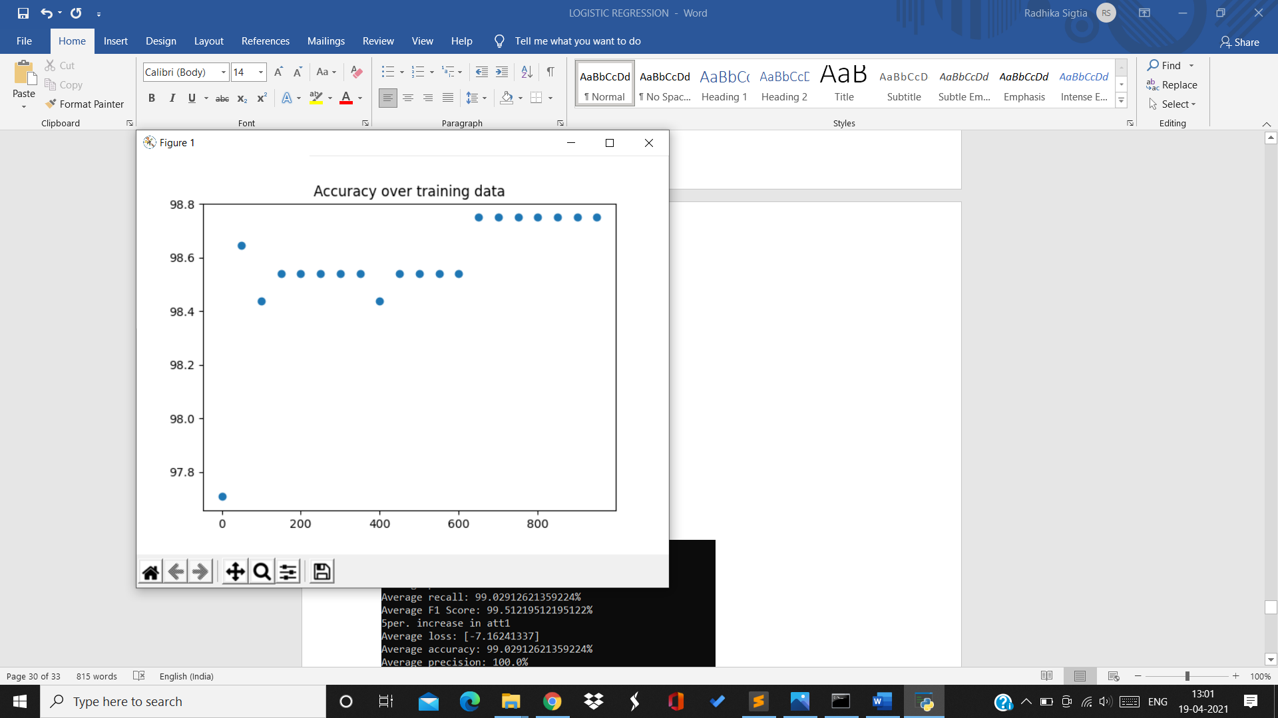

For 7th split:

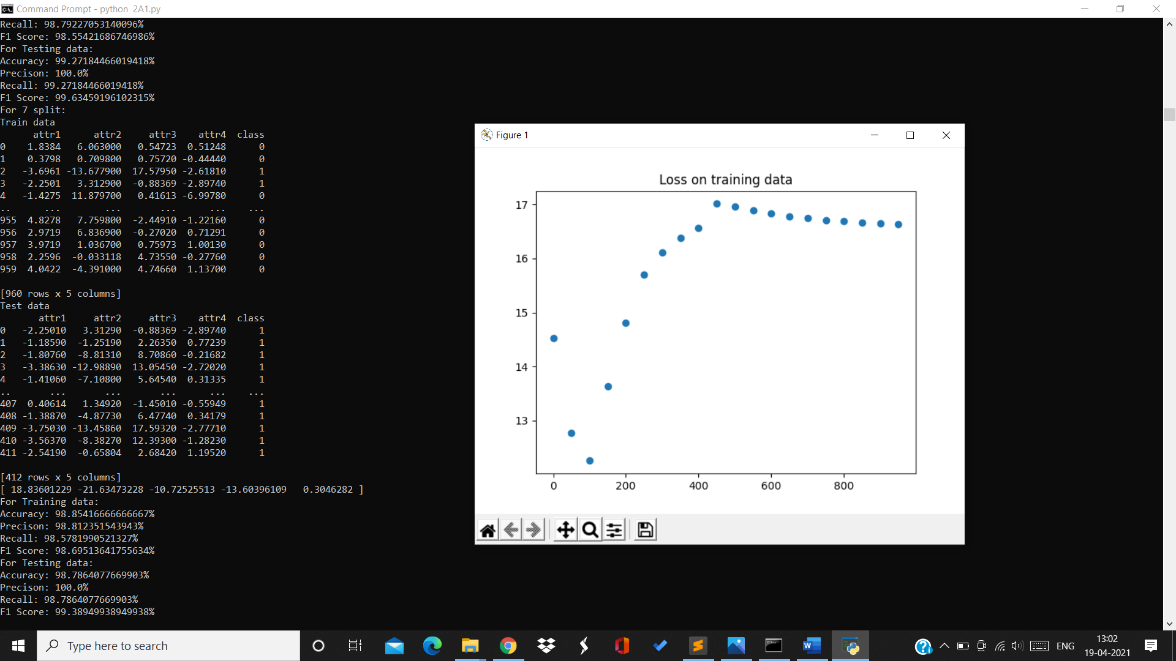

Training data:

Accuracy=98.85% Precision=98.81% Recall=98.57% F1Score=98.69%

Testing data:

Accuracy=98.78% Precision=100% Recall=98.78% F1Score=99.38%

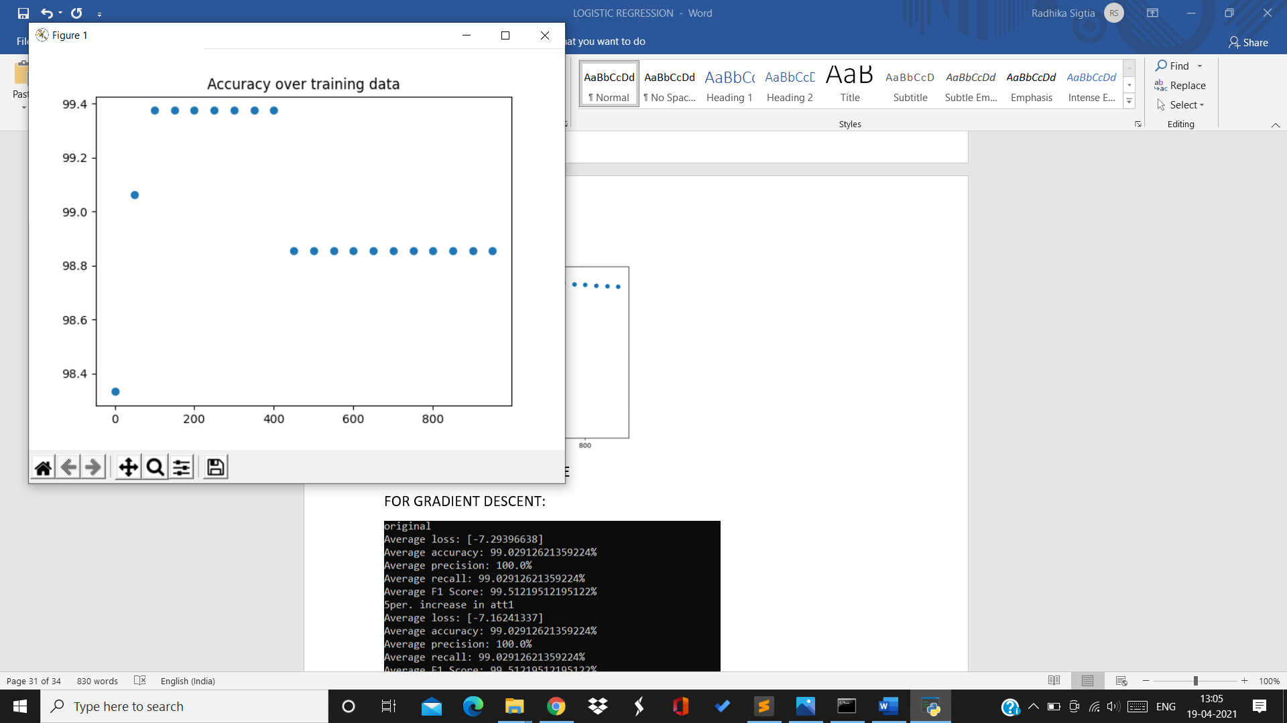

For 8th split:

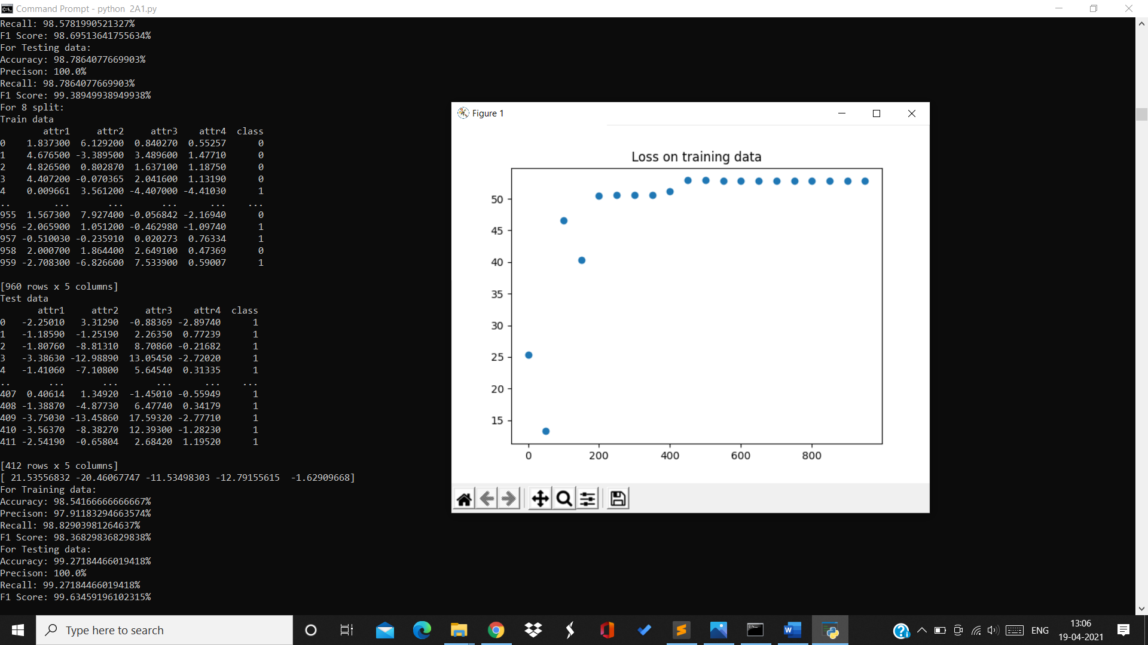

Training data:

Accuracy=98.54% Precision=97.9% Recall=98.8% F1Score=98.36%

Testing data:

Accuracy=99.27% Precision=100% Recall=99.27% F1Score=99.63%

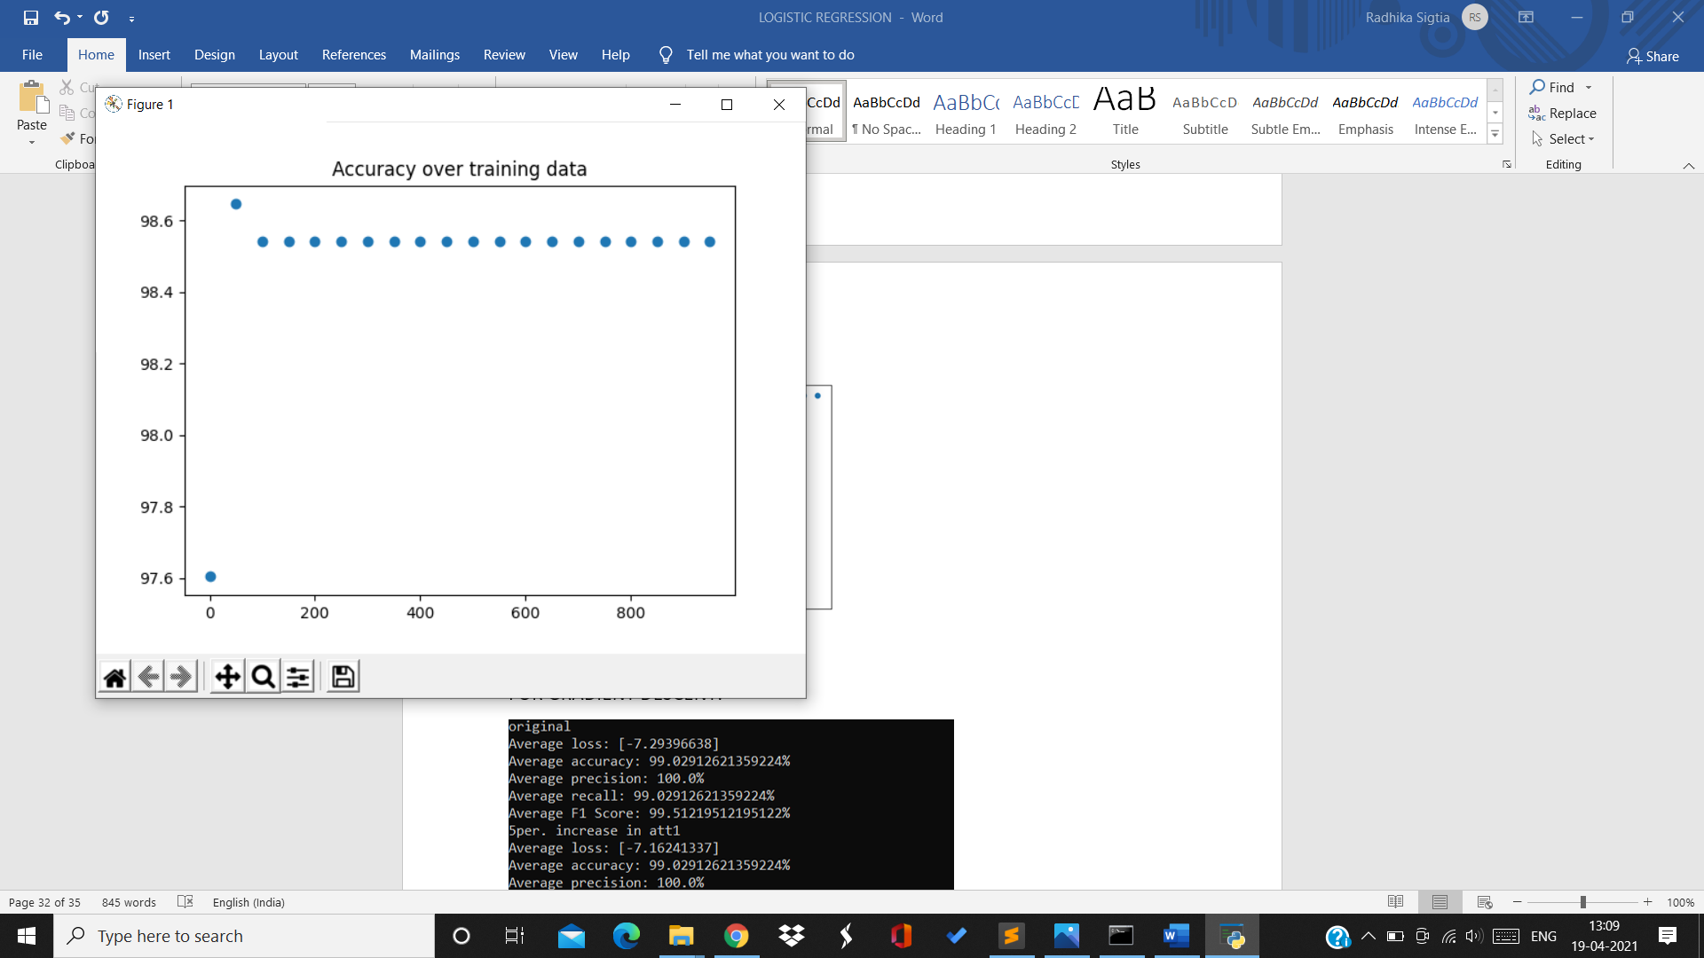

For 9th split:

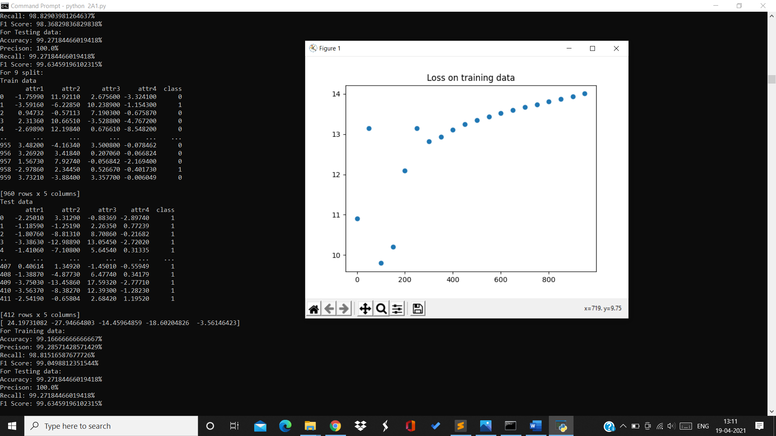

Training data:

Accuracy=99.16% Precision=99.28% F1Score=99.04%

Testing data:

Accuracy=99.27% Precision=100% Recall=99.27% F1Score=99.63%

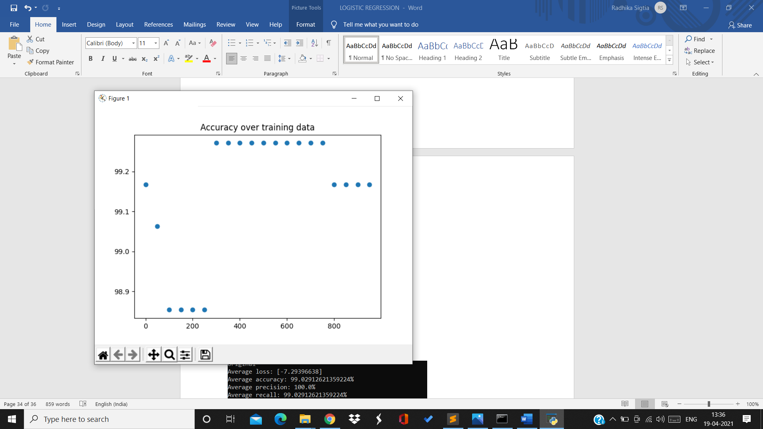

For 10th split:

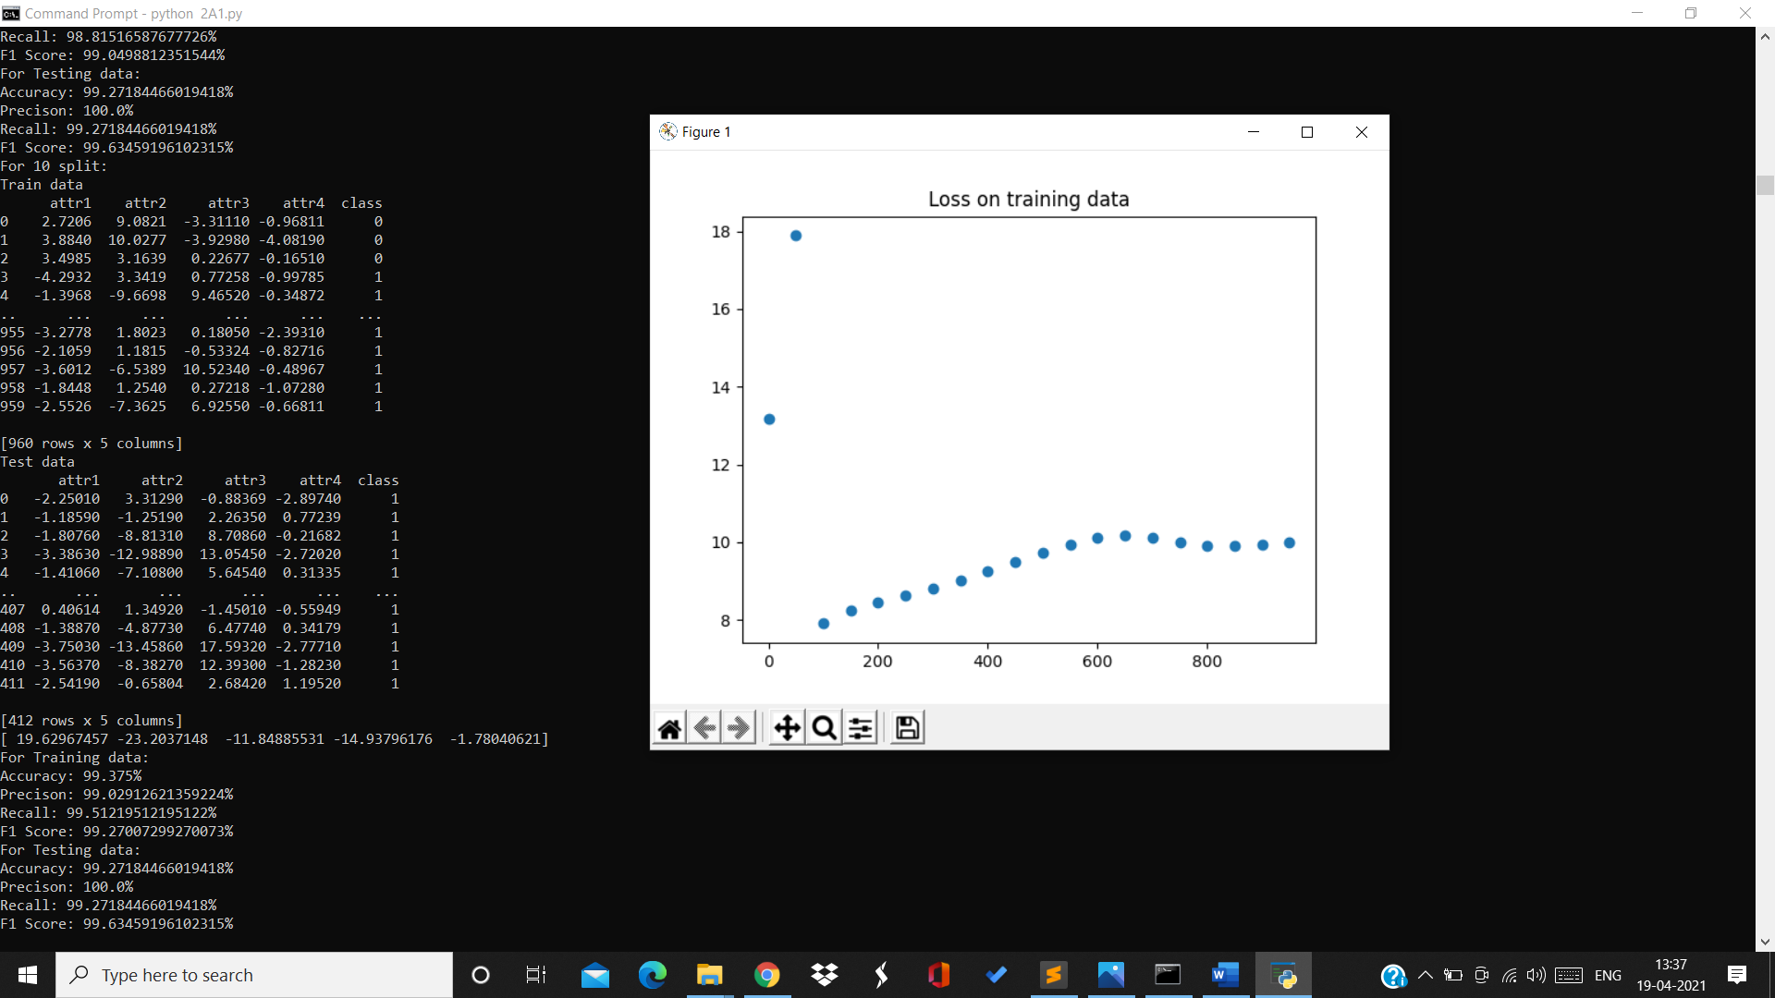

Training data:

Accuracy=99.375% Precision=99.02% Recall=99.51% F1Score=99.27%

Testing data:

Accuracy=99.27% Precision=100% Recall=99.27% F1Score=99.63%

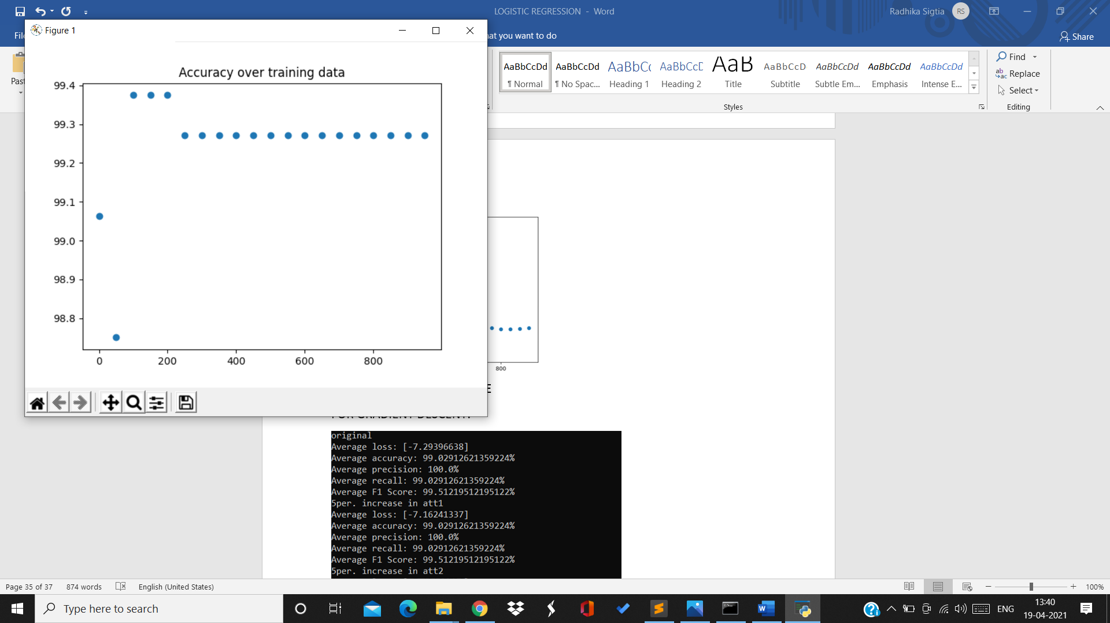

For rate 0.1:

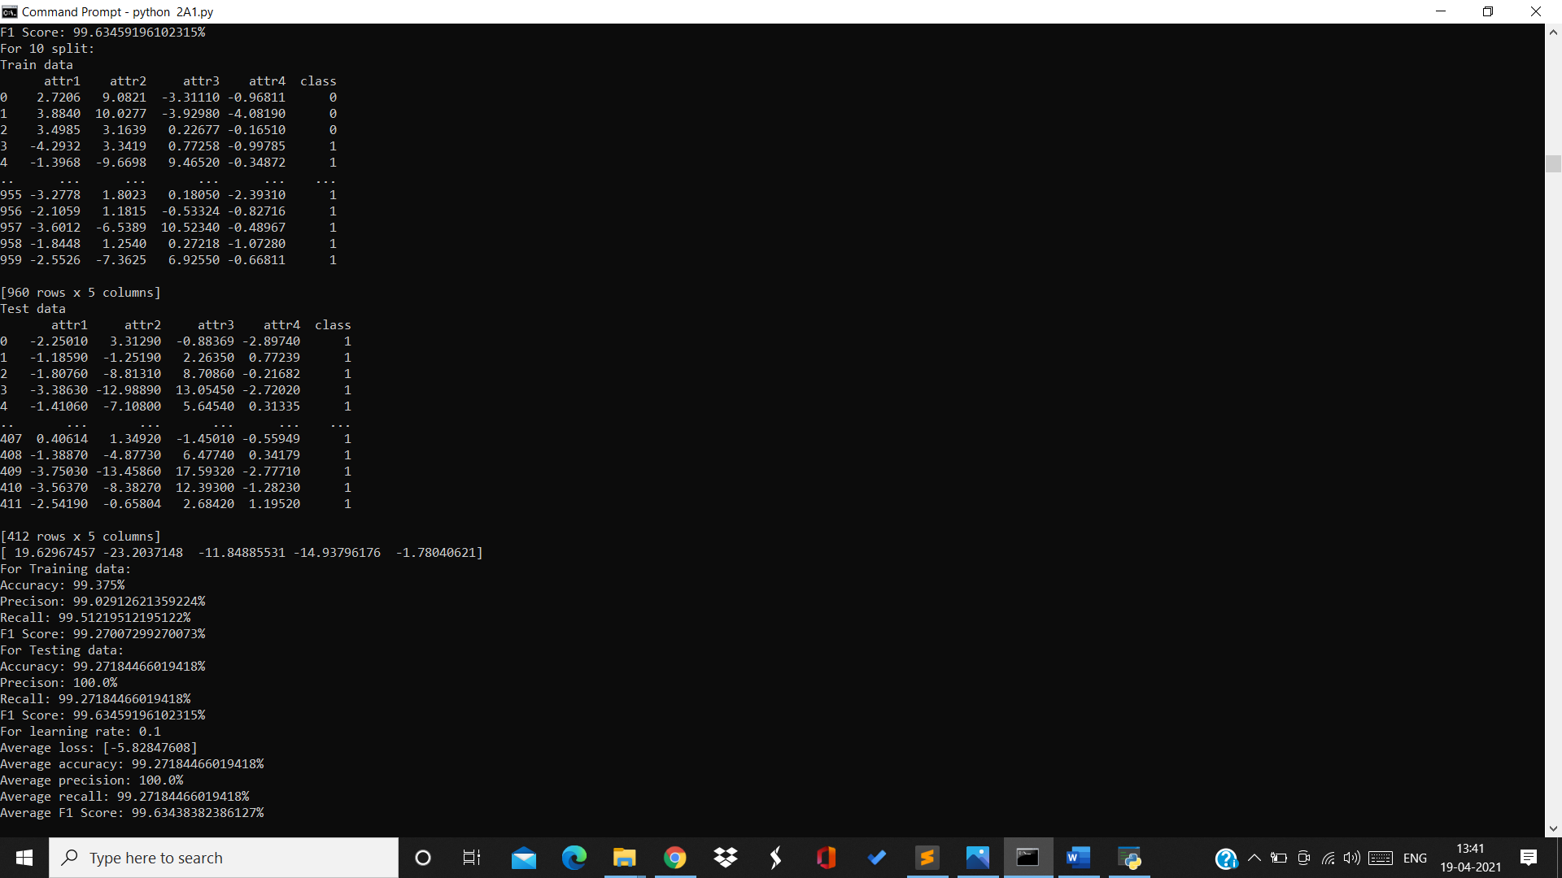

Average loss=-5.82 Average accuracy=99.27% Average precision=100%

Average recall=99.27% Average F1Score=99.63%

Accuracy over 10 splits on testing data for rate 0.1

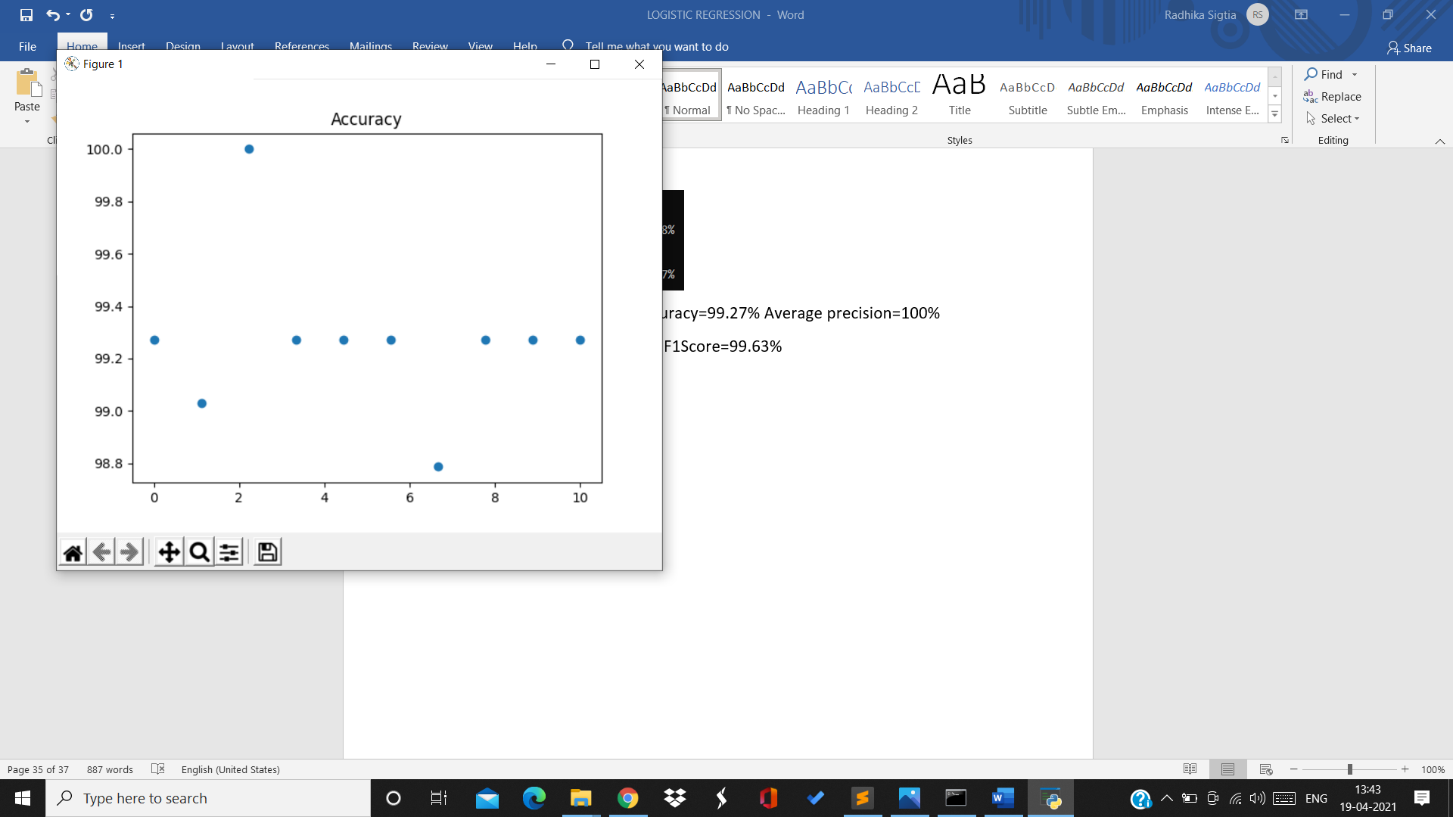

**FOR STOCHASTIC GRADIENT DESCENT:**

For rate=0.001:

For 1st split:

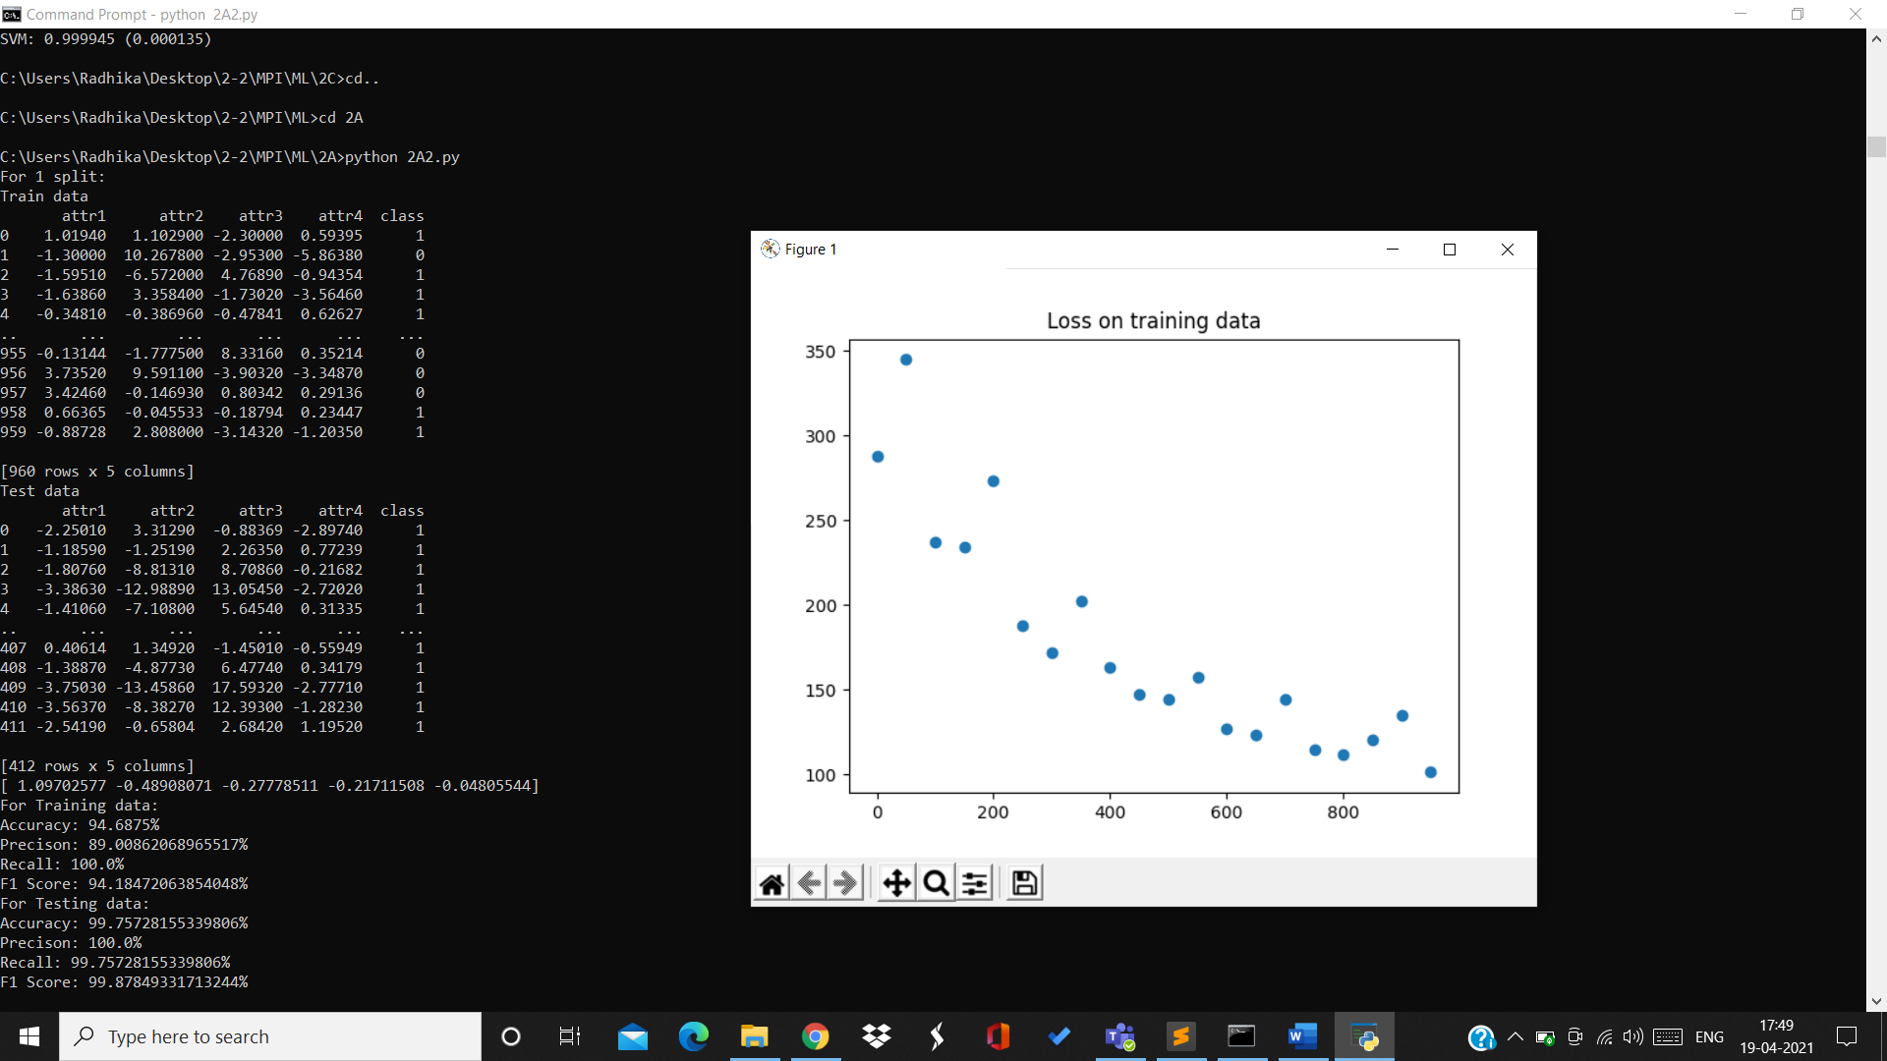

Training data:

Accuracy=95% Precision=89% Recall=100% F1Score=94.18%

Testing data:

Accuracy=99.75% Precision=100% Recall=99.75% F1Score=99.87%

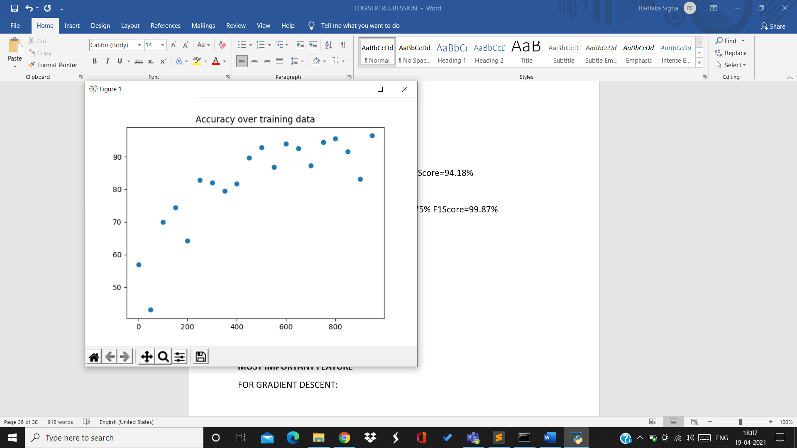

2nd split:

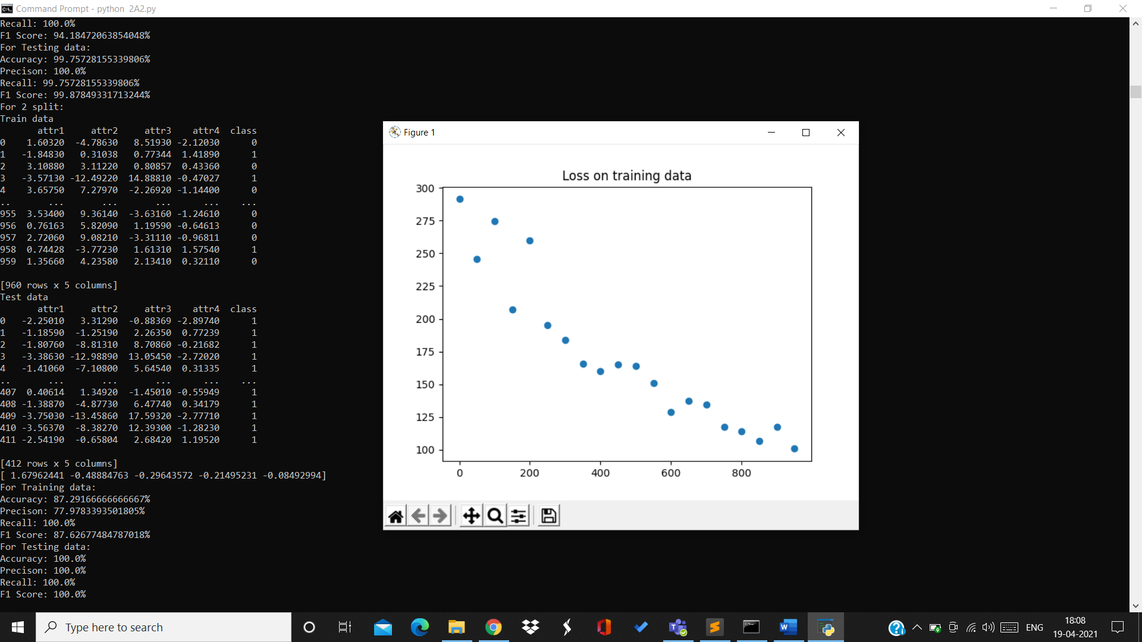

Training data:

Accuracy=87.29% Precision=77.97% Recall=100% F1Score=87.62%

Testing data:

Accuracy=100% Precision=100% Recall=100% F1Score=100%

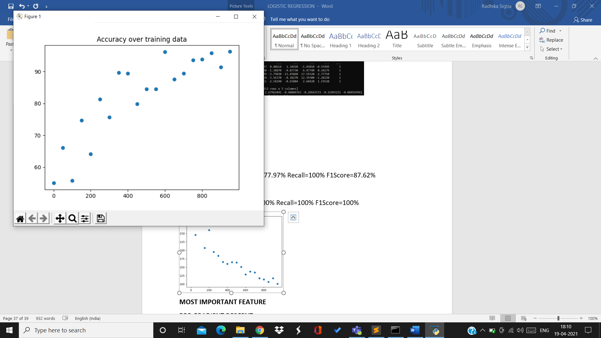

For 3rd split:

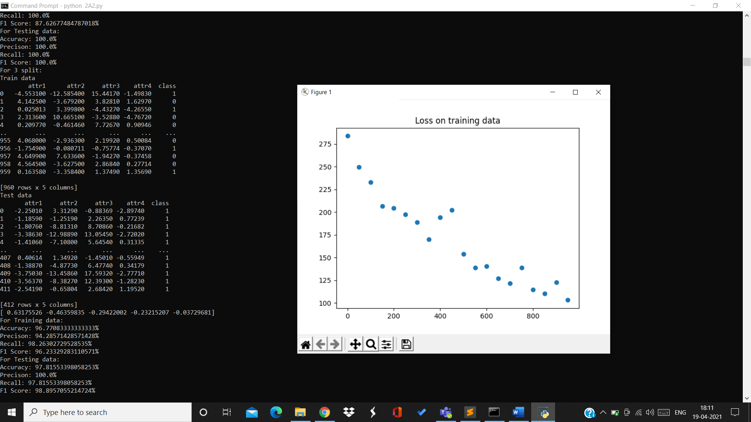

Training data:

Accuracy=96.7% Precision=94.28% Recall=98.26% F1Score=96.23%

Testing data:

Accuracy=97.81% Precision=100% Recall=97.81% F1Score=98.89%

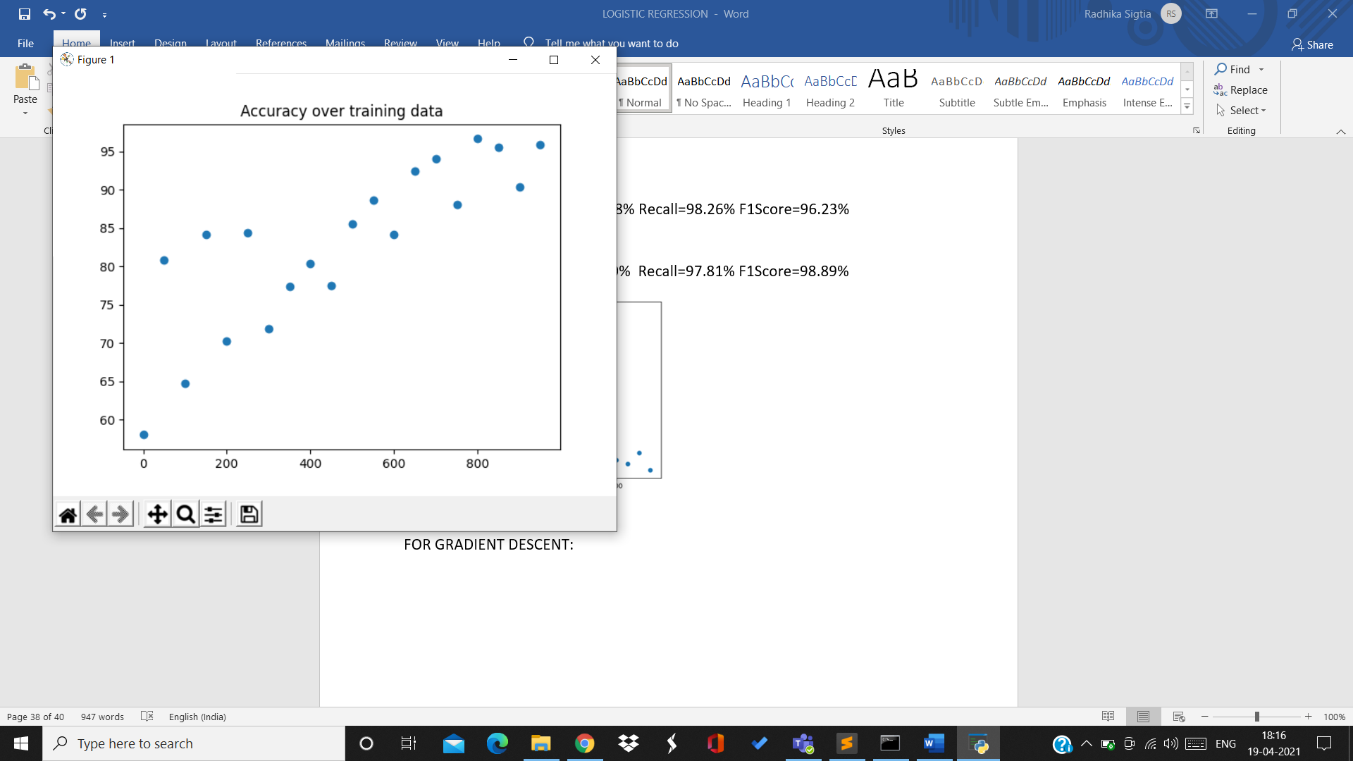

For 4th split:

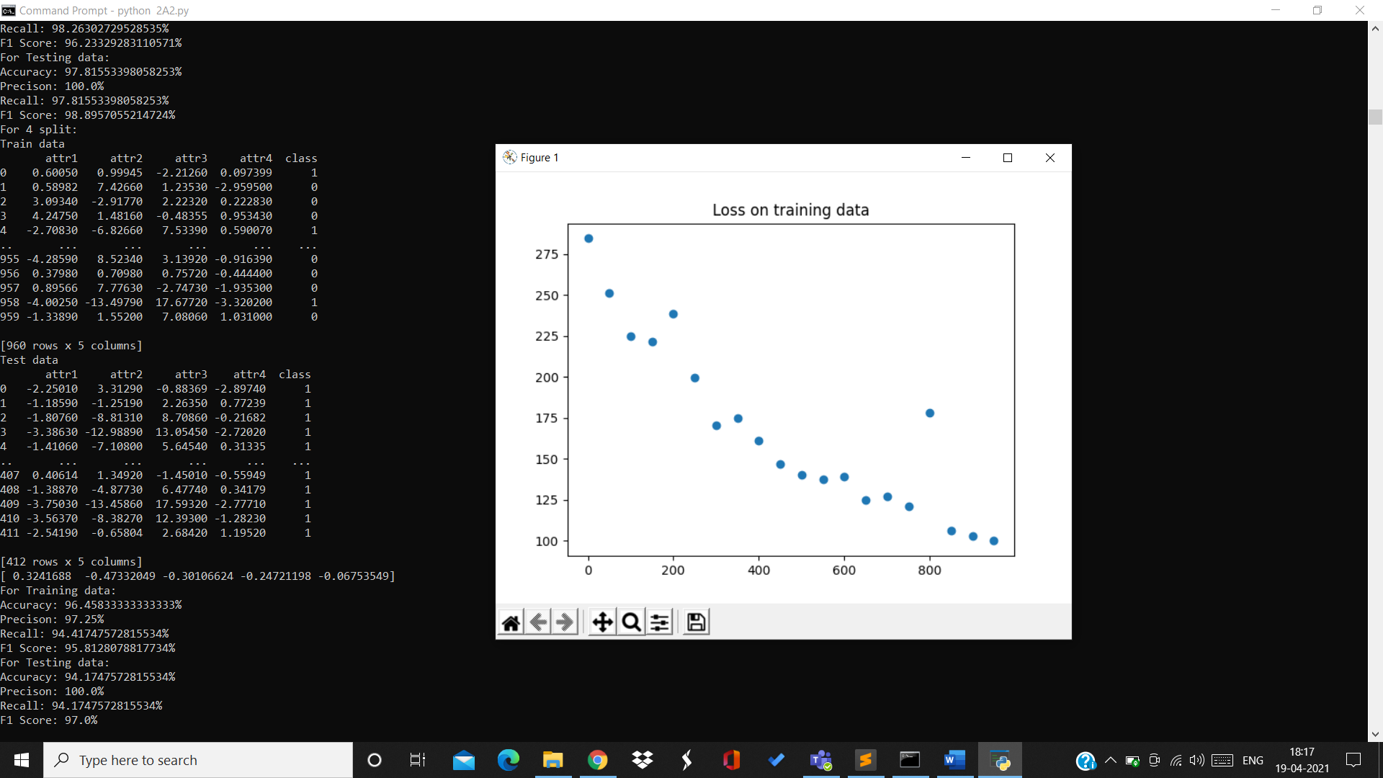

Training data:

Accuracy=96.45% Precision=97.25% Recall=94.41% F1Score=95.81%

Testing data:

Accuracy=94.17% Precision=100% Recall=94.17% F1Score=97%

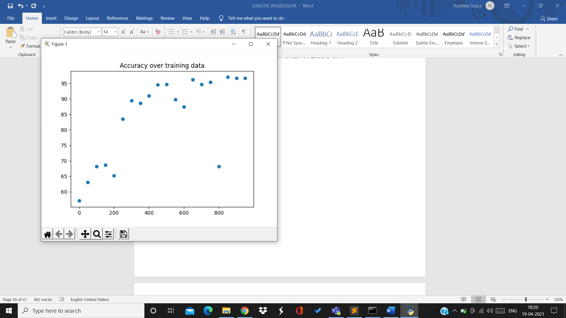

5th split:

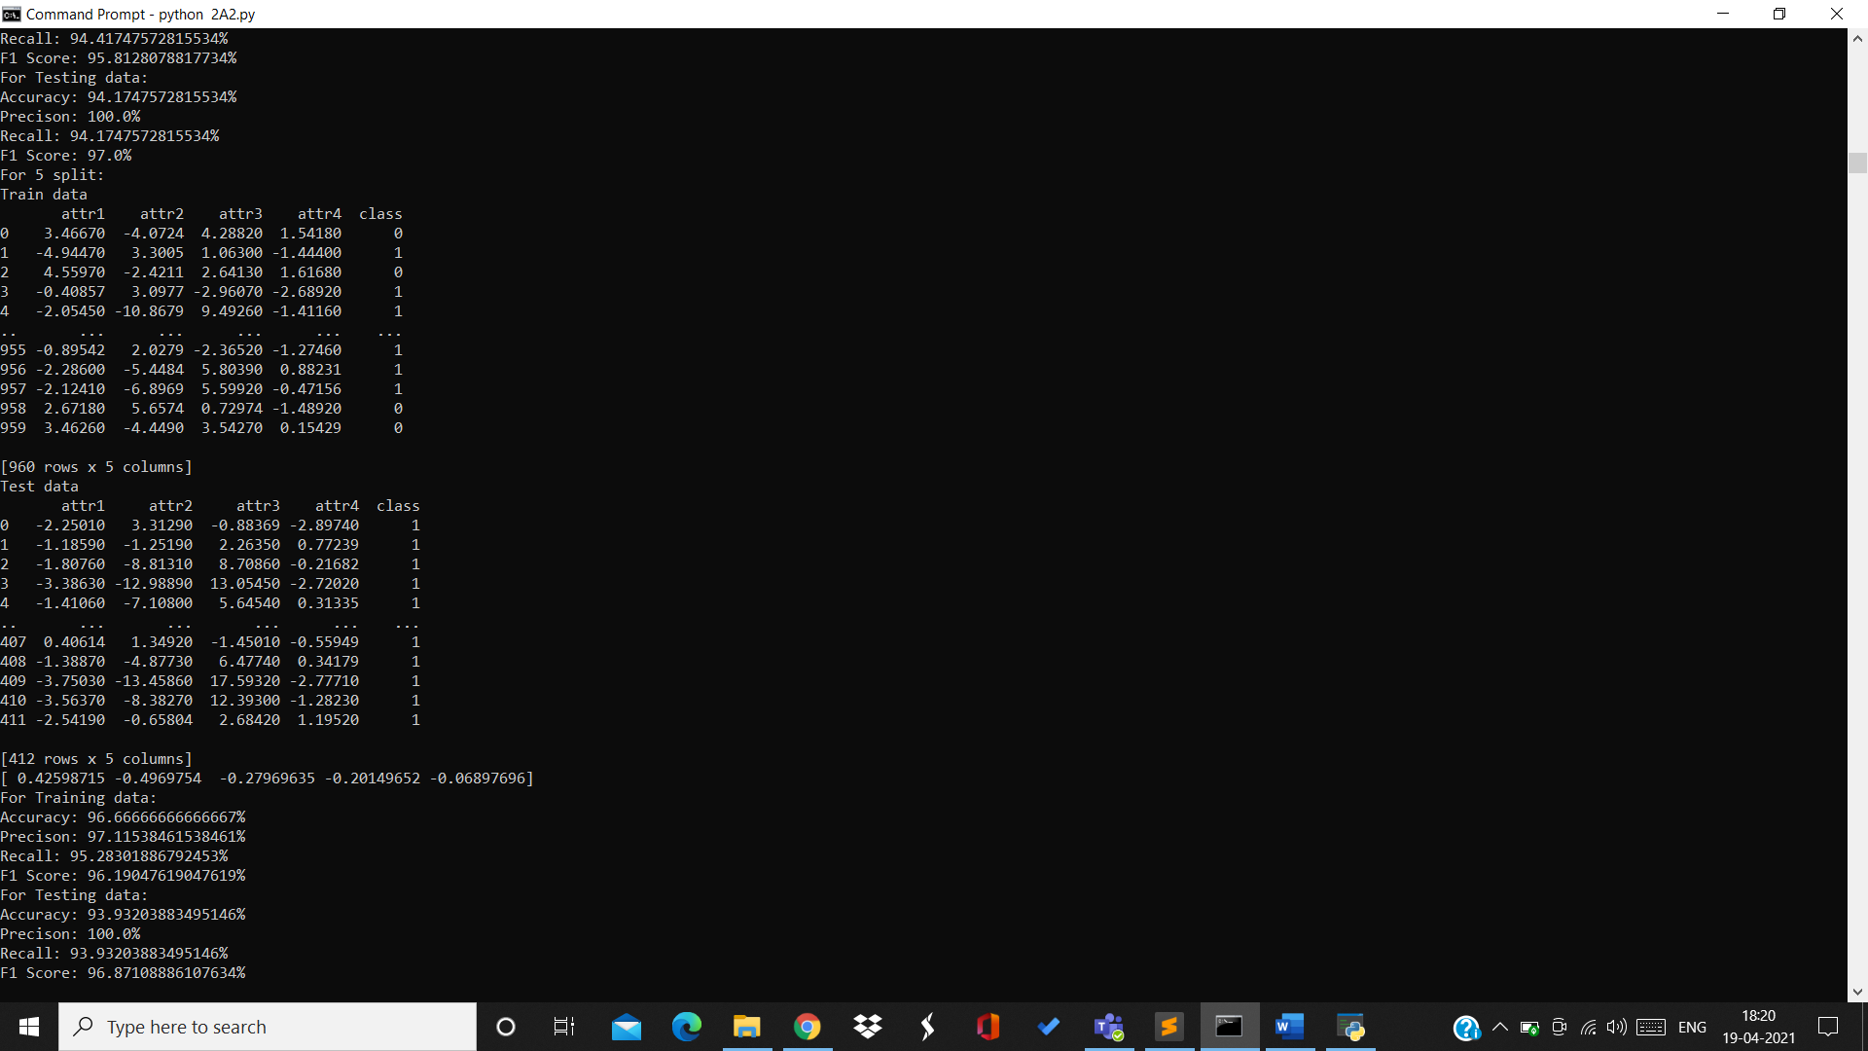

Training data:

Accuracy=96.66% Precision=97.15% Recall=95.28% F1Score=96.19%

Testing data:

Accuracy=93.93% Precision=100% Recall=93.93% F1Score=96.87%

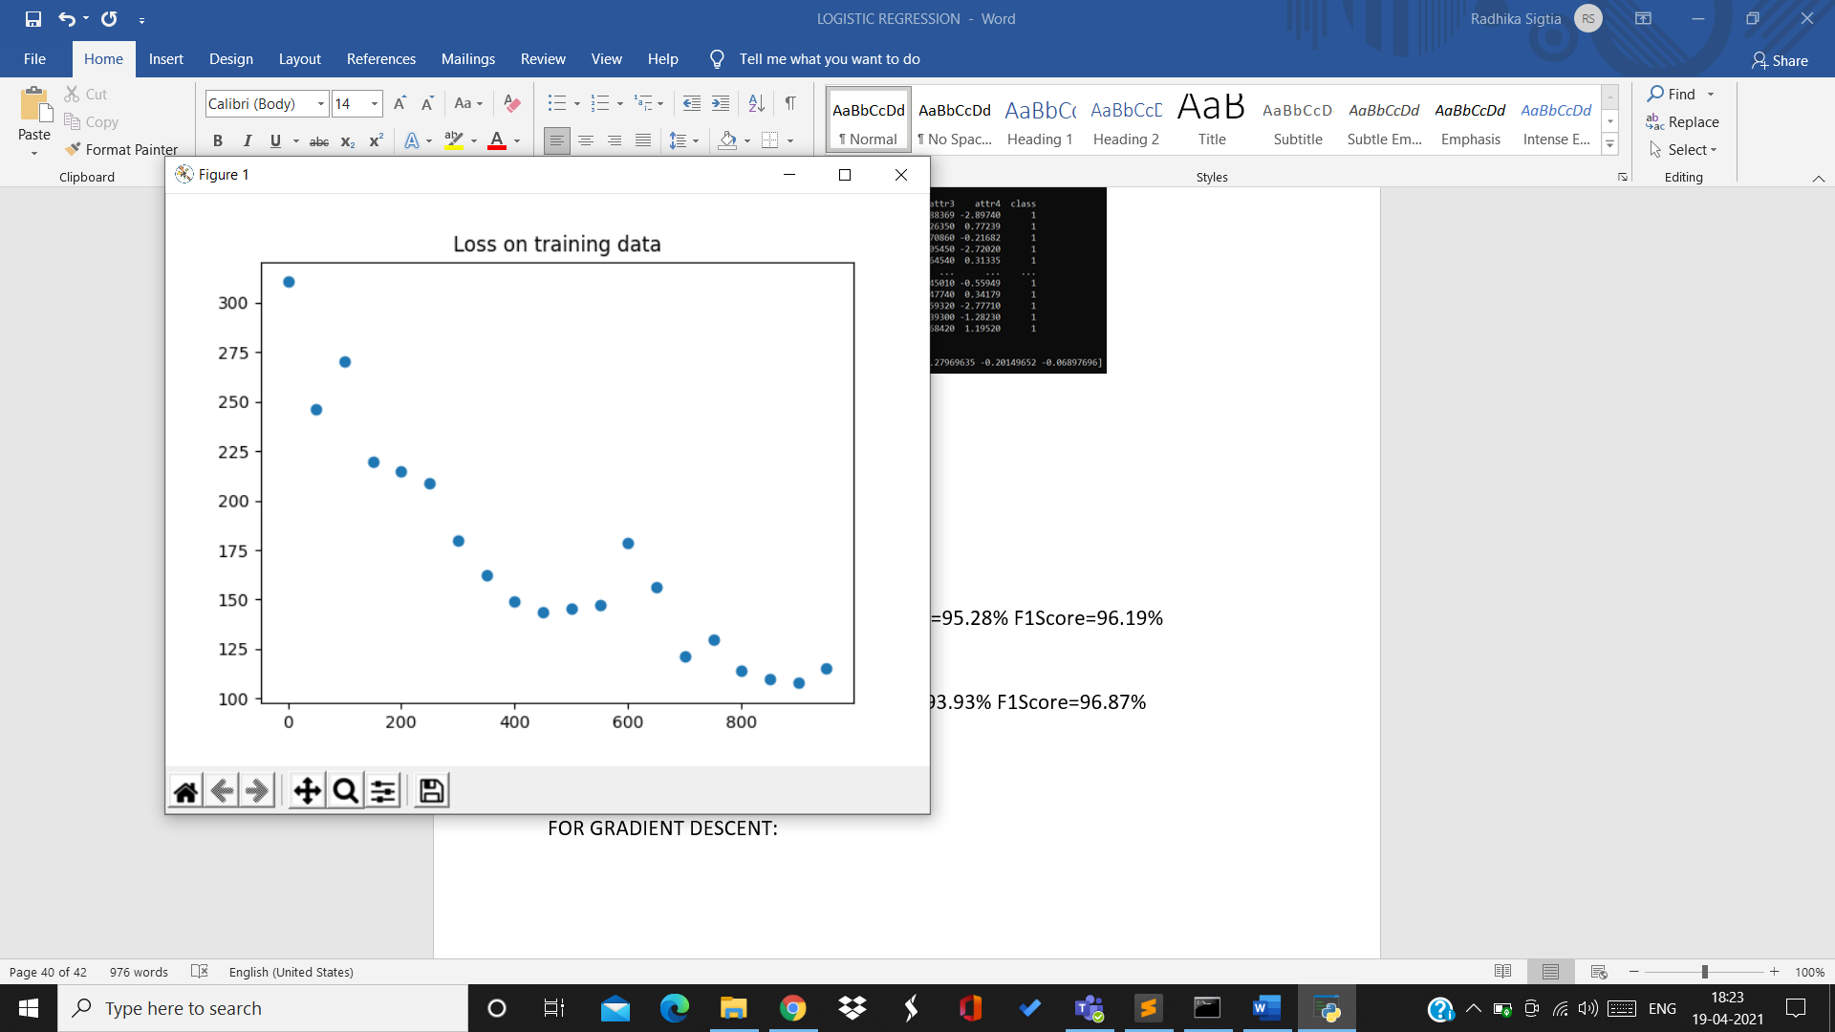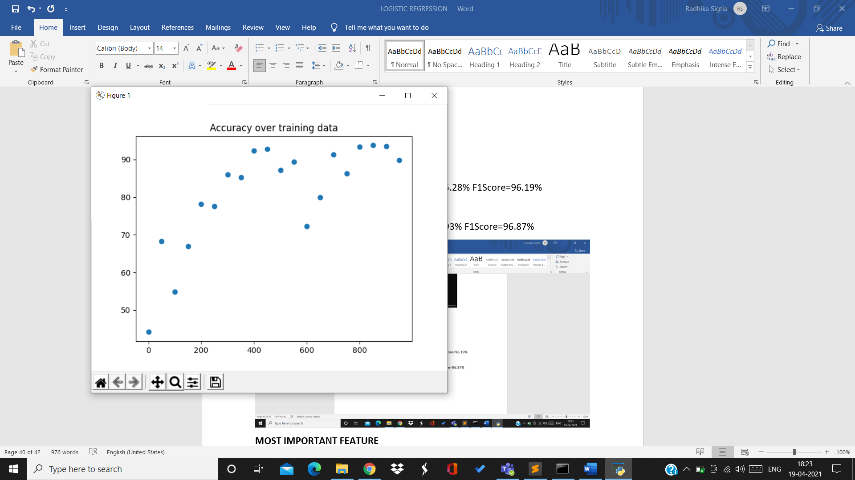

6th split:

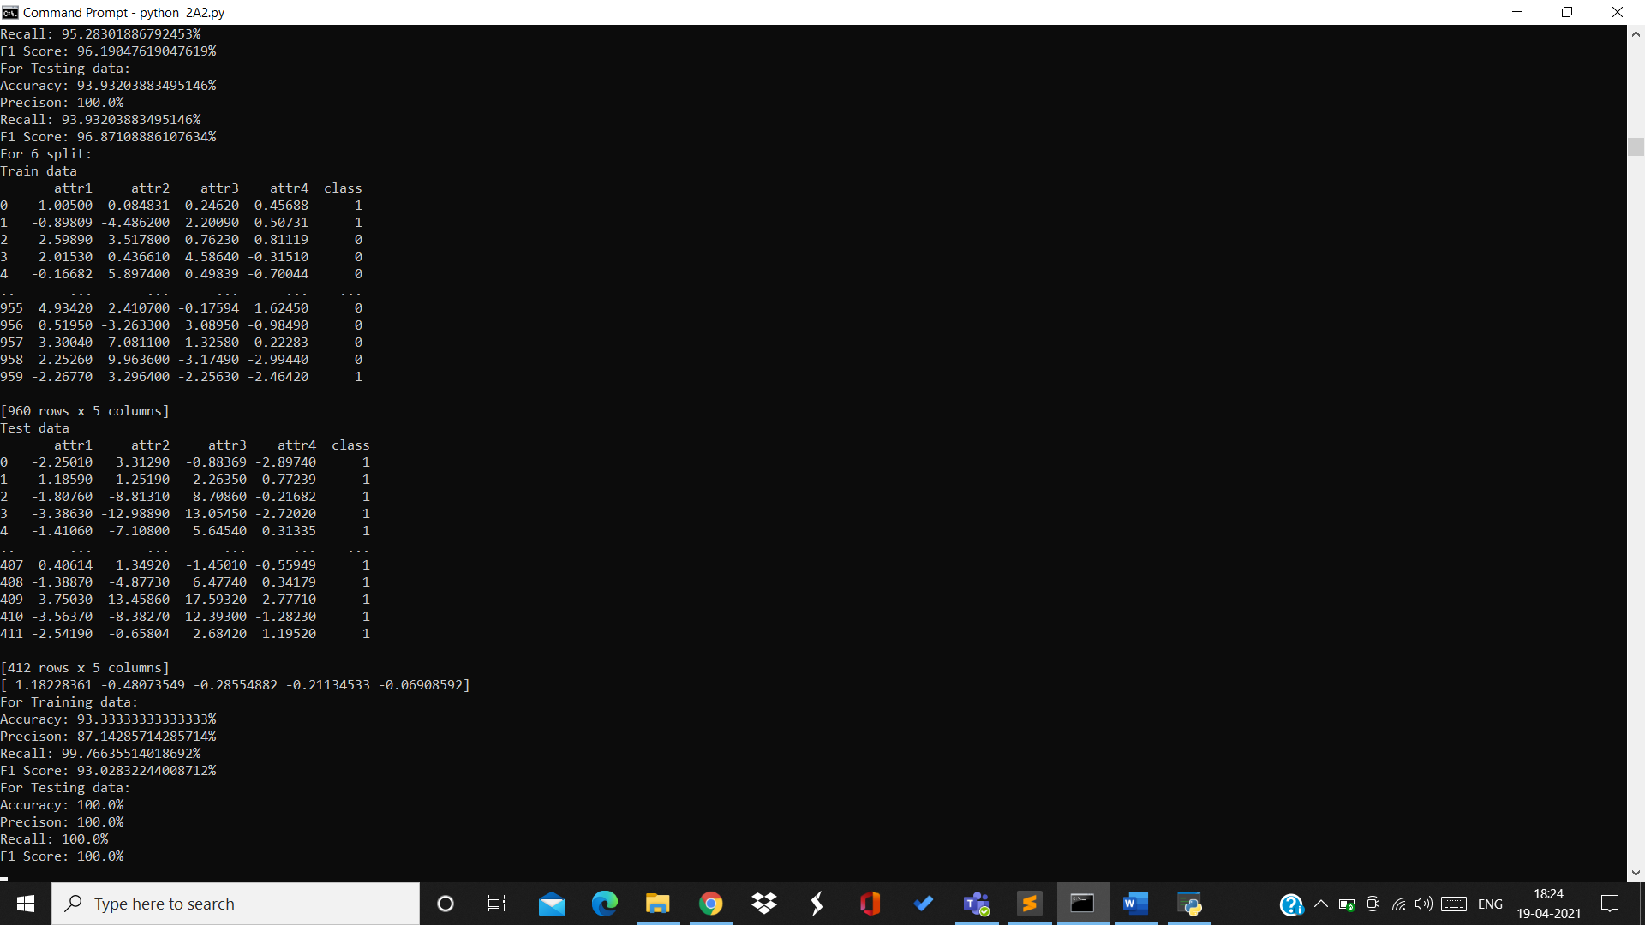

Training data:

Accuracy=93.33% Precision=87.14% Recall=99.765 F1Score=93.02%

Testing data:

Accuracy=100% Precision=100% Recall=100% F1Score=100%

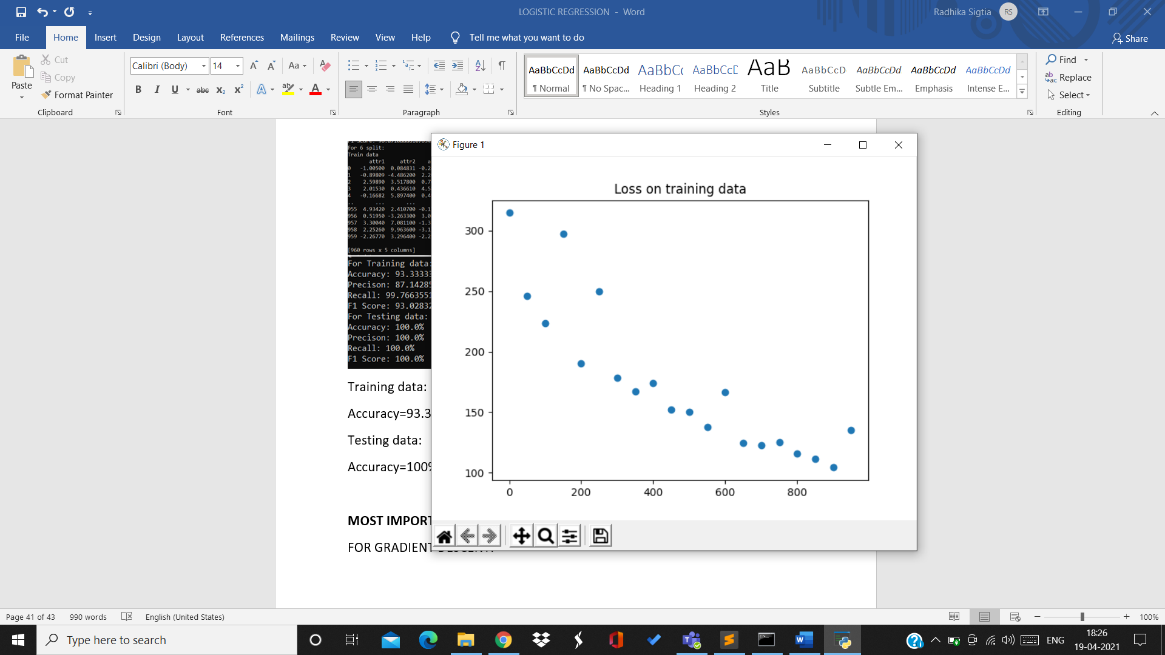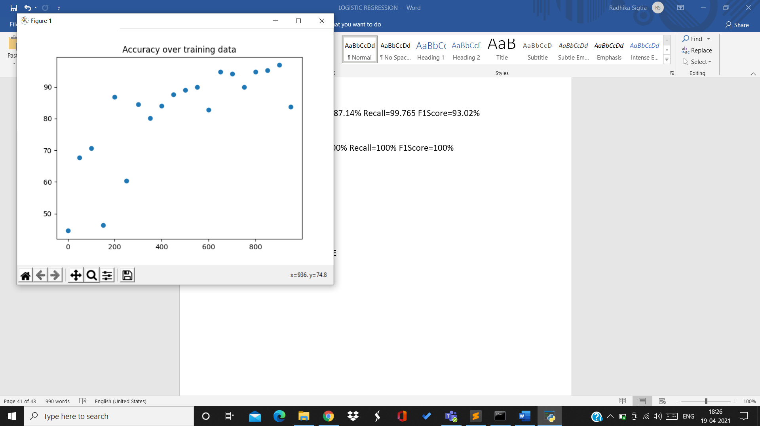

7th split:

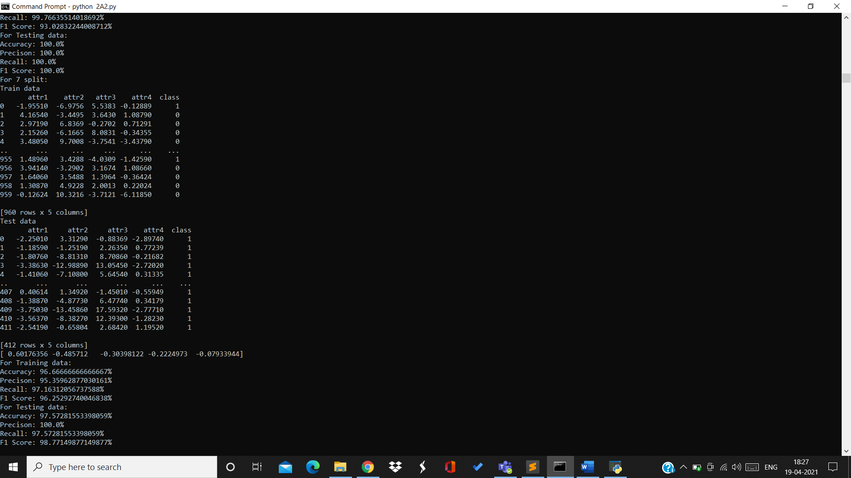

Training data:

Accuracy=96.66% Precision=95.35% Recall=97.16% F1Score=96.25%

Testing data:

Accuracy=97.57% Precision=100% Recall=97.5% F1Score=98.77%

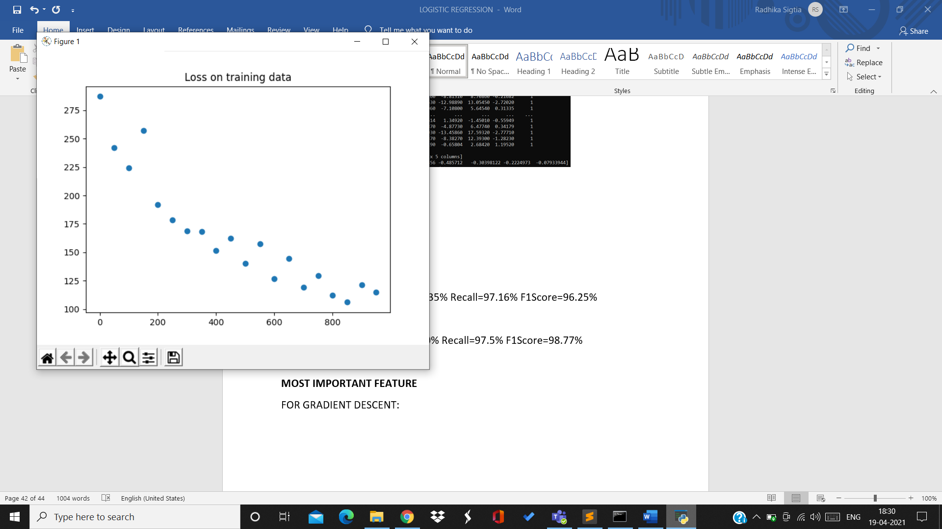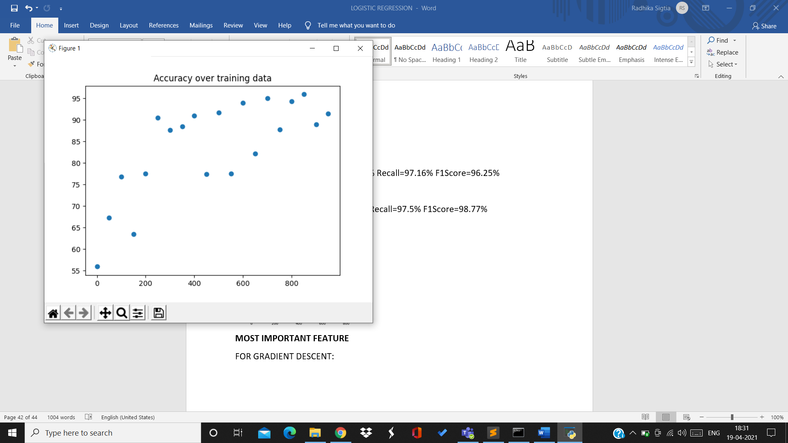

8th split:

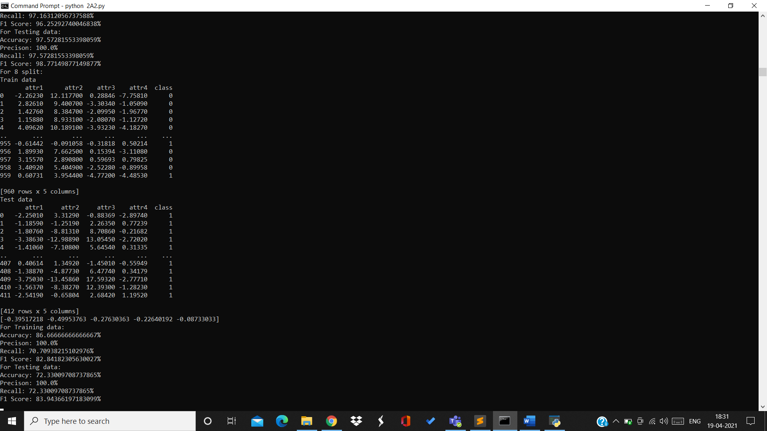

Training data:

Accuracy=86.66% Precision=100% Recall=70.79% F1Score=82.84%

Testing data:

Accuracy=72.33% Precision=100% Recall=72.33% F1Score=83.94%

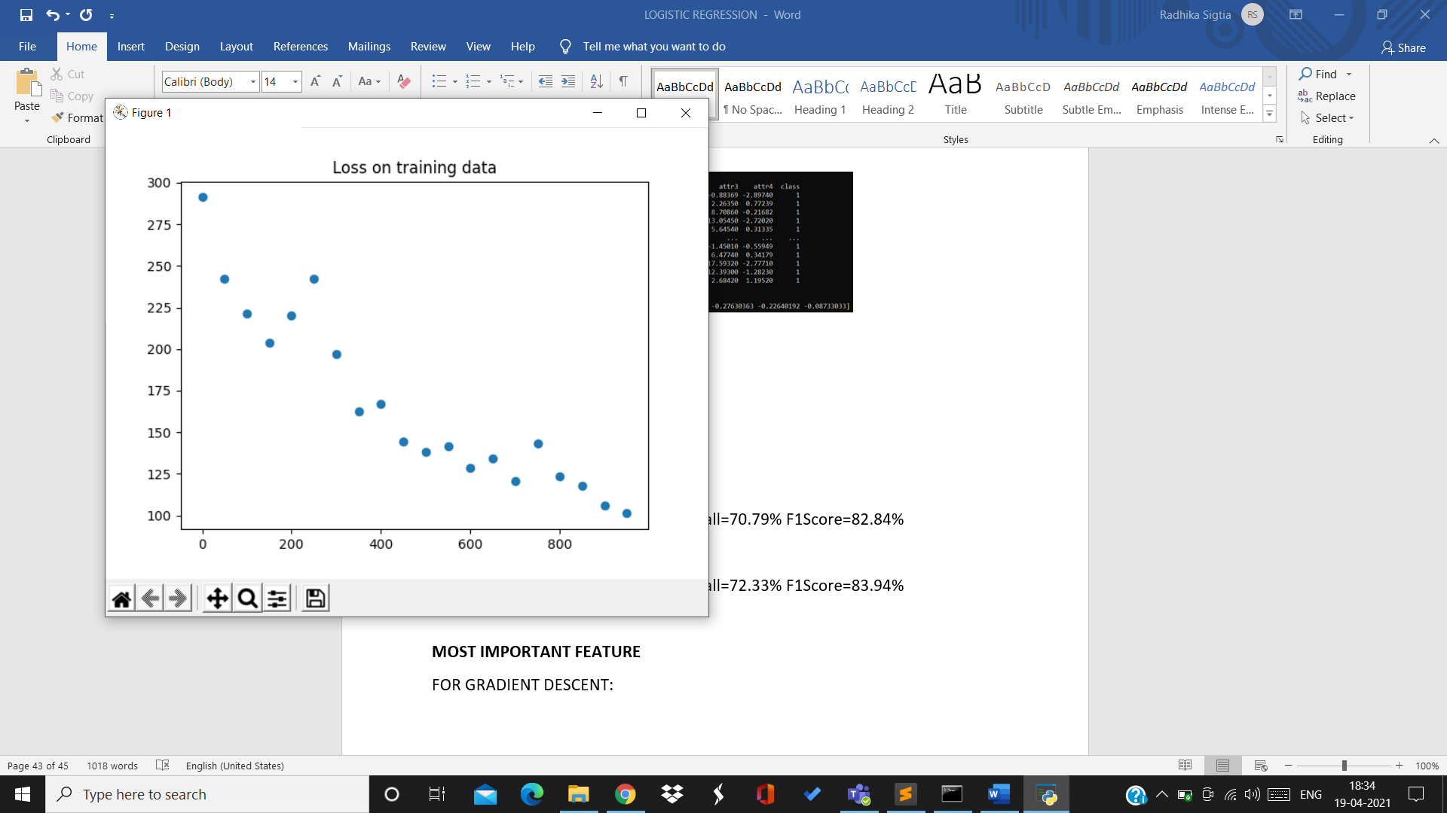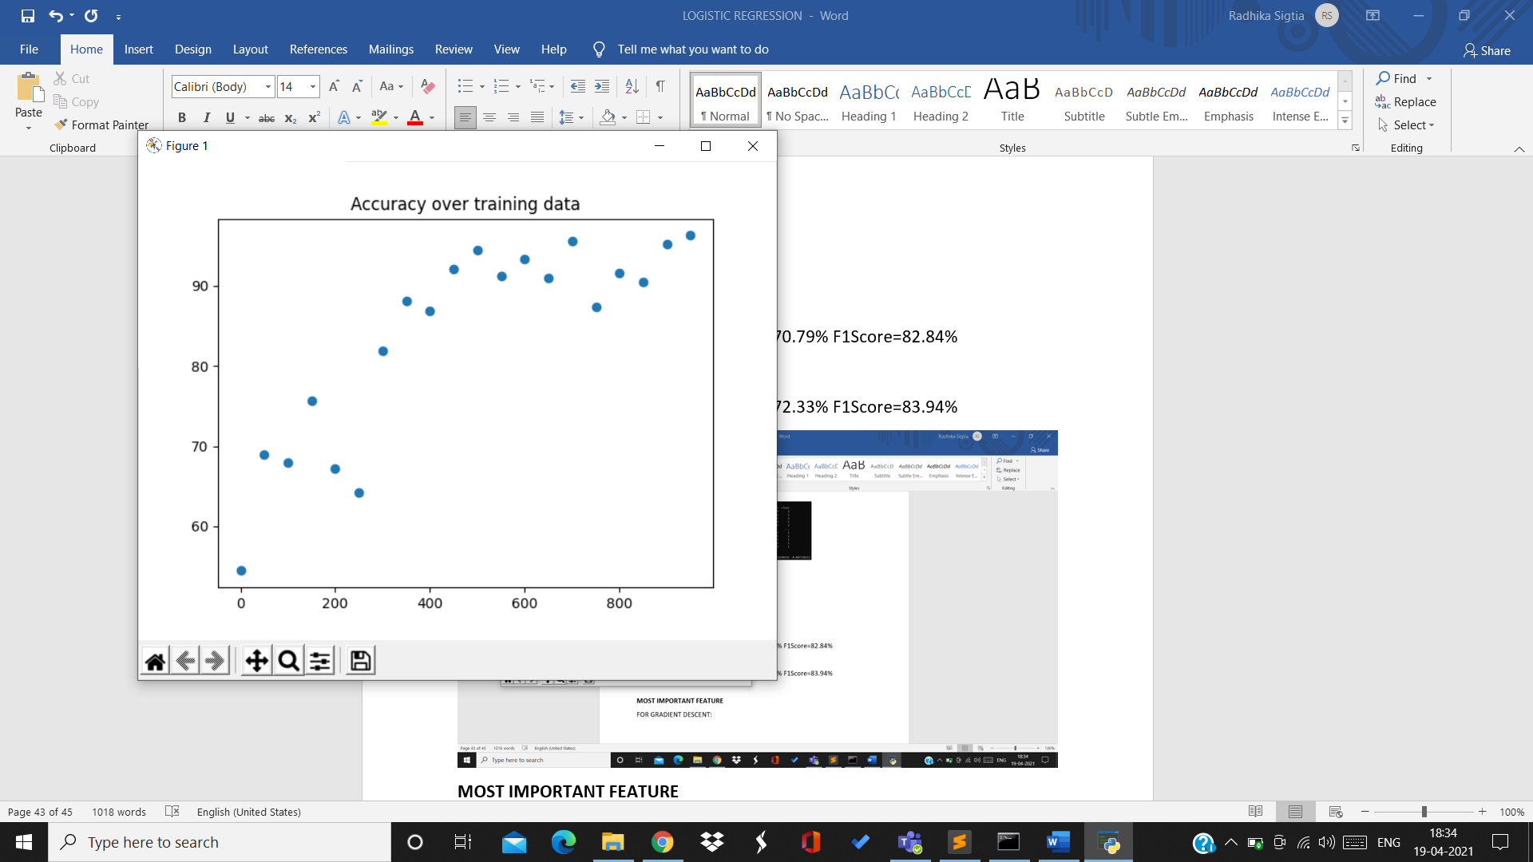

9th split:

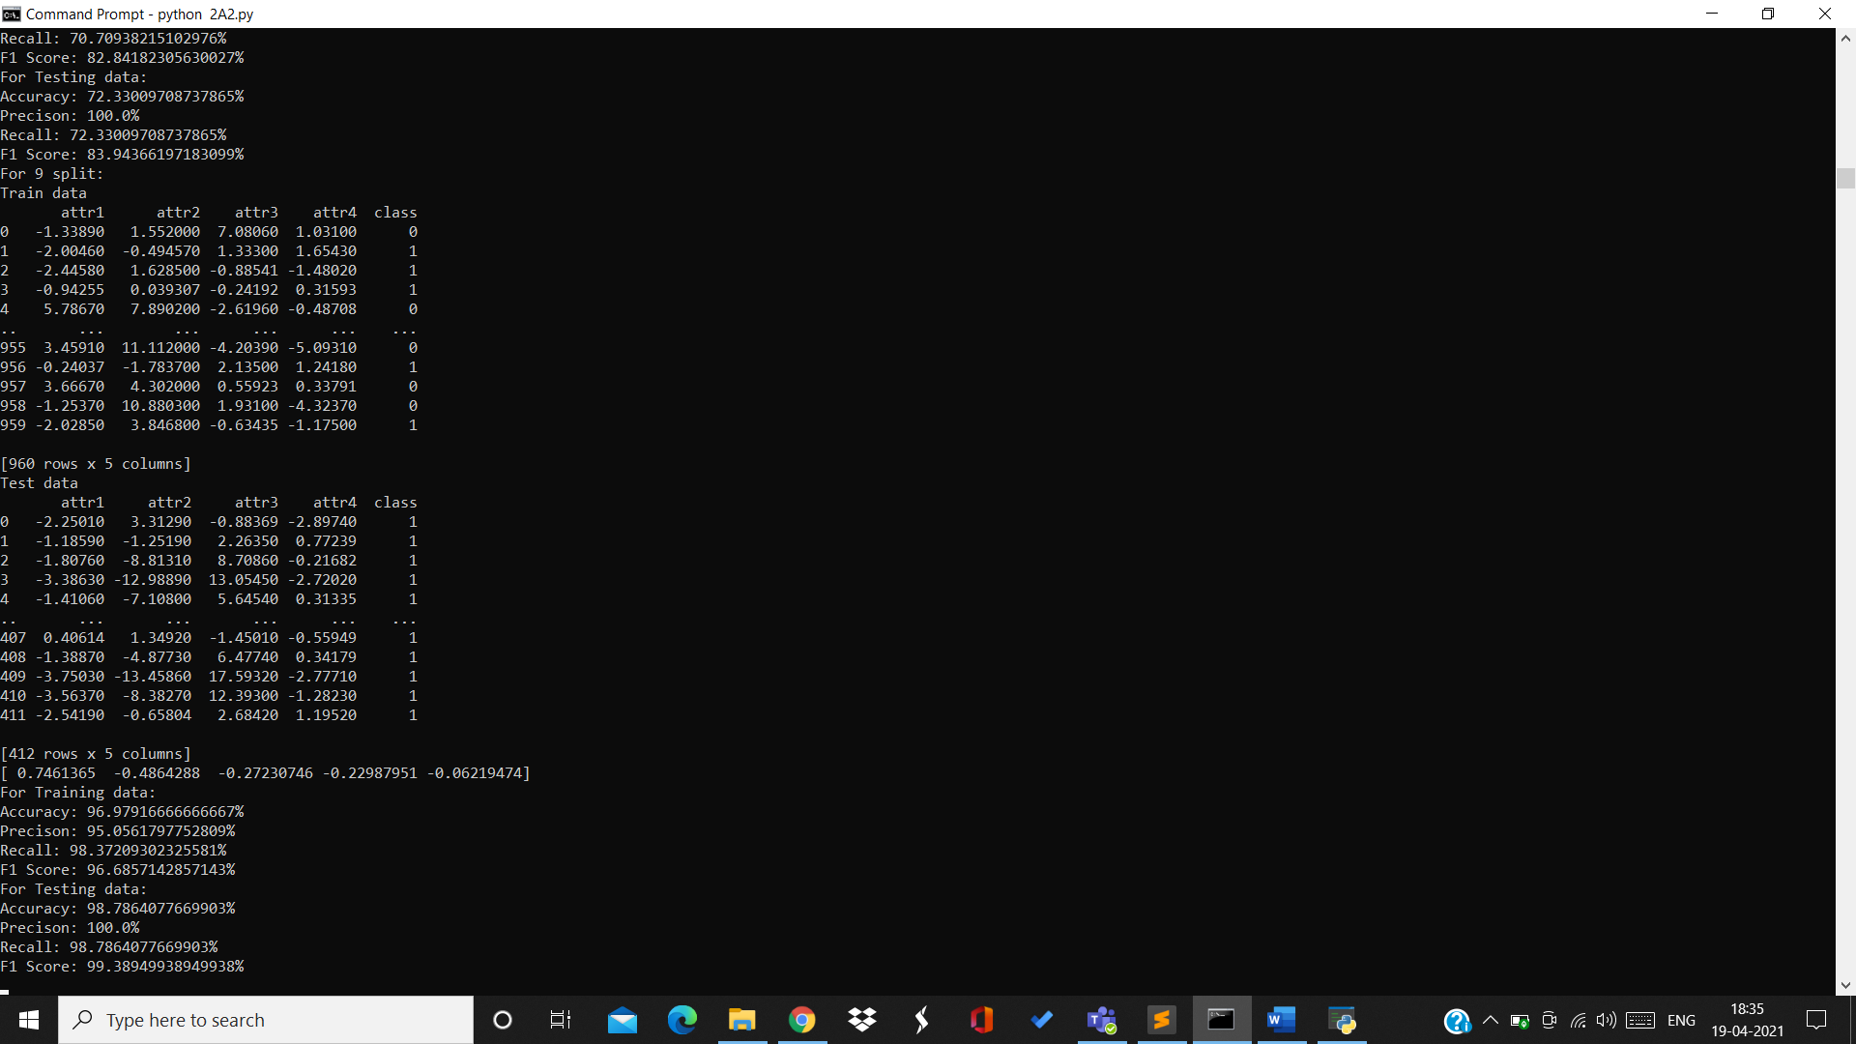

Training data:

Accuracy=96.97% Precision=95.05% Recall=98.37% F1Score=96.68%

Testing data:

Accuracy=98.78% Precision=100% Recall=98.78% F1Score=99.38%

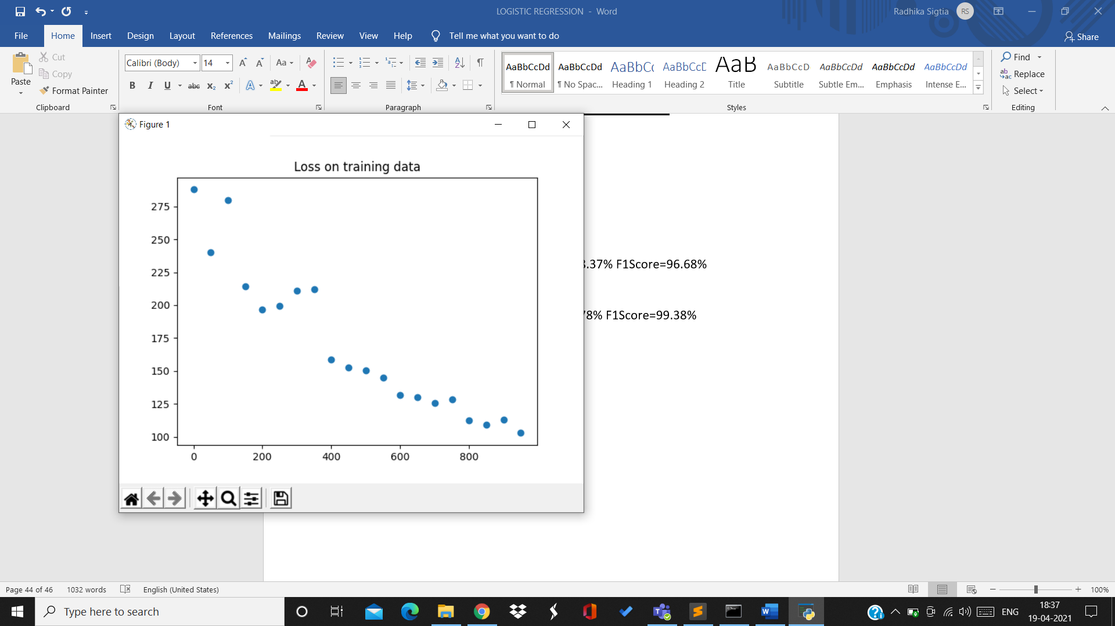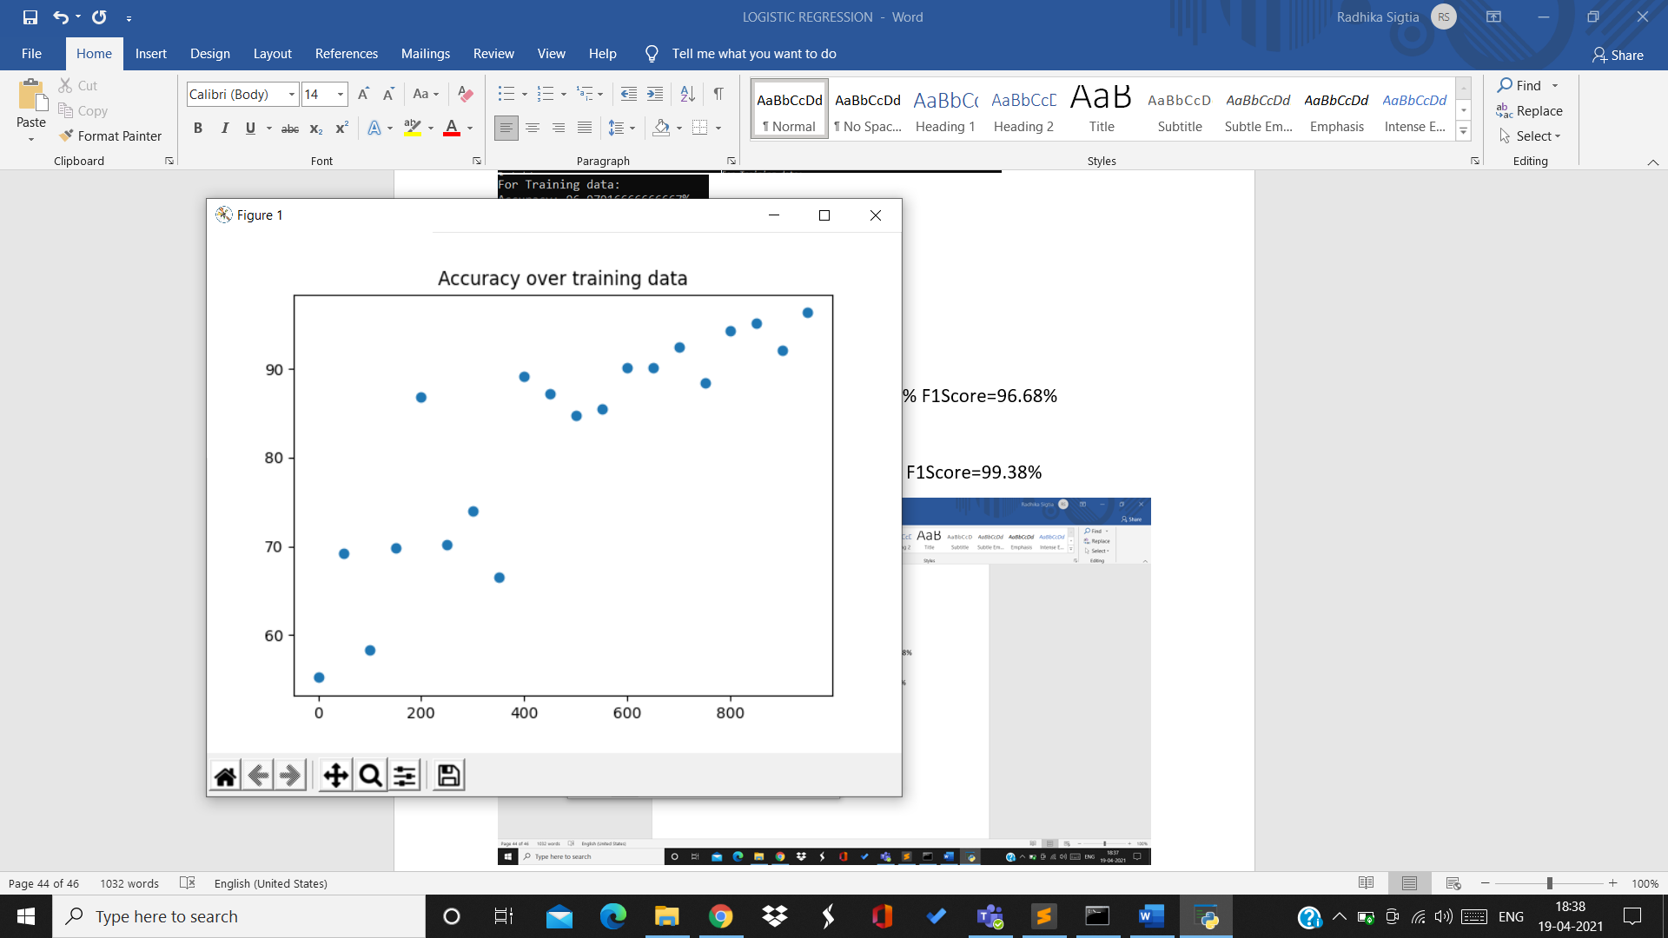

10th split:

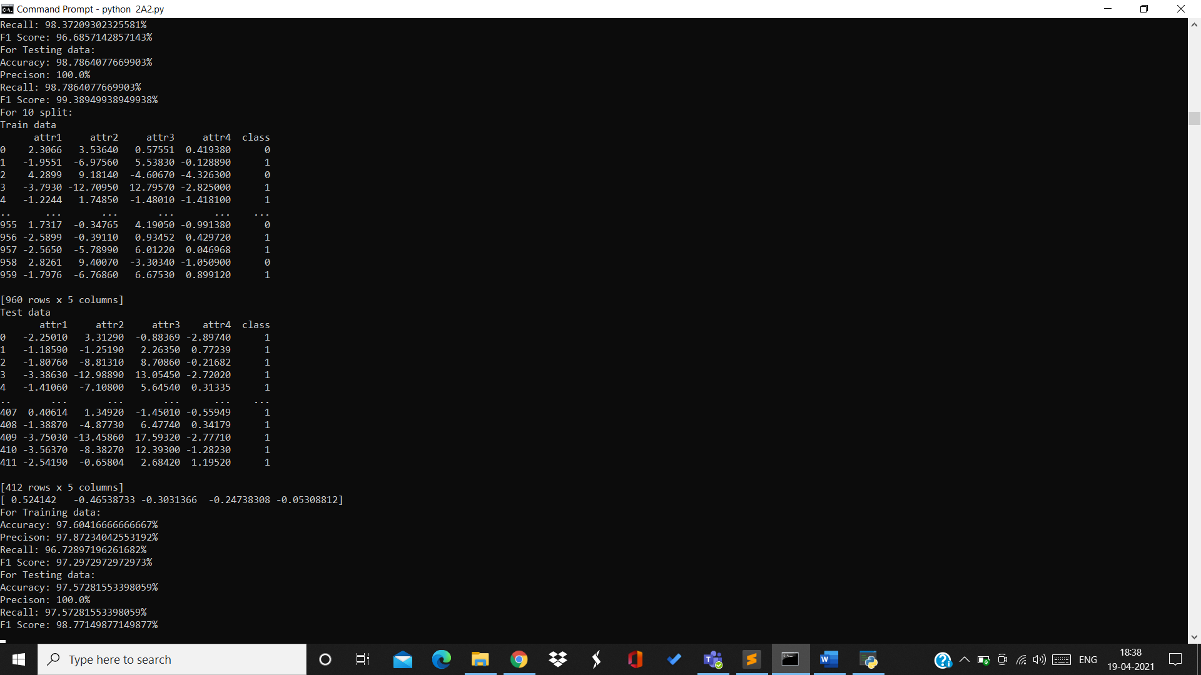

Training data:

Accuracy=97.6% Precision=97.87% Recall=96.72% F1Score=97.29%

Testing data:

Accuracy=97.57% Precision=100% Recall=97.57% F1Score=98.77%

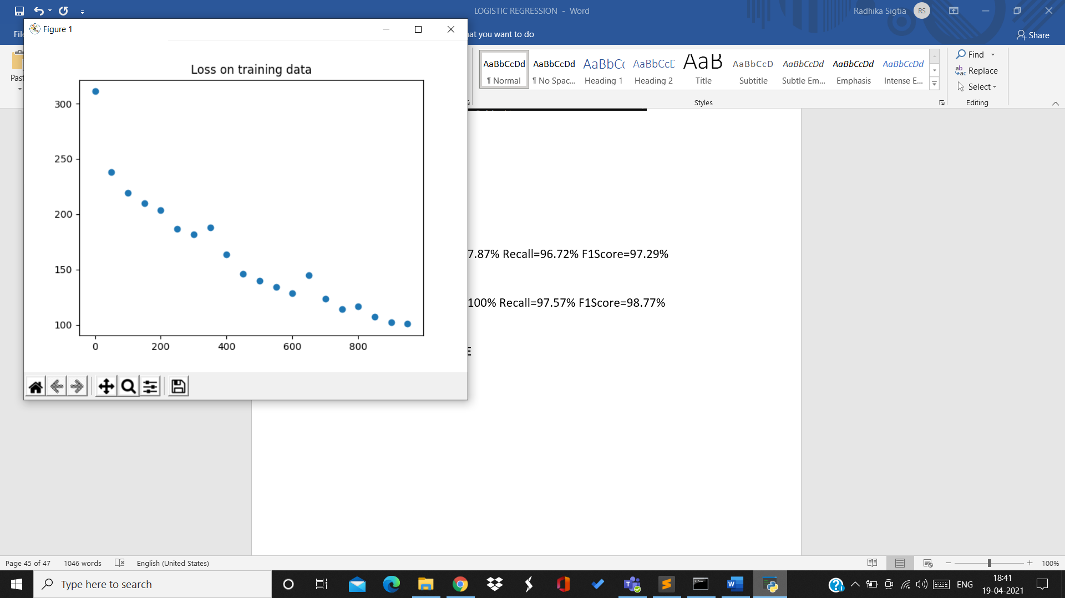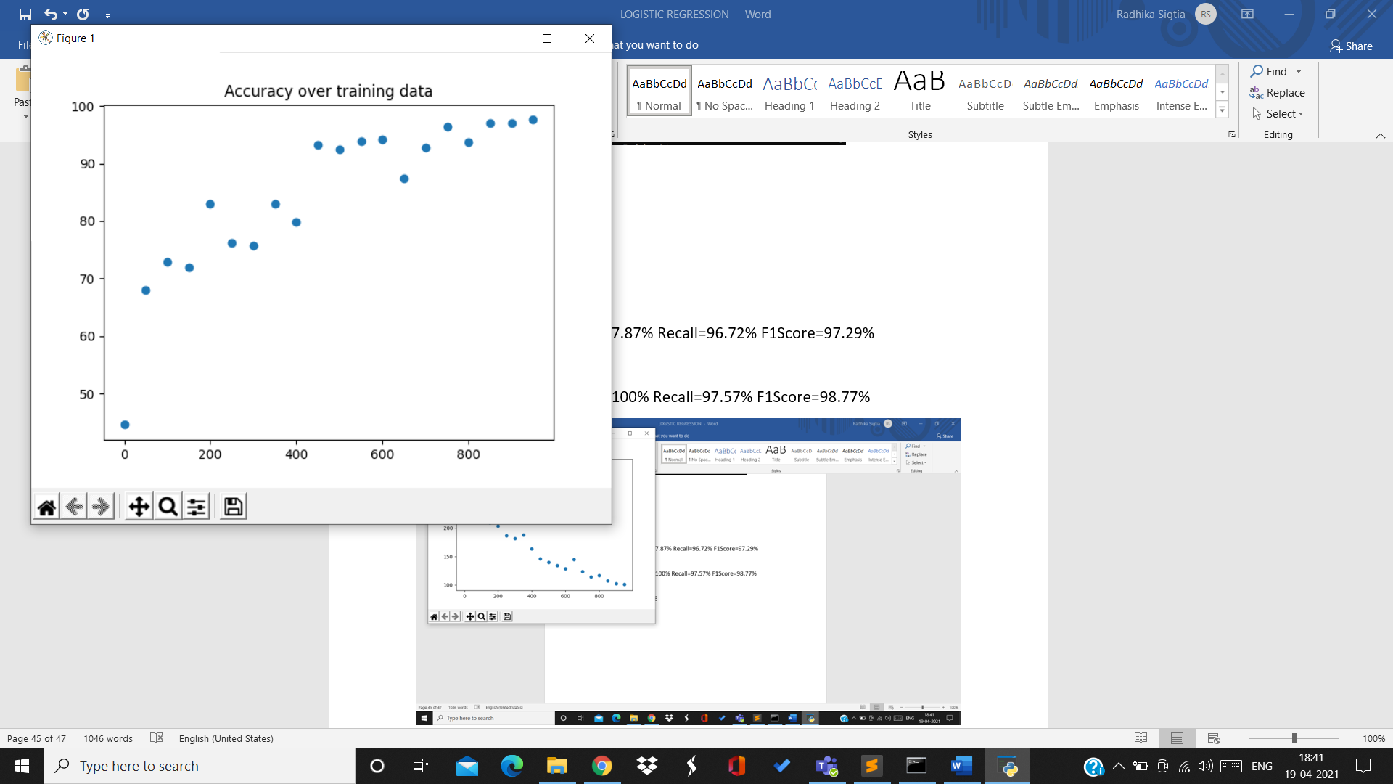

For rate 0.001:

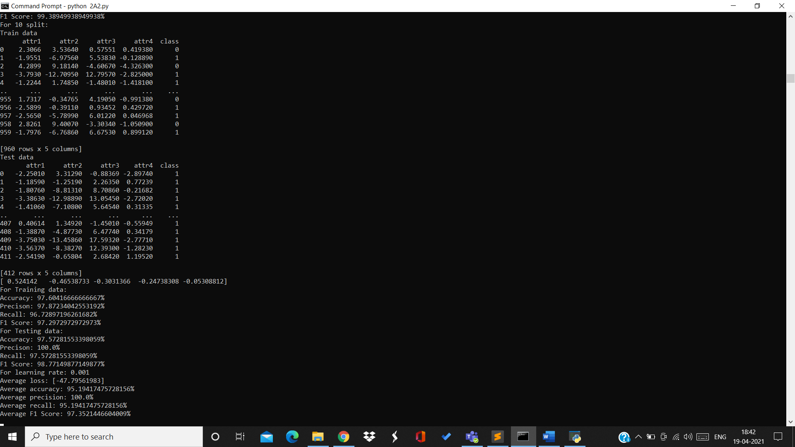

Average loss=-47.79 Average accuracy=95.19% Average precision=100%

Average recall=95.19% Average F1Score=97.35%

Accuracy over 10 splits on testing data for rate 0.001:

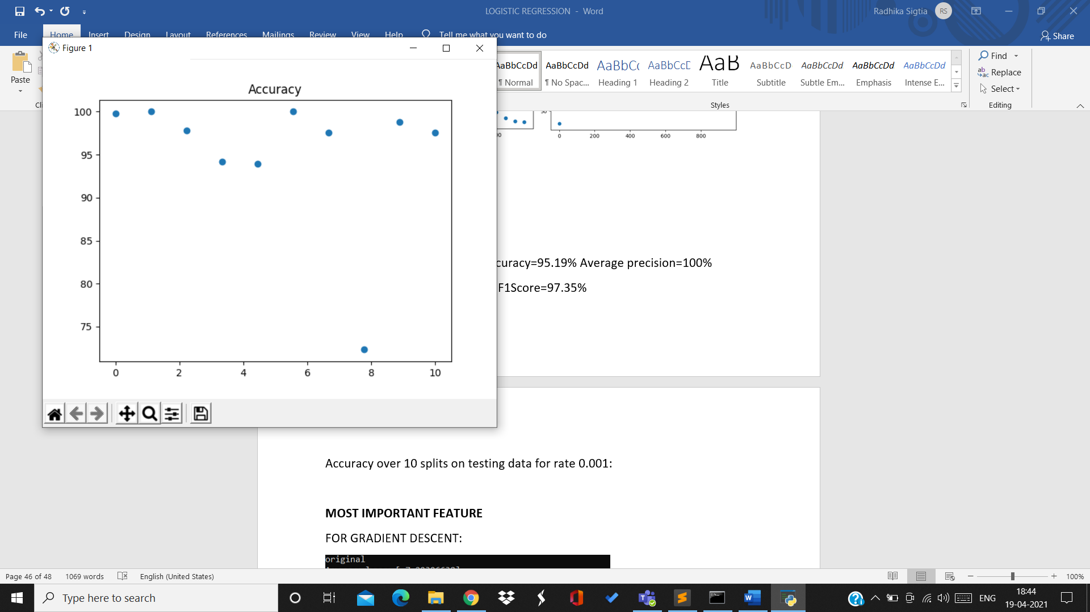

For rate=0.01:

1st split:

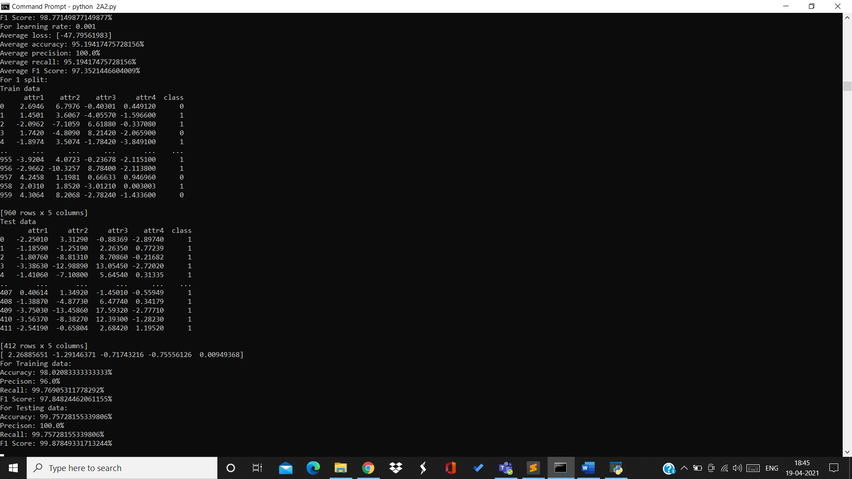

Training data:

Accuracy=98.02% Precision=96% Recall=99.76% F1Score=97.848%

Testing data:

Accuracy=99.75% Precision=100% Recall=99.75% F1Score=99.87%

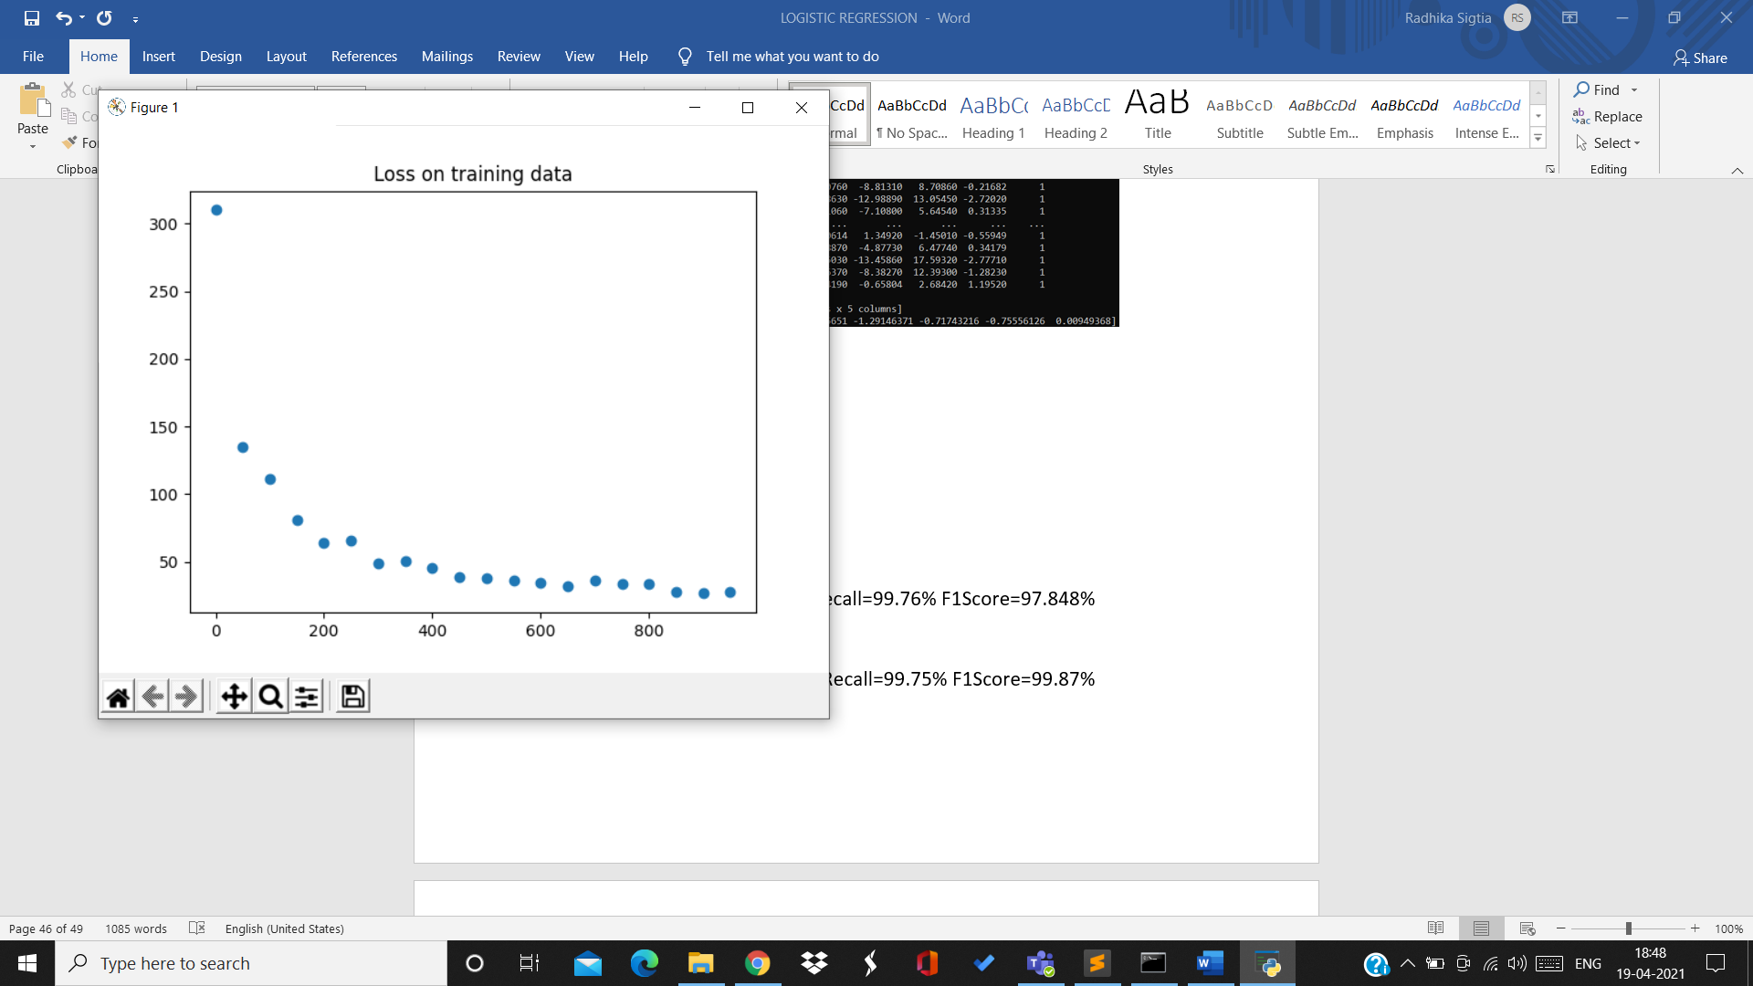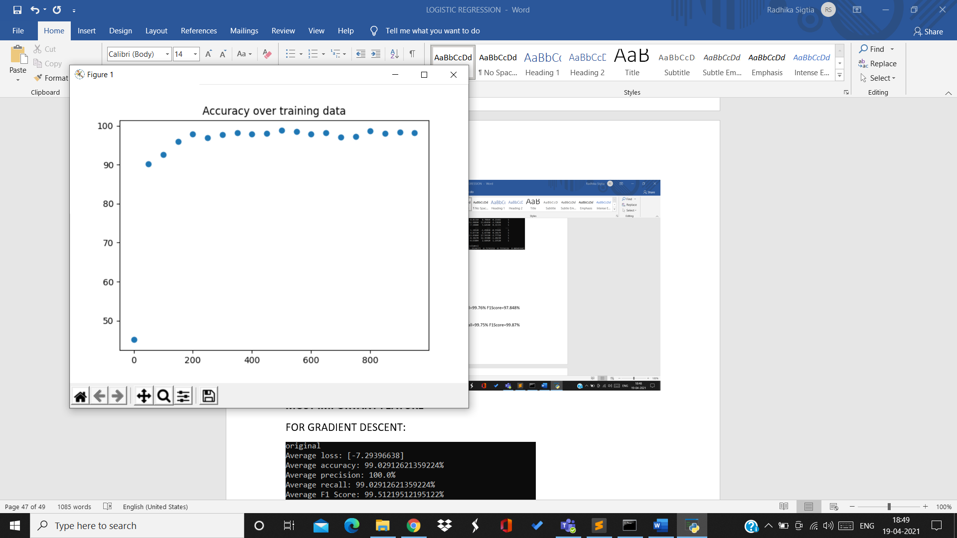

2nd split:

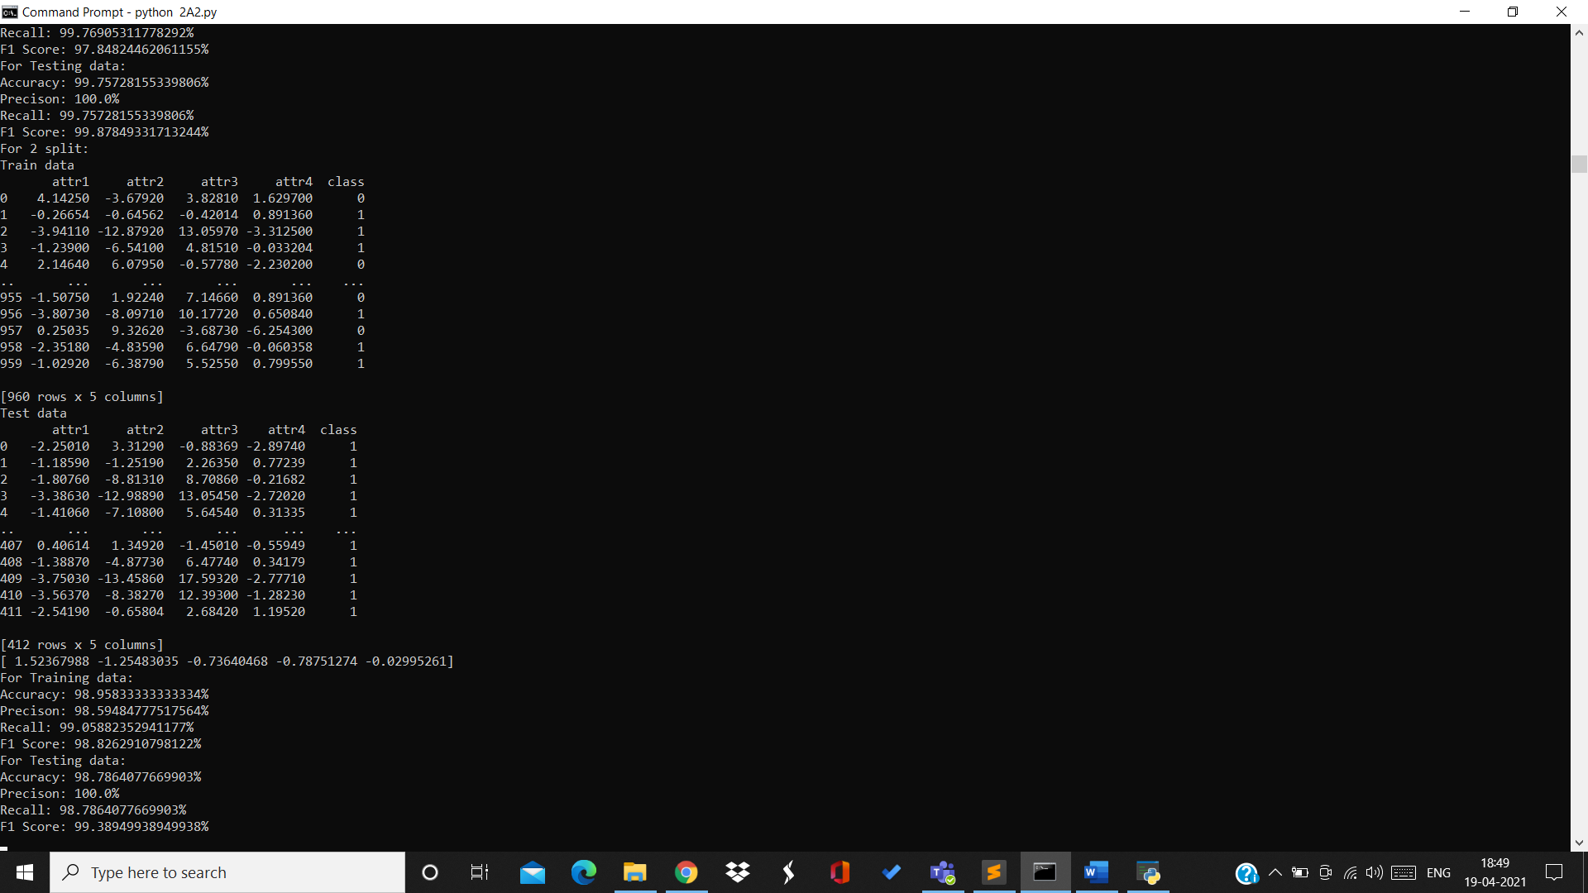

Training data:

Accuracy=98.95% Precision=98.59% Recall=99.05% F1Score=98.82%

Testing data:

Accuracy=98.78% Precision=100% Recall=98.78% F1Score=99.38%

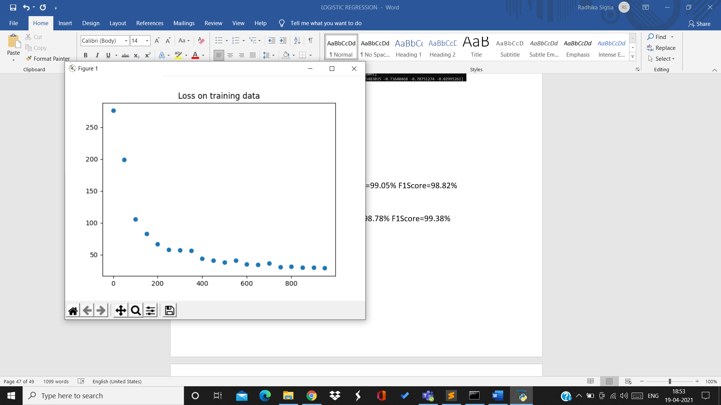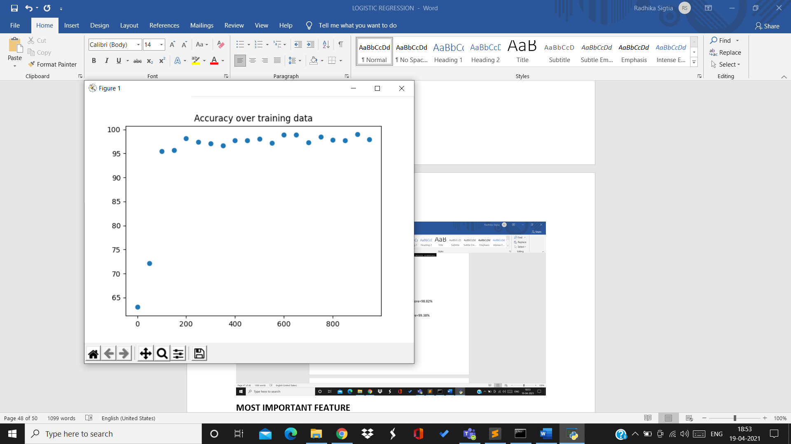

3rd split:

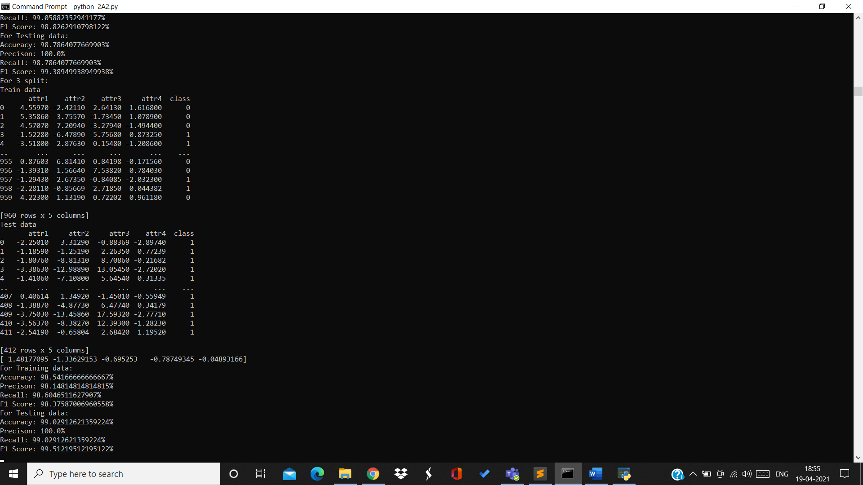

Training data:

Accuracy=98.54% Precision=98.14% Recall=98.6% F1Score=98.37%

Testing data:

Accuracy=99.02% Precision=100% Recall=00.02% F1Score=99.51%

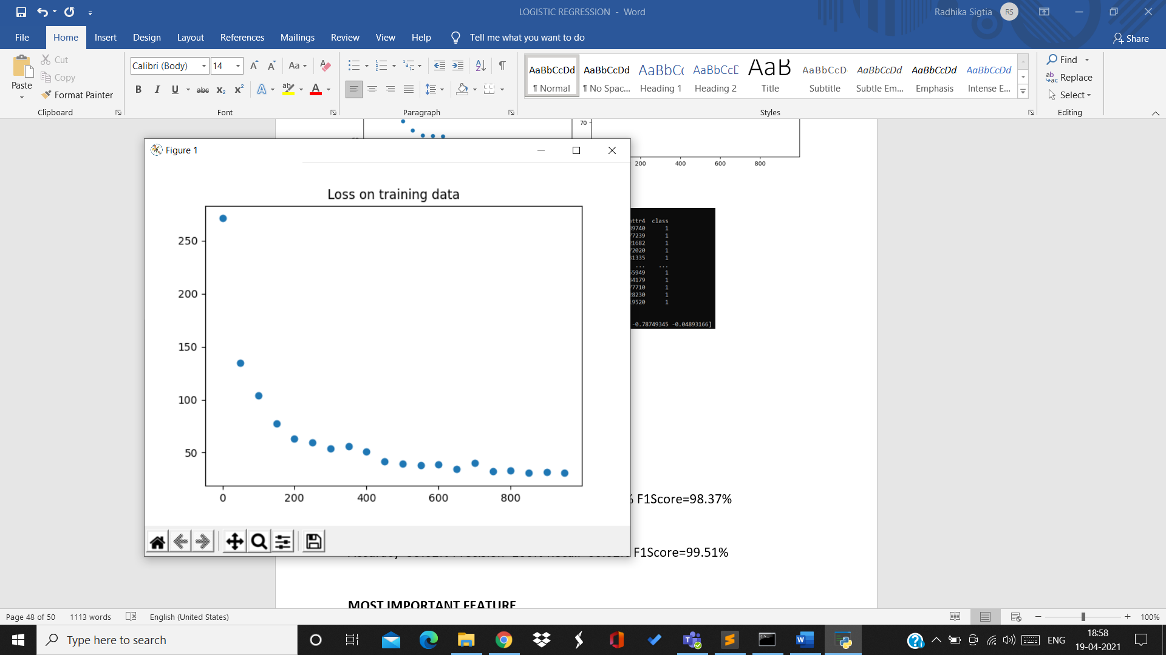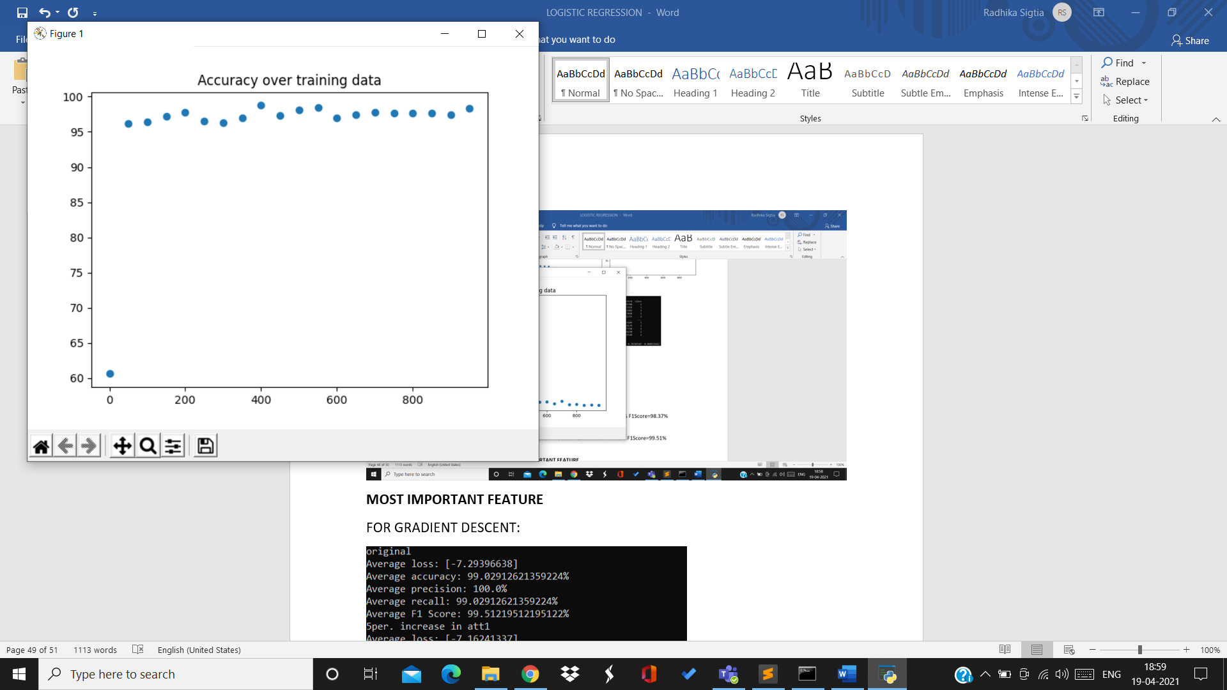

4th split:

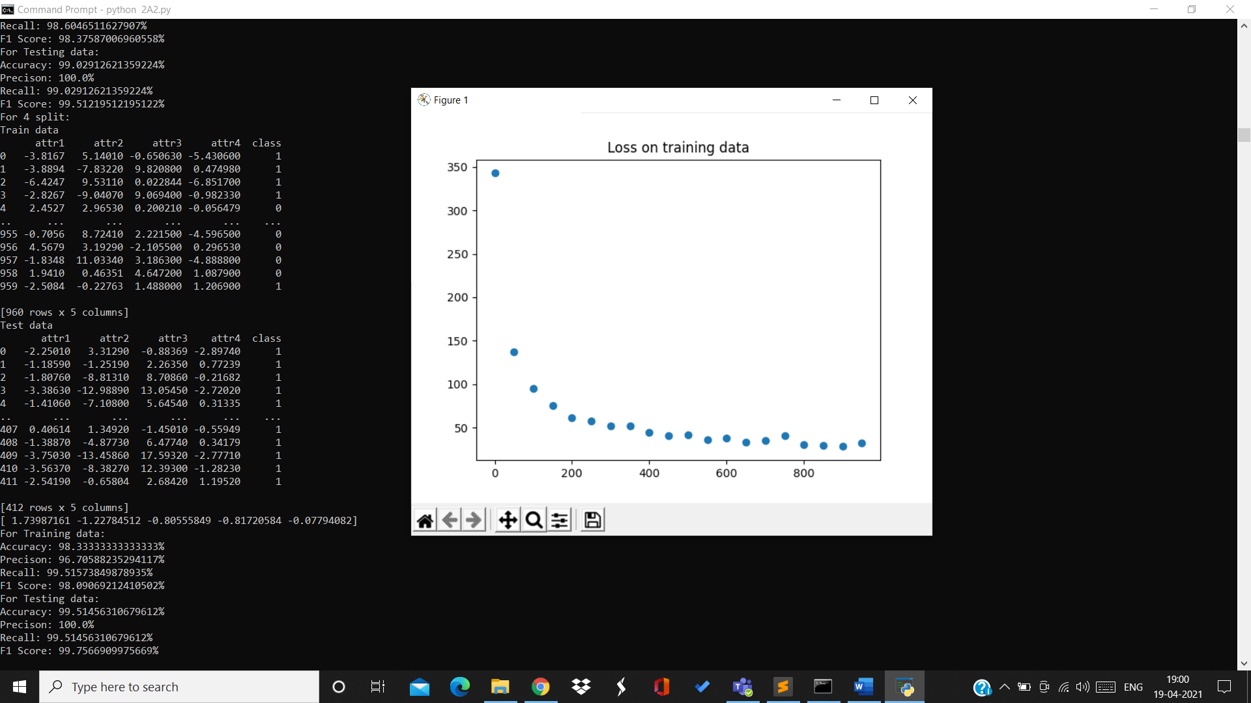

Training data:

Accuracy=98.33% Precision=96.7% Recall=99.51% F1Score=98.09%

Training data:

Accuracy=99.51% Precision=100% Recall=99.51% F1Score=99.75%

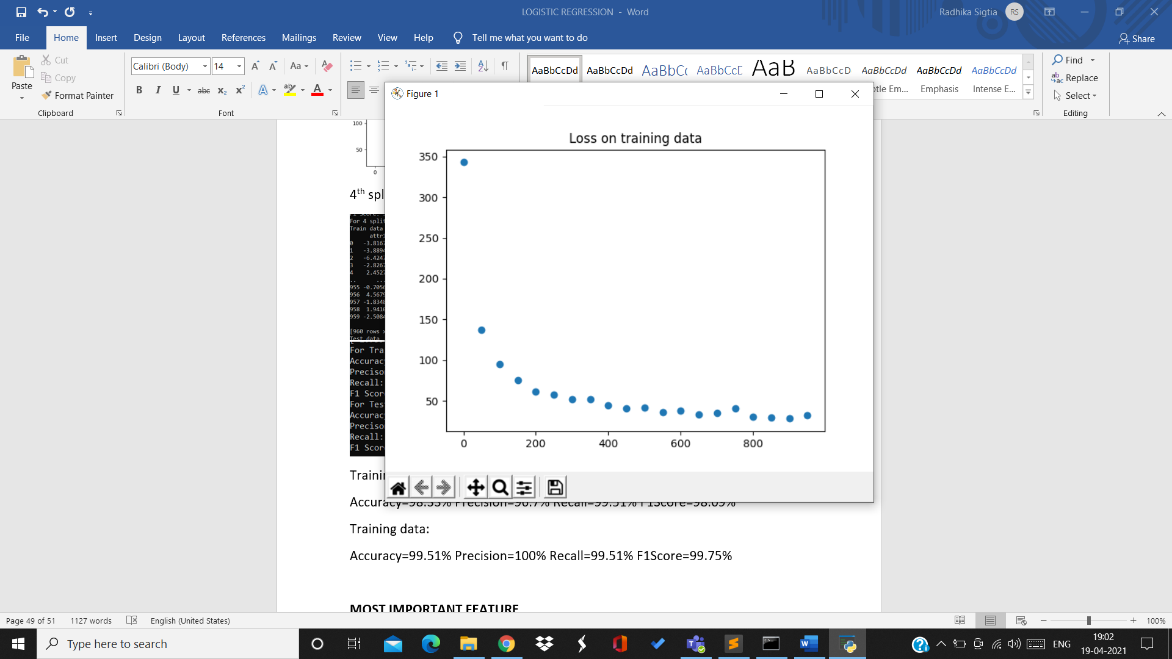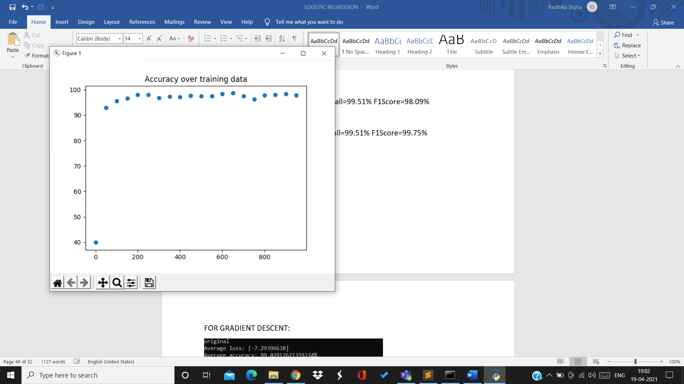

5th split:

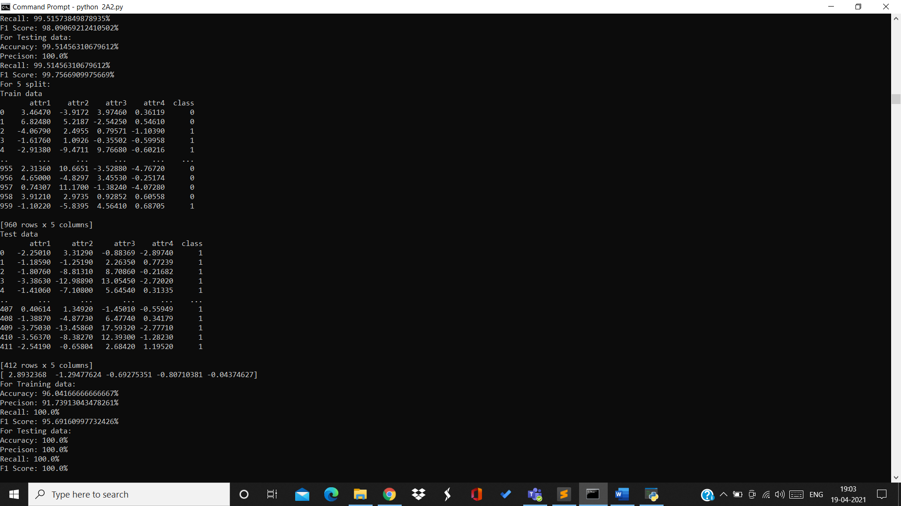

Training data:

Accuracy=96.04% Precision=91.73% Recall=100% F1Score=95.69%

Testing data:

Accuracy=100% Precision=100% Recall=100% F1Score=100%

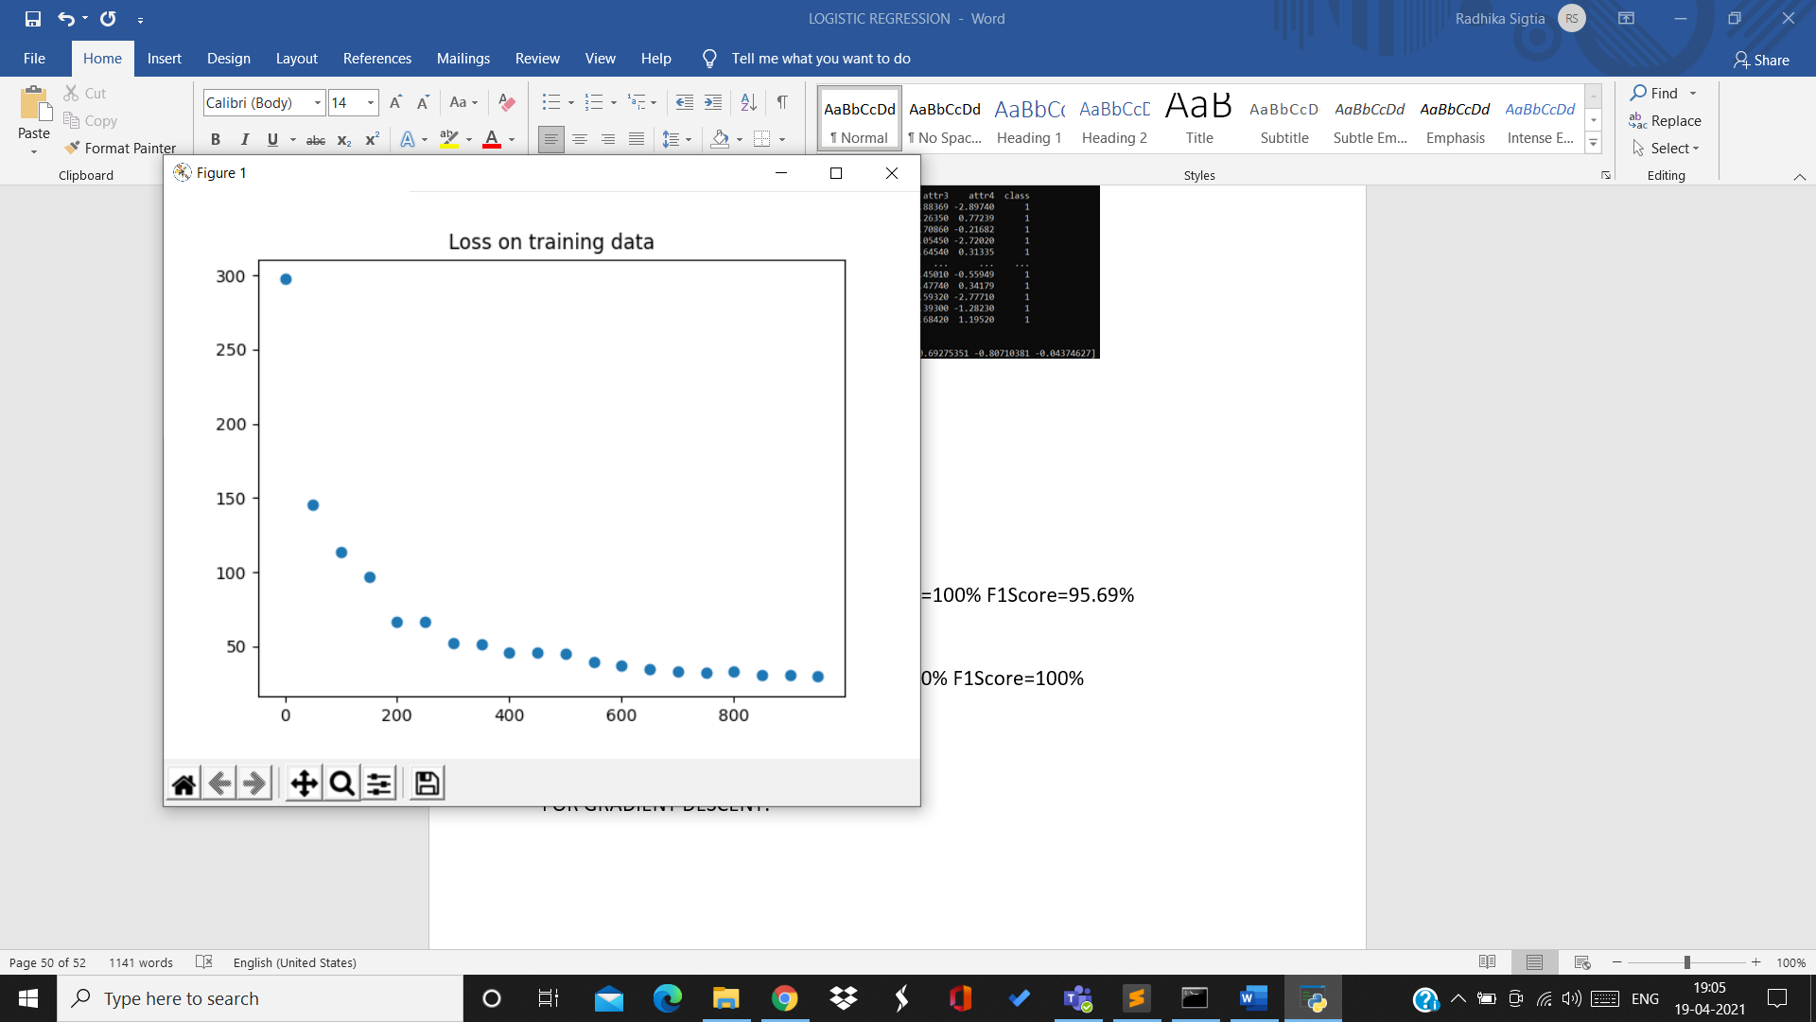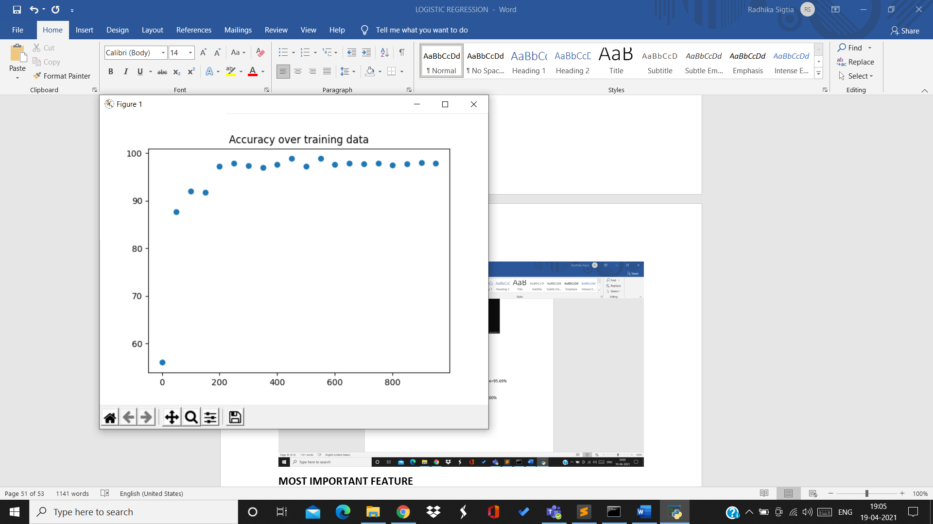

6th split:

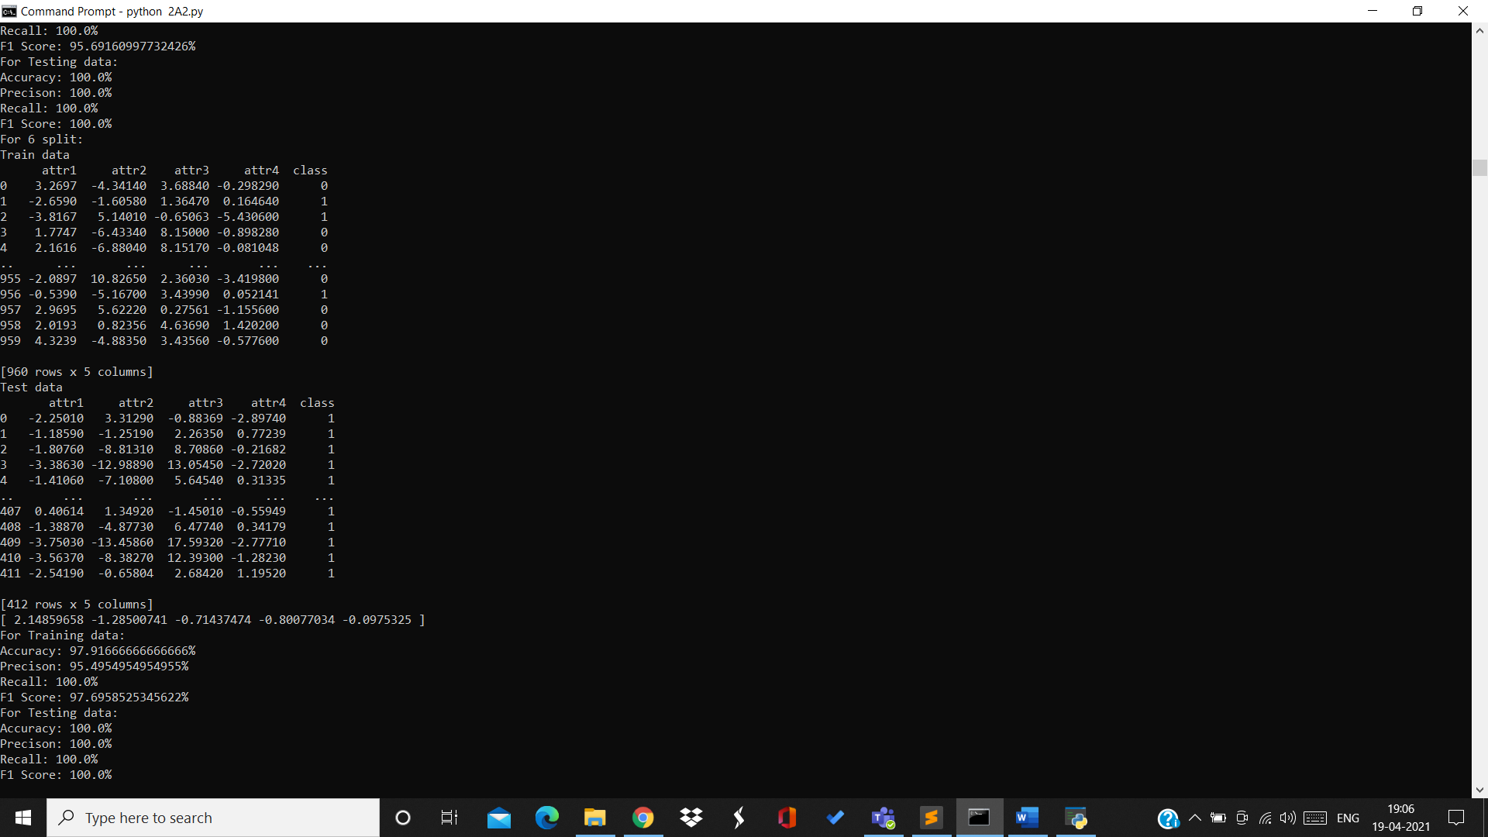

Training data:

Accuracy=97.91% Precision=95.49% Recall=100% F1Score=97.69%

Testing data:

Accuracy=100% Precision=100% Recall=100% F1Score=100%

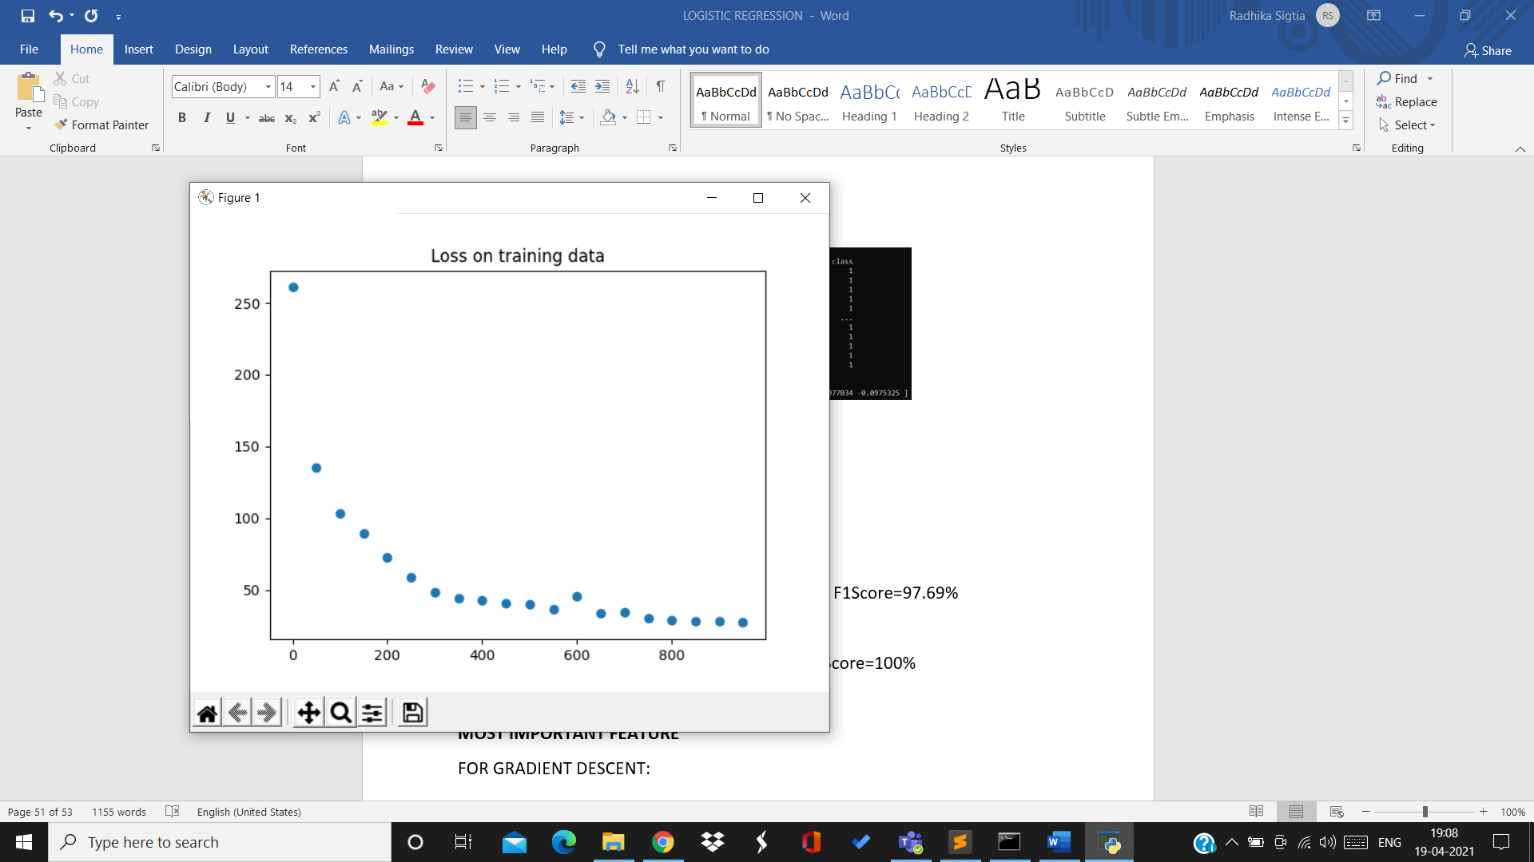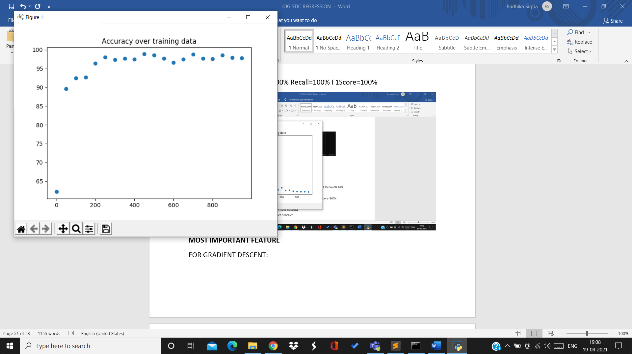

7th split:

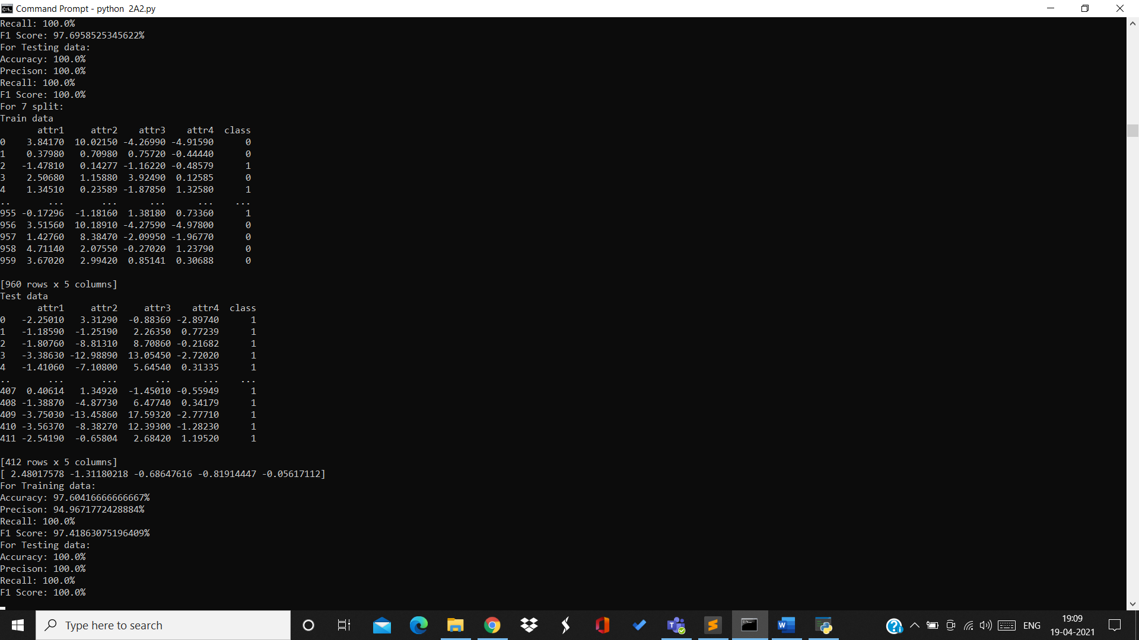

Training data:

Accuracy=97.6% Precision=94.69% Recall=100% F1Score=97.41%

Testing data:

Accuracy=100% Precision=100% Recall=100% F1Score=100%

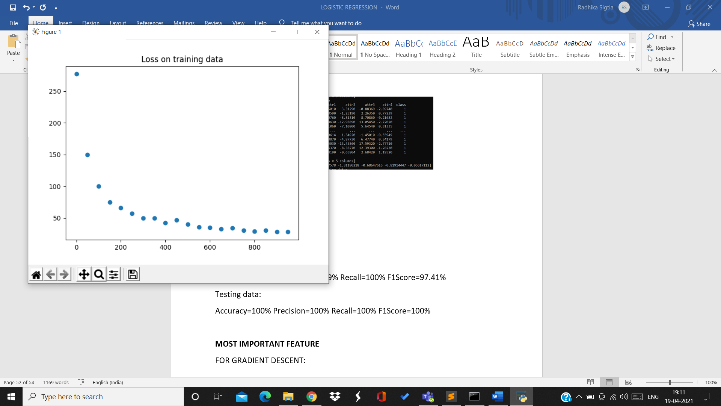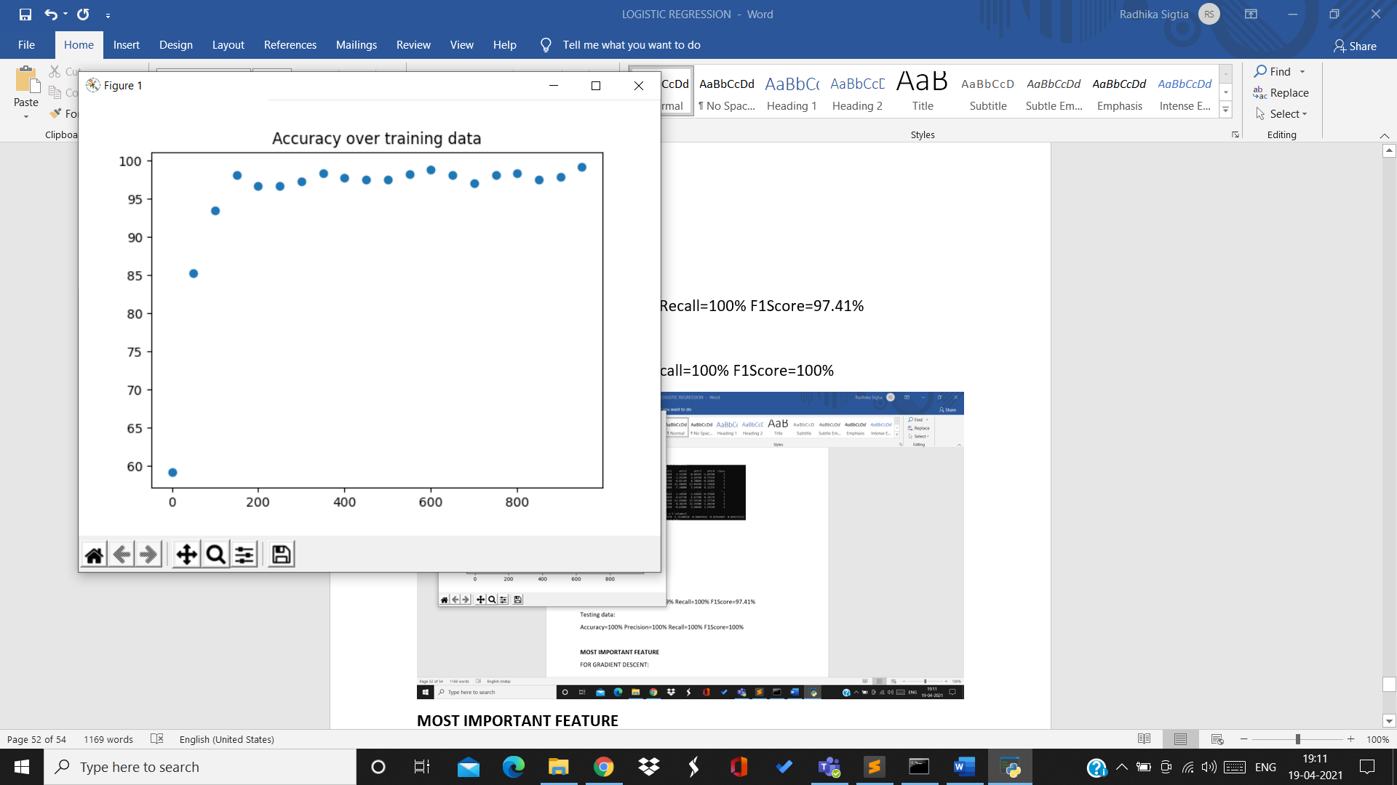

8th split:

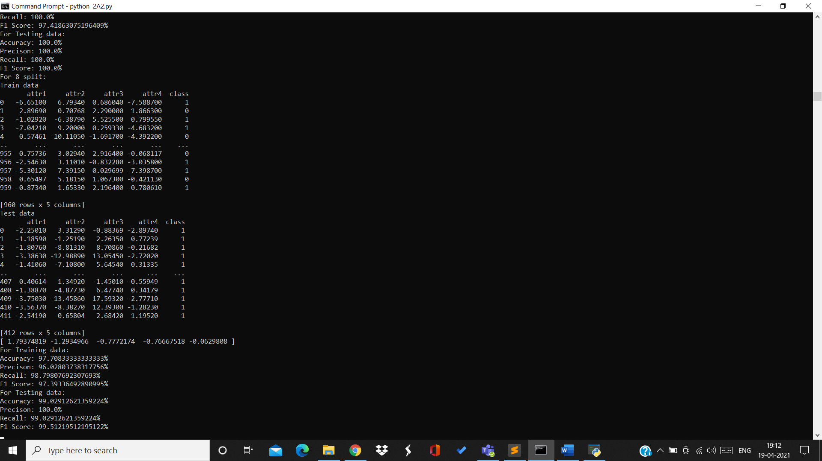

Training data:

Accuracy=97.7% Precision=96.02% Recall=98.79% F1Score=97.39%

Testing data:

Accuracy=99.02% Precision=100% Recall=99.02% F1Score=99.51%

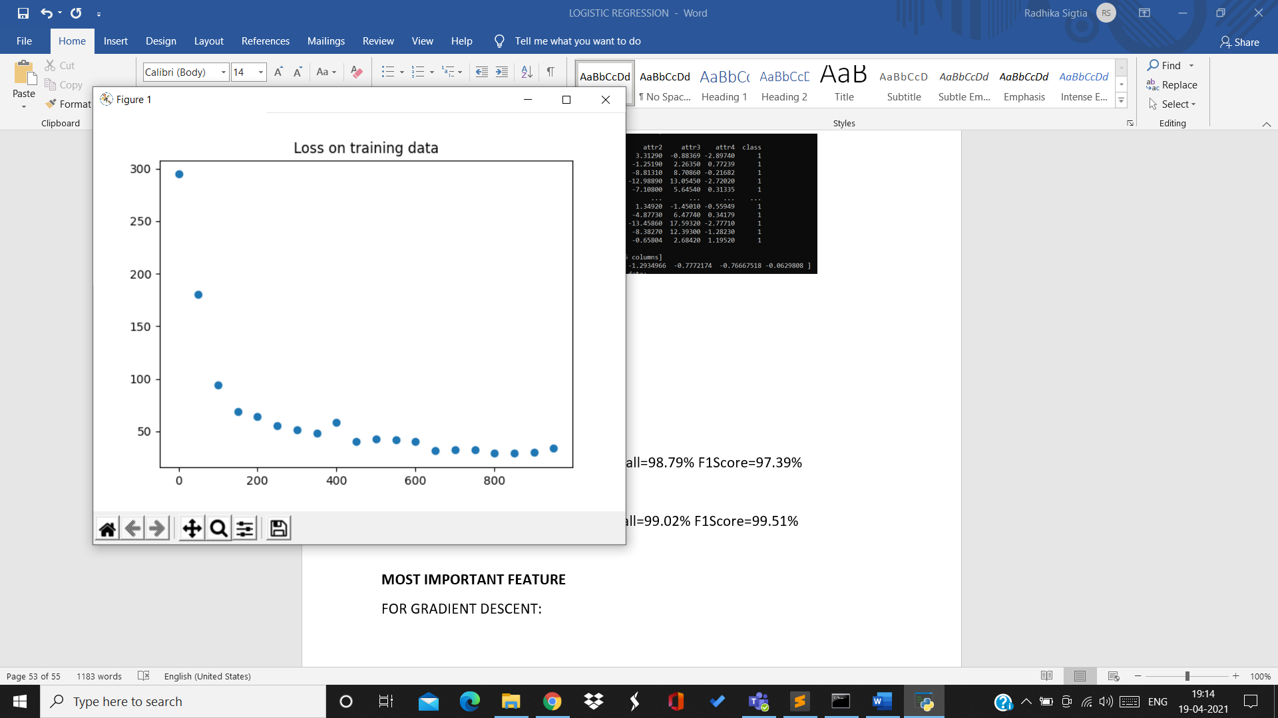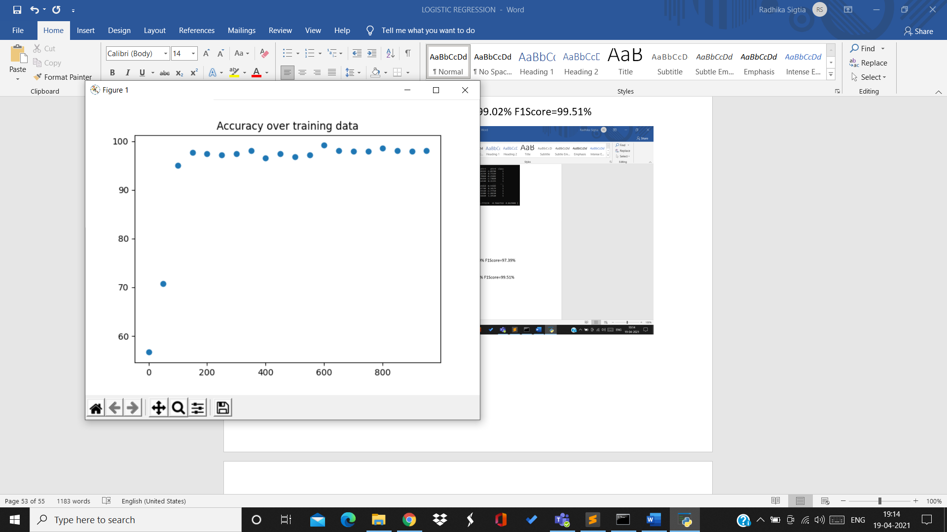

9th split:

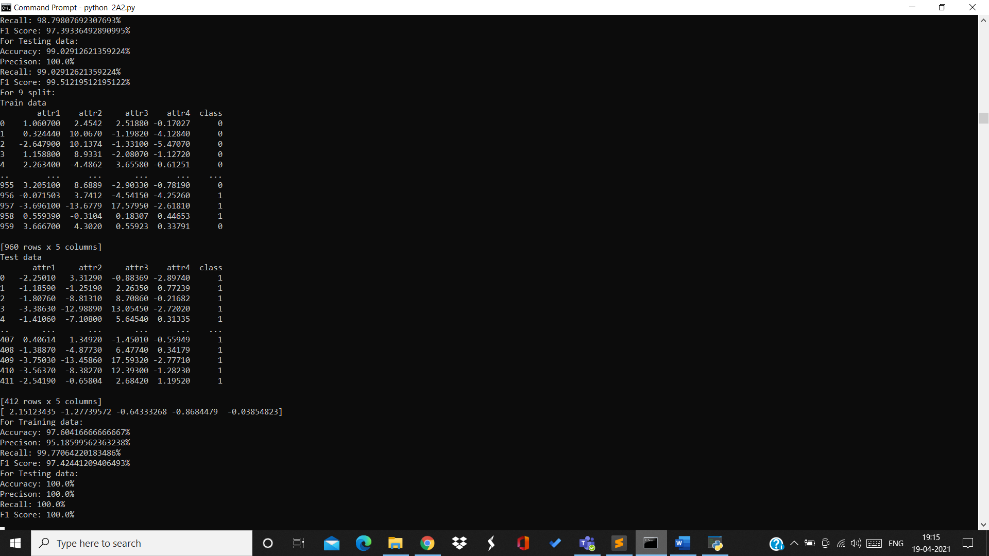

Training data:

Accuracy=97.6% Precision=95.18% Recall=99.77% F1Score=97.42%

Testing data:

Accuracy=100% Precision=1005 Recall=100% F1Score=100%

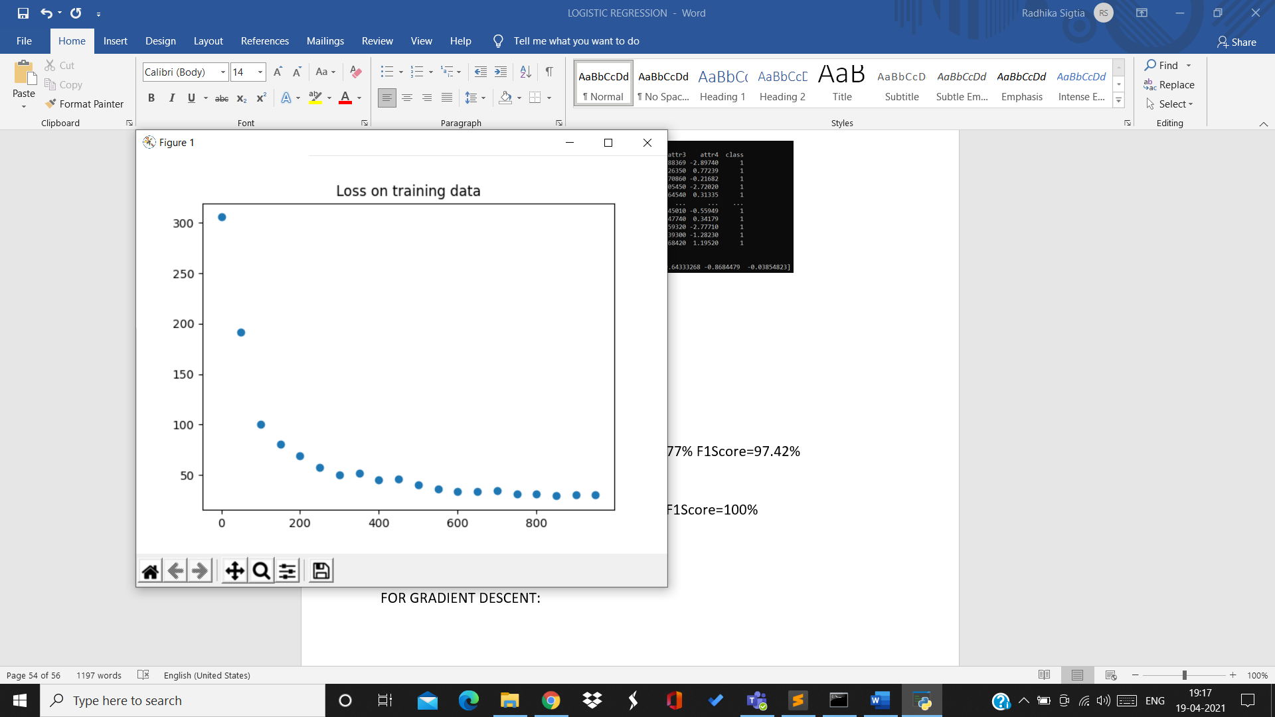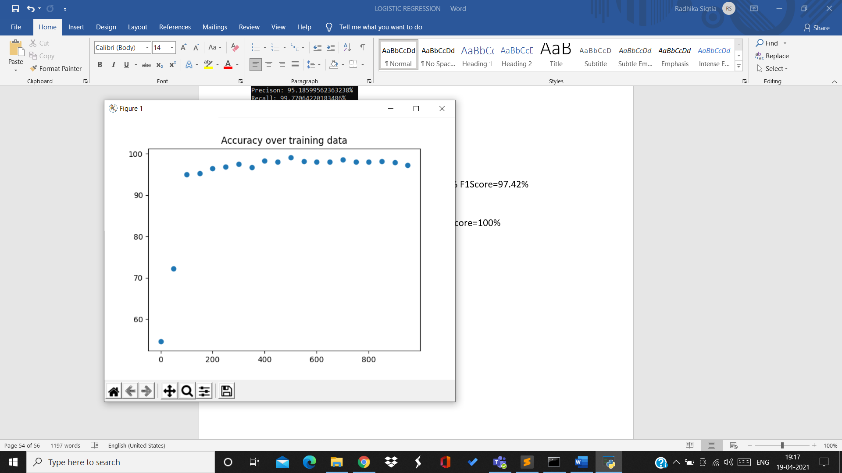

10th split:

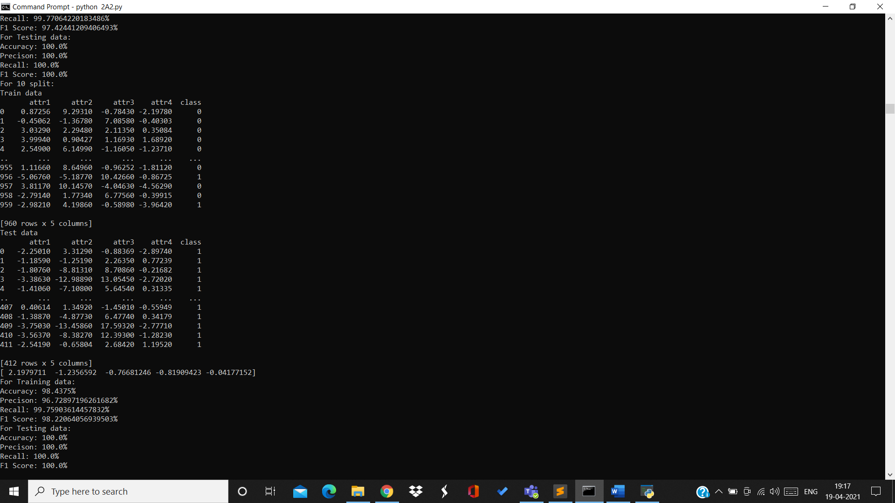

Training data:

Accuracy=98.43% Precision=96.72% Recall=99.75% F1Score=98.22%

Testing data:

Accuracy=100% Precision=100% Recall=100% F1Score=100%

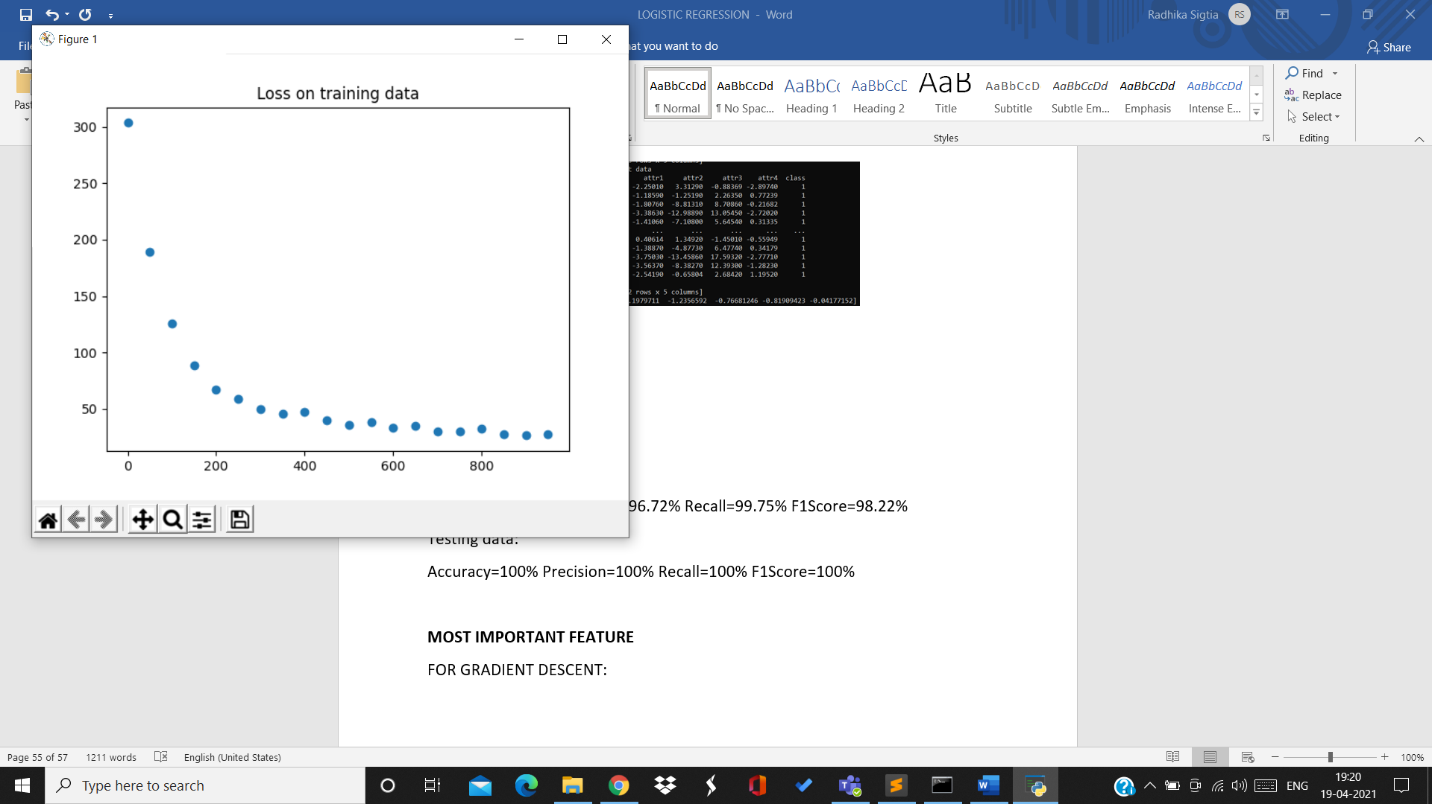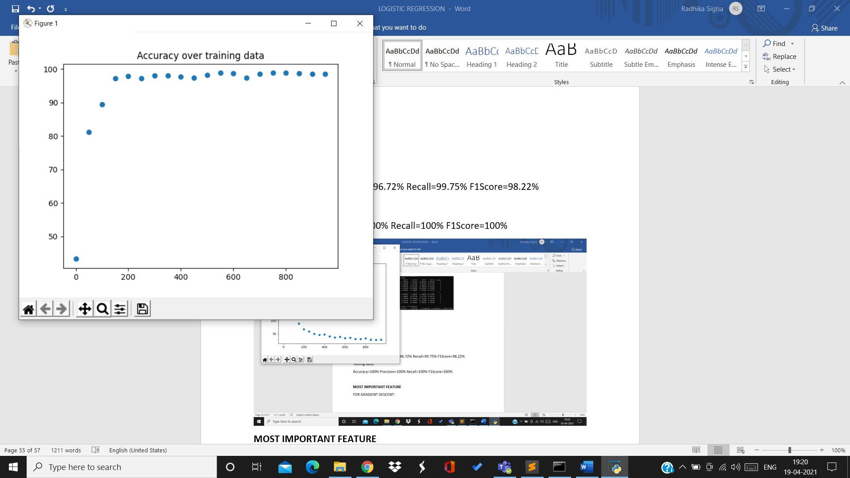

For rate 0.01:

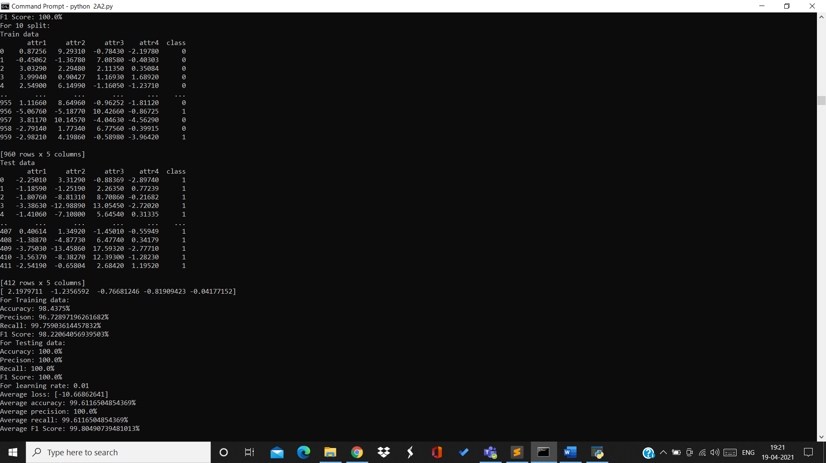

Average loss=-10.66 Average accuracy=99.61% Average precision=100%

Average recall-99.61% Average F1Score=99.8%

Accuracies over 10 splits for testing data for rate 0.01:

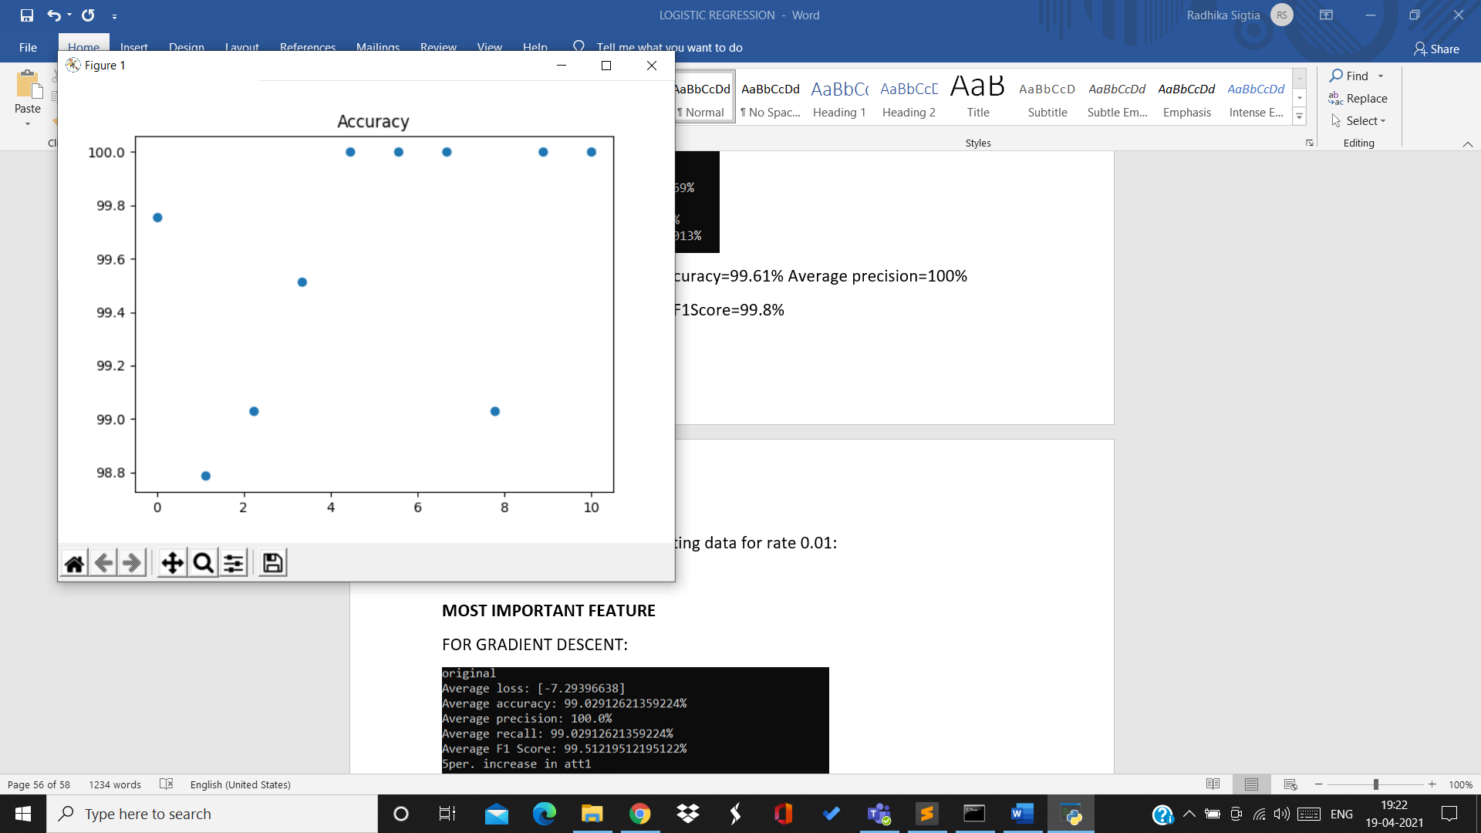

For rate=0.1:

1st split:

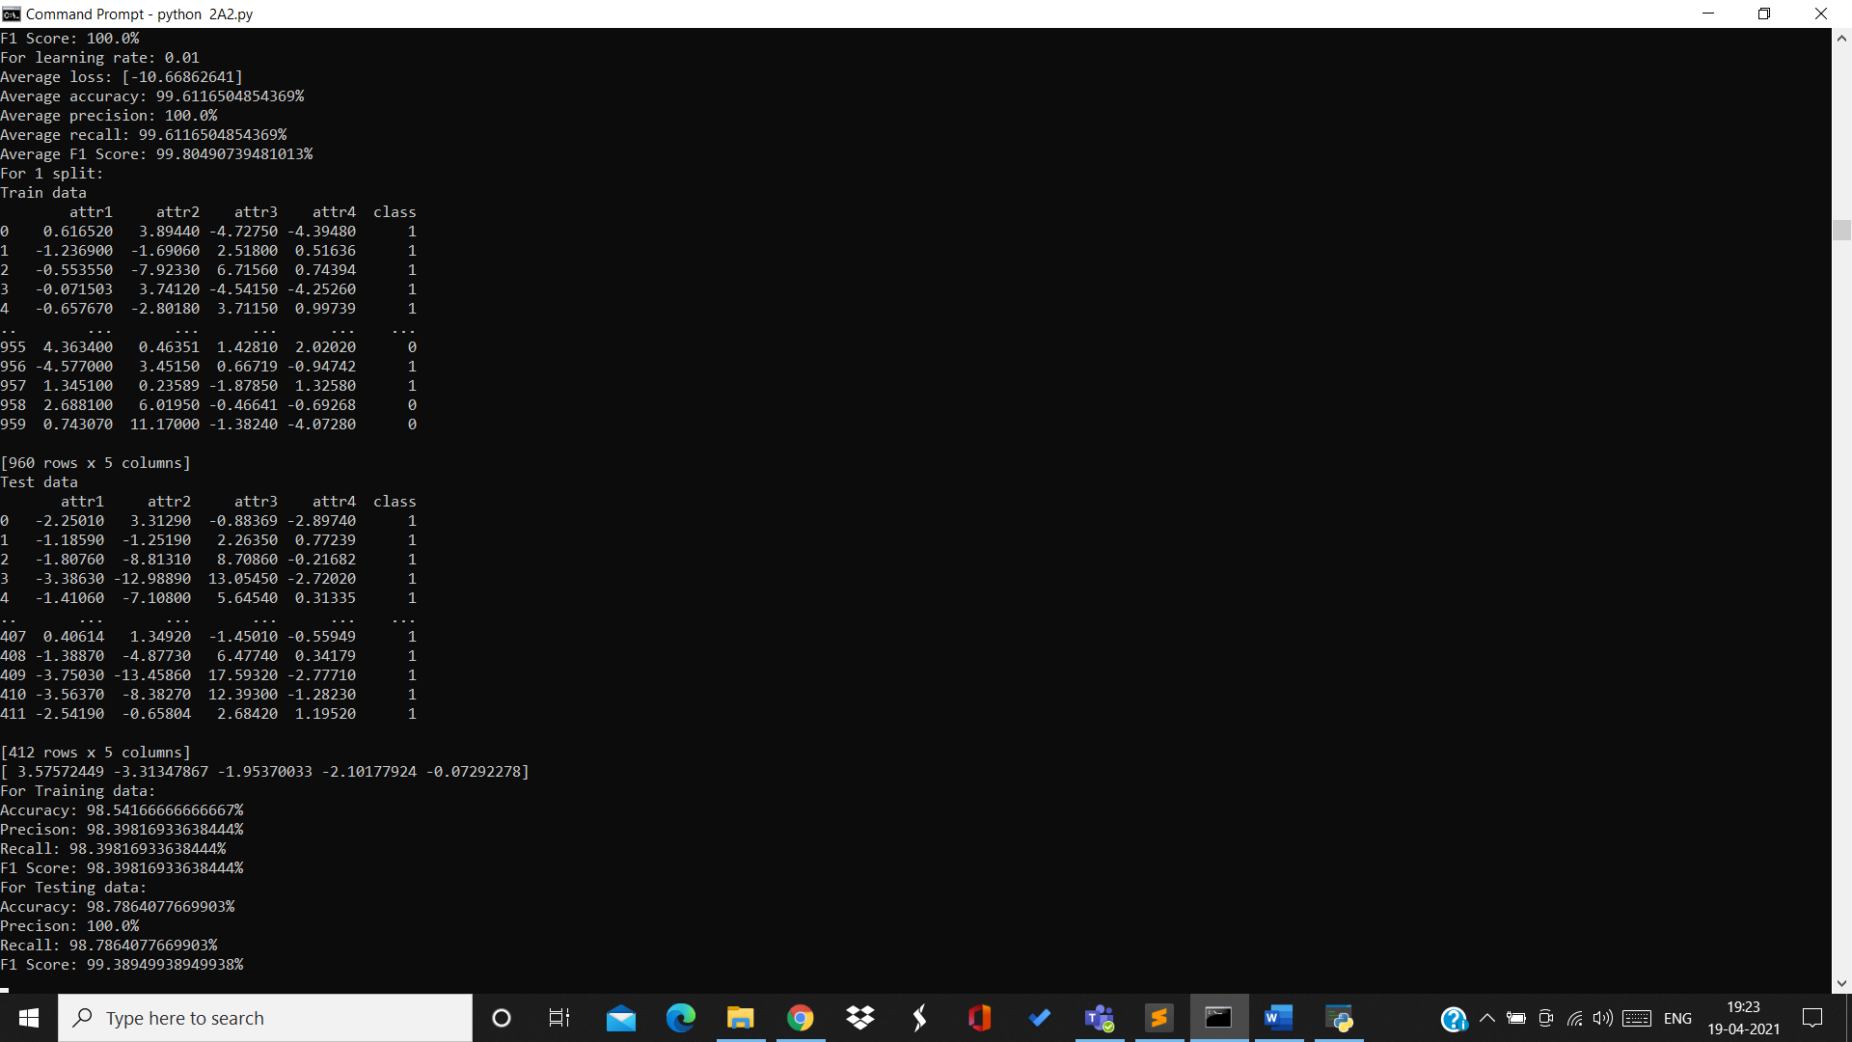

Training data:

Accuracy=98.54% Precision=98.39% Recall=98.39% F1Score=98.39%

Testing data:

Accuracy=98.78% Precision=100% Recall=98.78% F1Score=99.38%

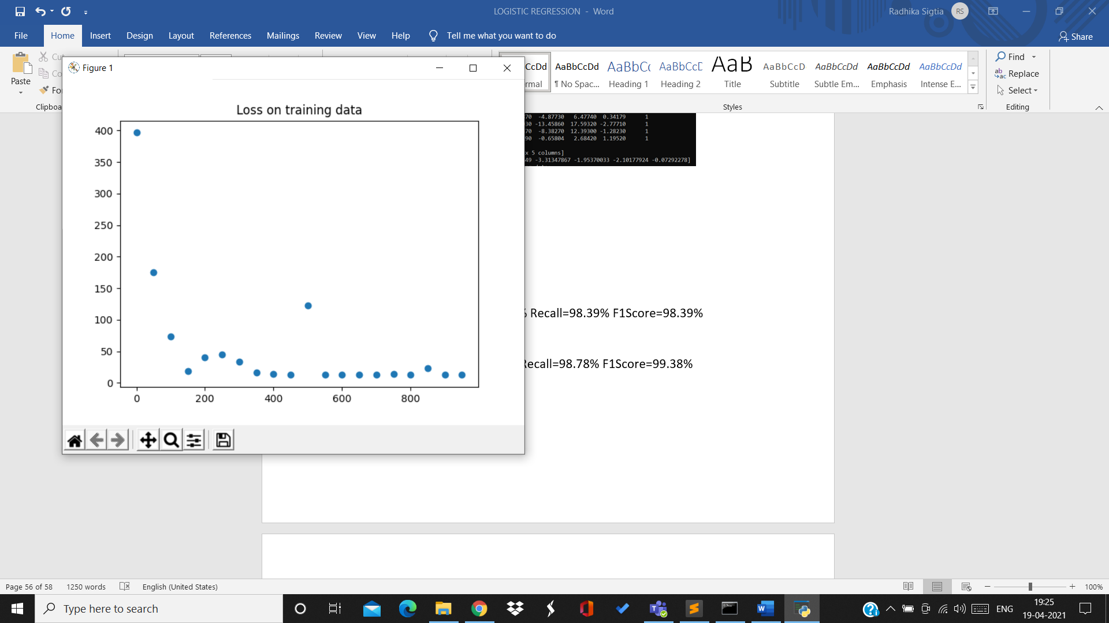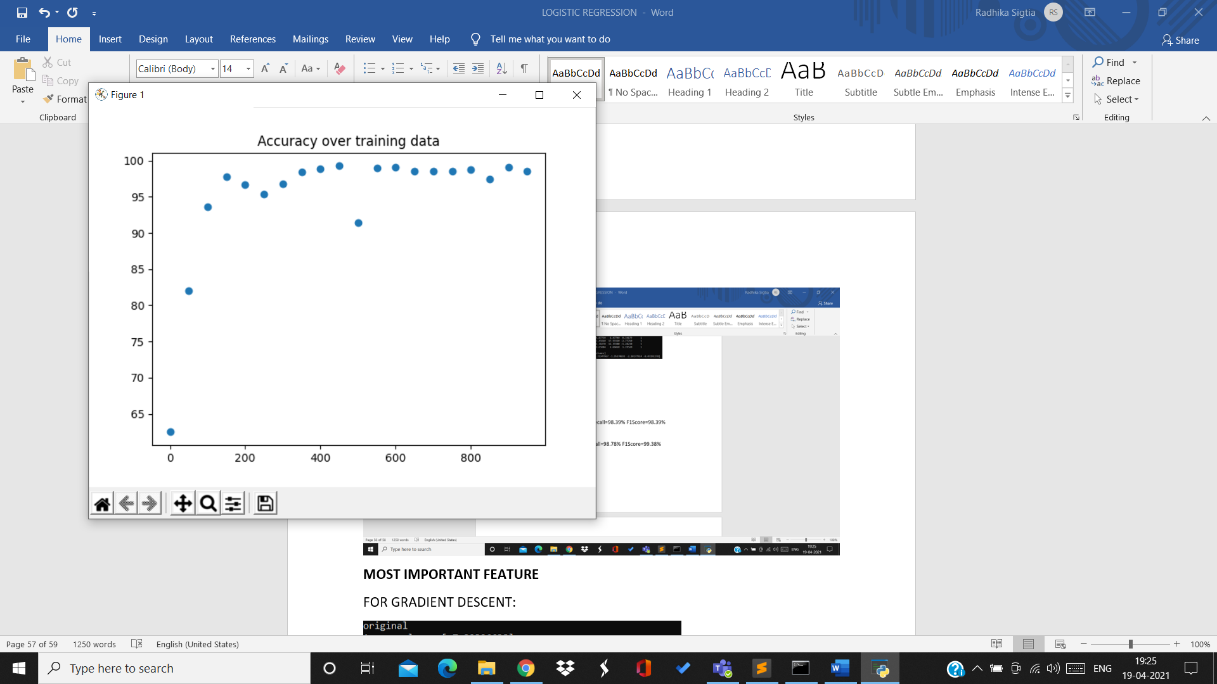

2nd split:

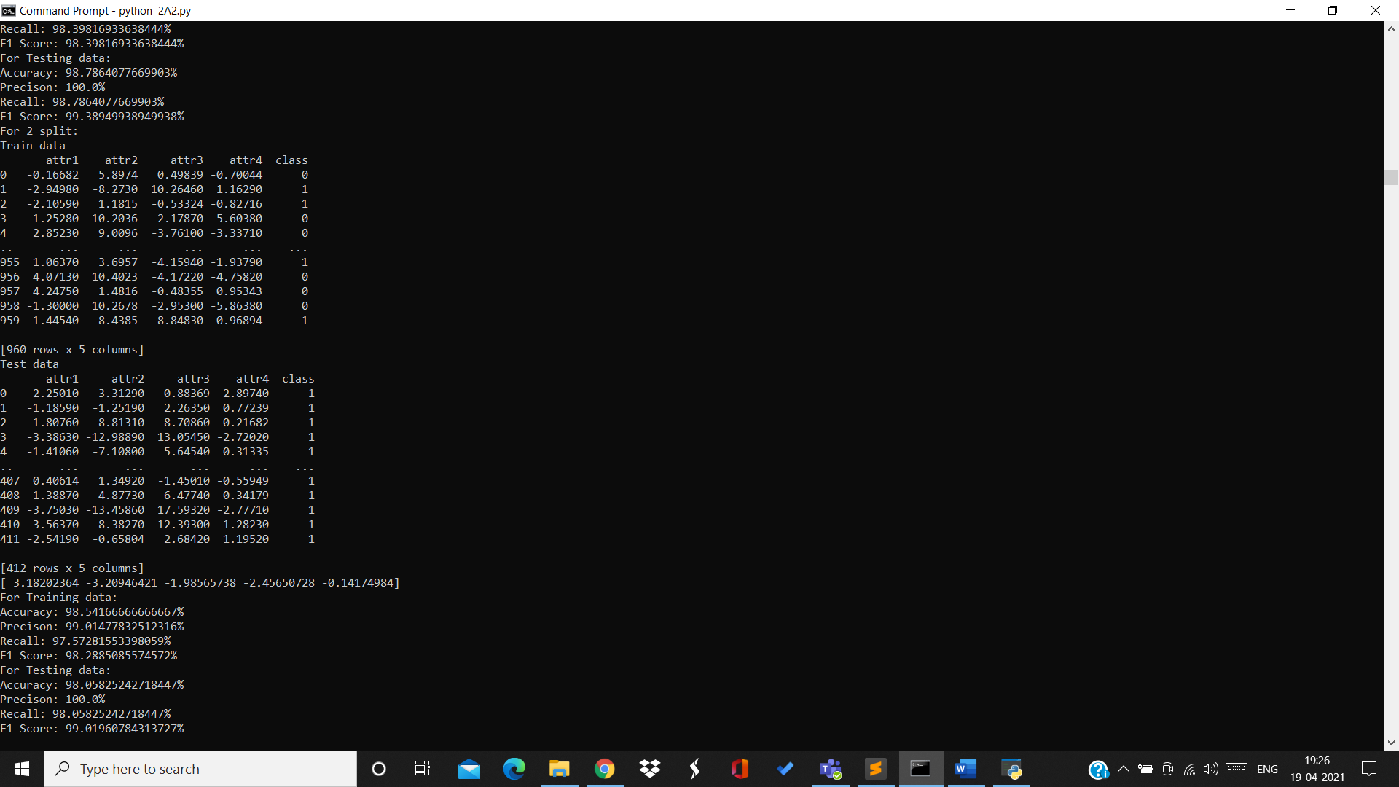

Training data:

Accuracy=98.54% Precision=99.04% Recall=97.57% F1Score=98.28%

Testing data:

Accuracy=98.05% Precision=100% Recall=98.05% F1Score=99.01%

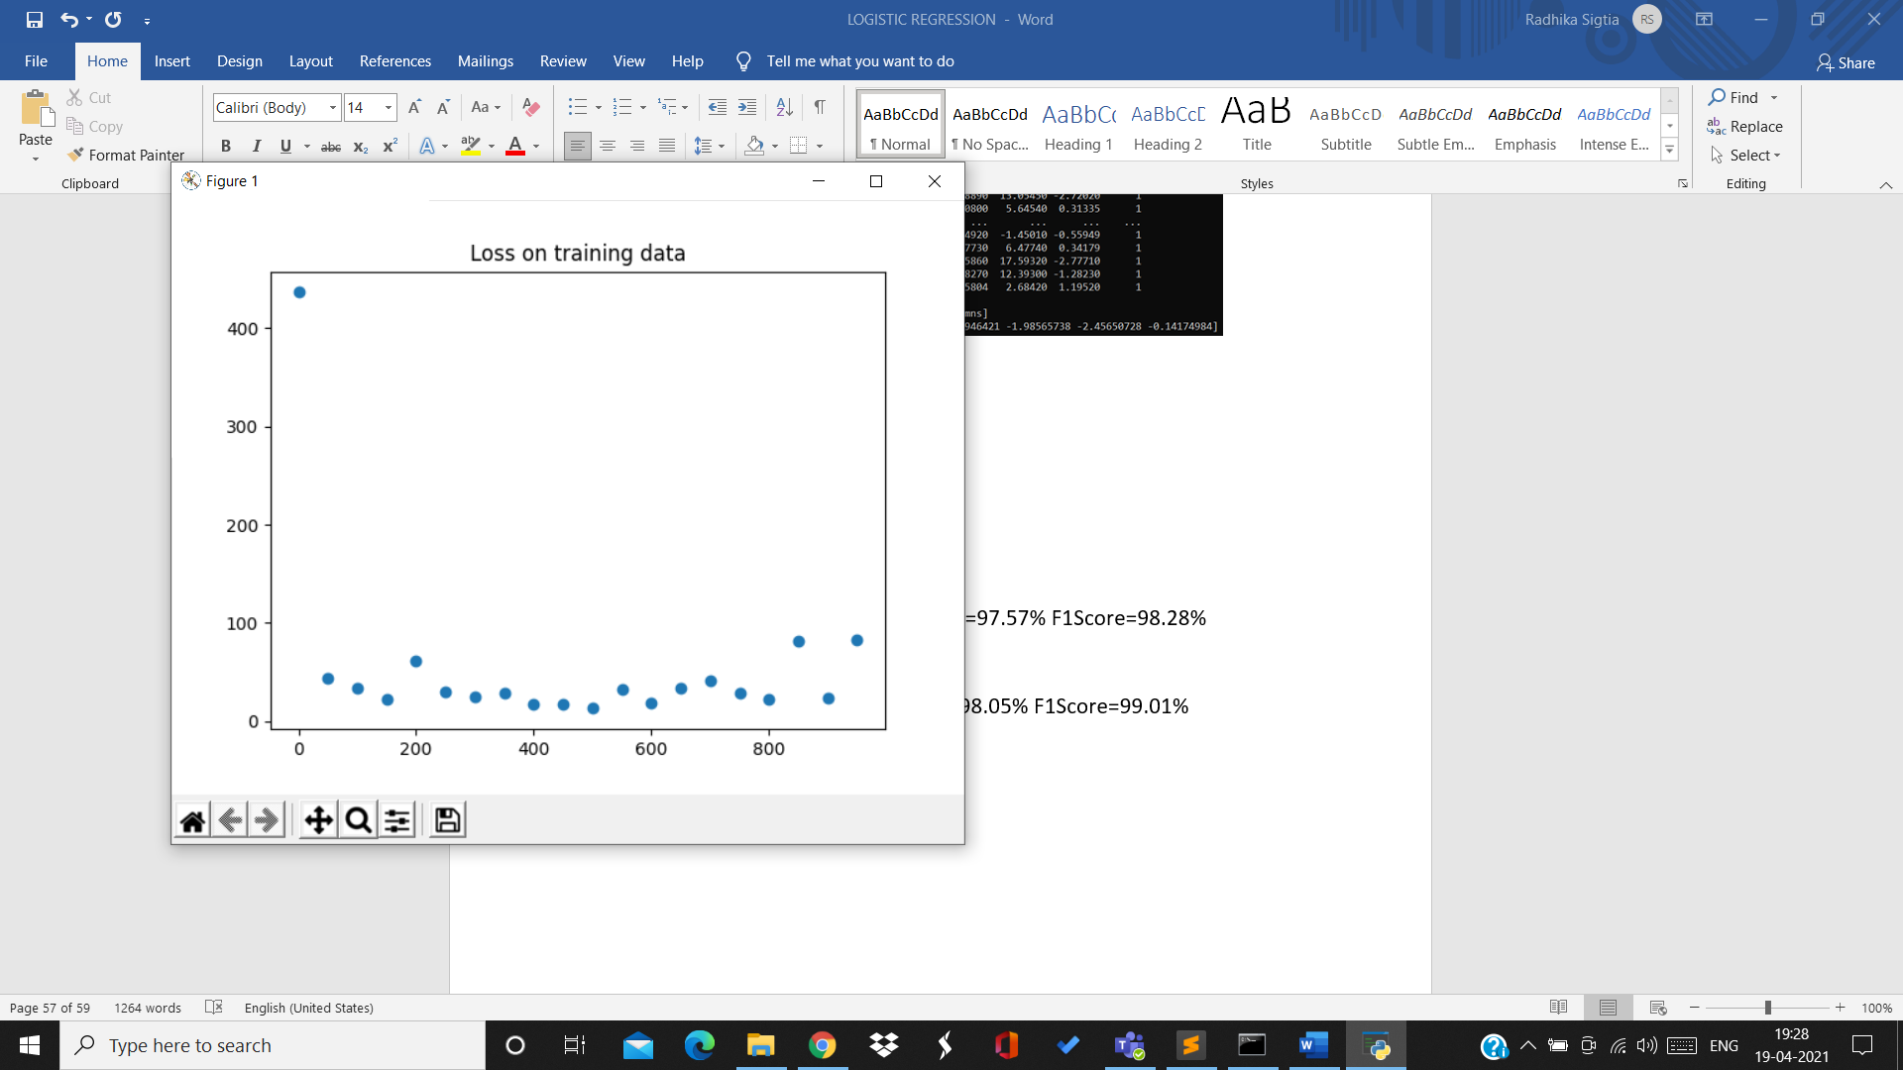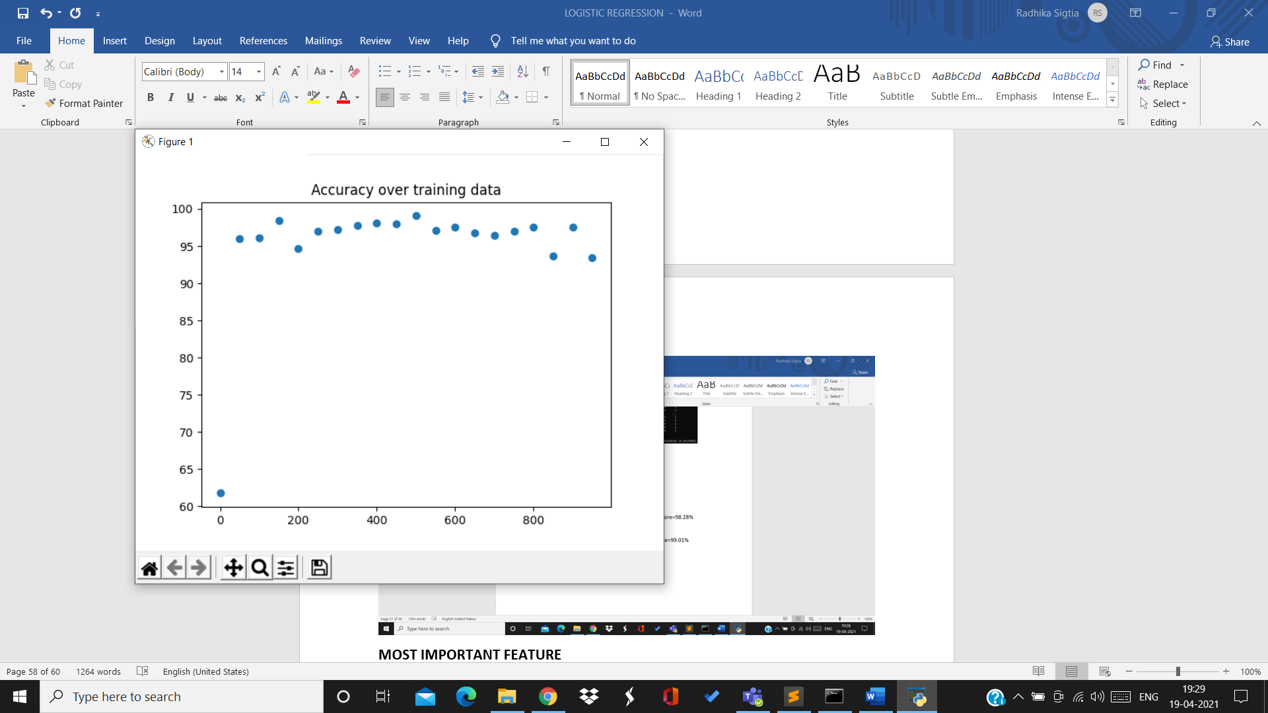

3rd split:

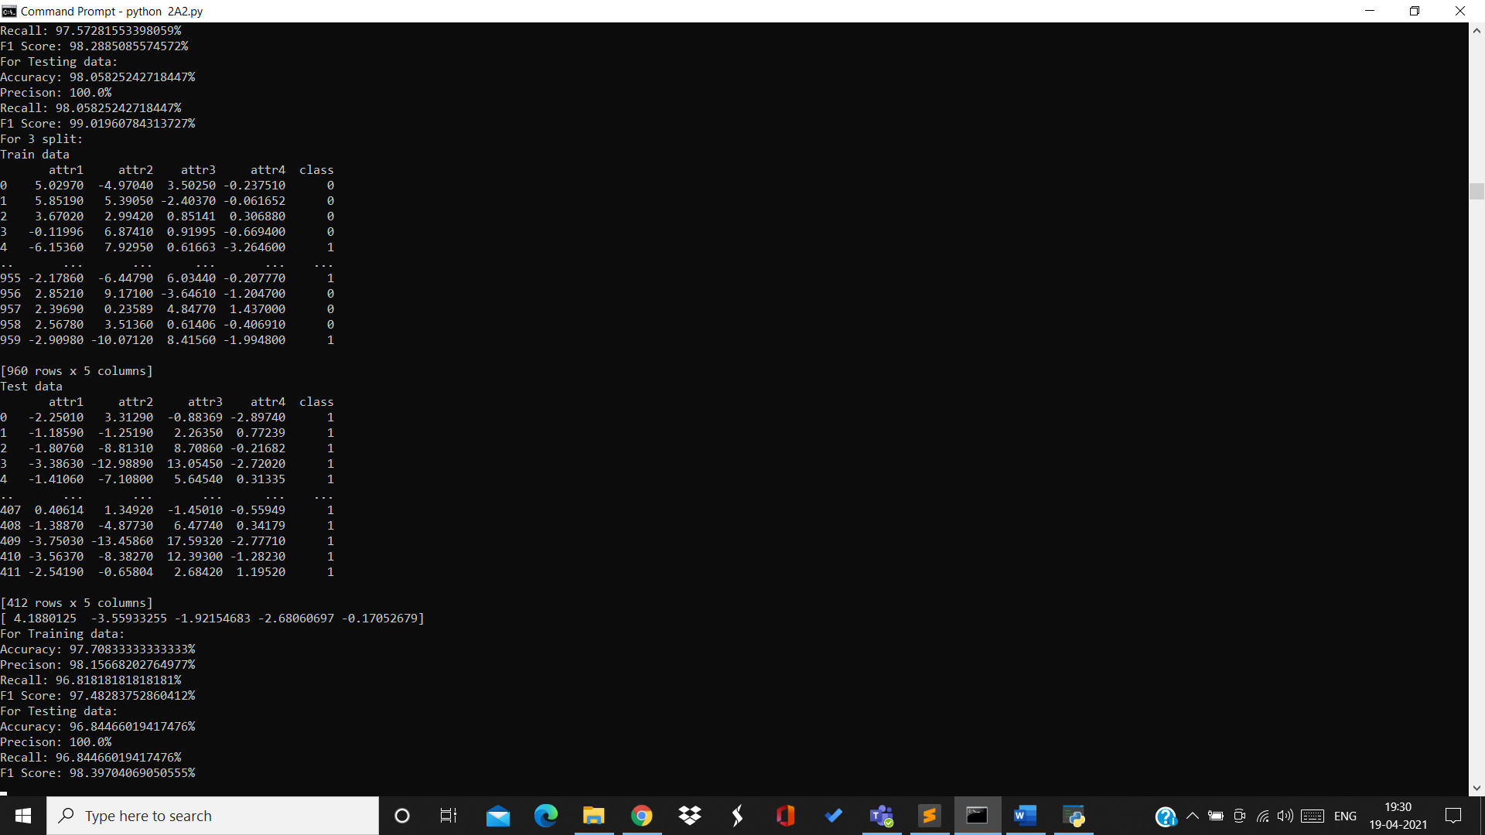

Training data:

Accuracy=97.7% Precision=98.15% Recall=9.81% F1Score=97.48%

Testing data:

Accuracy=96.84% Precision=100% Recall=96.84% F1Score=98.39%

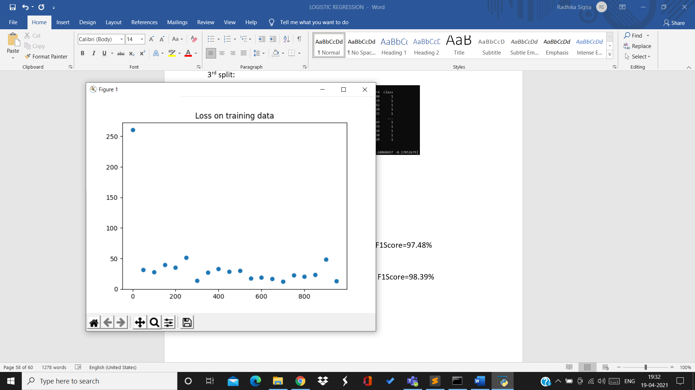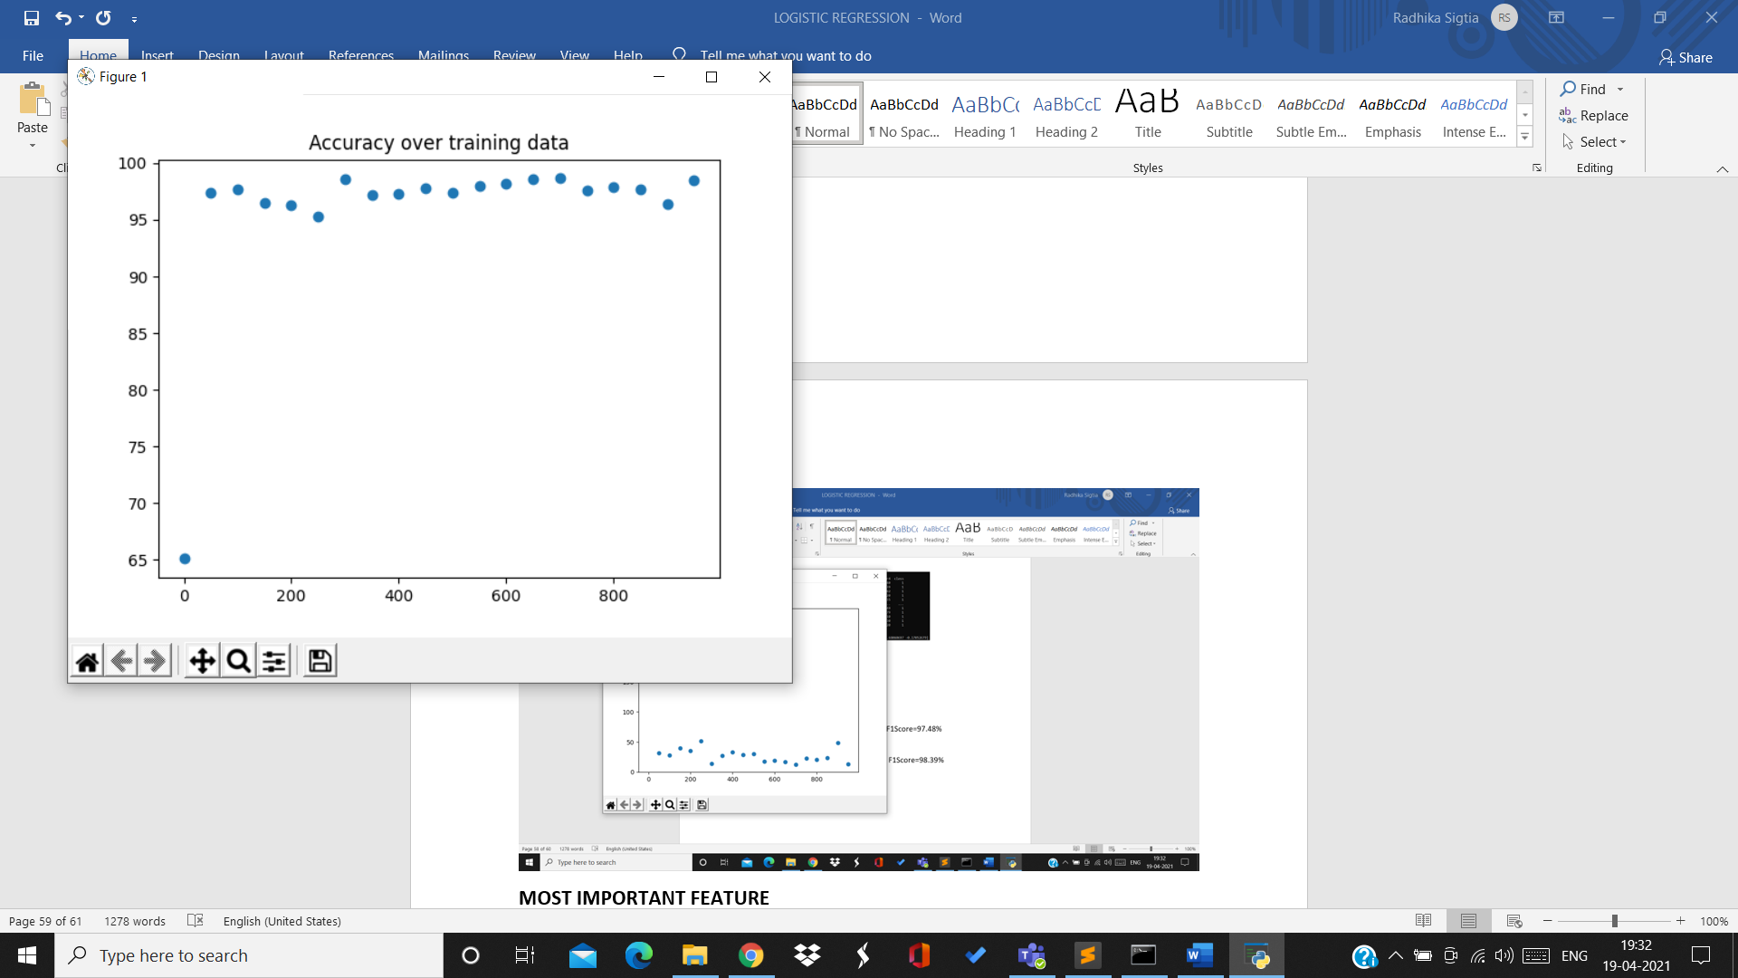

4th split:

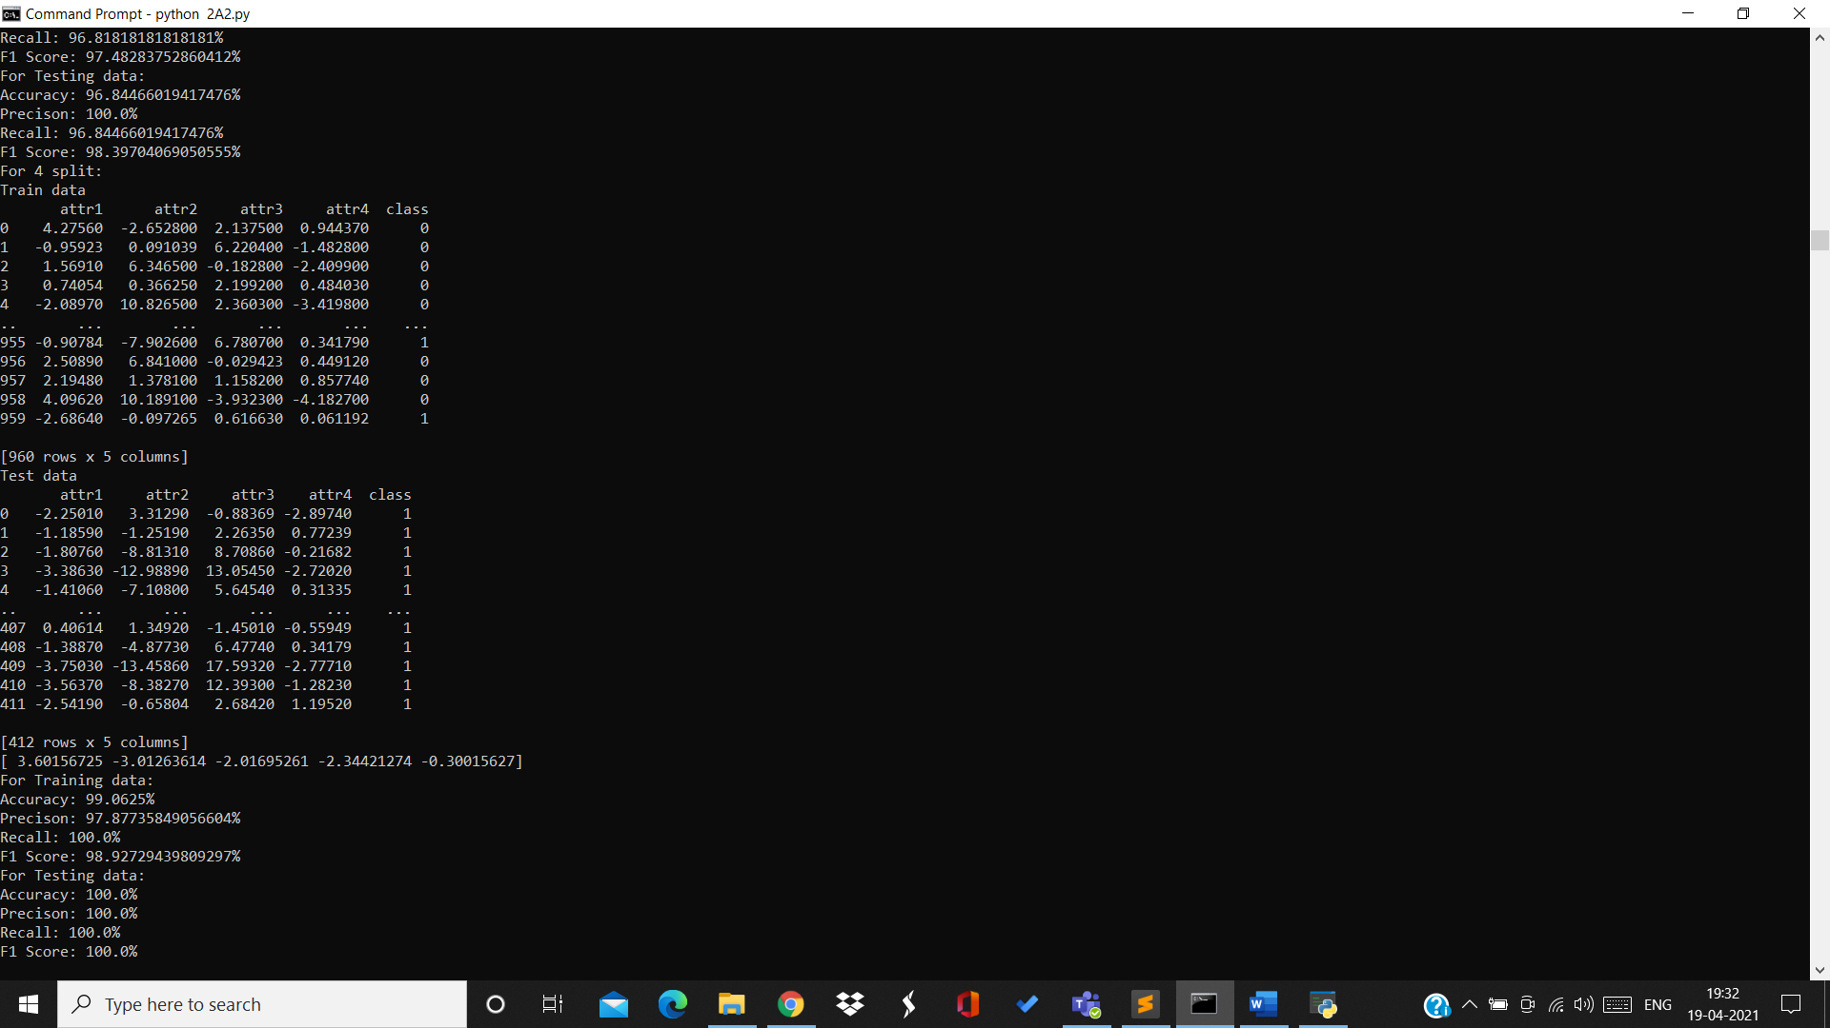

Training data:

Accuracy=99.06% Precision=97.87% Recall=100% F1Score=98.92%

Testing data:

Accuracy=100% Precision=100% Recall=100% F1Score=100%

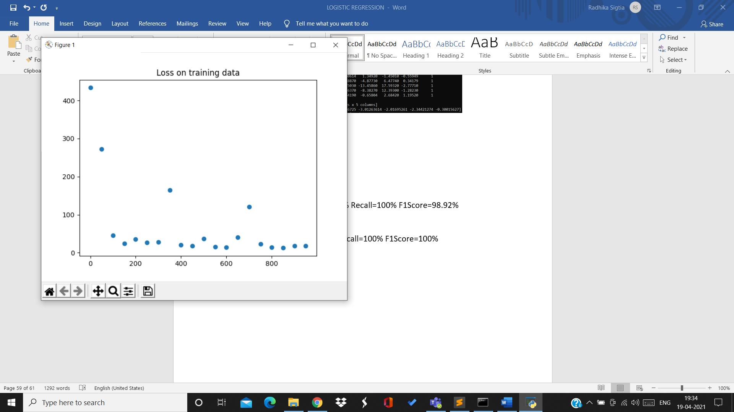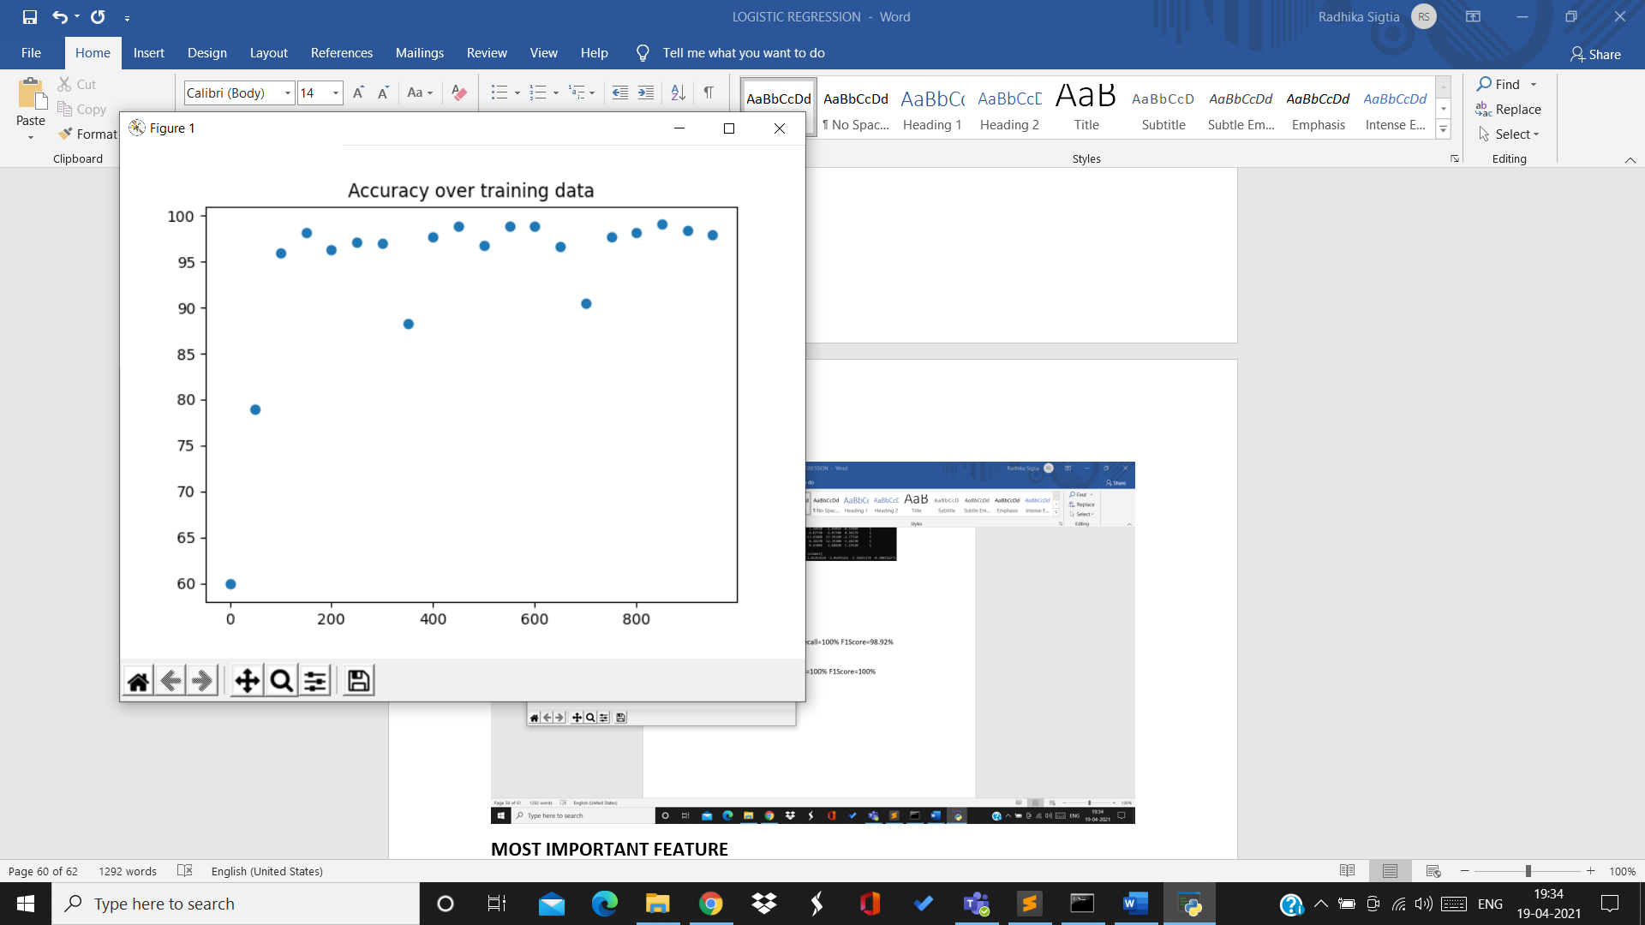

5th split:

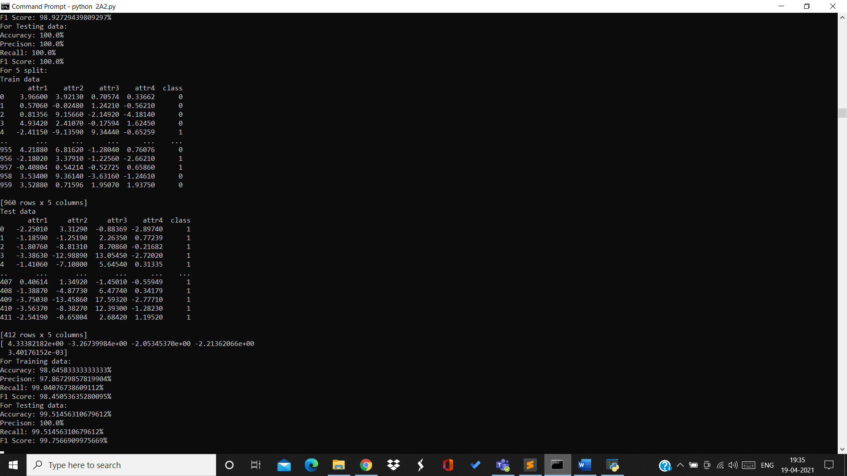

Training data:

Accuracy=98.64% Precision=97.86% Recall=99.04% F1Score=98.45%

Testing data:

Accuracy=99.51% Precision=100% Recall=99.51% F1Score=99.75%

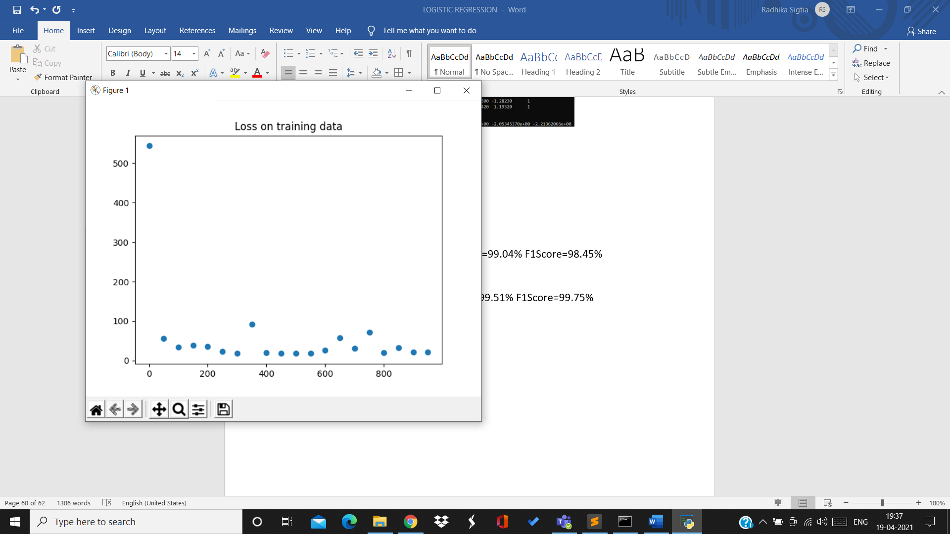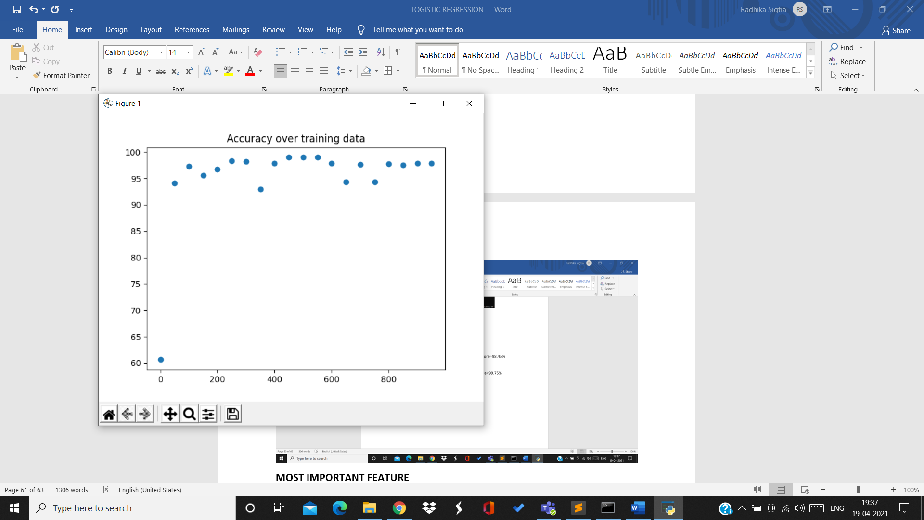

6th split:

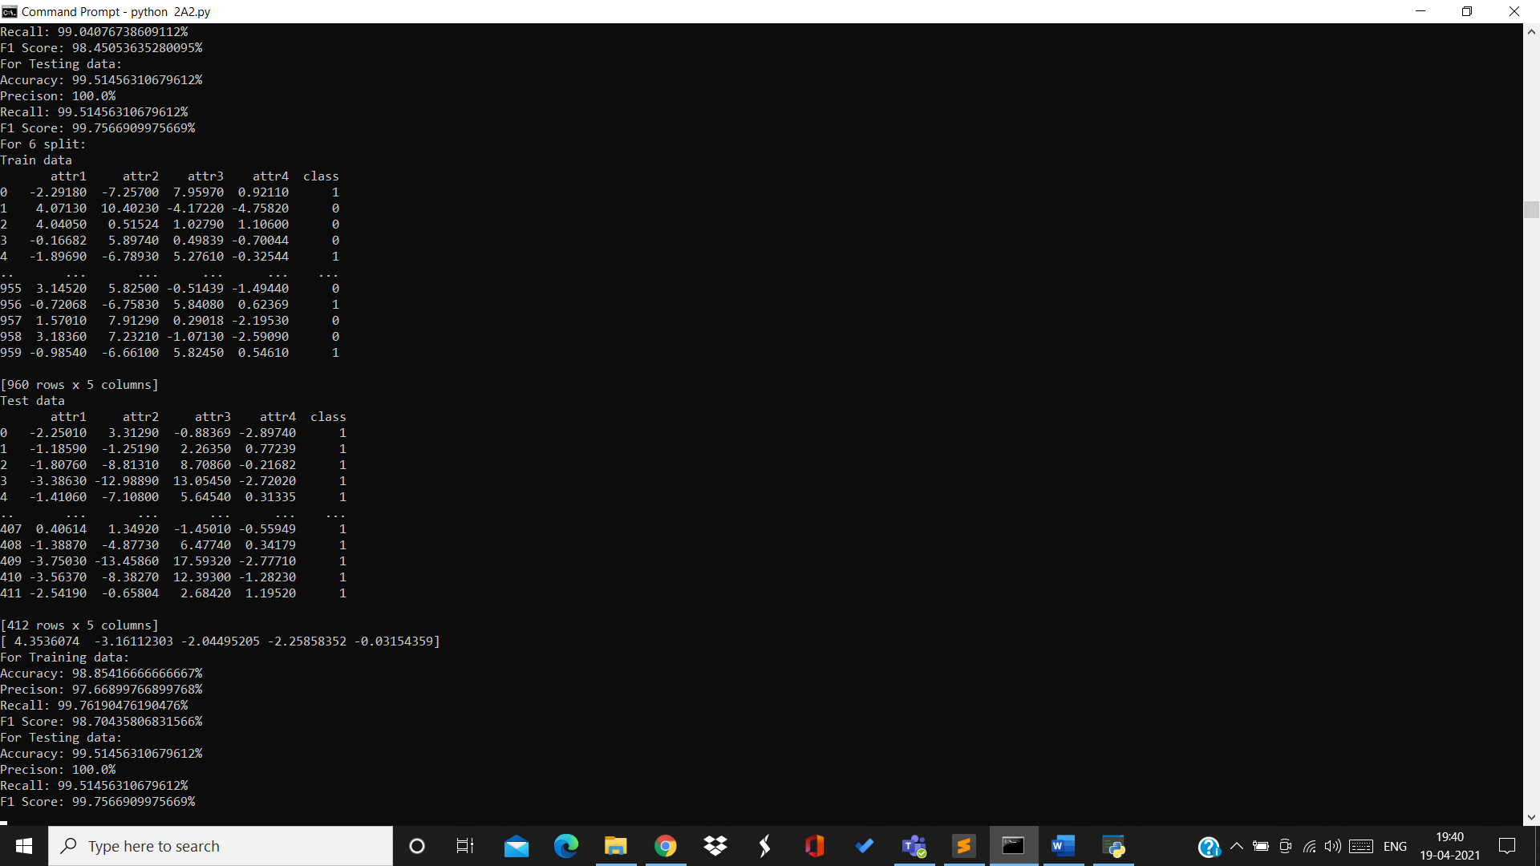

Training data:

Accuracy=98.85% Precision=97.66% Recall=99.76% F1Score=98.7%

Testing data:

Accuracy=99.51% Precision=100% Recall=99.51% F1Score=99.75%

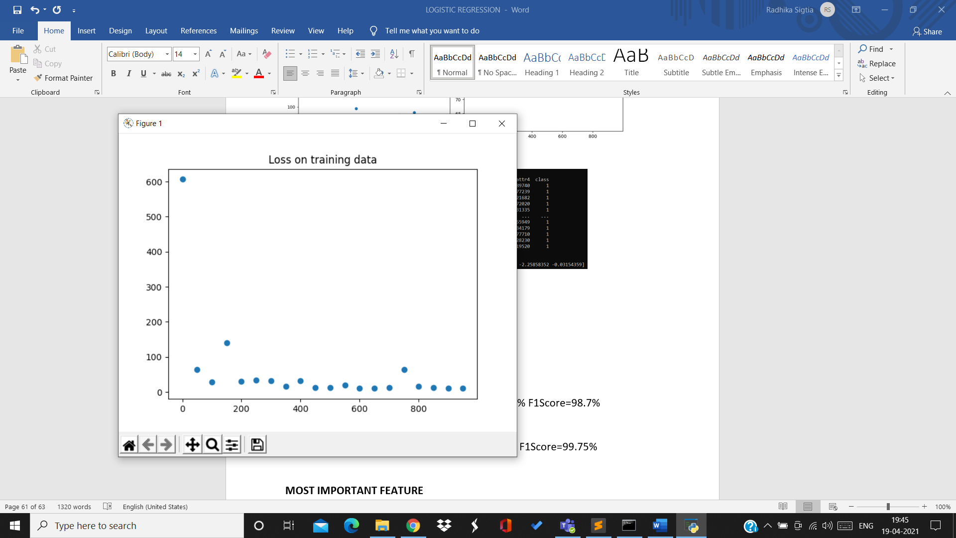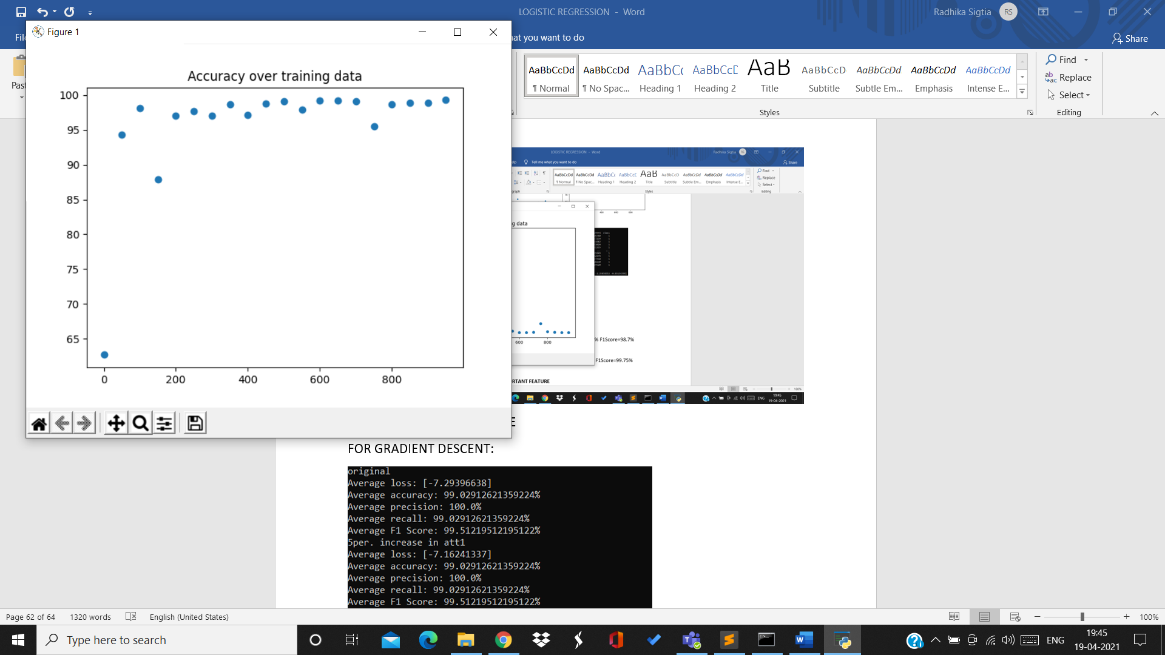

7th split:

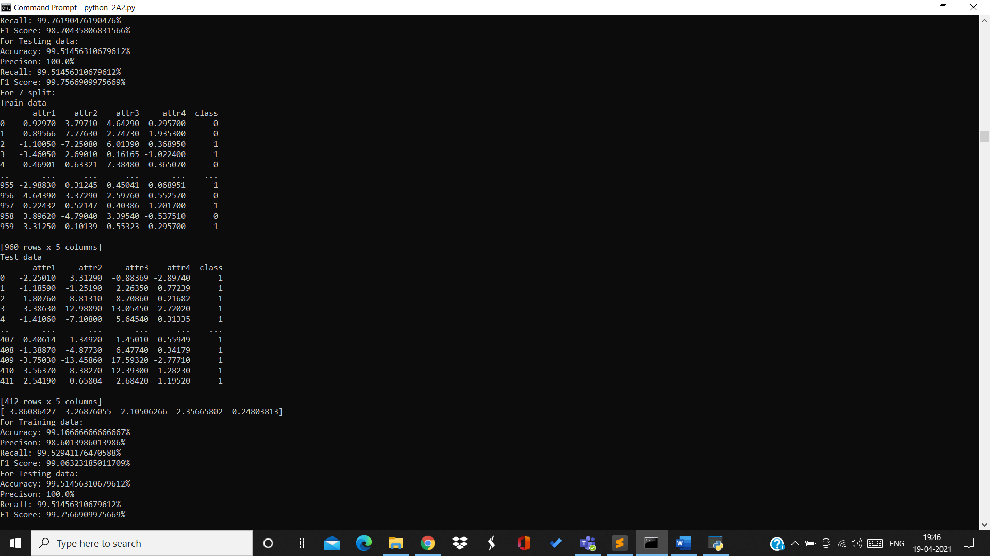

Training data:

Accuracy=99.16% Precision=98.6% Recall=99.52% F1Score=99.06%

Testing data:

Accuracy=99.51% Precision=100% Recall=99.51% F1Score=99.75%

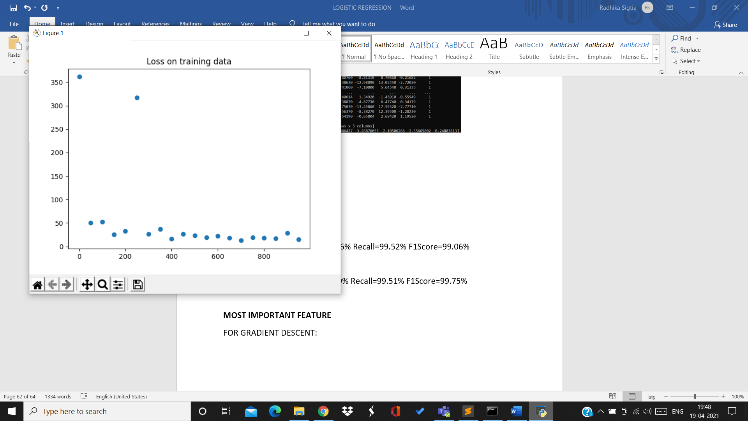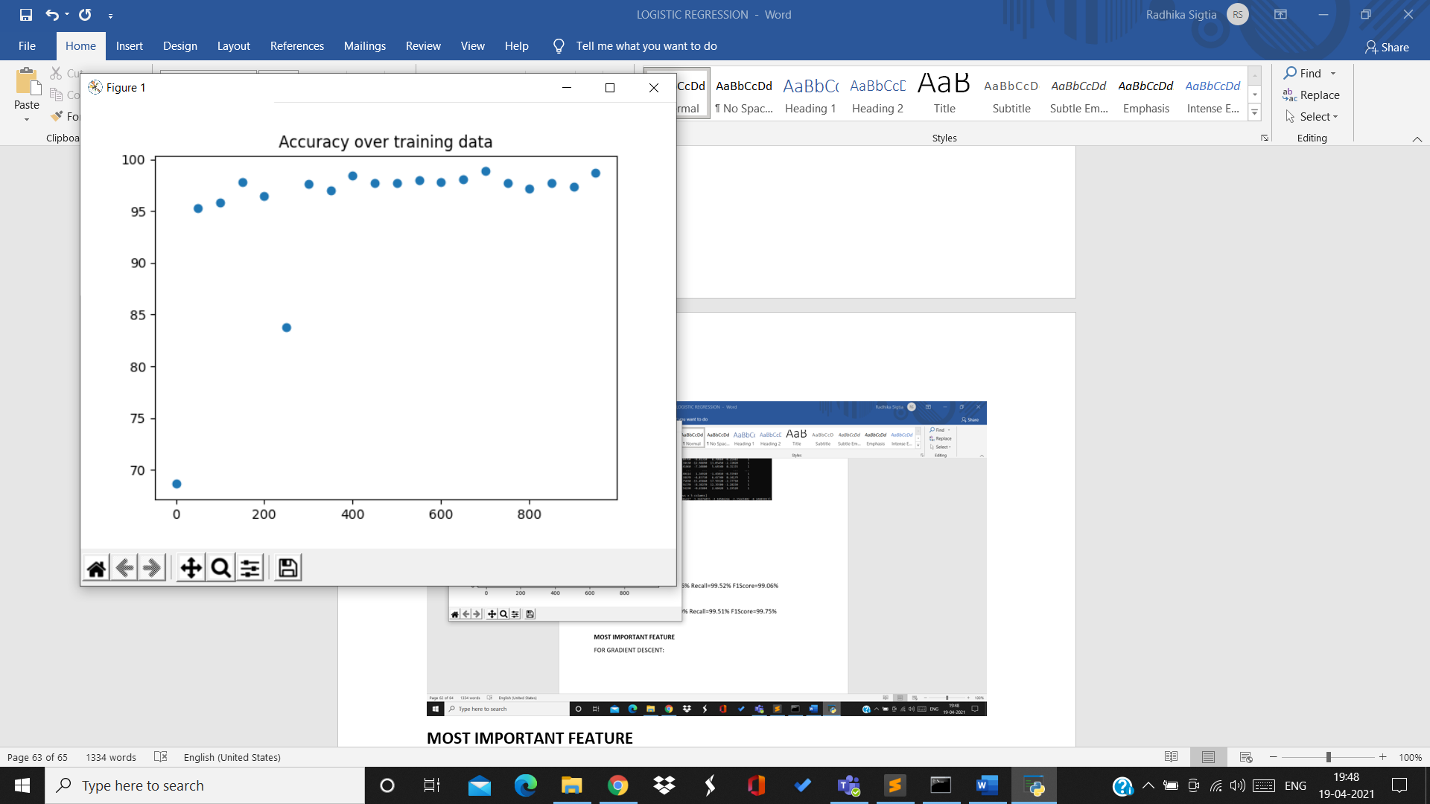

8th split:

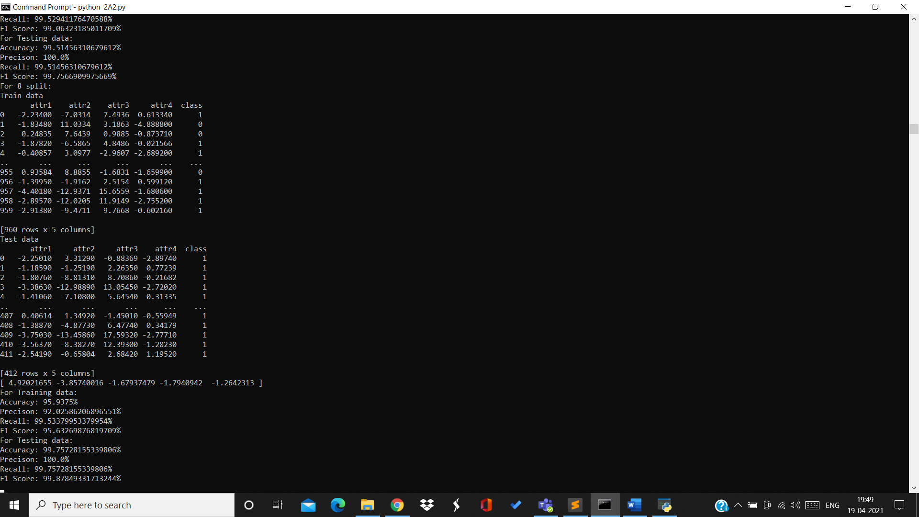

Training data:

Accuracy=95.93% Precision=92.02% Recall=99.53% F1Score=95.63%

Testing data:

Accuracy=99.75% Precision=100% Recall=99.75% F1Score=99.87%

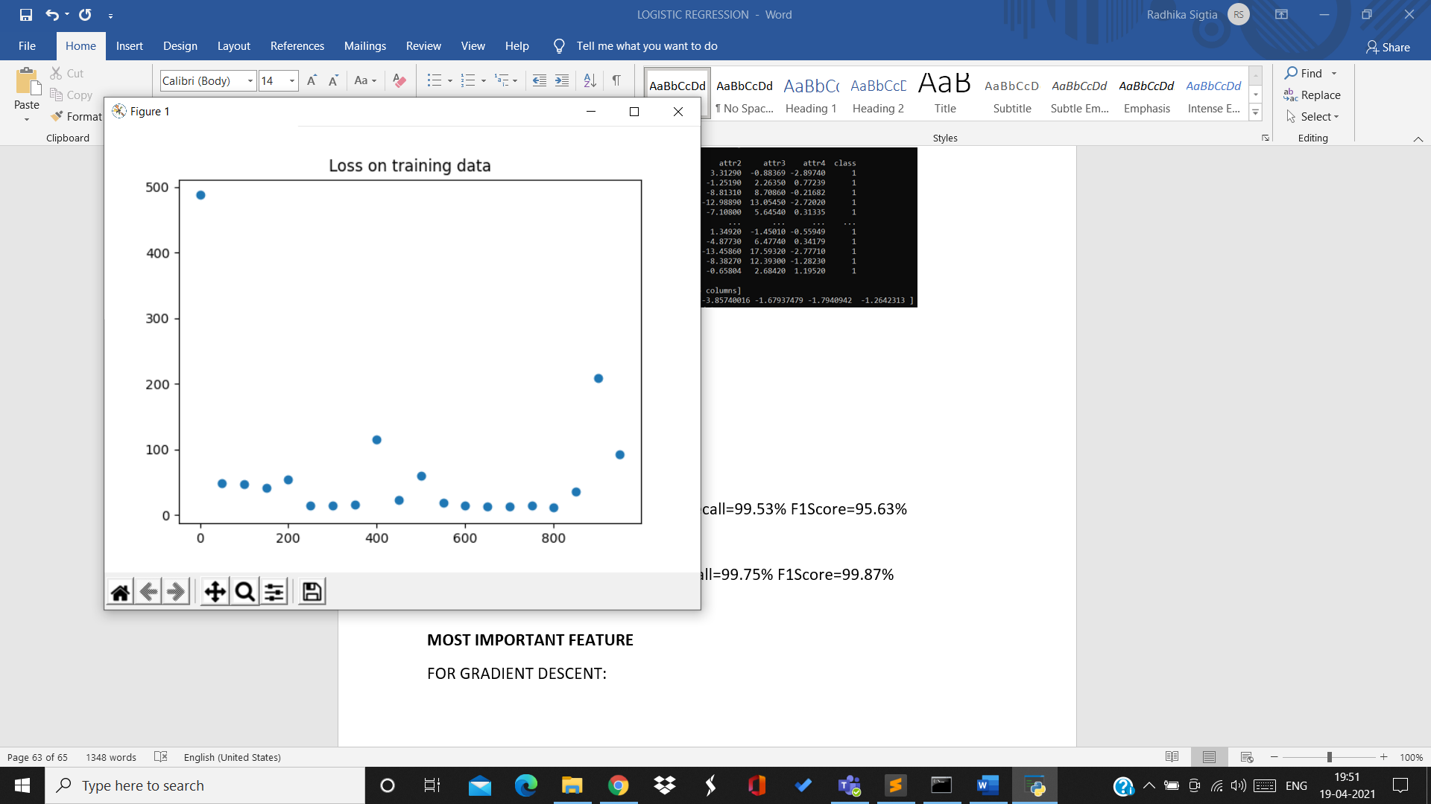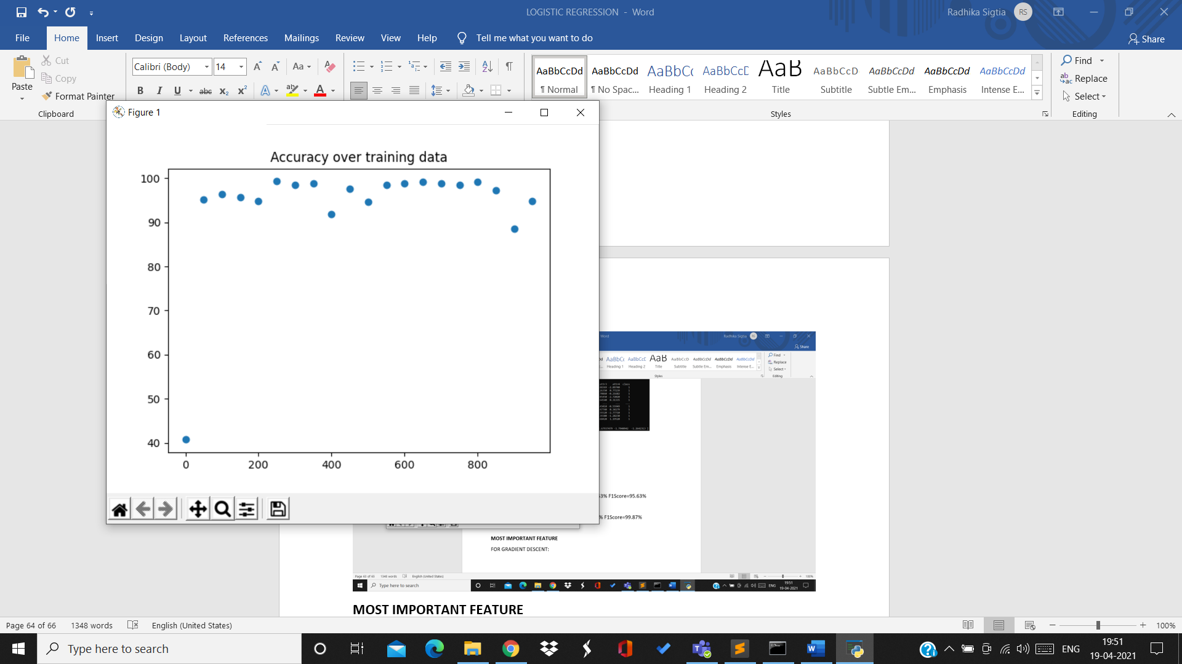

9th split:

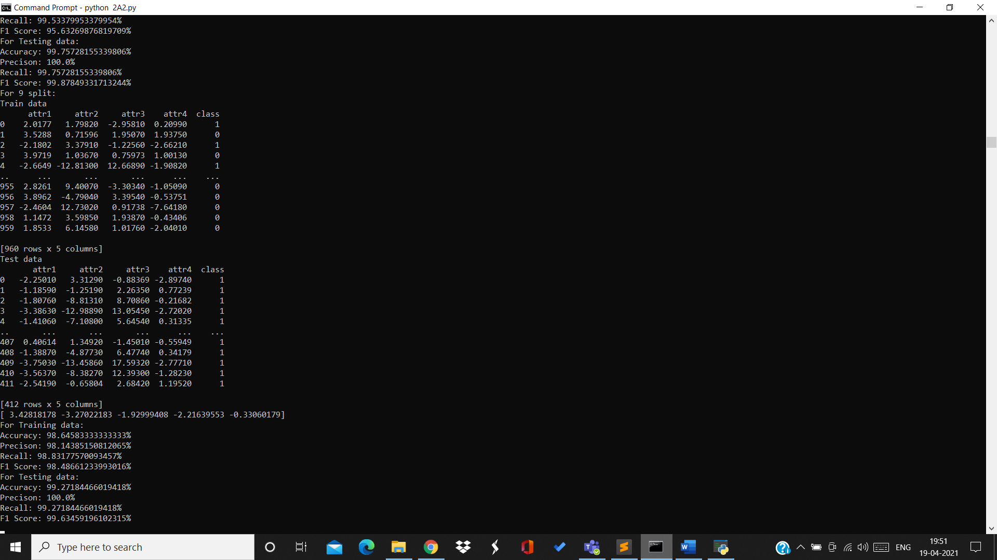

Training data:

Accuracy=98.64% Precision=98.14% Recall=98.83% F1Score=98.48%

Testing data:

Accuracy=99.27% Precision=100% Recall=99.27% F1Score=99.63%

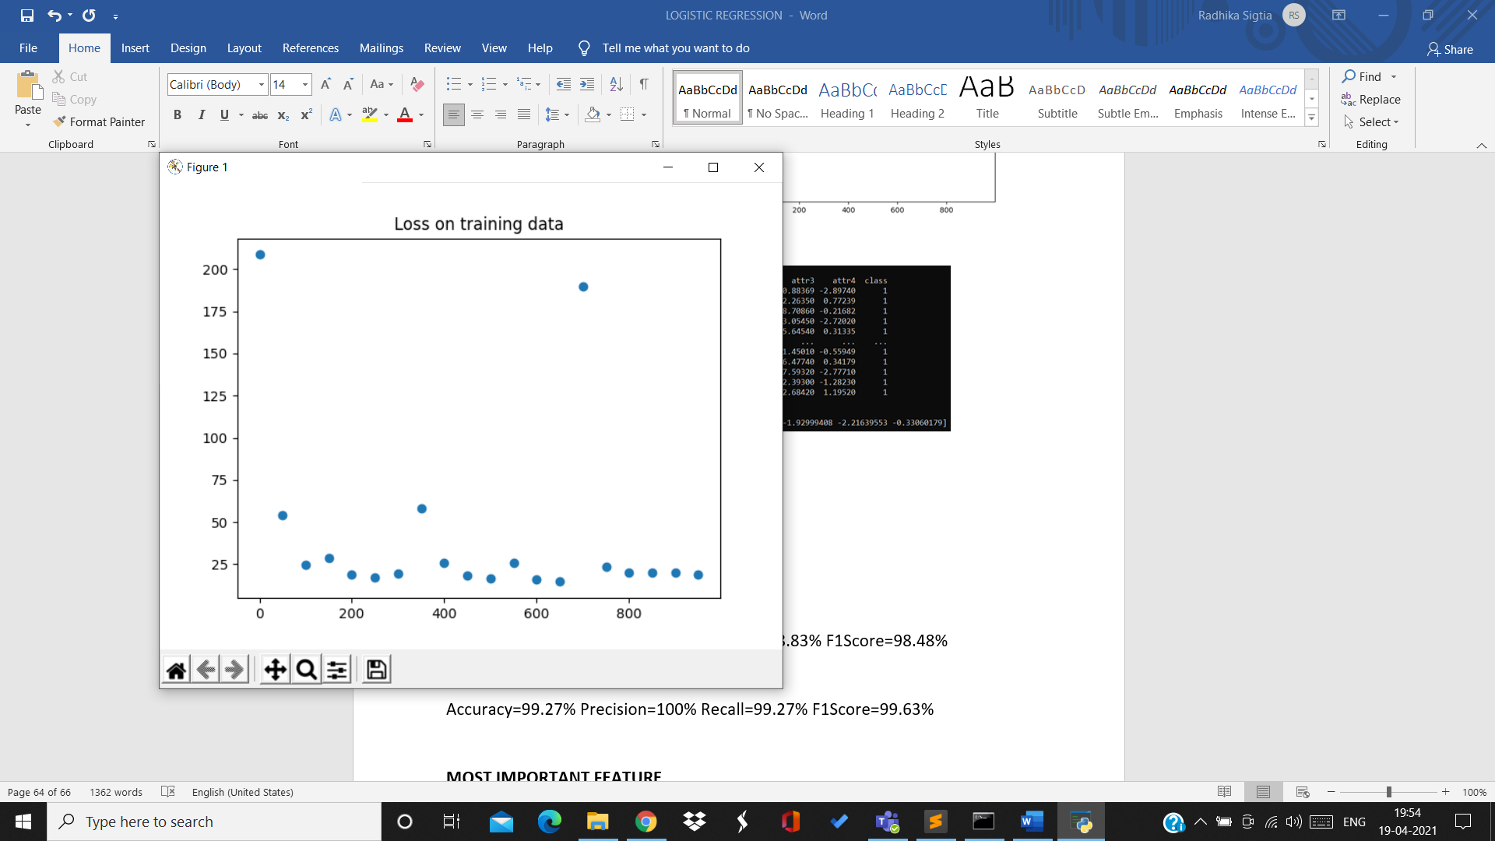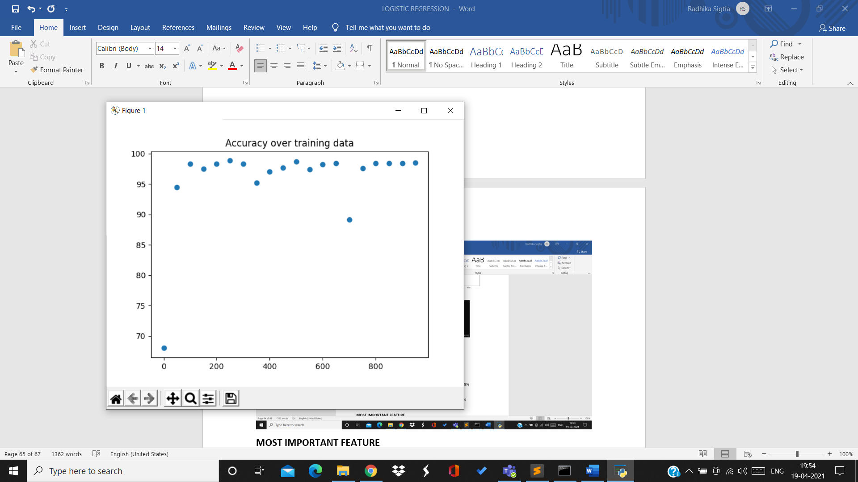

10th split:

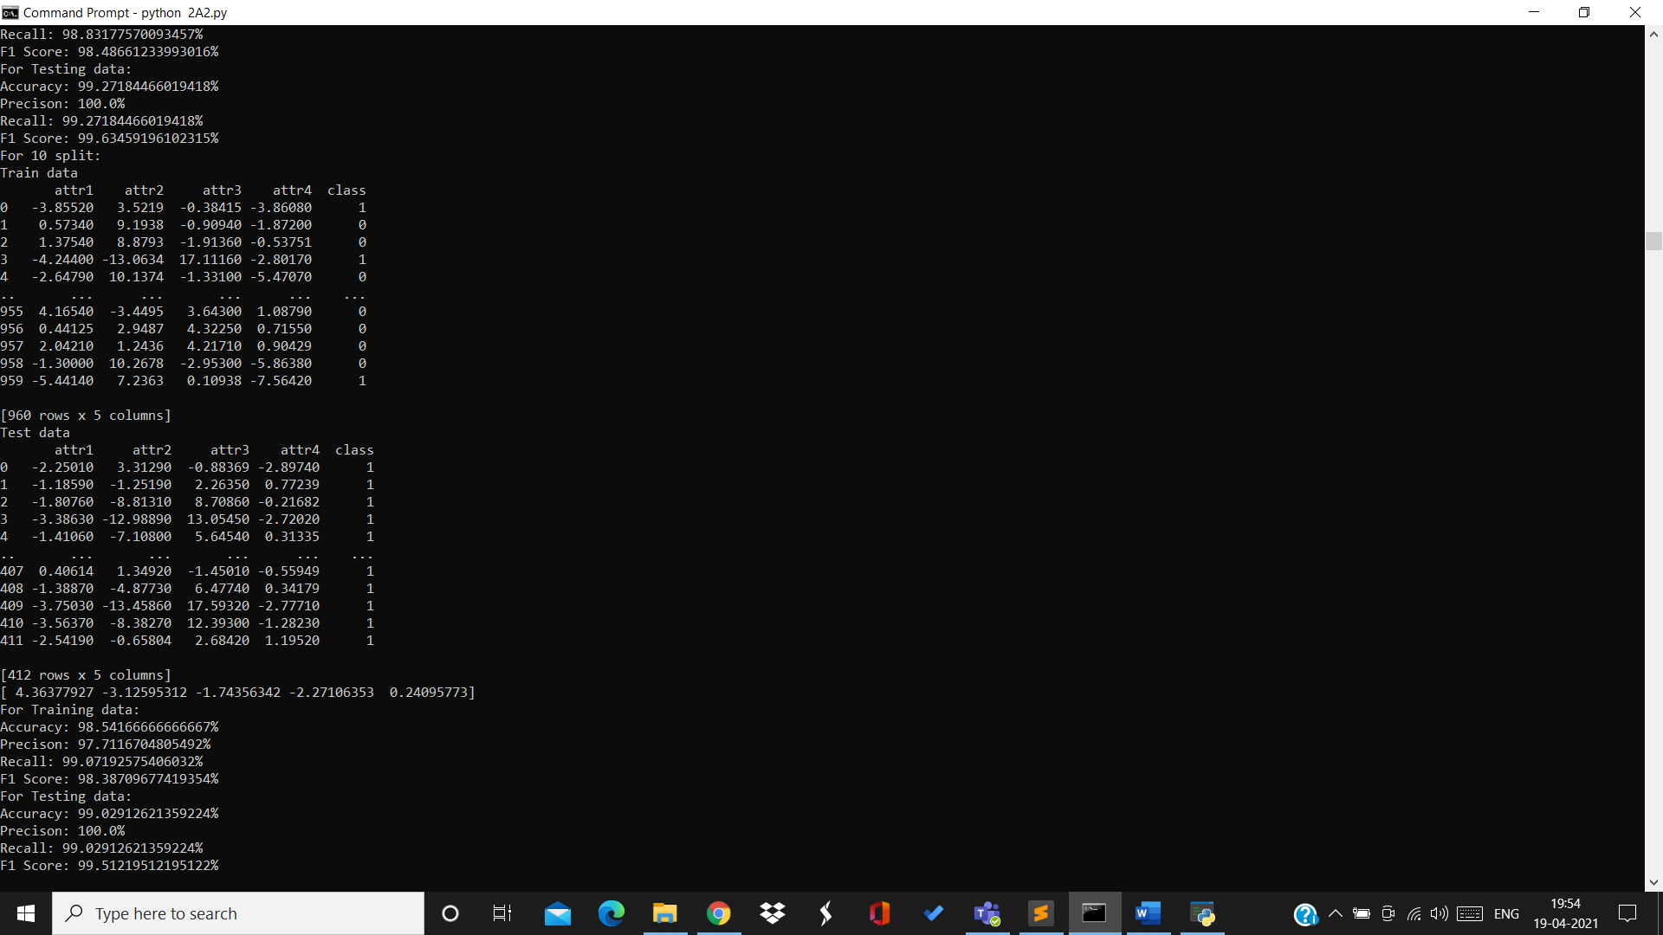

Training data:

Accuracy=98.54% Precision=97.71% Recall=99.07% F1Score=98.38%

Testing data:

Accuracy=99.02% Precision=100% Recall=99.02% F1Score=99.51%

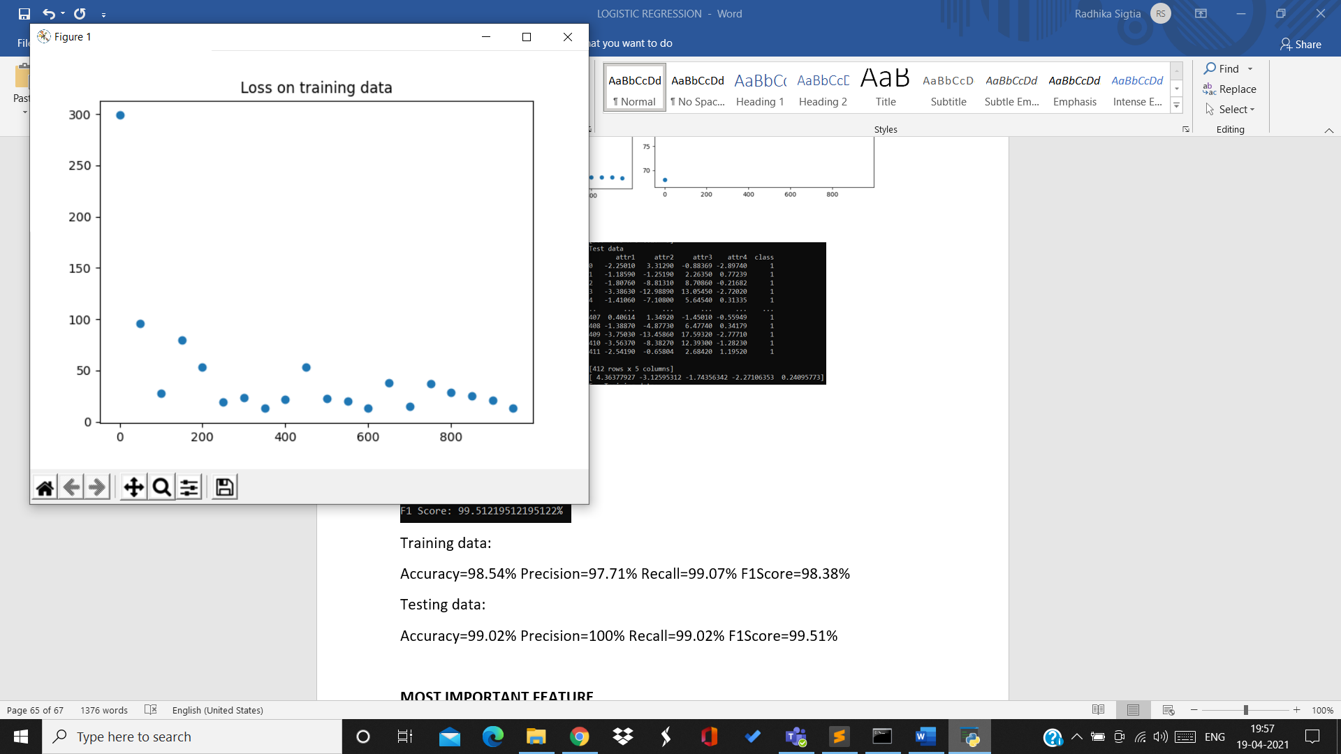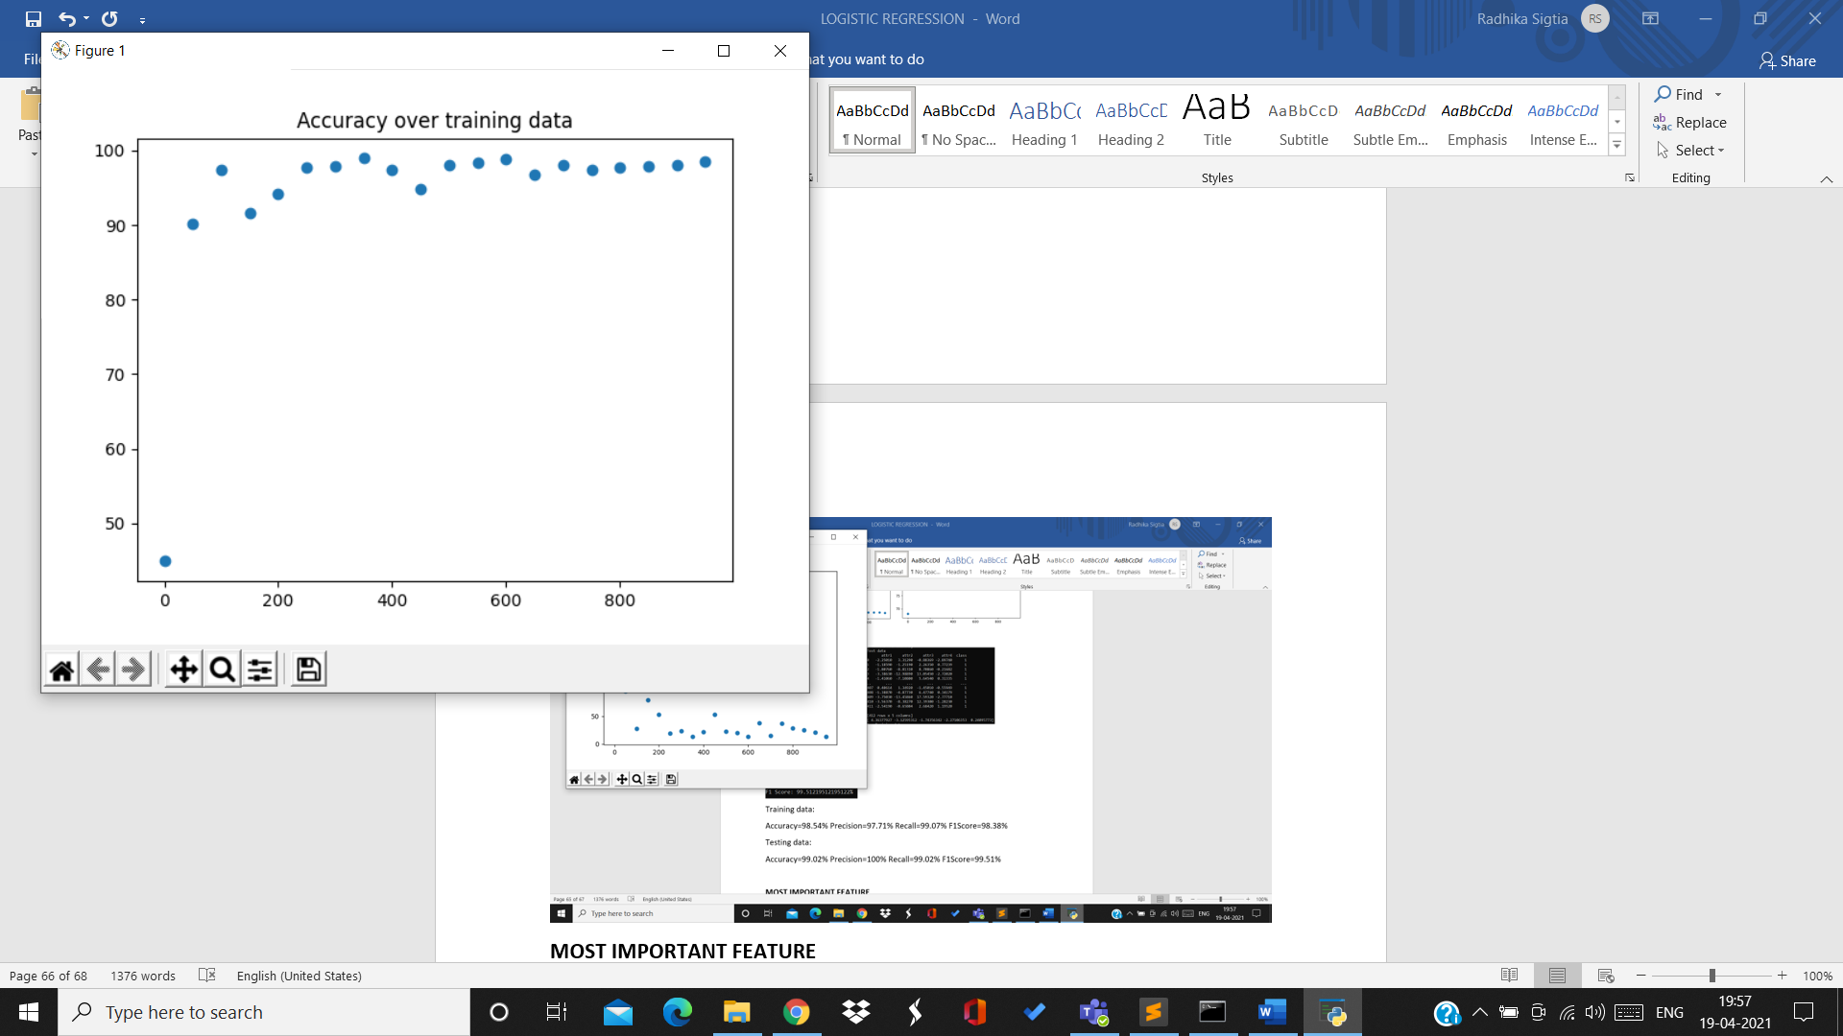

For rate 0.1:

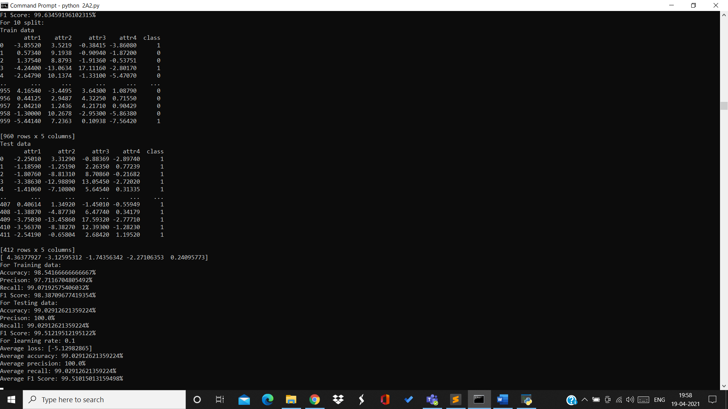

Average loss=-5.12 Average accuracy=99.02% Average precision=100%

Average recall=99.02% Average F1Score=99.51%

Accuracy over 10 splits for testing data with rate 0.1:

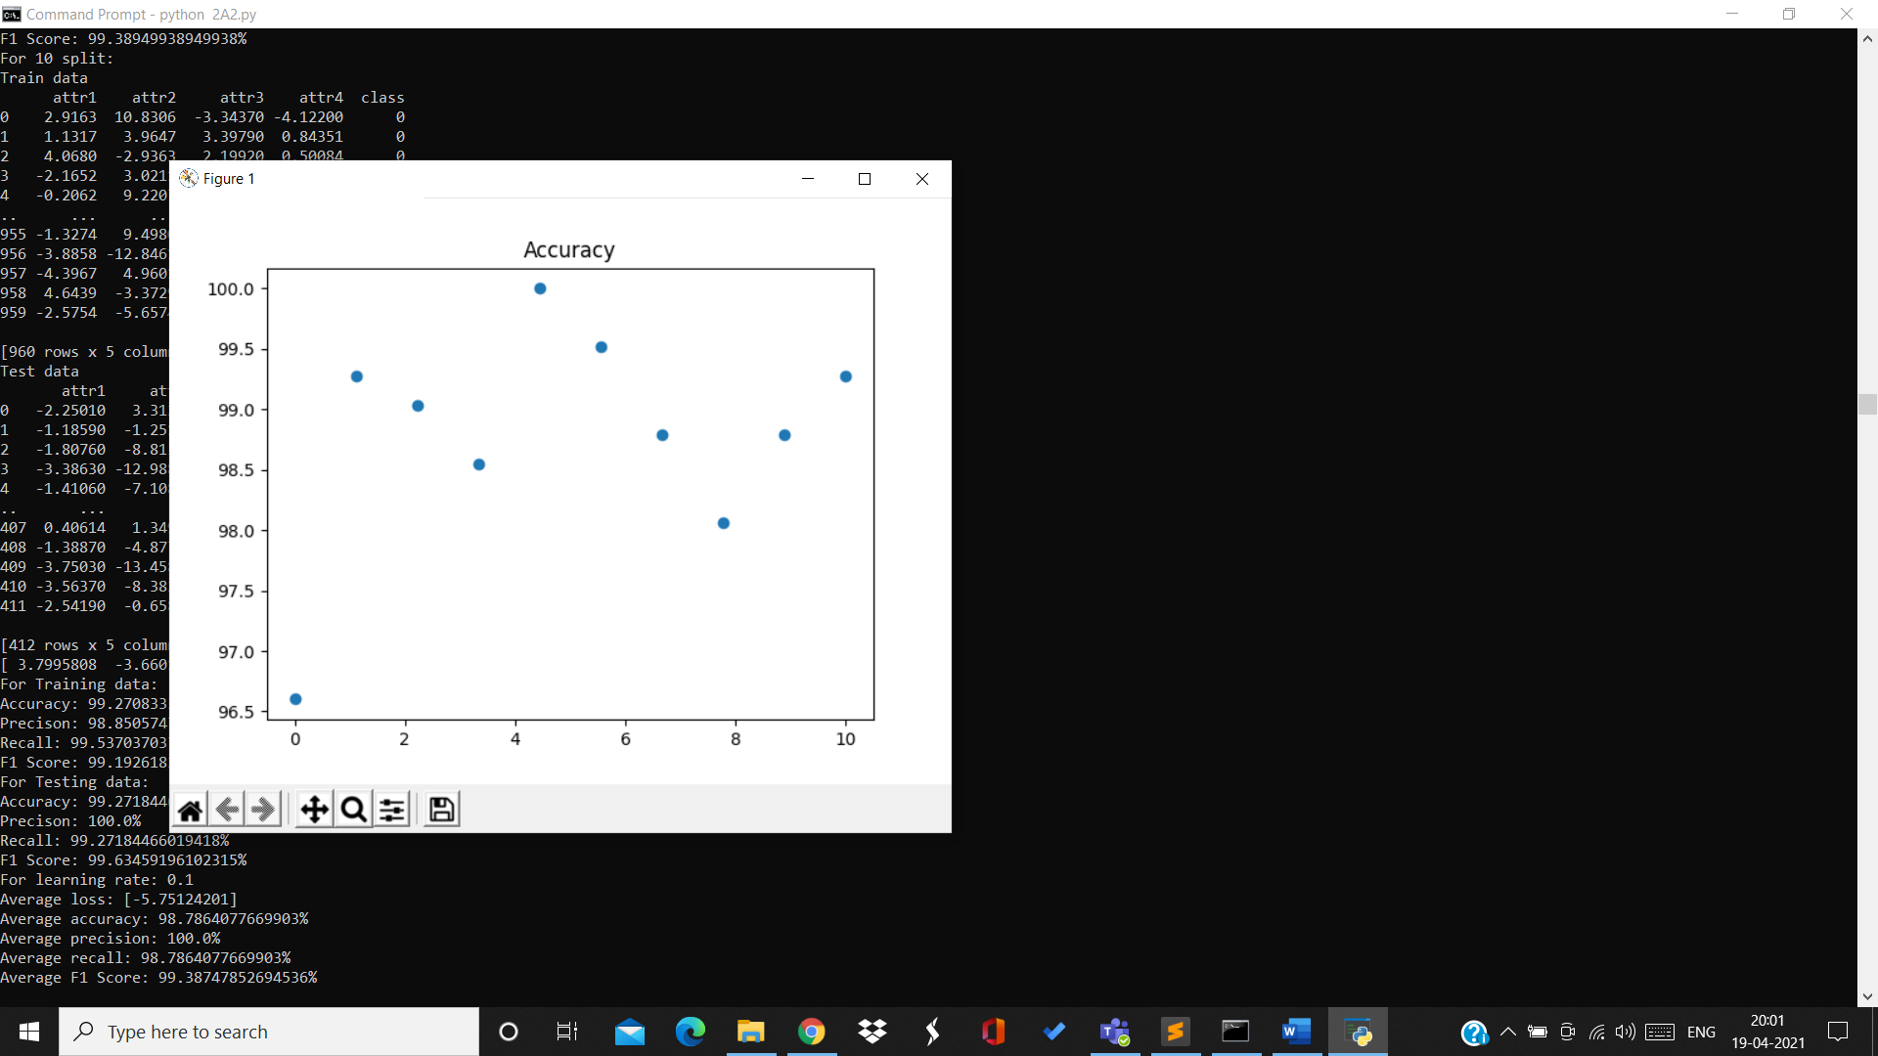

**MOST IMPORTANT FEATURE**

FOR GRADIENT DESCENT:

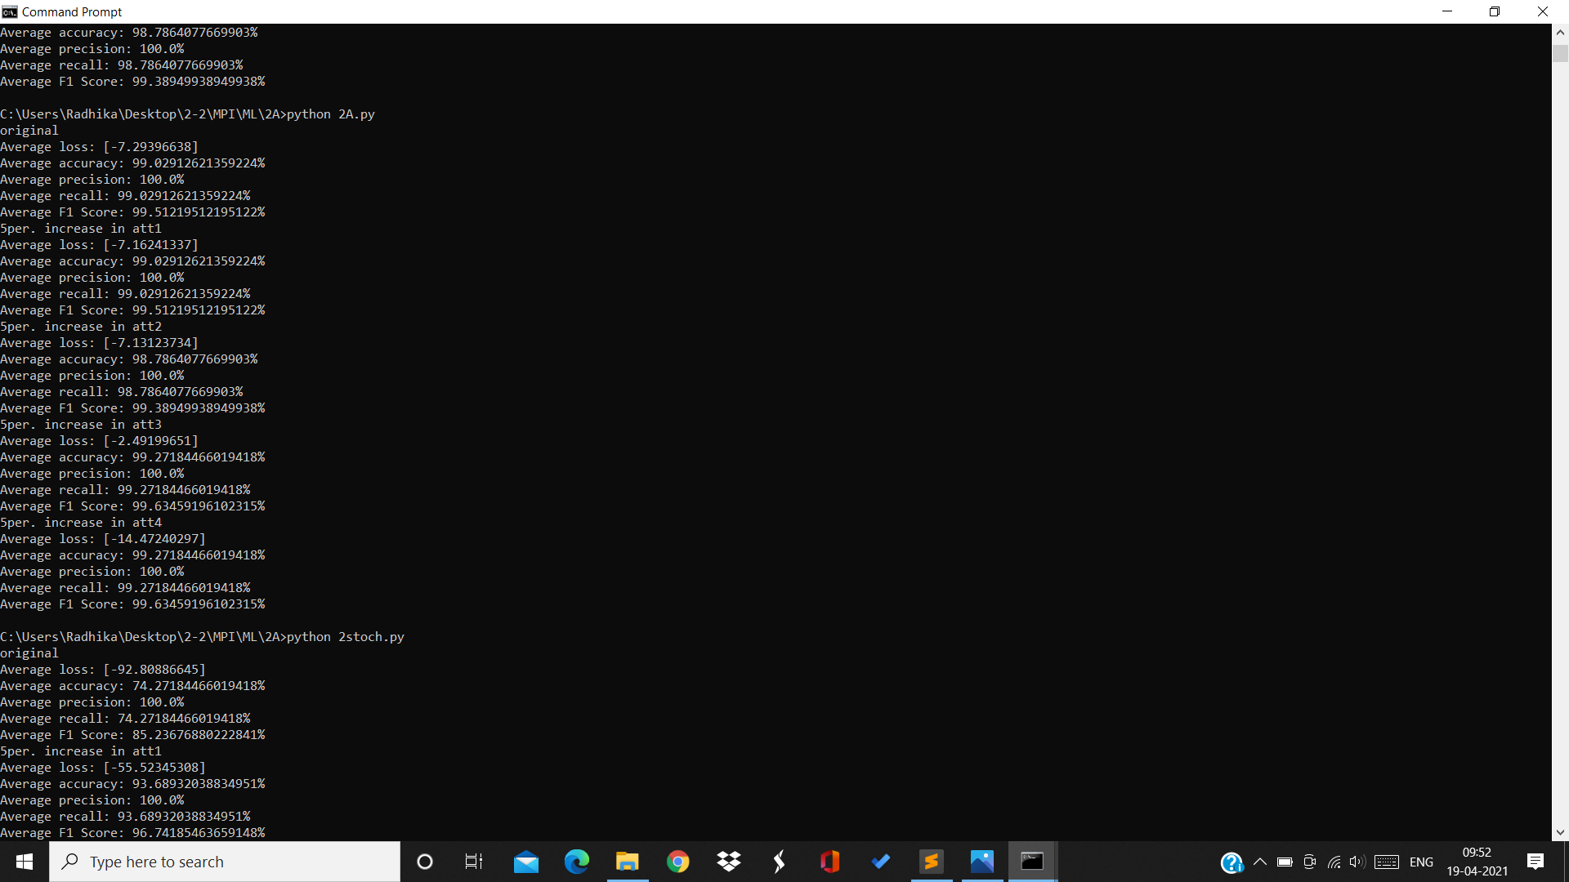

Original accuracy = 99.02%

Original loss = -7.29

Accuracy after 5% increment in attribute1 = 99.02%

Abs(original-attribute1)=0

Accuracy after 5% increment in attribute2 = 98.78%

Abs(original-attribute2)=0.24%

Accuracy after 5% increment in attribute3 = 99.27%

Abs(original-attribute3)=0.25%

Loss after 5% increment in attribute3 = -2.49

Accuracy after 5% increment in attribute4 = 99.27%

Abs(original-attribute4)=0.25%

Loss after 5% increment in attribute4 = -14.47

Accuracy for change in attribute 3 and 4 is same but change in loss due to attribute4 is more. Thus attribute 4 is most important feature.

FOR STOCHASTIC GRADIENT DESCENT:

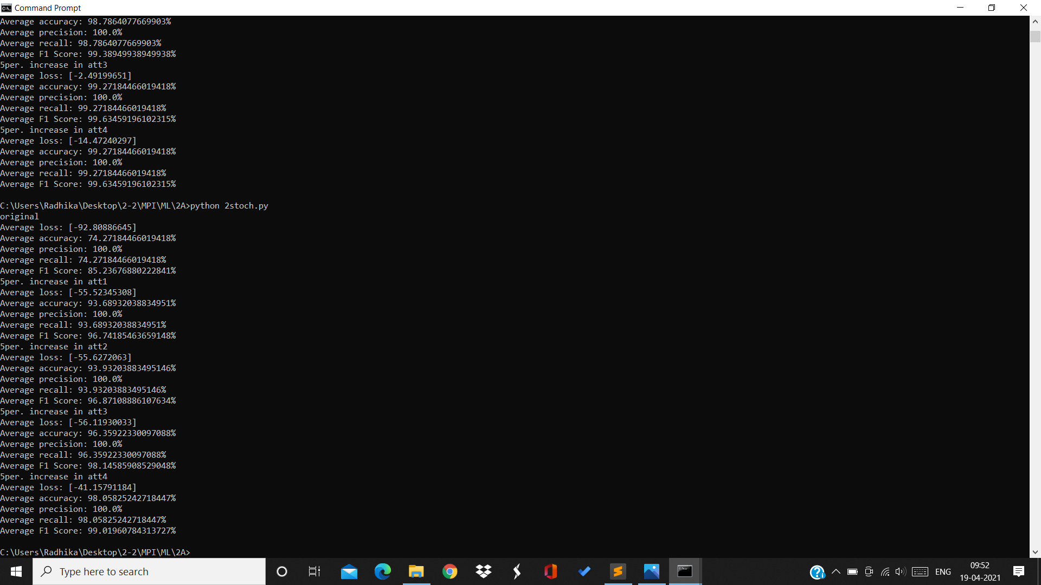

Original accuracy=74.27%

Original loss=-92.8

Accuracy after 5% increment in attribute1 = 93.68%

Accuracy after 5% increment in attribute2 = 93.93%

Accuracy after 5% increment in attribute3 = 96.35%

Accuracy after 5% increment in attribute4 = 98.05%

The highest increase in accuracy is due to change in attribute 4. Thus attribute 4 is the most important feature in the dataset.

BY:

Radhika Sigtia 2019A7PS0094H

Bathini Akash 2019A7PS0065H

Sharvani Reddy 2019A7PS0050H